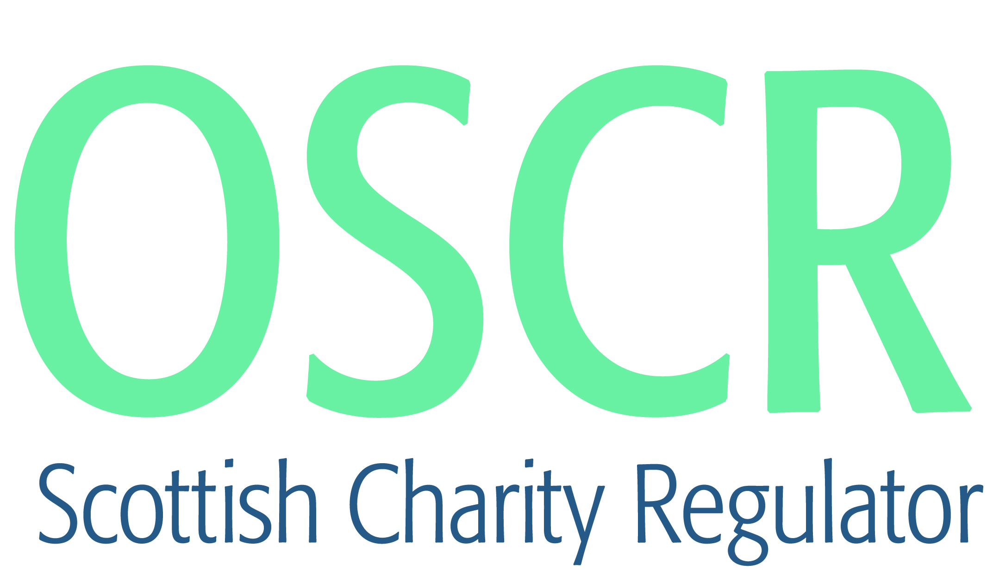

**Charities granted charitable status 1 to 28 February 2022**

|  |  |  |
| --- | --- | --- |
| Charity Number | Charity name | Legal form |
| [SC051557](https://www.oscr.org.uk/about-charities/search-the-register/charity-details?number=SC051557) | ECONOMIC LEAD FOR MINORITY & MARGINALISED COMMUNITIES | SCIO |
| [SC051558](https://www.oscr.org.uk/about-charities/search-the-register/charity-details?number=SC051558) | The Sangster Trust For Music | Trust |
| [SC051559](https://www.oscr.org.uk/about-charities/search-the-register/charity-details?number=SC051559) | Badenoch and Strathspey Orienteering Club | SCIO |
| [SC051560](https://www.oscr.org.uk/about-charities/search-the-register/charity-details?number=SC051560) | Alloa Hub Limited | CommunityBenefitSociety |
| [SC051561](https://www.oscr.org.uk/about-charities/search-the-register/charity-details?number=SC051561) | CoMA (Contemporary Music for All) | Company |
| [SC051562](https://www.oscr.org.uk/about-charities/search-the-register/charity-details?number=SC051562) | Drum Field Archers | SCIO |
| [SC051563](https://www.oscr.org.uk/about-charities/search-the-register/charity-details?number=SC051563) | Messenger of Saint Anthony UK | Company |
| [SC051564](https://www.oscr.org.uk/about-charities/search-the-register/charity-details?number=SC051564) | The George Barrie Rugby Foundation | SCIO |
| [SC051565](https://www.oscr.org.uk/about-charities/search-the-register/charity-details?number=SC051565) | Yarrows Heritage SCIO | SCIO |
| [SC051566](https://www.oscr.org.uk/about-charities/search-the-register/charity-details?number=SC051566) | Girvan Community Sport Hub | SCIO |
| [SC051567](https://www.oscr.org.uk/about-charities/search-the-register/charity-details?number=SC051567) | The Africulture Network | Company |
| [SC051568](https://www.oscr.org.uk/about-charities/search-the-register/charity-details?number=SC051568) | Samling Institute for Young Artists | Company |
| [SC051569](https://www.oscr.org.uk/about-charities/search-the-register/charity-details?number=SC051569) | Belvidere Bowling Club (SCIO) | SCIO |
| [SC051570](https://www.oscr.org.uk/about-charities/search-the-register/charity-details?number=SC051570) | Cumbernauld Poverty Action (SCIO) | SCIO |
| [SC051571](https://www.oscr.org.uk/about-charities/search-the-register/charity-details?number=SC051571) | evolving INverurie | SCIO |
| [SC051572](https://www.oscr.org.uk/about-charities/search-the-register/charity-details?number=SC051572) | The Duke of Edinburgh's Award - Perth and Kinross Association | SCIO |
| [SC051573](https://www.oscr.org.uk/about-charities/search-the-register/charity-details?number=SC051573) | Kincardine Forward (SCIO) | SCIO |
| [SC051574](https://www.oscr.org.uk/about-charities/search-the-register/charity-details?number=SC051574) | Fertility Care Scotland Limited | Company |
| [SC051575](https://www.oscr.org.uk/about-charities/search-the-register/charity-details?number=SC051575) | Coorie Creative Makers Ltd | Company |
| [SC051576](https://www.oscr.org.uk/about-charities/search-the-register/charity-details?number=SC051576) | The Boddam Hub [SCIO] | SCIO |
| [SC051577](https://www.oscr.org.uk/about-charities/search-the-register/charity-details?number=SC051577) | Women on Wheels (SCIO) | SCIO |
| [SC051578](https://www.oscr.org.uk/about-charities/search-the-register/charity-details?number=SC051578) | Dumfries & Galloway ME and Fibromyalgia Network [SCIO] | SCIO |
| [SC051579](https://www.oscr.org.uk/about-charities/search-the-register/charity-details?number=SC051579) | TRIUMPH CARE | SCIO |
| [SC051580](https://www.oscr.org.uk/about-charities/search-the-register/charity-details?number=SC051580) | Trossachs and Teith Community Sport and Social Hub | SCIO |
| [SC051581](https://www.oscr.org.uk/about-charities/search-the-register/charity-details?number=SC051581) | UTRUK | CIO |
| [SC051582](https://www.oscr.org.uk/about-charities/search-the-register/charity-details?number=SC051582) | Biggar Youth Project SCIO | SCIO |
| [SC051583](https://www.oscr.org.uk/about-charities/search-the-register/charity-details?number=SC051583) | Murieston Tennis and Sports Club | SCIO |
| [SC051584](https://www.oscr.org.uk/about-charities/search-the-register/charity-details?number=SC051584) | Saving and Rehoming Strays SCIO | SCIO |
| [SC051585](https://www.oscr.org.uk/about-charities/search-the-register/charity-details?number=SC051585) | North Berwick Community Centre SCIO | SCIO |
| [SC051586](https://www.oscr.org.uk/about-charities/search-the-register/charity-details?number=SC051586) | Greenock Baptist Church SCIO | SCIO |
| [SC051587](https://www.oscr.org.uk/about-charities/search-the-register/charity-details?number=SC051587) | North West Recovery Communities | SCIO |
| [SC051588](https://www.oscr.org.uk/about-charities/search-the-register/charity-details?number=SC051588) | Whitekirk Church New Life Trust | Trust |
| [SC051589](https://www.oscr.org.uk/about-charities/search-the-register/charity-details?number=SC051589) | Bilbster and Thuster Hall SCIO | SCIO |
| [SC051590](https://www.oscr.org.uk/about-charities/search-the-register/charity-details?number=SC051590) | Monarchs Speedway Academy | SCIO |
| [SC051591](https://www.oscr.org.uk/about-charities/search-the-register/charity-details?number=SC051591) | Ayr & Prestwick Men's Shed | SCIO |
| [SC051592](https://www.oscr.org.uk/about-charities/search-the-register/charity-details?number=SC051592) | UPPER URR ENVIRONMENTAL TRUST SCIO | SCIO |
| [SC051593](https://www.oscr.org.uk/about-charities/search-the-register/charity-details?number=SC051593) | Cargo Bike Movement SCIO | SCIO |
| [SC051594](https://www.oscr.org.uk/about-charities/search-the-register/charity-details?number=SC051594) | Rehoming Retired Greyhounds (Scotland) Ltd | Company |
| [SC051595](https://www.oscr.org.uk/about-charities/search-the-register/charity-details?number=SC051595) | Crossdykes Community Benefits Limited | Company |
| [SC051596](https://www.oscr.org.uk/about-charities/search-the-register/charity-details?number=SC051596) | Auchtermuchty Bowling Club | SCIO |
| [SC051597](https://www.oscr.org.uk/about-charities/search-the-register/charity-details?number=SC051597) | The E-Coe Group (SCIO) | SCIO |
| [SC051598](https://www.oscr.org.uk/about-charities/search-the-register/charity-details?number=SC051598) | Academy for African Studies [SCIO] | SCIO |
| [SC051599](https://www.oscr.org.uk/about-charities/search-the-register/charity-details?number=SC051599) | Let's Talk About Loss (LTAL) | CIO |
| [SC051600](https://www.oscr.org.uk/about-charities/search-the-register/charity-details?number=SC051600) | UIG COMMUNITY CENTRE ASSOCIATION SCIO | SCIO |
| [SC051601](https://www.oscr.org.uk/about-charities/search-the-register/charity-details?number=SC051601) | Hatton & Cruden Bay Mens Shed | SCIO |
| [SC051602](https://www.oscr.org.uk/about-charities/search-the-register/charity-details?number=SC051602) | The Astley Ainslie Community Trust | SCIO |
| [SC051603](https://www.oscr.org.uk/about-charities/search-the-register/charity-details?number=SC051603) | JGS Foundation [SCIO] | SCIO |
| [SC051604](https://www.oscr.org.uk/about-charities/search-the-register/charity-details?number=SC051604) | SCOULER SUPPORT FUND SCIO | SCIO |
| [SC051605](https://www.oscr.org.uk/about-charities/search-the-register/charity-details?number=SC051605) | Lochee Community Shed | SCIO |
| [SC051606](https://www.oscr.org.uk/about-charities/search-the-register/charity-details?number=SC051606) | Stray Cat Rescue Fife | SCIO |
| [SC051607](https://www.oscr.org.uk/about-charities/search-the-register/charity-details?number=SC051607) | Glut1 Deficiency UK | CIO |
| [SC051608](https://www.oscr.org.uk/about-charities/search-the-register/charity-details?number=SC051608) | Aultbea Hall [SCIO] | SCIO |
| [SC051609](https://www.oscr.org.uk/about-charities/search-the-register/charity-details?number=SC051609) | Meadows Festival Edinburgh | SCIO |
| [SC051610](https://www.oscr.org.uk/about-charities/search-the-register/charity-details?number=SC051610) | The Natasha Allergy Research Foundation | CIO |
| [SC051611](https://www.oscr.org.uk/about-charities/search-the-register/charity-details?number=SC051611) | Dark Skies Gigha (SCIO) | SCIO |
| [SC051612](https://www.oscr.org.uk/about-charities/search-the-register/charity-details?number=SC051612) | Ingliston Trust | Company |
| [SC051613](https://www.oscr.org.uk/about-charities/search-the-register/charity-details?number=SC051613) | BROUGHTY FERRY BAPTIST CHURCH SCIO | SCIO |
| [SC051614](https://www.oscr.org.uk/about-charities/search-the-register/charity-details?number=SC051614) | Mother Earth Hindu Temple, Glasgow | SCIO |
| [SC051615](https://www.oscr.org.uk/about-charities/search-the-register/charity-details?number=SC051615) | Mull Highland Games SCIO | SCIO |
| [SC051616](https://www.oscr.org.uk/about-charities/search-the-register/charity-details?number=SC051616) | FC Sonas | SCIO |