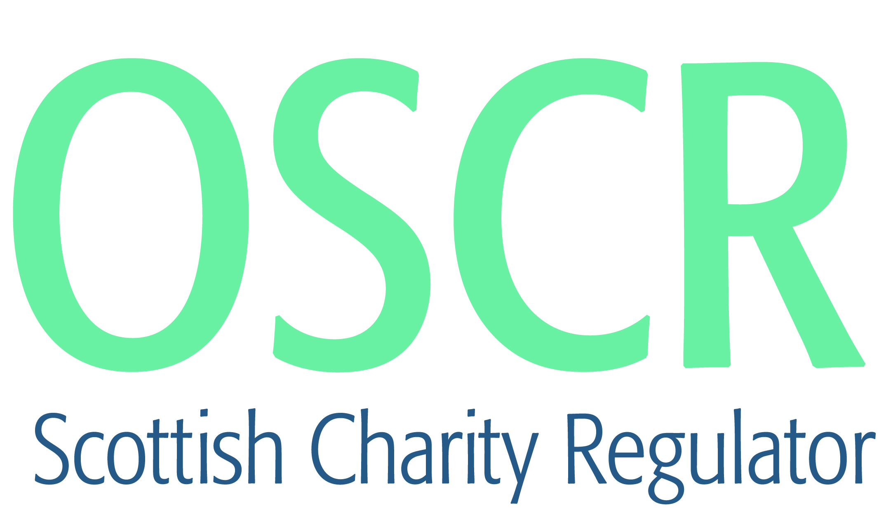

**Charities granted charitable status 1 to 31 December 2021**

|  |  |  |
| --- | --- | --- |
| **Charity Number** | **Charity name** | **Constitutional Form** |
| [SC051435](https://www.oscr.org.uk/search-charity-register/charity-extract/?charitynumber=SC051435) | UNCOVER | SCIO |
| [SC051436](https://www.oscr.org.uk/search-charity-register/charity-extract/?charitynumber=SC051436) | Katedaveali | SCIO |
| [SC051437](https://www.oscr.org.uk/search-charity-register/charity-extract/?charitynumber=SC051437) | Angels Hearts (SCIO) | SCIO |
| [SC051438](https://www.oscr.org.uk/search-charity-register/charity-extract/?charitynumber=SC051438) | Centre For Green Economy in Developing Countries (CeGED) | SCIO |
| [SC051439](https://www.oscr.org.uk/search-charity-register/charity-extract/?charitynumber=SC051439) | The Castle Menzies SCIO | SCIO |
| [SC051440](https://www.oscr.org.uk/search-charity-register/charity-extract/?charitynumber=SC051440) | Trek-on (SCIO) North East Community Costal Paths | SCIO |
| [SC051441](https://www.oscr.org.uk/search-charity-register/charity-extract/?charitynumber=SC051441) | St Ernan's by the Loch | SCIO |
| [SC051442](https://www.oscr.org.uk/search-charity-register/charity-extract/?charitynumber=SC051442) | Biosphere Bikes | Company |
| [SC051443](https://www.oscr.org.uk/search-charity-register/charity-extract/?charitynumber=SC051443) | Philokalia | SCIO |
| [SC051444](https://www.oscr.org.uk/search-charity-register/charity-extract/?charitynumber=SC051444) | 2nd Lochaber (Kilmallie) Scout Group | Unincorporated Association |
| [SC051445](https://www.oscr.org.uk/search-charity-register/charity-extract/?charitynumber=SC051445) | 45th Greenock & District (Quarriers) Scout Group | Statutory Corporation |
| [SC051446](https://www.oscr.org.uk/search-charity-register/charity-extract/?charitynumber=SC051446) | Generation You Employed, UK | Company |
| [SC051447](https://www.oscr.org.uk/search-charity-register/charity-extract/?charitynumber=SC051447) | Falling UP Together (SCIO) | SCIO |
| [SC051448](https://www.oscr.org.uk/search-charity-register/charity-extract/?charitynumber=SC051448) | United Kingdom Mathematics Trust | Unincorporated Association |
| [SC051449](https://www.oscr.org.uk/search-charity-register/charity-extract/?charitynumber=SC051449) | Muckle Toon Media Limited | Company |
| [SC051450](https://www.oscr.org.uk/search-charity-register/charity-extract/?charitynumber=SC051450) | Ballater Highland Games | Company |
| [SC051451](https://www.oscr.org.uk/search-charity-register/charity-extract/?charitynumber=SC051451) | 61st Glamis Scout Group | Unincorporated Association |
| [SC051452](https://www.oscr.org.uk/search-charity-register/charity-extract/?charitynumber=SC051452) | Life Fit SCIO | SCIO |
| [SC051453](https://www.oscr.org.uk/search-charity-register/charity-extract/?charitynumber=SC051453) | Kirkcaldy Gymnastics Club | SCIO |
| [SC051454](https://www.oscr.org.uk/search-charity-register/charity-extract/?charitynumber=SC051454) | Project Esperanza SCIO | SCIO |
| [SC051455](https://www.oscr.org.uk/search-charity-register/charity-extract/?charitynumber=SC051455) | Tain and North Highland YMCA SCIO | SCIO |
| [SC051456](https://www.oscr.org.uk/search-charity-register/charity-extract/?charitynumber=SC051456) | The Herodotus Helpline | SCIO |
| [SC051457](https://www.oscr.org.uk/search-charity-register/charity-extract/?charitynumber=SC051457) | Kirkcaldy Community Athletics Trust | SCIO |
| [SC051458](https://www.oscr.org.uk/search-charity-register/charity-extract/?charitynumber=SC051458) | Centre for Scottish Public Policy 2021 | SCIO |
| [SC051459](https://www.oscr.org.uk/search-charity-register/charity-extract/?charitynumber=SC051459) | The Fighting Scots Gym | SCIO |
| [SC051460](https://www.oscr.org.uk/search-charity-register/charity-extract/?charitynumber=SC051460) | EDINBURGH INTERNATIONAL CHRISTIAN CHURCH | Company |
| [SC051461](https://www.oscr.org.uk/search-charity-register/charity-extract/?charitynumber=SC051461) | Calibre Audio | Company |
| [SC051462](https://www.oscr.org.uk/search-charity-register/charity-extract/?charitynumber=SC051462) | Autismn Understanding Scotland ( SCIO) | SCIO |
| [SC051463](https://www.oscr.org.uk/search-charity-register/charity-extract/?charitynumber=SC051463) | The Talent Foundry Trust | Company |
| [SC051464](https://www.oscr.org.uk/search-charity-register/charity-extract/?charitynumber=SC051464) | The Catherine McInespie Foundation SCIO | SCIO |
| [SC051465](https://www.oscr.org.uk/search-charity-register/charity-extract/?charitynumber=SC051465) | Laxdale Community Association [SCIO] | SCIO |
| [SC051466](https://www.oscr.org.uk/search-charity-register/charity-extract/?charitynumber=SC051466) | Thrumster Community Development Association (SCIO) | SCIO |
| [SC051467](https://www.oscr.org.uk/search-charity-register/charity-extract/?charitynumber=SC051467) | Edinburgh Union Canal Society (SCIO) | SCIO |
| [SC051468](https://www.oscr.org.uk/search-charity-register/charity-extract/?charitynumber=SC051468) | Dryfesdale Lodge Visitor Centre | SCIO |