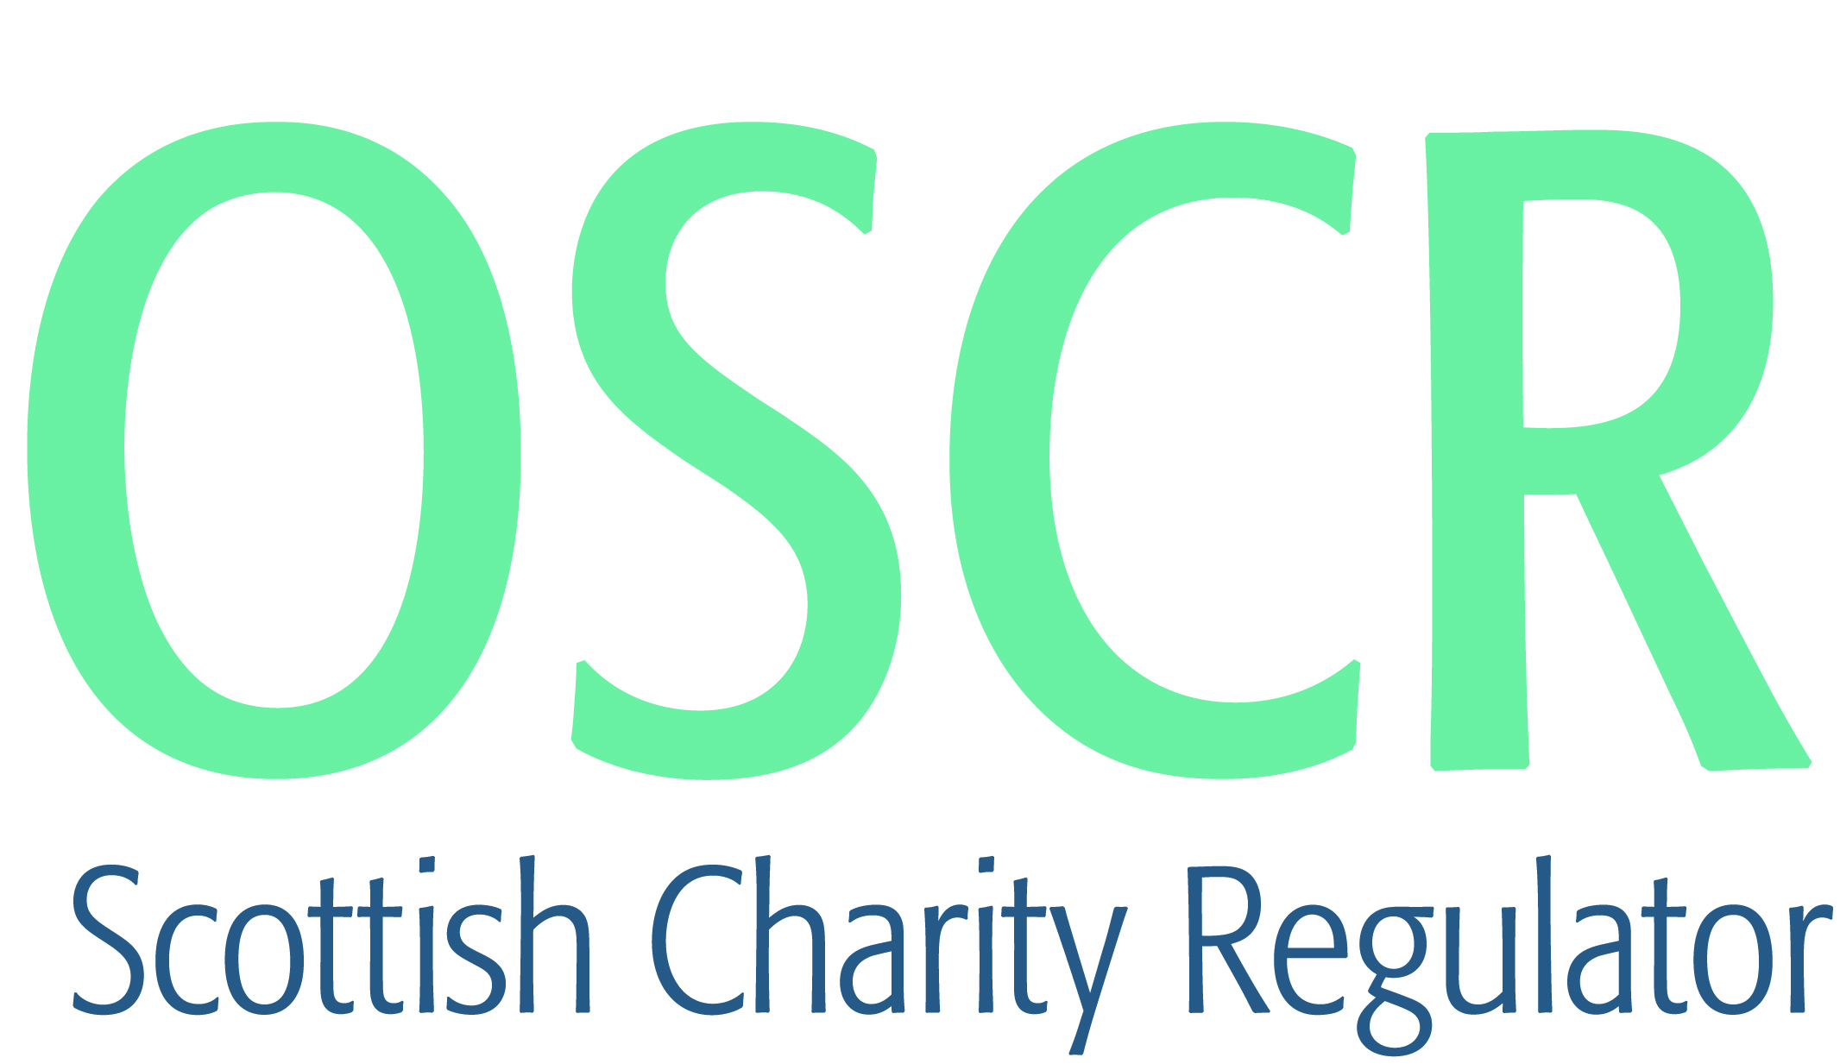

**Charities granted charitable status 1 to 30 November 2021**

|  |  |  |
| --- | --- | --- |
| **Charity Number** | **Charity name** | **Constitutional Form** |
| [SC051369](https://www.oscr.org.uk/search-charity-register/charity-extract/?charitynumber=SC051369) | Mollys Memory | UnincorporatedAssociation |
| [SC051370](https://www.oscr.org.uk/search-charity-register/charity-extract/?charitynumber=SC051370) | The Glorious Vision International Ministries ?A.K.A. SAWARI OGO MI?. (RECOVER MY GLORY) | UnincorporatedAssociation |
| [SC051371](https://www.oscr.org.uk/search-charity-register/charity-extract/?charitynumber=SC051371) | Hayley's Smiles | UnincorporatedAssociation |
| [SC051372](https://www.oscr.org.uk/search-charity-register/charity-extract/?charitynumber=SC051372) | The Petex Academy | SCIO |
| [SC051373](https://www.oscr.org.uk/search-charity-register/charity-extract/?charitynumber=SC051373) | PATT Foundation (Scotland) SCIO | SCIO |
| [SC051374](https://www.oscr.org.uk/search-charity-register/charity-extract/?charitynumber=SC051374) | One Step Borders SCIO | SCIO |
| [SC051375](https://www.oscr.org.uk/search-charity-register/charity-extract/?charitynumber=SC051375) | Kelburne Hockey and Community Sports Club | SCIO |
| [SC051376](https://www.oscr.org.uk/search-charity-register/charity-extract/?charitynumber=SC051376) | Transform Craigshill | SCIO |
| [SC051377](https://www.oscr.org.uk/search-charity-register/charity-extract/?charitynumber=SC051377) | Comics Youth [SCIO] | SCIO |
| [SC051378](https://www.oscr.org.uk/search-charity-register/charity-extract/?charitynumber=SC051378) | Nonsuch (History & Dance) Limited | Company |
| [SC051379](https://www.oscr.org.uk/search-charity-register/charity-extract/?charitynumber=SC051379) | SNAPS NL (Special Needs and Parent Support North Lanarkshire) | SCIO |
| [SC051380](https://www.oscr.org.uk/search-charity-register/charity-extract/?charitynumber=SC051380) | Max Appeal! Supporting Families Affected by DiGeorge Syndrome/VCFS/22q11.2 deletion. | UnincorporatedAssociation |
| [SC051381](https://www.oscr.org.uk/search-charity-register/charity-extract/?charitynumber=SC051381) | Brighter Futures Health Hub | SCIO |
| [SC051382](https://www.oscr.org.uk/search-charity-register/charity-extract/?charitynumber=SC051382) | Melville-Knox Christian School Aberdeen | Company |
| [SC051383](https://www.oscr.org.uk/search-charity-register/charity-extract/?charitynumber=SC051383) | Awais Foundation | SCIO |
| [SC051384](https://www.oscr.org.uk/search-charity-register/charity-extract/?charitynumber=SC051384) | House of Bread Charity | SCIO |
| [SC051385](https://www.oscr.org.uk/search-charity-register/charity-extract/?charitynumber=SC051385) | East Neuk First Responders SCIO | SCIO |
| [SC051386](https://www.oscr.org.uk/search-charity-register/charity-extract/?charitynumber=SC051386) | Stromness Drama Club SCIO | SCIO |
| [SC051387](https://www.oscr.org.uk/search-charity-register/charity-extract/?charitynumber=SC051387) | HELPING HAND-Cambodia | SCIO |
| [SC051388](https://www.oscr.org.uk/search-charity-register/charity-extract/?charitynumber=SC051388) | THE ELEVATOR FOUNDATION | Company |
| [SC051389](https://www.oscr.org.uk/search-charity-register/charity-extract/?charitynumber=SC051389) | Inverclyde Heritage Network | UnincorporatedAssociation |
| [SC051390](https://www.oscr.org.uk/search-charity-register/charity-extract/?charitynumber=SC051390) | Anaphylaxis Campaign | Company |
| [SC051391](https://www.oscr.org.uk/search-charity-register/charity-extract/?charitynumber=SC051391) | The Cairngorm Capital Foundation | Trust |
| [SC051392](https://www.oscr.org.uk/search-charity-register/charity-extract/?charitynumber=SC051392) | Bute Baptist Church | SCIO |
| [SC051393](https://www.oscr.org.uk/search-charity-register/charity-extract/?charitynumber=SC051393) | Jedderfield Farm | SCIO |
| [SC051394](https://www.oscr.org.uk/search-charity-register/charity-extract/?charitynumber=SC051394) | Kintyre Trail Association | SCIO |
| [SC051395](https://www.oscr.org.uk/search-charity-register/charity-extract/?charitynumber=SC051395) | My Foundations | Trust |
| [SC051396](https://www.oscr.org.uk/search-charity-register/charity-extract/?charitynumber=SC051396) | Lochranza Loos [SCIO] | SCIO |
| [SC051397](https://www.oscr.org.uk/search-charity-register/charity-extract/?charitynumber=SC051397) | Ethiopia Reads UK | SCIO |
| [SC051398](https://www.oscr.org.uk/search-charity-register/charity-extract/?charitynumber=SC051398) | Fernhill Foundation (Scotland) | SCIO |
| [SC051399](https://www.oscr.org.uk/search-charity-register/charity-extract/?charitynumber=SC051399) | CoHousing for Independent Living | SCIO |
| [SC051400](https://www.oscr.org.uk/search-charity-register/charity-extract/?charitynumber=SC051400) | Al-Bushra Empowerment Vision Trust | Trust |
| [SC051401](https://www.oscr.org.uk/search-charity-register/charity-extract/?charitynumber=SC051401) | Be Someone's Santa (SCIO) | SCIO |
| [SC051402](https://www.oscr.org.uk/search-charity-register/charity-extract/?charitynumber=SC051402) | 3rd Bishopton Rainbows | StatutoryCorporation |
| [SC051403](https://www.oscr.org.uk/search-charity-register/charity-extract/?charitynumber=SC051403) | Kirkcaldy Parks Running Festival | SCIO |
| [SC051404](https://www.oscr.org.uk/search-charity-register/charity-extract/?charitynumber=SC051404) | Peace for Darfur | SCIO |
| [SC051405](https://www.oscr.org.uk/search-charity-register/charity-extract/?charitynumber=SC051405) | Strathspey Railway Association | Company |
| [SC051406](https://www.oscr.org.uk/search-charity-register/charity-extract/?charitynumber=SC051406) | POYPIN | Trust |
| [SC051407](https://www.oscr.org.uk/search-charity-register/charity-extract/?charitynumber=SC051407) | Dunfermline District 3 Ranger Unit | UnincorporatedAssociation |
| [SC051408](https://www.oscr.org.uk/search-charity-register/charity-extract/?charitynumber=SC051408) | THE HIVE LGBT + CENTRE | SCIO |
| [SC051409](https://www.oscr.org.uk/search-charity-register/charity-extract/?charitynumber=SC051409) | Friends of Leith Hall | UnincorporatedAssociation |
| [SC051410](https://www.oscr.org.uk/search-charity-register/charity-extract/?charitynumber=SC051410) | Adored (SCIO) | SCIO |
| [SC051411](https://www.oscr.org.uk/search-charity-register/charity-extract/?charitynumber=SC051411) | Mossblown Matters | UnincorporatedAssociation |
| [SC051412](https://www.oscr.org.uk/search-charity-register/charity-extract/?charitynumber=SC051412) | Denny Baptist Church SCIO | SCIO |
| [SC051413](https://www.oscr.org.uk/search-charity-register/charity-extract/?charitynumber=SC051413) | ÀBAN Outdoor | Company |
| [SC051414](https://www.oscr.org.uk/search-charity-register/charity-extract/?charitynumber=SC051414) | AFC Heritage SCIO | SCIO |
| [SC051415](https://www.oscr.org.uk/search-charity-register/charity-extract/?charitynumber=SC051415) | Robert Chebe Foundation (SCIO) | SCIO |
| [SC051416](https://www.oscr.org.uk/search-charity-register/charity-extract/?charitynumber=SC051416) | Angus Toy Appeal | SCIO |
| [SC051417](https://www.oscr.org.uk/search-charity-register/charity-extract/?charitynumber=SC051417) | The Aviemore and Glenmore Community Trust | Company |
| [SC051418](https://www.oscr.org.uk/search-charity-register/charity-extract/?charitynumber=SC051418) | ISEC Foundation | Company |
| [SC051419](https://www.oscr.org.uk/search-charity-register/charity-extract/?charitynumber=SC051419) | AWARE Scotland | SCIO |
| [SC051420](https://www.oscr.org.uk/search-charity-register/charity-extract/?charitynumber=SC051420) | Teen Advocacy | SCIO |
| [SC051421](https://www.oscr.org.uk/search-charity-register/charity-extract/?charitynumber=SC051421) | Glasgow Athletic Football Club | SCIO |
| [SC051422](https://www.oscr.org.uk/search-charity-register/charity-extract/?charitynumber=SC051422) | Rotary Club of Alloway SCIO | SCIO |
| [SC051423](https://www.oscr.org.uk/search-charity-register/charity-extract/?charitynumber=SC051423) | Turriff Local Charity (SCIO) | SCIO |
| [SC051424](https://www.oscr.org.uk/search-charity-register/charity-extract/?charitynumber=SC051424) | Perth Phoenix Allstars SCIO | SCIO |
| [SC051425](https://www.oscr.org.uk/search-charity-register/charity-extract/?charitynumber=SC051425) | Bathgate Hills Venture SCIO | SCIO |
| [SC051426](https://www.oscr.org.uk/search-charity-register/charity-extract/?charitynumber=SC051426) | The Judith & Michael Steel Charitable Trust | SCIO |
| [SC051427](https://www.oscr.org.uk/search-charity-register/charity-extract/?charitynumber=SC051427) | 2nd Strathaven Guides | UnincorporatedAssociation |
| [SC051428](https://www.oscr.org.uk/search-charity-register/charity-extract/?charitynumber=SC051428) | 3rd Strathaven Brownies | UnincorporatedAssociation |
| [SC051429](https://www.oscr.org.uk/search-charity-register/charity-extract/?charitynumber=SC051429) | Cnoc Soilleir Limited | Company |
| [SC051430](https://www.oscr.org.uk/search-charity-register/charity-extract/?charitynumber=SC051430) | Moray Rugby Football Club | SCIO |
| [SC051431](https://www.oscr.org.uk/search-charity-register/charity-extract/?charitynumber=SC051431) | J&K Carnbo TTC | SCIO |
| [SC051432](https://www.oscr.org.uk/search-charity-register/charity-extract/?charitynumber=SC051432) | Reviving Souls SCIO | SCIO |
| [SC051433](https://www.oscr.org.uk/search-charity-register/charity-extract/?charitynumber=SC051433) | SPAN THE GAP (SCIO) | SCIO |
| [SC051434](https://www.oscr.org.uk/search-charity-register/charity-extract/?charitynumber=SC051434) | Stewarton Annick Youth & Community Association (SCIO) | SCIO |