Cross-border charity regulation in Scotland

- Introduction
- How the regulators work together
  - Concerns and inquiries
  - Reporting by Auditors and Independent Examiners to the Regulators
- Registration
  - When to register in Scotland
  - SCIOs and CIOs
- Charity trustee duties
  - Trustee remuneration
  - References to charitable status
  - Making changes to your charity – Consent and notification

- Accounts
- Fundraising

1. Introduction
What this guidance covers
This guidance explains what cross-border charities; charities registered with the Charity Commission for England and Wales (CCEW) and with the Scottish Charity Regulator (OSCR) need to know about how OSCR regulates them.
The primary piece of charity law in Scotland is:
- Charities and Trustee Investment (Scotland) Act 2005 (2005 Act)

The primary piece of charity law in England and Wales is:
- Charities Acts 2011
Generally speaking the regulatory regime for charities in Scotland applies equally to all charities entered in the Scottish Charity Register. The following sections explain the key elements of Scottish charity regulation that cross-border charities need to know. More guidance can be found on OSCR’s website.
The guidance also explains when a charity registered with CCEW needs to register with OSCR.
Who is the guidance for?
This guidance is aimed at charity trustees of cross-border charities and people working with or advising charity trustees.
It will also be useful to those looking to apply to OSCR to become a cross-border charity.
How to use the guide
The guide is split into sections to help you find the information most relevant to you and your charity. Each section contains summary information, a brief explanation of the relevant laws and links to further guidance from OSCR and CCEW.
Sources of help and advice
- HM Revenue & Customs (HMRC)
- Charity Commission for England and Wales (CCEW)
- Charity Commission for Northern Ireland (CCNI)
- Scottish Council for Voluntary Organisations (SCVO)
- National Council for Voluntary Organisations (NCVO)
- Northern Ireland Council for Voluntary Action (NICVA)
- Institute of Chartered Accountants of Scotland (ICAS)
- Institute of Chartered Accountants in England and Wales (ICAEW)

2. How the regulators work together
Concerns and inquiries
Under a Memorandum of Understanding, OSCR and CCEW operate effective information sharing and joint working arrangements.
OSCR and CCEW work on a ‘lead regulator’ basis for cross-border charities to reduce the regulatory burden. This means that CCEW will be the lead regulator for cross-border charities and in general will take responsibility for dealing with concerns about cross-border charities, unless the concern relates to a Scottish specific matter that OSCR would be best placed to look at. There may be some circumstances where a joint inquiry is appropriate.
This does not mean that cross-border charities only have to report to CCEW. All charities registered in Scotland must fully comply with the requirements of Scottish charity law.
Both regulators have similar regimes in terms of when charities should report certain events and incidents to them. CCEW calls this ‘serious incident’ reporting, while OSCR refers to it as ‘notifiable events’. Cross border charities are required to report to CCEW, but do not need to also report the incident/event to OSCR.
Reporting by Auditors and Independent Examiners to the Regulators
This is the statutory duty to report to the regulator placed on auditors and independent examiners of charity accounts where, in the course of their work, they identify:
- a matter of material significance or
- a matter which they believe should be reported to the regulator to assist in the fulfilment of the regulator’s functions.
OSCR, CCNI and CCEW have developed joint guidance on Matters of Material Significance reportable to UK charity regulators. In relation to cross-border charities, neither OSCR nor CCEW is considered to be the ‘lead regulator’ for this purpose and auditors/independent examiners should report to both regulators who will then determine which regulator takes forward the issues raised.
Memoranda of Understanding with other organisations
As well as the MOU that exists between OSCR and CCEW, OSCR has MOUs with the Charity Commission for Northern Ireland (CCNI) and HM Revenue and Customs (HMRC).
The MOU between OSCR and HMRC details specific information exchanges that take place on a quarterly basis and includes provisions on liaison at both policy and operational levels. For more information see our Memoranda of Understanding page.

3. Registration
  - When to register in Scotland
Under the 2005 Act, all organisations which represent themselves as charities in Scotland must register with OSCR. This includes bodies that are established and/or registered as charities in other legal jurisdictions, such as England and Wales.
The 2005 Act provides some exceptions where a cross-border charity represents itself as a charity but does not have substantive activity in Scotland.
Generally if you want to call yourself a charity in Scotland you have to be on the Scottish Charity Register. If an organisation is not listed in the Scottish Charity Register then it is not a charity in Scotland. There are no categories of charities exempt or excepted from registration in Scotland.
The Charities and Trustee Investment (Scotland) Act 2005 (the 2005 Act) includes all charitable operations in Scotland and therefore organisations registered or recognised as a charity in another jurisdiction may be required to register with OSCR if they meet certain criteria. The 2005 Act recognises that it is appropriate to draw a distinction between a significant operation in Scotland and an organisation which has only an occasional connection.
The questions below will help you decide if your organisation needs to apply to OSCR. If after reading this factsheet you are still unsure please contact us to discuss.

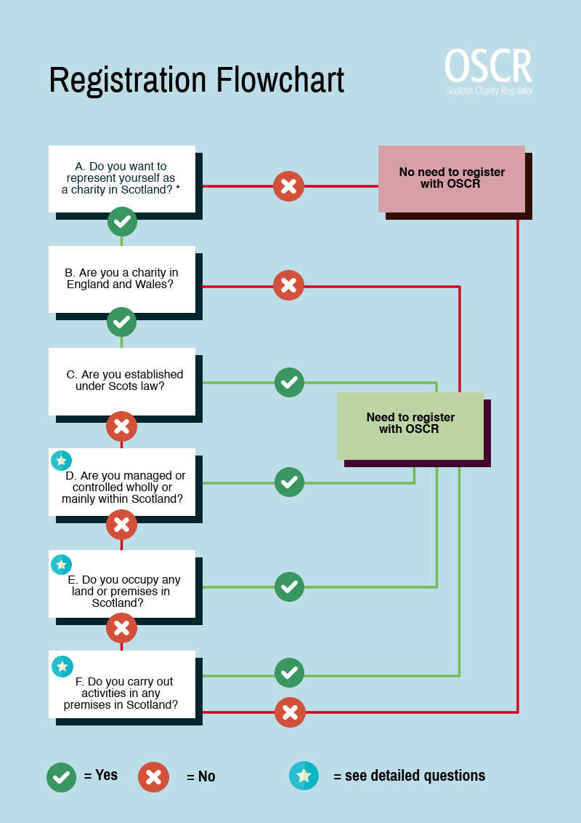

A Does your organisation wish to represent itself as a charity in Scotland?
This means any public reference (written or verbal) to the organisation being a charity, made by the organisation or by a person acting on behalf it. For example a funding application or a request for rates relief in which the organisation makes reference to being a charity would be considered to be representing itself as a charity. Internal communications lack a public element and aren’t classed as representation.
- No: don’t need to register with OSCR.
- Yes: go to question B.

B Is your organisation a charity under the law of England and Wales?
- No: you must register with OSCR.
- Yes: go to question C.
C Is your organisation established under the law of Scotland?
- No: go to question D.
- Yes: you must register with OSCR.
D Is your organisation managed or controlled wholly or mainly within Scotland?
It doesn’t matter if the charity trustees – the people in general management and control of the charity – live in Scotland or not. What matters is whether the management or control of the organisation takes place here. For example, where the office of the organisation is, where the administration of the organisation takes place, or where the charity trustees meet on a regular basis.
- No: go to question E.
- Yes: you must register with OSCR.
E Does your organisation occupy any land or premises in Scotland?
The key factor here is occupation. Owning land without occupying it (for example as an investment) does not create a requirement to register. If your organisation is liable for business rates or council tax in respect of a property in Scotland, then it will be considered to occupy this land or premises.
- No: go to question F.
- Yes: you must register with OSCR.
F Does your organisation carry out activities in any office, shop or similar premises in Scotland?
This question breaks down into two parts – both of which need to apply for your organisation to be required to register.
- No: don’t need to register with OSCR.
- Yes: you must register with OSCR.
1. Does your organisation carry out activities in Scotland?
Generally speaking ‘activities’ include a wide range of actions – from fundraising to providing services, including admin activities. However, when deciding if the organisation needs to register with OSCR the significance of the organisation’s operations will be a factor. Such as:
- Are your activities in Scotland significant to your organisation relative to its activities elsewhere? If you carry out a sizeable or an important part of your overall activities in Scotland, then this is significant activity. For example if the benefit from your activities falls primarily in Scotland then this would be considered to be ‘significant’, even if your activities as a whole are not that extensive (for example because your organisation is small).
- Are your activities in Scotland of a frequent or ongoing nature? For instance if you held conferences on a one-off or irregular basis in Scotland (with no commitment to these being repeated in future) this would probably not be considered as carrying out significant activities here.
- Is the overall impact of the activities significant? It is possible that even a single annual event could have enough impact to mean that you need to register. A nationwide annual fundraising event held in Scotland could for example be considered significant because of the amount of money raised or because of its public profile.

2. If you do carry out activities in Scotland, do you carry them out in an office, shop or similar premises?
‘Similar premises’ means a ‘place of business,’ that is, a place in which commercial activity and/or the activities of charities are carried out.
- What are ‘premises’?
‘Premises’ can be a building, a structure, a construction, a place, a property or a site. This could mean anything from a mobile kiosk to a tower block or even an open air market.
- What is the current primary purpose of the premises?
The current primary purpose of the premises may not be the one for which it was originally intended. For example where a house has been converted to offices the primary purpose should be taken as being business not residential. A useful guide in this context may be how the local authority treats the premises for purposes of planning or rates.
- Premises with more than one purpose.
If the primary purpose of the premises is not for business, then is there a particular part of the premises dedicated to business? For example a room in a house converted to an office or shop and used on a long term basis.
- Not owning or renting the premises
You don’t have to own or rent the premises to be carrying out activities. For example, a self help group holding weekly sessions in a church hall would be considered to ‘carry out activities in similar premises’.
- Homeworking
Generally if the activities only take place within an employee’s private residence in Scotland on an occasional basis, then you will not need to register with OSCR.
However, if the employee also frequently works in a place of business by regularly visiting other organisations in their offices or attending meetings or public events in Scotland that would be carrying out activities in a place of business and you would need to register.
OSCR can only register an organisation as a charity in Scotland if it meets the requirements of the charity test set out in the 2005 Act, Meeting the Charity Test: Guidance. These requirements differ in some ways from the legal requirements governing which organisations can be charities in England and Wales.
Guidance on registering with OSCR.
Guidance on registering with CCEW.
  - Charitable Incorporated Organisation (CIOs) and
Scottish Charitable Incorporated Organisation (SCIOs)
Charitable Incorporated Organisations (CIOs) incorporated in England and Wales which represent themselves as charities in Scotland must also register here. It is also possible for an unincorporated charity registered with CCEW to become a Charitable Incorporated Organisation (CIO) or for a charitable company or registered society registered with CCEW and OSCR to convert to a CIO. If you are looking to do this you should contact OSCR first.
There is a Scottish equivalent to the CIO, the Scottish Charitable Incorporated Organisation (SCIO). However, OSCR can only incorporate a SCIO if its principal office is in Scotland. This means that a SCIO cannot register with CCEW as it will not fall under the laws of England and Wales.
For more information on SCIOs see: SCIOs: A Guide
For more information on CIOs see:
How to set up a charity (CC21a)
Charity types: how to choose a charity structure (CC22a)
Change your charity structure

4. Charity trustee duties
Charity trustees are defined in the same way under both sets of laws: ‘the persons having the general control and management of the administration of a charity’.
Under the 2005 Act charity trustees have legal duties and responsibilities. These trustee duties apply equally to charity trustees of cross-border charities. OSCR’s Guidance and good practice for Charity Trustees explains these duties.
The general principles of running a charity are the same between Scotland and England and Wales; however, there are some specific differences and requirements between the two sets of laws. Cross-border charity trustees need to be aware of these. See Charity Commission guidance, publications and information.

  - Trustee remuneration
The rules on paying charity trustees are different between Scotland and England and Wales. Cross-border charities should make sure they are familiar with the requirements under both sets of legislation.
- In Scotland
A charity trustee must not be paid, for services provided to the charity, either as a charity trustee or under contract, unless all of the conditions set out in the 2005 Act are met. For more details on the conditions see Guidance and Good Practice for charity trustees.
- In England and Wales
In England and Wales, generally, charities can’t pay their trustees for simply being a trustee. Some charities do pay their trustees – they can only do so because it’s allowed by their governing document, or they have obtained consent to do so from CCEW or the courts.
See Payments to charity trustees: what the rules are for more information.
  - References to charitable status
All UK registered charities have to show their charity number and other details on external documents.
- In Scotland
In Scotland charity trustees must make sure that the charity’s details, including the Scottish Charity Number (SC0[zero]xxxxx), are on all the charity’s formal communications, like letters, emails, invoices and websites.
Further details on the requirements and the type of documents which they affect can be found in Guidance and good practice for Charity Trustees. You can also add the OSCR Registration logo to your documents.
- In England and Wales
Charities registered with CCEW also have to provide information in documents, see The essential trustee: what you need to know, what you need to do (CC3).
  - Making changes to your charity – Consent and notification
Depending on the change you want to make, your charity may need to get consent and/or notify OSCR and CCEW.
- In Scotland
Under the 2005 Act you must seek OSCR’s consent before making any of the changes listed below:
- Change to name
- Change to charitable purposes
- Amalgamate with another body
- Wind itself up or dissolve itself
- Apply to the Court in relation to any of the above actions.
See Making changes to your charity for more information on when to seek OSCR’s consent and when to notify us of changes.
- In England and Wales
CCEW consent is also required in respect of some of the above changes for certain types of charities. In these cases charities should apply to both regulators simultaneously and make sure the change is not made until the consent of both CCEW and OSCR is received. See the Managing your charity for more information.

5. Accounts
Every year you must send to OSCR your:
- Annual report and accounts (this includes your trustees’ annual report)
- External scrutiny report (audit or independent examination), and an
- Online annual return.
Do we have to submit accounts to both regulators?
Yes, the same annual report and accounts must be sent to OSCR and CCEW. The accounts submitted must meet the requirements of legislation in both England and Wales and Scotland.
The format of accounts between the two sets of regulations is very similar, especially for fully accrued accounts. However, there are differences in the external scrutiny requirements and filing deadlines – see the tables below.
Filing of accounts
 | Scotland | England and Wales
Deadline for filing accounts with charity regulator | 9 months from the date of the financial year end | 10 months from the date of the financial year end

Format of accounts
Gross income | Scotland |  | England and Wales
Less than £25,000 | Non-company charities: receipts and payments accounts | Charitable companies:  fully accrued accounts | Non-company charities: receipts and payments accounts | Charitable companies: fully accrued accounts
£25,000 - £250,000
£250,000 and above | Fully accrued accounts |  | Fully accrued accounts

External scrutiny of accounts

Where there is a requirement for audit within a charity’s governing document or any applicable law that sets out this requirement, this takes priority over the income and asset thresholds outlined below.
Gross Income | Scotland |  | England and Wales
Less than £25,000 | Non-company charities: independent examination by a person with requisite skills (where receipts and payments accounts are prepared) | Charitable companies: independent examination by a qualified person | N/A
£25,000 - £250,000 |  |  | Independent examination by a person with requisite skills
£250,000 - £500,000 | Independent examination by a qualified person |  | Independent examination by a qualified person
Over £500,000 | Audit |  | Independent examination by a qualified person
Over £1,000,000 | Audit |  | Audit
 | Audit also required where accrued accounts are prepared and gross assets are more than £3.26m for accounting periods |  | Audit also required where income is £250,000 or more and gross assets are more than £3.26m

Guidance for auditors and independent examiners of cross-border charities
Independent examiners acting for cross-border charities may wish to refer to the CCEW guidance on independent examination which contains example independent examiner’s reports for cross-border charities. See the guidance from CCEW for more information:
Independent examination of charity accounts: trustees (CC31)
Independent examination of charity accounts: examiners (CC32)

6. Fundraising
The fundraising landscape in the UK can be complex. Fundraising regulation is a mix of statutory and non-statutory rules and involves different regulators depending on the rules involved.
The Code of Fundraising Practice and its associated rule books for street and door fundraising outline the standards expected of all charitable fundraising across the UK. The Fundraising Regulator has responsibility for the Code and the rule books.
Individual charities are the first point of call for any complaints about fundraising practices. Where a charity is unable to resolve the complaint, the complainant can escalate it to one of the following:
- In Scotland, it is Scottish Fundraising Standards Panel.
- In England and Wales and Northern Ireland it is the Fundraising Regulator.
Charity law in Scotland does, however, set out certain requirements for fundraising activity. These requirements are explained in more detail in our guidance.
There are additional legal requirements in England and Wales, for information see CCEWs guidance.

Licenses for public benevolent collections
Issuing licenses for public benevolent collections – that is, collections in public places – continues to be the responsibility of local authorities in Scotland. There is no proposal for OSCR to license individual operators. In England and Wales, local authorities outside London are responsible for granting collection licences in their area. In London, licences are granted by the Metropolitan police or City of London Corporation Licensing Service – depending on the location of the collection.
See Chapter 16 of the Fundraising Code - public collections for more information.

