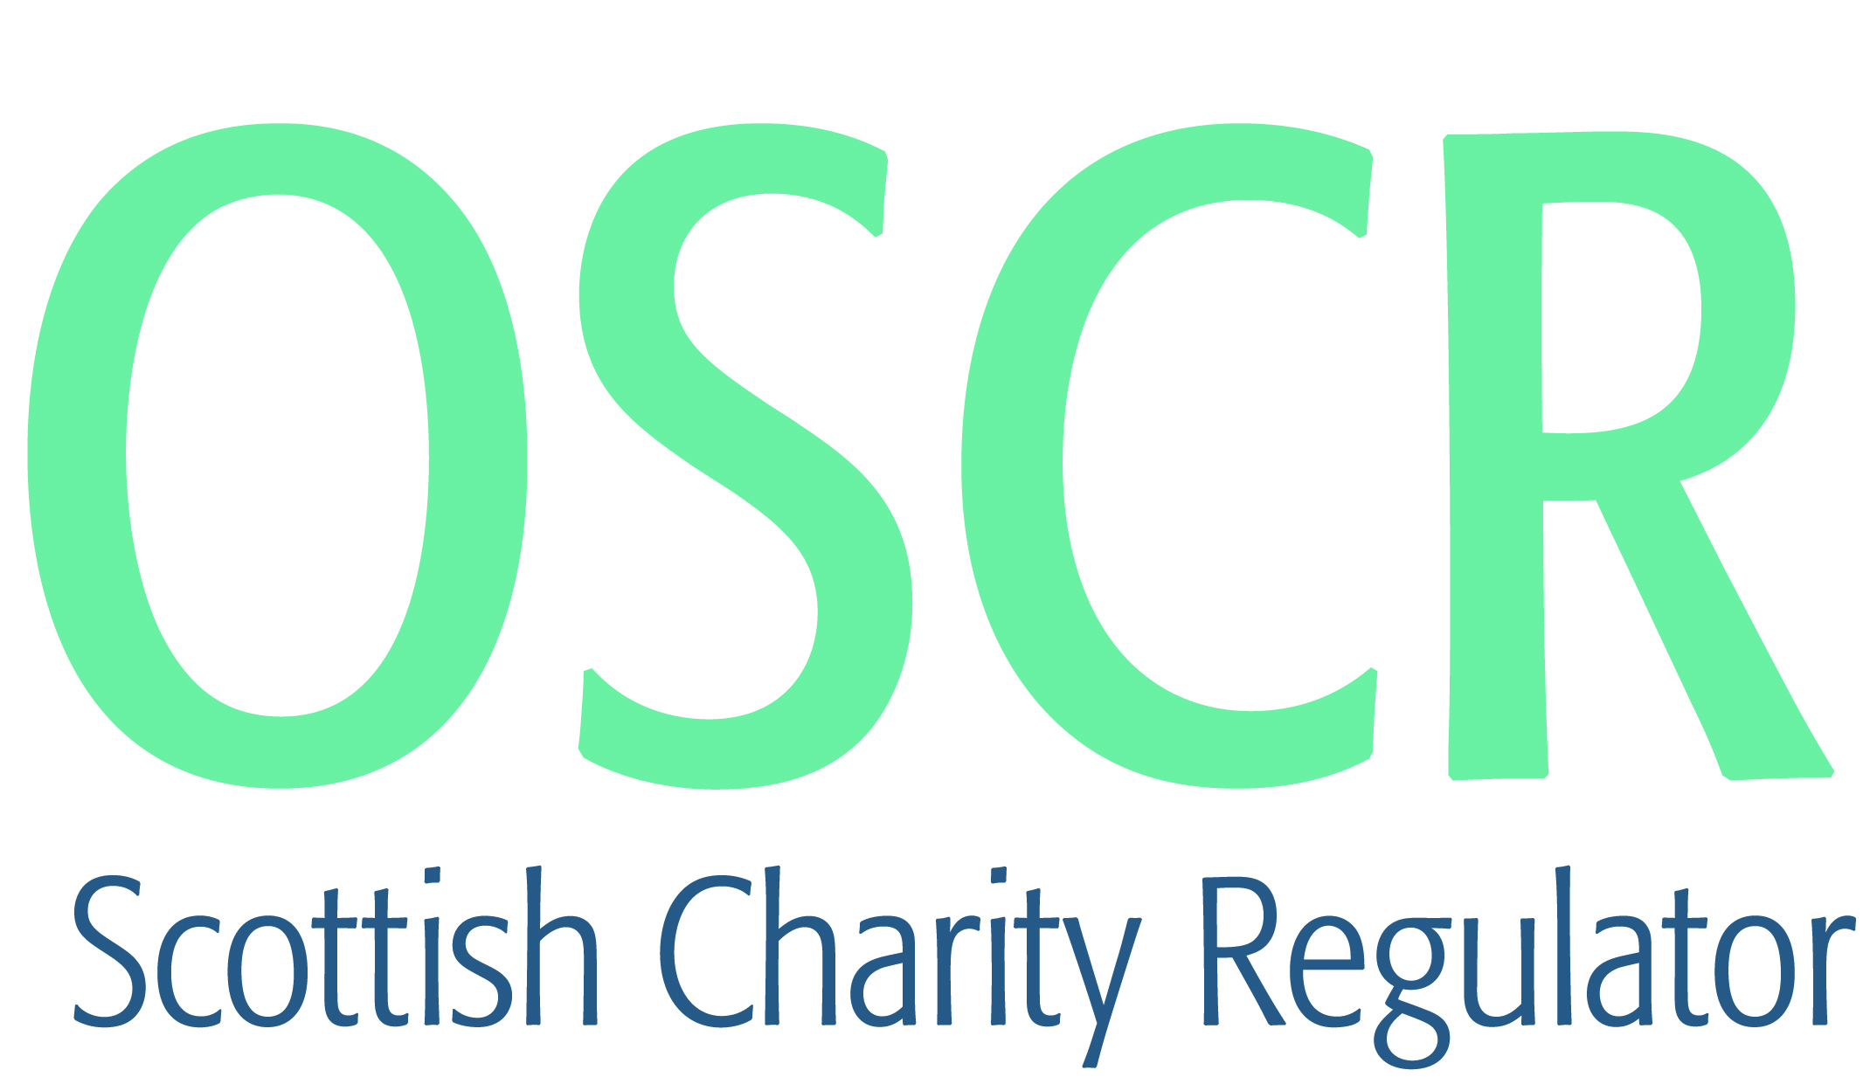

**Charities granted charitable status 1 to 30 April 2021**

|  |  |  |
| --- | --- | --- |
| **Charity Number** | **Charity Name** | **Constitutional Form** |
| [SC050883](https://www.oscr.org.uk/search-charity-register/charity-extract/?charitynumber=SC050883) | Equanicity (SCIO) | SCIO |
| [SC050884](https://www.oscr.org.uk/search-charity-register/charity-extract/?charitynumber=SC050884) | BPD Support (SCIO) | SCIO |
| [SC050885](https://www.oscr.org.uk/search-charity-register/charity-extract/?charitynumber=SC050885) | Connecting Spean Roy Area SCIO | SCIO |
| [SC050886](https://www.oscr.org.uk/search-charity-register/charity-extract/?charitynumber=SC050886) | IQRA Education | Unincorporated Association |
| [SC050887](https://www.oscr.org.uk/search-charity-register/charity-extract/?charitynumber=SC050887) | The Central Park Community Trust (SCIO) | SCIO |
| [SC050888](https://www.oscr.org.uk/search-charity-register/charity-extract/?charitynumber=SC050888) | Portree Angling Association SCIO | SCIO |
| [SC050889](https://www.oscr.org.uk/search-charity-register/charity-extract/?charitynumber=SC050889) | The Hive Activity Centre SCIO | SCIO |
| [SC050890](https://www.oscr.org.uk/search-charity-register/charity-extract/?charitynumber=SC050890) | Watson's Malawi Partnership | SCIO |
| [SC050891](https://www.oscr.org.uk/search-charity-register/charity-extract/?charitynumber=SC050891) | East Lothian Animal Rescue and Advice | SCIO |
| [SC050892](https://www.oscr.org.uk/search-charity-register/charity-extract/?charitynumber=SC050892) | Friends of Stoneworks Orkney | Unincorporated Association |
| [SC050893](https://www.oscr.org.uk/search-charity-register/charity-extract/?charitynumber=SC050893) | ARCADIA SCULPTURE CENTRE | SCIO |
| [SC050894](https://www.oscr.org.uk/search-charity-register/charity-extract/?charitynumber=SC050894) | Transition Edinburgh South (Scotland) Ltd | Company |
| [SC050895](https://www.oscr.org.uk/search-charity-register/charity-extract/?charitynumber=SC050895) | Kirkmaiden Old Kirk | SCIO |
| [SC050896](https://www.oscr.org.uk/search-charity-register/charity-extract/?charitynumber=SC050896) | Tinne Charitable Trust | Trust |
| [SC050897](https://www.oscr.org.uk/search-charity-register/charity-extract/?charitynumber=SC050897) | Sharpen Her: the African Women's Network. | Unincorporated Association |
| [SC050898](https://www.oscr.org.uk/search-charity-register/charity-extract/?charitynumber=SC050898) | The Ark Initiative For Support And Development | SCIO |
| [SC050899](https://www.oscr.org.uk/search-charity-register/charity-extract/?charitynumber=SC050899) | Highland Migrant and Refugee Action | SCIO |
| [SC050900](https://www.oscr.org.uk/search-charity-register/charity-extract/?charitynumber=SC050900) | Motherwell Athletics Club | SCIO |
| [SC050901](https://www.oscr.org.uk/search-charity-register/charity-extract/?charitynumber=SC050901) | Sapana School Project | Trust |
| [SC050902](https://www.oscr.org.uk/search-charity-register/charity-extract/?charitynumber=SC050902) | The Sunrise Charitable Trust for Newport Wormit and Forgan | SCIO |
| [SC050903](https://www.oscr.org.uk/search-charity-register/charity-extract/?charitynumber=SC050903) | Caithness Foodbank SCIO | SCIO |
| [SC050904](https://www.oscr.org.uk/search-charity-register/charity-extract/?charitynumber=SC050904) | Glass Community Association (SCIO) | SCIO |
| [SC050905](https://www.oscr.org.uk/search-charity-register/charity-extract/?charitynumber=SC050905) | Friends of Toowa | Trust |
| [SC050906](https://www.oscr.org.uk/search-charity-register/charity-extract/?charitynumber=SC050906) | Lunan Bay Communities Partnership | SCIO |
| [SC050907](https://www.oscr.org.uk/search-charity-register/charity-extract/?charitynumber=SC050907) | Tornagrain Community Association | SCIO |
| [SC050908](https://www.oscr.org.uk/search-charity-register/charity-extract/?charitynumber=SC050908) | Billy McNeill Commemoration Charity | SCIO |
| [SC050909](https://www.oscr.org.uk/search-charity-register/charity-extract/?charitynumber=SC050909) | Salvation Ministries (Home of Success) Scotland | Company |
| [SC050910](https://www.oscr.org.uk/search-charity-register/charity-extract/?charitynumber=SC050910) | 5th Blairgowrie Brownie Unit | Unincorporated Association |
| [SC050911](https://www.oscr.org.uk/search-charity-register/charity-extract/?charitynumber=SC050911) | 1st Blairgowrie Brownie Unit | Unincorporated Association |
| [SC050912](https://www.oscr.org.uk/search-charity-register/charity-extract/?charitynumber=SC050912) | Frontiers (Overseas) | SCIO |
| [SC050913](https://www.oscr.org.uk/search-charity-register/charity-extract/?charitynumber=SC050913) | Bruntsfield St. Oswald's | Company |
| [SC050914](https://www.oscr.org.uk/search-charity-register/charity-extract/?charitynumber=SC050914) | Bible Baptist Church of Dundee SCIO | SCIO |
| [SC050915](https://www.oscr.org.uk/search-charity-register/charity-extract/?charitynumber=SC050915) | The Roxburgh International Trust | Company |
| [SC050916](https://www.oscr.org.uk/search-charity-register/charity-extract/?charitynumber=SC050916) | Helensburgh Event Cycle Responders | SCIO |
| [SC050917](https://www.oscr.org.uk/search-charity-register/charity-extract/?charitynumber=SC050917) | Our Future Health | Company |
| [SC050918](https://www.oscr.org.uk/search-charity-register/charity-extract/?charitynumber=SC050918) | Buta Azerbaijan-Scotland Association | Unincorporated Association |
| [SC050919](https://www.oscr.org.uk/search-charity-register/charity-extract/?charitynumber=SC050919) | Yellow Rose Launchpad SCIO | SCIO |
| [SC050920](https://www.oscr.org.uk/search-charity-register/charity-extract/?charitynumber=SC050920) | Friends of Alcaig Telephone Box (SCIO) | SCIO |
| [SC050921](https://www.oscr.org.uk/search-charity-register/charity-extract/?charitynumber=SC050921) | The Smith-Magenis Syndrome (SMS) Foundation UK CIO | CIO |
| [SC050922](https://www.oscr.org.uk/search-charity-register/charity-extract/?charitynumber=SC050922) | Caithness F.M. Limited | Company |
| [SC050923](https://www.oscr.org.uk/search-charity-register/charity-extract/?charitynumber=SC050923) | Bonnyrigg Rose Community Football Club (SCIO) | SCIO |
| [SC050924](https://www.oscr.org.uk/search-charity-register/charity-extract/?charitynumber=SC050924) | Wing Tsjun Scotland SCIO | SCIO |
| [SC050925](https://www.oscr.org.uk/search-charity-register/charity-extract/?charitynumber=SC050925) | Portobello Baptist Church SCIO | SCIO |
| [SC050926](https://www.oscr.org.uk/search-charity-register/charity-extract/?charitynumber=SC050926) | Kairos Women+ [KW+] | SCIO |
| [SC050927](https://www.oscr.org.uk/search-charity-register/charity-extract/?charitynumber=SC050927) | 3rd South Rainbows | Unincorporated Association |
| [SC050928](https://www.oscr.org.uk/search-charity-register/charity-extract/?charitynumber=SC050928) | SCOTTISH MENTAL HEALTH AND WELLBEING FOOTBALL LEAGUE | SCIO |
| [SC050929](https://www.oscr.org.uk/search-charity-register/charity-extract/?charitynumber=SC050929) | Engage Nepal with Science | Unincorporated Association |
| [SC050930](https://www.oscr.org.uk/search-charity-register/charity-extract/?charitynumber=SC050930) | The Bridge | Unincorporated Association |
| [SC050931](https://www.oscr.org.uk/search-charity-register/charity-extract/?charitynumber=SC050931) | Hampden Bowling Club SCIO | SCIO |
| [SC050932](https://www.oscr.org.uk/search-charity-register/charity-extract/?charitynumber=SC050932) | St Cuthbert's Kirkyard Heritage Association | Unincorporated Association |
| [SC050933](https://www.oscr.org.uk/search-charity-register/charity-extract/?charitynumber=SC050933) | Hillview Islamic & Education Centre (SCIO) | SCIO |
| [SC050934](https://www.oscr.org.uk/search-charity-register/charity-extract/?charitynumber=SC050934) | Scottish Schools Orchestra Trust SCIO | SCIO |
| [SC050935](https://www.oscr.org.uk/search-charity-register/charity-extract/?charitynumber=SC050935) | Kindness Homeless Street Team Glasgow SCIO | SCIO |
| [SC050936](https://www.oscr.org.uk/search-charity-register/charity-extract/?charitynumber=SC050936) | Burra Baptist Church | SCIO |
| [SC050937](https://www.oscr.org.uk/search-charity-register/charity-extract/?charitynumber=SC050937) | Wind Band Association | Unincorporated Association |
| [SC050938](https://www.oscr.org.uk/search-charity-register/charity-extract/?charitynumber=SC050938) | Equality and Human Rights | Unincorporated Association |
| [SC050939](https://www.oscr.org.uk/search-charity-register/charity-extract/?charitynumber=SC050939) | Kelso Baptist Church SCIO | SCIO |
| [SC050940](https://www.oscr.org.uk/search-charity-register/charity-extract/?charitynumber=SC050940) | Honorary Scotians SCIO | SCIO |
| [SC050941](https://www.oscr.org.uk/search-charity-register/charity-extract/?charitynumber=SC050941) | Gosford Bay Outdoors SCIO | SCIO |
| [SC050942](https://www.oscr.org.uk/search-charity-register/charity-extract/?charitynumber=SC050942) | Melvich Community SCIO | SCIO |
| [SC050943](https://www.oscr.org.uk/search-charity-register/charity-extract/?charitynumber=SC050943) | Hubbub Foundation UK | Company |
| [SC050944](https://www.oscr.org.uk/search-charity-register/charity-extract/?charitynumber=SC050944) | KLSB Community Group | SCIO |
| [SC050945](https://www.oscr.org.uk/search-charity-register/charity-extract/?charitynumber=SC050945) | Library Builders (SCIO) | SCIO |
| [SC050946](https://www.oscr.org.uk/search-charity-register/charity-extract/?charitynumber=SC050946) | Farr Community Hall SCIO | SCIO |
| [SC050947](https://www.oscr.org.uk/search-charity-register/charity-extract/?charitynumber=SC050947) | West Dunbartonshire Gymnastics Club | SCIO |
| [SC050948](https://www.oscr.org.uk/search-charity-register/charity-extract/?charitynumber=SC050948) | Lochview Rural Training | SCIO |