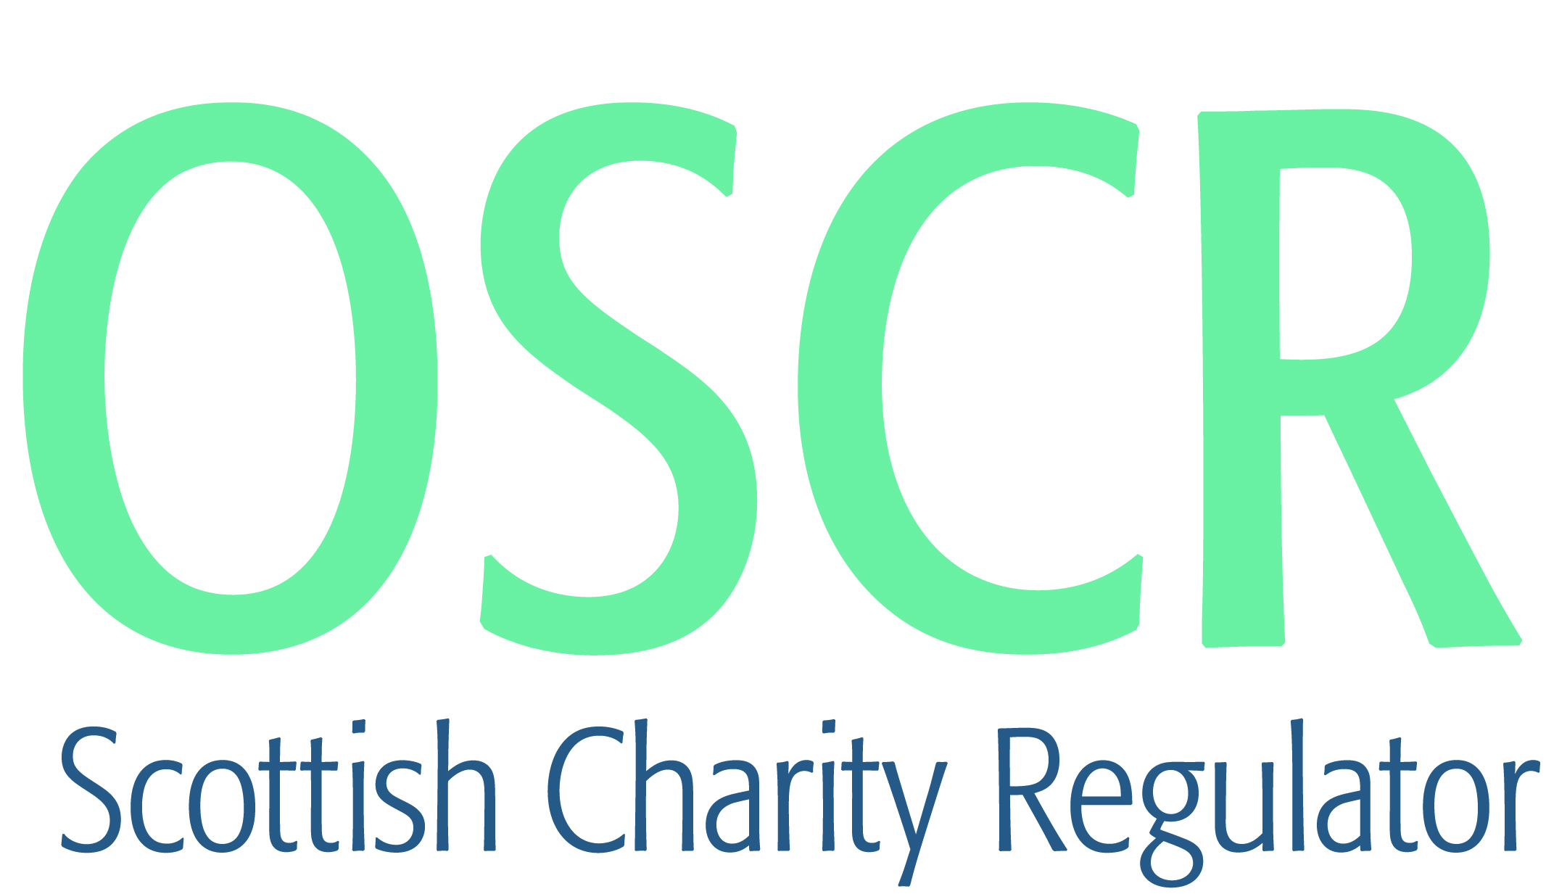

**Charities granted charitable status 1 to 28 February 2021**

|  |  |  |
| --- | --- | --- |
| **Charity Number** | **Charity Name** | **Constitutional Form** |
| [SC050732](https://www.oscr.org.uk/search-charity-register/charity-extract/?charitynumber=SC050732) | Asteria: Space & Satellites | SCIO |
| [SC050733](https://www.oscr.org.uk/search-charity-register/charity-extract/?charitynumber=SC050733) | Grantown Initiative | Company |
| [SC050734](https://www.oscr.org.uk/search-charity-register/charity-extract/?charitynumber=SC050734) | New Lanark Hotels Limited | Company |
| [SC050735](https://www.oscr.org.uk/search-charity-register/charity-extract/?charitynumber=SC050735) | New Lanark Trading Limited | Company |
| [SC050736](https://www.oscr.org.uk/search-charity-register/charity-extract/?charitynumber=SC050736) | The Sheonagh Brook-Smith compassion in midwifery award | SCIO |
| [SC050737](https://www.oscr.org.uk/search-charity-register/charity-extract/?charitynumber=SC050737) | Oromo Community in Scotland | Community Benefit Society |
| [SC050738](https://www.oscr.org.uk/search-charity-register/charity-extract/?charitynumber=SC050738) | Rosebery Centre SCIO | SCIO |
| [SC050739](https://www.oscr.org.uk/search-charity-register/charity-extract/?charitynumber=SC050739) | Friends of Canongate Parent Council | Unincorporated Association |
| [SC050740](https://www.oscr.org.uk/search-charity-register/charity-extract/?charitynumber=SC050740) | Bailliefields Community Hub | SCIO |
| [SC050741](https://www.oscr.org.uk/search-charity-register/charity-extract/?charitynumber=SC050741) | 1st Marnoch Scout Group | Unincorporated Association |
| [SC050742](https://www.oscr.org.uk/search-charity-register/charity-extract/?charitynumber=SC050742) | My Brother | SCIO |
| [SC050743](https://www.oscr.org.uk/search-charity-register/charity-extract/?charitynumber=SC050743) | Charis Bethel SCIO | SCIO |
| [SC050744](https://www.oscr.org.uk/search-charity-register/charity-extract/?charitynumber=SC050744) | Spirit of Springburn SCIO | SCIO |
| [SC050745](https://www.oscr.org.uk/search-charity-register/charity-extract/?charitynumber=SC050745) | Project Muyembe | SCIO |
| [SC050746](https://www.oscr.org.uk/search-charity-register/charity-extract/?charitynumber=SC050746) | Stableroom Playgroup (SCIO) | SCIO |
| [SC050747](https://www.oscr.org.uk/search-charity-register/charity-extract/?charitynumber=SC050747) | Port Elphinstone Community House SCIO | SCIO |
| [SC050748](https://www.oscr.org.uk/search-charity-register/charity-extract/?charitynumber=SC050748) | East Neuk Community Emergency Planning Team | Unincorporated Association |
| [SC050749](https://www.oscr.org.uk/search-charity-register/charity-extract/?charitynumber=SC050749) | Footgolf Association of Scotland | SCIO |
| [SC050750](https://www.oscr.org.uk/search-charity-register/charity-extract/?charitynumber=SC050750) | Viewfield Baptist Church SCIO | SCIO |
| [SC050751](https://www.oscr.org.uk/search-charity-register/charity-extract/?charitynumber=SC050751) | Patchwork Recovery Community SCIO | SCIO |
| [SC050752](https://www.oscr.org.uk/search-charity-register/charity-extract/?charitynumber=SC050752) | Overcoming Multiple Sclerosis | Company |
| [SC050753](https://www.oscr.org.uk/search-charity-register/charity-extract/?charitynumber=SC050753) | Code Your Future | CIO |
| [SC050754](https://www.oscr.org.uk/search-charity-register/charity-extract/?charitynumber=SC050754) | Fa'side Community Kitchen | SCIO |
| [SC050755](https://www.oscr.org.uk/search-charity-register/charity-extract/?charitynumber=SC050755) | Wester Ross Fisheries Trust | Company |
| [SC050756](https://www.oscr.org.uk/search-charity-register/charity-extract/?charitynumber=SC050756) | Awesome Glasgow | SCIO |
| [SC050757](https://www.oscr.org.uk/search-charity-register/charity-extract/?charitynumber=SC050757) | Spean Bridge Golf Club SCIO | SCIO |
| [SC050758](https://www.oscr.org.uk/search-charity-register/charity-extract/?charitynumber=SC050758) | 18th B East Kilbride Guide Unit | Unincorporated Association |
| [SC050759](https://www.oscr.org.uk/search-charity-register/charity-extract/?charitynumber=SC050759) | Scottish Theatre Alliance for Growing Education and Diversity | Trust |
| [SC050760](https://www.oscr.org.uk/search-charity-register/charity-extract/?charitynumber=SC050760) | Weekday Wow Factor | Company |
| [SC050761](https://www.oscr.org.uk/search-charity-register/charity-extract/?charitynumber=SC050761) | Migration Policy Scotland | SCIO |
| [SC050762](https://www.oscr.org.uk/search-charity-register/charity-extract/?charitynumber=SC050762) | Sticks and Stones Therapeutic Forest School SCIO | SCIO |
| [SC050763](https://www.oscr.org.uk/search-charity-register/charity-extract/?charitynumber=SC050763) | Fisher Bequest for the Poor | Trust |
| [SC050764](https://www.oscr.org.uk/search-charity-register/charity-extract/?charitynumber=SC050764) | Yoker Resource Centre SCIO | SCIO |
| [SC050765](https://www.oscr.org.uk/search-charity-register/charity-extract/?charitynumber=SC050765) | Ae Development Group | SCIO |
| [SC050766](https://www.oscr.org.uk/search-charity-register/charity-extract/?charitynumber=SC050766) | West Lothian Social Enterprise Network | Company |
| [SC050767](https://www.oscr.org.uk/search-charity-register/charity-extract/?charitynumber=SC050767) | Blue Highlands Raptor Rescue & Avian Conservation Centre Ltd | Company |
| [SC050768](https://www.oscr.org.uk/search-charity-register/charity-extract/?charitynumber=SC050768) | The Jonathan Cartmell Miller Charitable Trust | SCIO |
| [SC050769](https://www.oscr.org.uk/search-charity-register/charity-extract/?charitynumber=SC050769) | Sportschallenge Trust | Trust |
| [SC050770](https://www.oscr.org.uk/search-charity-register/charity-extract/?charitynumber=SC050770) | Inverclyde Heritage SCIO | SCIO |
| [SC050771](https://www.oscr.org.uk/search-charity-register/charity-extract/?charitynumber=SC050771) | Victory Hill Church | SCIO |
| [SC050772](https://www.oscr.org.uk/search-charity-register/charity-extract/?charitynumber=SC050772) | The Sounding Board Charity (SCIO) | SCIO |
| [SC050773](https://www.oscr.org.uk/search-charity-register/charity-extract/?charitynumber=SC050773) | D-HOPE | SCIO |
| [SC050774](https://www.oscr.org.uk/search-charity-register/charity-extract/?charitynumber=SC050774) | Ross County Girls and Women | Unincorporated Association |
| [SC050775](https://www.oscr.org.uk/search-charity-register/charity-extract/?charitynumber=SC050775) | Go Dharmic Welfare UK | CIO |
| [SC050776](https://www.oscr.org.uk/search-charity-register/charity-extract/?charitynumber=SC050776) | Run for Heroes Ltd | Company |
| [SC050777](https://www.oscr.org.uk/search-charity-register/charity-extract/?charitynumber=SC050777) | Thurso Heritage Society (SCIO) | SCIO |
| [SC050778](https://www.oscr.org.uk/search-charity-register/charity-extract/?charitynumber=SC050778) | Black Women in Action | Unincorporated Association |
| [SC050779](https://www.oscr.org.uk/search-charity-register/charity-extract/?charitynumber=SC050779) | The Corinthian Church and Healing Association Scotland | SCIO |
| [SC050780](https://www.oscr.org.uk/search-charity-register/charity-extract/?charitynumber=SC050780) | City Gates Baptist Church SCIO | SCIO |
| [SC050781](https://www.oscr.org.uk/search-charity-register/charity-extract/?charitynumber=SC050781) | The Scotland Malawi Partnership SCIO | SCIO |
| [SC050782](https://www.oscr.org.uk/search-charity-register/charity-extract/?charitynumber=SC050782) | Newtongrange Development Trust | Company |
| [SC050783](https://www.oscr.org.uk/search-charity-register/charity-extract/?charitynumber=SC050783) | Inverness Musical Theatre Company SCIO | SCIO |
| [SC050784](https://www.oscr.org.uk/search-charity-register/charity-extract/?charitynumber=SC050784) | Mwamba | SCIO |
| [SC050785](https://www.oscr.org.uk/search-charity-register/charity-extract/?charitynumber=SC050785) | Kittybrewster Parent Council | Unincorporated Association |
| [SC050786](https://www.oscr.org.uk/search-charity-register/charity-extract/?charitynumber=SC050786) | Go Together SCIO | SCIO |
| [SC050787](https://www.oscr.org.uk/search-charity-register/charity-extract/?charitynumber=SC050787) | Farr North Community Development Trust | Company |
| [SC050788](https://www.oscr.org.uk/search-charity-register/charity-extract/?charitynumber=SC050788) | Champions Of Autism Spectrum Together (COAST) | Unincorporated Association |
| [SC050789](https://www.oscr.org.uk/search-charity-register/charity-extract/?charitynumber=SC050789) | Reach Mongolia | SCIO |
| [SC050790](https://www.oscr.org.uk/search-charity-register/charity-extract/?charitynumber=SC050790) | Colinton Lawn Tennis Club | SCIO |
| [SC050791](https://www.oscr.org.uk/search-charity-register/charity-extract/?charitynumber=SC050791) | The Bop Shop | Unincorporated Association |
| [SC050792](https://www.oscr.org.uk/search-charity-register/charity-extract/?charitynumber=SC050792) | The Redeemed Christian Church of God, Covenant Restoration Assembly, Dunfermline. Fife | SCIO |
| [SC050793](https://www.oscr.org.uk/search-charity-register/charity-extract/?charitynumber=SC050793) | LoveDougalston Limited | Company |
| [SC050794](https://www.oscr.org.uk/search-charity-register/charity-extract/?charitynumber=SC050794) | TreeLink Stirling | SCIO |
| [SC050795](https://www.oscr.org.uk/search-charity-register/charity-extract/?charitynumber=SC050795) | 1st South Queensferry Guide Unit | Unincorporated Association |
| [SC050796](https://www.oscr.org.uk/search-charity-register/charity-extract/?charitynumber=SC050796) | 1st Balloch (Inverness) Rainbow Unit | Unincorporated Association |
| [SC050797](https://www.oscr.org.uk/search-charity-register/charity-extract/?charitynumber=SC050797) | Chirnside United Football Club | Unincorporated Association |
| [SC050798](https://www.oscr.org.uk/search-charity-register/charity-extract/?charitynumber=SC050798) | Chinese Community Services of Scotland (CCSoS) | SCIO |
| [SC050799](https://www.oscr.org.uk/search-charity-register/charity-extract/?charitynumber=SC050799) | Alford and Donside Heritage Association | SCIO |
| [SC050800](https://www.oscr.org.uk/search-charity-register/charity-extract/?charitynumber=SC050800) | ASSOCIATION OF CHILD PROTECTION PROFESSIONALS | CIO |
| [SC050801](https://www.oscr.org.uk/search-charity-register/charity-extract/?charitynumber=SC050801) | Croy Community Hub Ltd | Company |