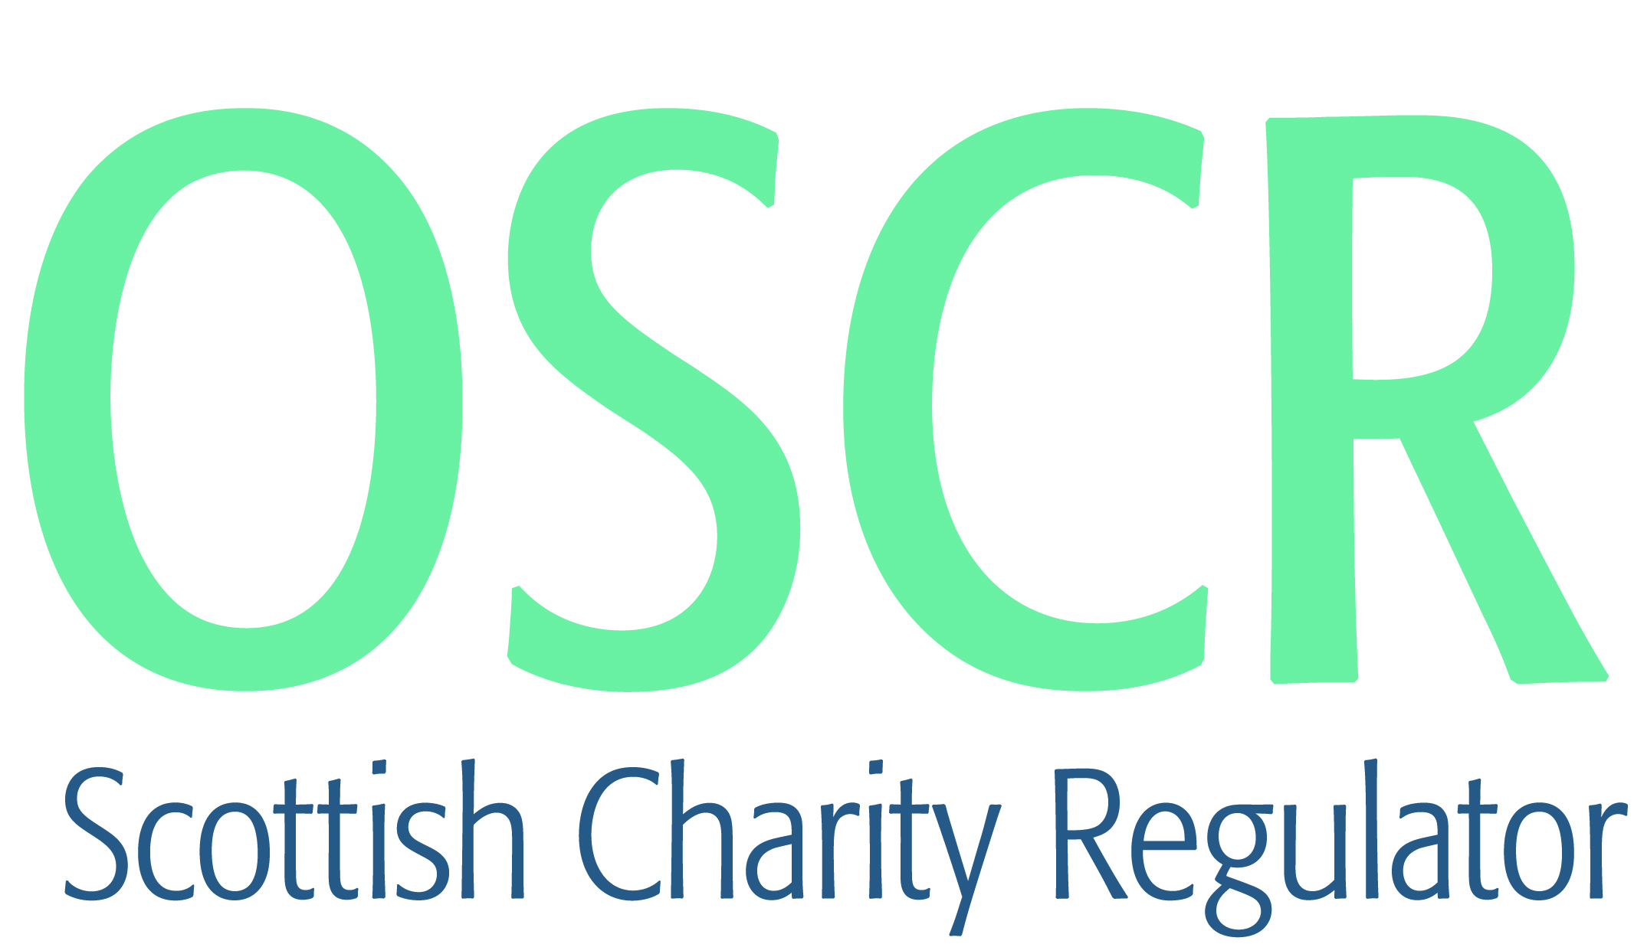

**Charities granted charitable status 1 to 31 January 2021**

|  |  |  |
| --- | --- | --- |
| **Charity Number** | **Charity Name** | **Constitutional Form** |
|  |  |  |
| [**SC050648**](https://www.oscr.org.uk/search-charity-register/charity-extract/?charitynumber=SC050648) | **Common Ground Against Homelessness** | **Community Benefit Society** |
| [**SC050649**](https://www.oscr.org.uk/search-charity-register/charity-extract/?charitynumber=SC050649) | **Friends of Orchard Park** | **Unincorporated Association** |
| [**SC050650**](https://www.oscr.org.uk/search-charity-register/charity-extract/?charitynumber=SC050650) | **East Kintyre Community Fund** | **SCIO** |
| [**SC050651**](https://www.oscr.org.uk/search-charity-register/charity-extract/?charitynumber=SC050651) | **The BRAvery Trust** | **Trust** |
| [**SC050652**](https://www.oscr.org.uk/search-charity-register/charity-extract/?charitynumber=SC050652) | **Shetland Rural Methodist Church** | **Unincorporated Association** |
| [**SC050653**](https://www.oscr.org.uk/search-charity-register/charity-extract/?charitynumber=SC050653) | **Roots** | **SCIO** |
| [**SC050654**](https://www.oscr.org.uk/search-charity-register/charity-extract/?charitynumber=SC050654) | **Cowal Combined Services Club (SCIO)** | **SCIO** |
| [**SC050655**](https://www.oscr.org.uk/search-charity-register/charity-extract/?charitynumber=SC050655) | **Garrabost Gniomhach: Active Garrabost** | **SCIO** |
| [**SC050656**](https://www.oscr.org.uk/search-charity-register/charity-extract/?charitynumber=SC050656) | **Linlithgow Kayak Racing SCIO** | **SCIO** |
| [**SC050657**](https://www.oscr.org.uk/search-charity-register/charity-extract/?charitynumber=SC050657) | **1st Cowal Boys' Brigade & Girls' Association** | **SCIO** |
| [**SC050658**](https://www.oscr.org.uk/search-charity-register/charity-extract/?charitynumber=SC050658) | **I-IMPACT4G7** | **Trust** |
| [**SC050659**](https://www.oscr.org.uk/search-charity-register/charity-extract/?charitynumber=SC050659) | **Enterprise Foundation** | **Company** |
| [**SC050660**](https://www.oscr.org.uk/search-charity-register/charity-extract/?charitynumber=SC050660) | **Essentia Foundation SCIO** | **SCIO** |
| [**SC050661**](https://www.oscr.org.uk/search-charity-register/charity-extract/?charitynumber=SC050661) | **Methodist Minister's Housing Society** | **Company** |
| [**SC050662**](https://www.oscr.org.uk/search-charity-register/charity-extract/?charitynumber=SC050662) | **Fire & Peace Recovery** | **SCIO** |
| [**SC050663**](https://www.oscr.org.uk/search-charity-register/charity-extract/?charitynumber=SC050663) | **Western Isles Motocross Club** | **SCIO** |
| [**SC050664**](https://www.oscr.org.uk/search-charity-register/charity-extract/?charitynumber=SC050664) | **Sea the Change** | **SCIO** |
| [**SC050665**](https://www.oscr.org.uk/search-charity-register/charity-extract/?charitynumber=SC050665) | **MoJoTraverse Charitable Trust** | **Trust** |
| [**SC050666**](https://www.oscr.org.uk/search-charity-register/charity-extract/?charitynumber=SC050666) | **FLOW for ALL** | **SCIO** |
| [**SC050667**](https://www.oscr.org.uk/search-charity-register/charity-extract/?charitynumber=SC050667) | **Gascon Cattle Society UK** | **SCIO** |
| [**SC050668**](https://www.oscr.org.uk/search-charity-register/charity-extract/?charitynumber=SC050668) | **Medfauna SCIO** | **SCIO** |
| [**SC050669**](https://www.oscr.org.uk/search-charity-register/charity-extract/?charitynumber=SC050669) | **The Aiteal Trust** | **SCIO** |
| [**SC050670**](https://www.oscr.org.uk/search-charity-register/charity-extract/?charitynumber=SC050670) | **Action Deafness** | **Company** |
| [**SC050671**](https://www.oscr.org.uk/search-charity-register/charity-extract/?charitynumber=SC050671) | **38th Brownie City of Edinburgh** | **Unincorporated Association** |
| [**SC050672**](https://www.oscr.org.uk/search-charity-register/charity-extract/?charitynumber=SC050672) | **38th Rainbow City of Edinburgh** | **Unincorporated Association** |
| [**SC050673**](https://www.oscr.org.uk/search-charity-register/charity-extract/?charitynumber=SC050673) | **The Destiny Project** | **SCIO** |
| [**SC050674**](https://www.oscr.org.uk/search-charity-register/charity-extract/?charitynumber=SC050674) | **Association of Turkish Alumni and Students in Scotland** | **SCIO** |
| [**SC050675**](https://www.oscr.org.uk/search-charity-register/charity-extract/?charitynumber=SC050675) | **Kinross-shire Move Greener Organisation (SCIO)** | **SCIO** |
| [**SC050676**](https://www.oscr.org.uk/search-charity-register/charity-extract/?charitynumber=SC050676) | **Cumbernauld Resilience** | **SCIO** |
| [**SC050677**](https://www.oscr.org.uk/search-charity-register/charity-extract/?charitynumber=SC050677) | **Christ Centred Church** | **SCIO** |
| [**SC050678**](https://www.oscr.org.uk/search-charity-register/charity-extract/?charitynumber=SC050678) | **Forces Online CIO** | **CIO** |
| [**SC050679**](https://www.oscr.org.uk/search-charity-register/charity-extract/?charitynumber=SC050679) | **Newmachar and Kingseat Community Allotments [SCIO]** | **SCIO** |
| [**SC050680**](https://www.oscr.org.uk/search-charity-register/charity-extract/?charitynumber=SC050680) | **Girlguiding Shetland Division** | **Unincorporated Association** |
| [**SC050681**](https://www.oscr.org.uk/search-charity-register/charity-extract/?charitynumber=SC050681) | **4th City of Edinburgh Rainbow Unit** | **Unincorporated Association** |
| [**SC050682**](https://www.oscr.org.uk/search-charity-register/charity-extract/?charitynumber=SC050682) | **Adam Amos Charity SCIO** | **SCIO** |
| [**SC050683**](https://www.oscr.org.uk/search-charity-register/charity-extract/?charitynumber=SC050683) | **Paisley Opera SCIO** | **SCIO** |
| [**SC050684**](https://www.oscr.org.uk/search-charity-register/charity-extract/?charitynumber=SC050684) | **Dalmellington Parish Development Trust** | **Company** |
| [**SC050685**](https://www.oscr.org.uk/search-charity-register/charity-extract/?charitynumber=SC050685) | **The VS Foundation** | **SCIO** |
| [**SC050686**](https://www.oscr.org.uk/search-charity-register/charity-extract/?charitynumber=SC050686) | **The Bridge of Don Brigade** | **SCIO** |
| [**SC050687**](https://www.oscr.org.uk/search-charity-register/charity-extract/?charitynumber=SC050687) | **Rossvale Community Football Club** | **SCIO** |
| [**SC050688**](https://www.oscr.org.uk/search-charity-register/charity-extract/?charitynumber=SC050688) | **WrestleKind** | **SCIO** |
| [**SC050689**](https://www.oscr.org.uk/search-charity-register/charity-extract/?charitynumber=SC050689) | **Shed47 Railway Restoration Group** | **SCIO** |
| [**SC050690**](https://www.oscr.org.uk/search-charity-register/charity-extract/?charitynumber=SC050690) | **2nd Wishaw Guide Unit** | **Unincorporated Association** |
| [**SC050691**](https://www.oscr.org.uk/search-charity-register/charity-extract/?charitynumber=SC050691) | **4th Wishaw Ranger Unit** | **Unincorporated Association** |
| [**SC050692**](https://www.oscr.org.uk/search-charity-register/charity-extract/?charitynumber=SC050692) | **Kirkcaldy Canoe Club** | **SCIO** |
| [**SC050693**](https://www.oscr.org.uk/search-charity-register/charity-extract/?charitynumber=SC050693) | **BarkingMad UK SCIO** | **SCIO** |
| [**SC050694**](https://www.oscr.org.uk/search-charity-register/charity-extract/?charitynumber=SC050694) | **GOD'S AMAZING LOVE ASSEMBLY (GALA)** | **Unincorporated Association** |
| [**SC050695**](https://www.oscr.org.uk/search-charity-register/charity-extract/?charitynumber=SC050695) | **Clyde Coast Radio** | **SCIO** |
| [**SC050696**](https://www.oscr.org.uk/search-charity-register/charity-extract/?charitynumber=SC050696) | **186th City Of Edinburgh Brownie Unit** | **Unincorporated Association** |
| [**SC050697**](https://www.oscr.org.uk/search-charity-register/charity-extract/?charitynumber=SC050697) | **Ferguslie Community Development Trust** | **SCIO** |
| [**SC050698**](https://www.oscr.org.uk/search-charity-register/charity-extract/?charitynumber=SC050698) | **Restoration Fife Ltd** | **Company** |
| [**SC050699**](https://www.oscr.org.uk/search-charity-register/charity-extract/?charitynumber=SC050699) | **19th Perth Rainbow unit** | **Unincorporated Association** |
| [**SC050700**](https://www.oscr.org.uk/search-charity-register/charity-extract/?charitynumber=SC050700) | **Crown Connects** | **SCIO** |
| [**SC050701**](https://www.oscr.org.uk/search-charity-register/charity-extract/?charitynumber=SC050701) | **Shetland UHI Ltd** | **Company** |
| [**SC050702**](https://www.oscr.org.uk/search-charity-register/charity-extract/?charitynumber=SC050702) | **116th City Of Edinburgh Rainbow Unit** | **Unincorporated Association** |
| [**SC050703**](https://www.oscr.org.uk/search-charity-register/charity-extract/?charitynumber=SC050703) | **SCIENCE OF THE SOUL BRITISH ISLES** | **CIO** |
| [**SC050704**](https://www.oscr.org.uk/search-charity-register/charity-extract/?charitynumber=SC050704) | **Glasgow Street Aid (SCIO)** | **SCIO** |
| [**SC050705**](https://www.oscr.org.uk/search-charity-register/charity-extract/?charitynumber=SC050705) | **1st Strathpeffer Rangers** | **Unincorporated Association** |
| [**SC050706**](https://www.oscr.org.uk/search-charity-register/charity-extract/?charitynumber=SC050706) | **25th Inverness (Drakies) Brownie Unit** | **Unincorporated Association** |
| [**SC050707**](https://www.oscr.org.uk/search-charity-register/charity-extract/?charitynumber=SC050707) | **The Architecture Centre** | **SCIO** |
| [**SC050708**](https://www.oscr.org.uk/search-charity-register/charity-extract/?charitynumber=SC050708) | **Man On! Inverclyde** | **Company** |
| [**SC050709**](https://www.oscr.org.uk/search-charity-register/charity-extract/?charitynumber=SC050709) | **Deveronvale Community Football Club** | **SCIO** |
| [**SC050710**](https://www.oscr.org.uk/search-charity-register/charity-extract/?charitynumber=SC050710) | **British Society of Animal Science SCIO** | **SCIO** |
| [**SC050711**](https://www.oscr.org.uk/search-charity-register/charity-extract/?charitynumber=SC050711) | **Pearl International** | **SCIO** |
| [**SC050712**](https://www.oscr.org.uk/search-charity-register/charity-extract/?charitynumber=SC050712) | **Tap O' The Toon** | **SCIO** |
| [**SC050713**](https://www.oscr.org.uk/search-charity-register/charity-extract/?charitynumber=SC050713) | **Linlithgow Primary School Parent Council** | **SCIO** |
| [**SC050714**](https://www.oscr.org.uk/search-charity-register/charity-extract/?charitynumber=SC050714) | **6th Troon (Barassie) Brownie Unit** | **Unincorporated Association** |
| [**SC050715**](https://www.oscr.org.uk/search-charity-register/charity-extract/?charitynumber=SC050715) | **Clann an Eich 'Children of the Horse'** | **SCIO** |
| [**SC050716**](https://www.oscr.org.uk/search-charity-register/charity-extract/?charitynumber=SC050716) | **Association of NHS Charities** | **Company** |
| [**SC050717**](https://www.oscr.org.uk/search-charity-register/charity-extract/?charitynumber=SC050717) | **Light Up Peterhead** | **Unincorporated Association** |
| [**SC050718**](https://www.oscr.org.uk/search-charity-register/charity-extract/?charitynumber=SC050718) | **89th North Glen Scout Group** | **Unincorporated Association** |
| [**SC050719**](https://www.oscr.org.uk/search-charity-register/charity-extract/?charitynumber=SC050719) | **Jericho Fly Fishers** | **SCIO** |
| [**SC050720**](https://www.oscr.org.uk/search-charity-register/charity-extract/?charitynumber=SC050720) | **Wanlockhead Community Trust** | **Company** |
| [**SC050721**](https://www.oscr.org.uk/search-charity-register/charity-extract/?charitynumber=SC050721) | **Wester Ross Biosphere Ltd** | **Company** |
| [**SC050722**](https://www.oscr.org.uk/search-charity-register/charity-extract/?charitynumber=SC050722) | **GREIG STEVEN MEMORIAL SCIO** | **SCIO** |
| [**SC050723**](https://www.oscr.org.uk/search-charity-register/charity-extract/?charitynumber=SC050723) | **Tullibody Community Garden** | **SCIO** |
| [**SC050724**](https://www.oscr.org.uk/search-charity-register/charity-extract/?charitynumber=SC050724) | **Barmaddy Centre** | **SCIO** |
| [**SC050725**](https://www.oscr.org.uk/search-charity-register/charity-extract/?charitynumber=SC050725) | **Carrick Rugby Football Club** | **SCIO** |
| [**SC050726**](https://www.oscr.org.uk/search-charity-register/charity-extract/?charitynumber=SC050726) | **Tongue, Melness & Skerray Wildlife Group** | **Unincorporated Association** |
| [**SC050727**](https://www.oscr.org.uk/search-charity-register/charity-extract/?charitynumber=SC050727) | **Christ Ambassadors Community Church of God** | **Unincorporated Association** |
| [**SC050728**](https://www.oscr.org.uk/search-charity-register/charity-extract/?charitynumber=SC050728) | **Strathclyde Park Rowing Club** | **SCIO** |
| [**SC050729**](https://www.oscr.org.uk/search-charity-register/charity-extract/?charitynumber=SC050729) | **Stand Tall Above Scoliosis SCIO** | **SCIO** |
| [**SC050730**](https://www.oscr.org.uk/search-charity-register/charity-extract/?charitynumber=SC050730) | **Dundee Rugby Charitable Trust** | **Trust** |
| [**SC050731**](https://www.oscr.org.uk/search-charity-register/charity-extract/?charitynumber=SC050731) | **RHEMA PLACE MINISTRIES INTERNATIONAL** | **SCIO** |