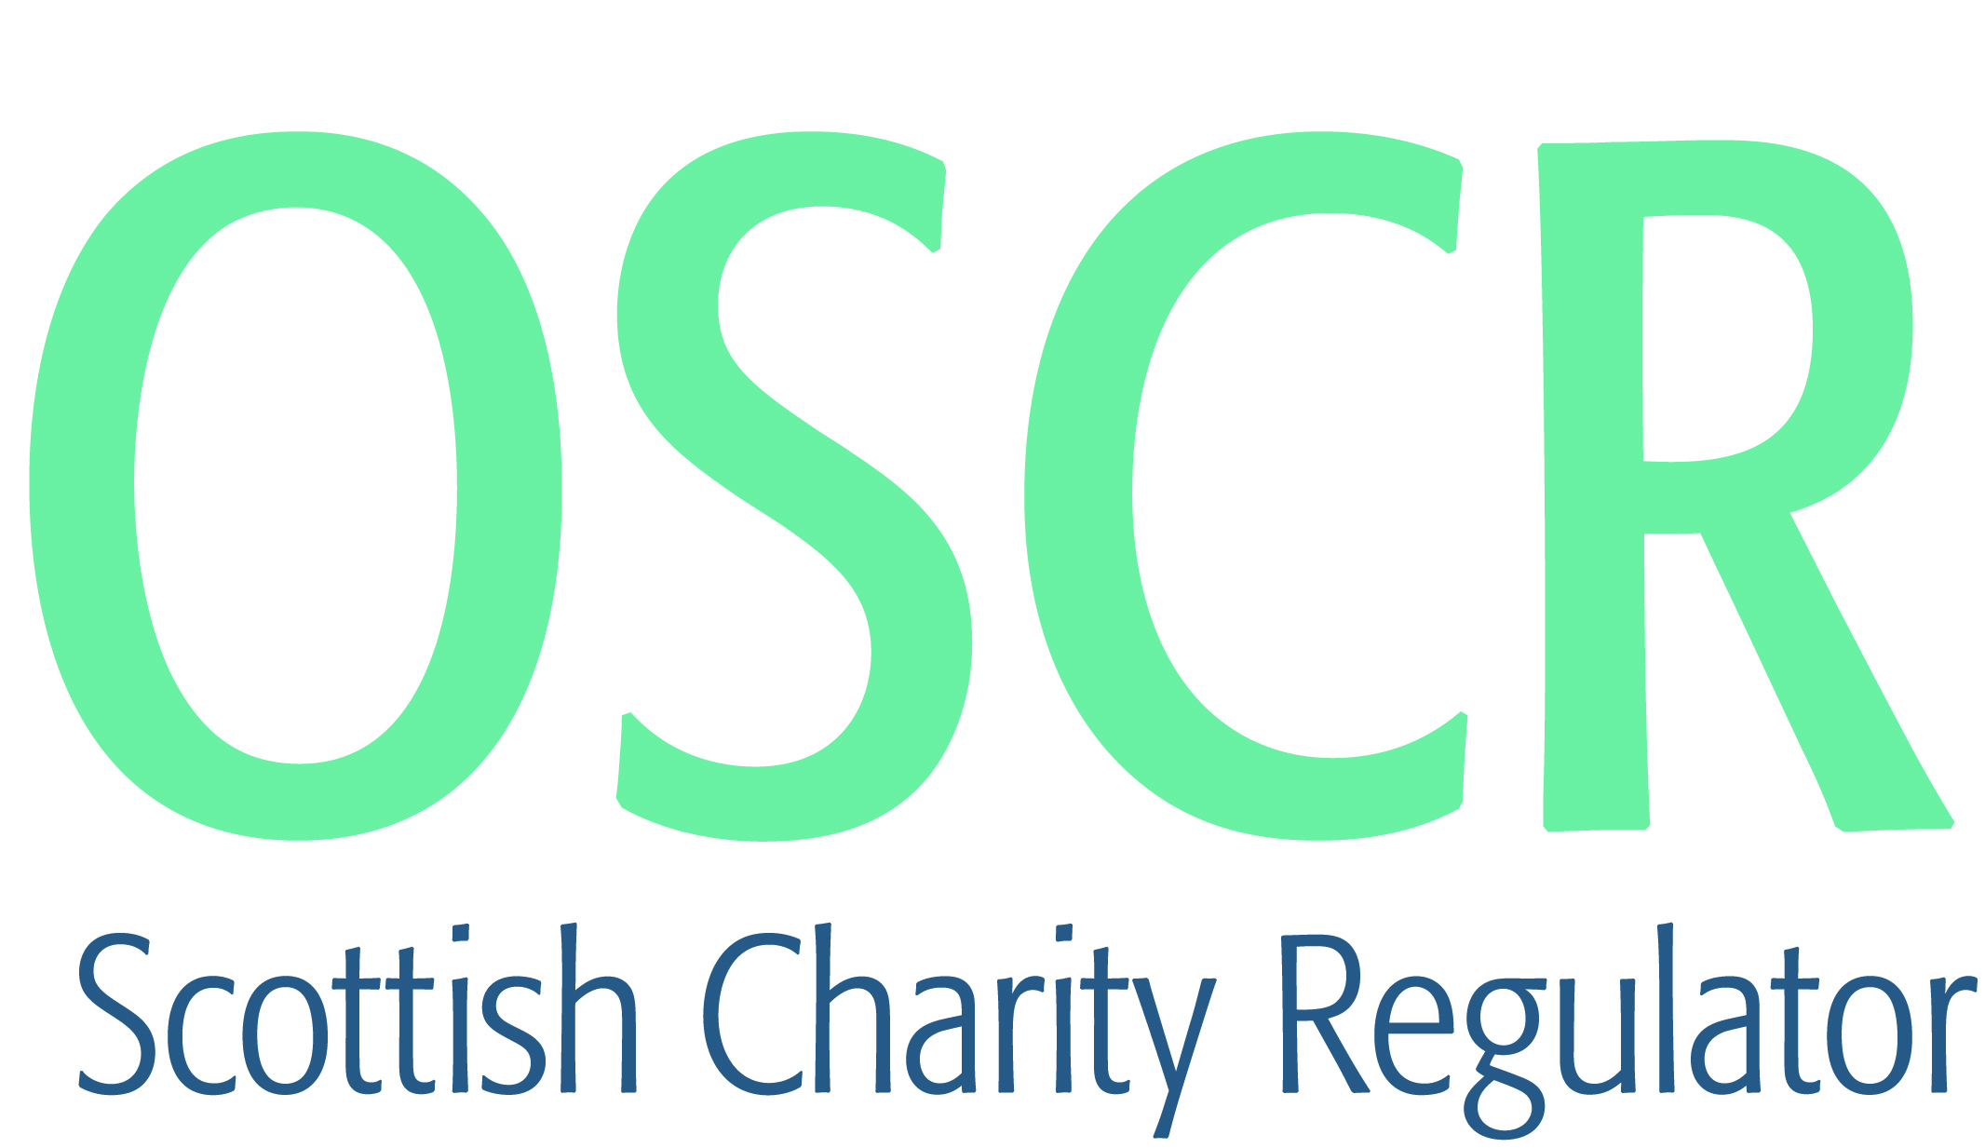

**Charities granted charitable status 1 to 31 March 2020**

|  |  |  |
| --- | --- | --- |
| **Charity Number** | **Charity Name** | **Constitutional Form** |
| [SC050046](https://www.oscr.org.uk/search-charity-register/charity-extract/?charitynumber=SC050046) | 1st Comrie Guide and Ranger Unit | Unincorporated Association |
| [SC050026](https://www.oscr.org.uk/search-charity-register/charity-extract/?charitynumber=SC050026) | 26th Perthshire (Dunning) Scout Group | Unincorporated Association |
| [SC050047](https://www.oscr.org.uk/search-charity-register/charity-extract/?charitynumber=SC050047) | African Parks UK | Company |
| [SC050050](https://www.oscr.org.uk/search-charity-register/charity-extract/?charitynumber=SC050050) | African Relief Support | SCIO |
| [SC050041](https://www.oscr.org.uk/search-charity-register/charity-extract/?charitynumber=SC050041) | A-Team Productions | SCIO |
| [SC050000](https://www.oscr.org.uk/search-charity-register/charity-extract/?charitynumber=SC050000) | Ayr Hospital Radio SCIO | SCIO |
| [SC050016](https://www.oscr.org.uk/search-charity-register/charity-extract/?charitynumber=SC050016) | Berwickshire Marine Reserve(SCIO) | SCIO |
| [SC050058](https://www.oscr.org.uk/search-charity-register/charity-extract/?charitynumber=SC050058) | Biggar Arts Ltd | Company |
| [SC050022](https://www.oscr.org.uk/search-charity-register/charity-extract/?charitynumber=SC050022) | Bonar Bridge Football Club | SCIO |
| [SC050006](https://www.oscr.org.uk/search-charity-register/charity-extract/?charitynumber=SC050006) | British Arachnological Society | CIO |
| [SC049997](https://www.oscr.org.uk/search-charity-register/charity-extract/?charitynumber=SC049997) | Brookwood Community Trust | SCIO |
| [SC049998](https://www.oscr.org.uk/search-charity-register/charity-extract/?charitynumber=SC049998) | Brough Bay Association | Company |
| [SC050044](https://www.oscr.org.uk/search-charity-register/charity-extract/?charitynumber=SC050044) | Broxburn & Uphall Community Website Trust | Trust |
| [SC050004](https://www.oscr.org.uk/search-charity-register/charity-extract/?charitynumber=SC050004) | Carstairs Junction Welcome All Hub | SCIO |
| [SC050015](https://www.oscr.org.uk/search-charity-register/charity-extract/?charitynumber=SC050015) | Castlebrae Community SCIO | SCIO |
| [SC050013](https://www.oscr.org.uk/search-charity-register/charity-extract/?charitynumber=SC050013) | Charity Heroes | SCIO |
| [SC050029](https://www.oscr.org.uk/search-charity-register/charity-extract/?charitynumber=SC050029) | Cliftonville & Coatdyke Community Group | SCIO |
| [SC050027](https://www.oscr.org.uk/search-charity-register/charity-extract/?charitynumber=SC050027) | Craigmillar Now | SCIO |
| [SC050057](https://www.oscr.org.uk/search-charity-register/charity-extract/?charitynumber=SC050057) | Dalmarnock Youth Project(SCIO) | SCIO |
| [SC049995](https://www.oscr.org.uk/search-charity-register/charity-extract/?charitynumber=SC049995) | Donerry Aid | Unincorporated Association |
| [SC050008](https://www.oscr.org.uk/search-charity-register/charity-extract/?charitynumber=SC050008) | Edinburgh Architectural Association SCIO | SCIO |
| [SC050018](https://www.oscr.org.uk/search-charity-register/charity-extract/?charitynumber=SC050018) | Equal Community Foundation UK | Company |
| [SC050005](https://www.oscr.org.uk/search-charity-register/charity-extract/?charitynumber=SC050005) | Equals Advocacy Ltd | Company |
| [SC050038](https://www.oscr.org.uk/search-charity-register/charity-extract/?charitynumber=SC050038) | Falkirk Baptist Church SCIO | SCIO |
| [SC050039](https://www.oscr.org.uk/search-charity-register/charity-extract/?charitynumber=SC050039) | Fintry And Friends Out of School Care SCIO | SCIO |
| [SC050048](https://www.oscr.org.uk/search-charity-register/charity-extract/?charitynumber=SC050048) | Glasgow's Pre-Loved Uniforms (SCIO) | SCIO |
| [SC050045](https://www.oscr.org.uk/search-charity-register/charity-extract/?charitynumber=SC050045) | Green Blox | SCIO |
| [SC050040](https://www.oscr.org.uk/search-charity-register/charity-extract/?charitynumber=SC050040) | Greener Every Day Scotland (SCIO) | SCIO |
| [SC049996](https://www.oscr.org.uk/search-charity-register/charity-extract/?charitynumber=SC049996) | Imo Progressive Union | SCIO |
| [SC050024](https://www.oscr.org.uk/search-charity-register/charity-extract/?charitynumber=SC050024) | Jim Matthew Camera Collection Trust | SCIO |
| [SC050003](https://www.oscr.org.uk/search-charity-register/charity-extract/?charitynumber=SC050003) | KOOL SKOOL | Company |
| [SC050033](https://www.oscr.org.uk/search-charity-register/charity-extract/?charitynumber=SC050033) | Leslie Baptist Church SCIO | SCIO |
| [SC050007](https://www.oscr.org.uk/search-charity-register/charity-extract/?charitynumber=SC050007) | Limitless Sports SCIO | SCIO |
| [SC050037](https://www.oscr.org.uk/search-charity-register/charity-extract/?charitynumber=SC050037) | Loudon Pond Volunteer Group | SCIO |
| [SC050034](https://www.oscr.org.uk/search-charity-register/charity-extract/?charitynumber=SC050034) | Lucky Ewe | SCIO |
| [SC050001](https://www.oscr.org.uk/search-charity-register/charity-extract/?charitynumber=SC050001) | MalDent Student Aid | SCIO |
| [SC050031](https://www.oscr.org.uk/search-charity-register/charity-extract/?charitynumber=SC050031) | Moray Concert Brass SCIO | SCIO |
| [SC050011](https://www.oscr.org.uk/search-charity-register/charity-extract/?charitynumber=SC050011) | Neilston & Uplawmoor First Responders SCIO | SCIO |
| [SC050051](https://www.oscr.org.uk/search-charity-register/charity-extract/?charitynumber=SC050051) | New Abbey Village Hall | SCIO |
| [SC050014](https://www.oscr.org.uk/search-charity-register/charity-extract/?charitynumber=SC050014) | New Way | SCIO |
| [SC050023](https://www.oscr.org.uk/search-charity-register/charity-extract/?charitynumber=SC050023) | Portobello Timebank (SCIO) | SCIO |
| [SC050021](https://www.oscr.org.uk/search-charity-register/charity-extract/?charitynumber=SC050021) | Produced Moon | SCIO |
| [SC050017](https://www.oscr.org.uk/search-charity-register/charity-extract/?charitynumber=SC050017) | Redeemer Church Edinburgh | SCIO |
| [SC050054](https://www.oscr.org.uk/search-charity-register/charity-extract/?charitynumber=SC050054) | Salen Primary School Parent Council | Unincorporated Association |
| [SC050043](https://www.oscr.org.uk/search-charity-register/charity-extract/?charitynumber=SC050043) | Scottish Community Development Network | SCIO |
| [SC050052](https://www.oscr.org.uk/search-charity-register/charity-extract/?charitynumber=SC050052) | Site Collective | SCIO |
| [SC050019](https://www.oscr.org.uk/search-charity-register/charity-extract/?charitynumber=SC050019) | Skateraw Hall | SCIO |
| [SC050025](https://www.oscr.org.uk/search-charity-register/charity-extract/?charitynumber=SC050025) | South Ayrshire Swim Team | Unincorporated Association |
| [SC050032](https://www.oscr.org.uk/search-charity-register/charity-extract/?charitynumber=SC050032) | The Albert Kennedy Trust | Company |
| [SC050030](https://www.oscr.org.uk/search-charity-register/charity-extract/?charitynumber=SC050030) | The Campaign for a Scottish Borders National Park | SCIO |
| [SC050002](https://www.oscr.org.uk/search-charity-register/charity-extract/?charitynumber=SC050002) | The Hut | SCIO |
| [SC050042](https://www.oscr.org.uk/search-charity-register/charity-extract/?charitynumber=SC050042) | The Lighthouse Support Centre | Company |
| [SC049999](https://www.oscr.org.uk/search-charity-register/charity-extract/?charitynumber=SC049999) | The Mackintosh Choir | Unincorporated Association |
| [SC050010](https://www.oscr.org.uk/search-charity-register/charity-extract/?charitynumber=SC050010) | The Moray Monday Club | SCIO |
| [SC050056](https://www.oscr.org.uk/search-charity-register/charity-extract/?charitynumber=SC050056) | The Seed Box Limited | Company |
| [SC050012](https://www.oscr.org.uk/search-charity-register/charity-extract/?charitynumber=SC050012) | The Slade & Slade Charitable Trust | Trust |
| [SC050049](https://www.oscr.org.uk/search-charity-register/charity-extract/?charitynumber=SC050049) | Tillydrone Community Flat SCIO | SCIO |
| [SC050028](https://www.oscr.org.uk/search-charity-register/charity-extract/?charitynumber=SC050028) | Tortoise in a Nutshell | SCIO |
| [SC050020](https://www.oscr.org.uk/search-charity-register/charity-extract/?charitynumber=SC050020) | Village Church | SCIO |
| [SC050036](https://www.oscr.org.uk/search-charity-register/charity-extract/?charitynumber=SC050036) | VoiceAbility Advocacy | Company |
| [SC050053](https://www.oscr.org.uk/search-charity-register/charity-extract/?charitynumber=SC050053) | Waist Not Want Not | SCIO |
| [SC050055](https://www.oscr.org.uk/search-charity-register/charity-extract/?charitynumber=SC050055) | West End Road Runners | SCIO |
| [SC050059](https://www.oscr.org.uk/search-charity-register/charity-extract/?charitynumber=SC050059) | Westwoodhill Evangelical Church SCIO | SCIO |
| [SC050009](https://www.oscr.org.uk/search-charity-register/charity-extract/?charitynumber=SC050009) | Wild Skies Shetland | SCIO |