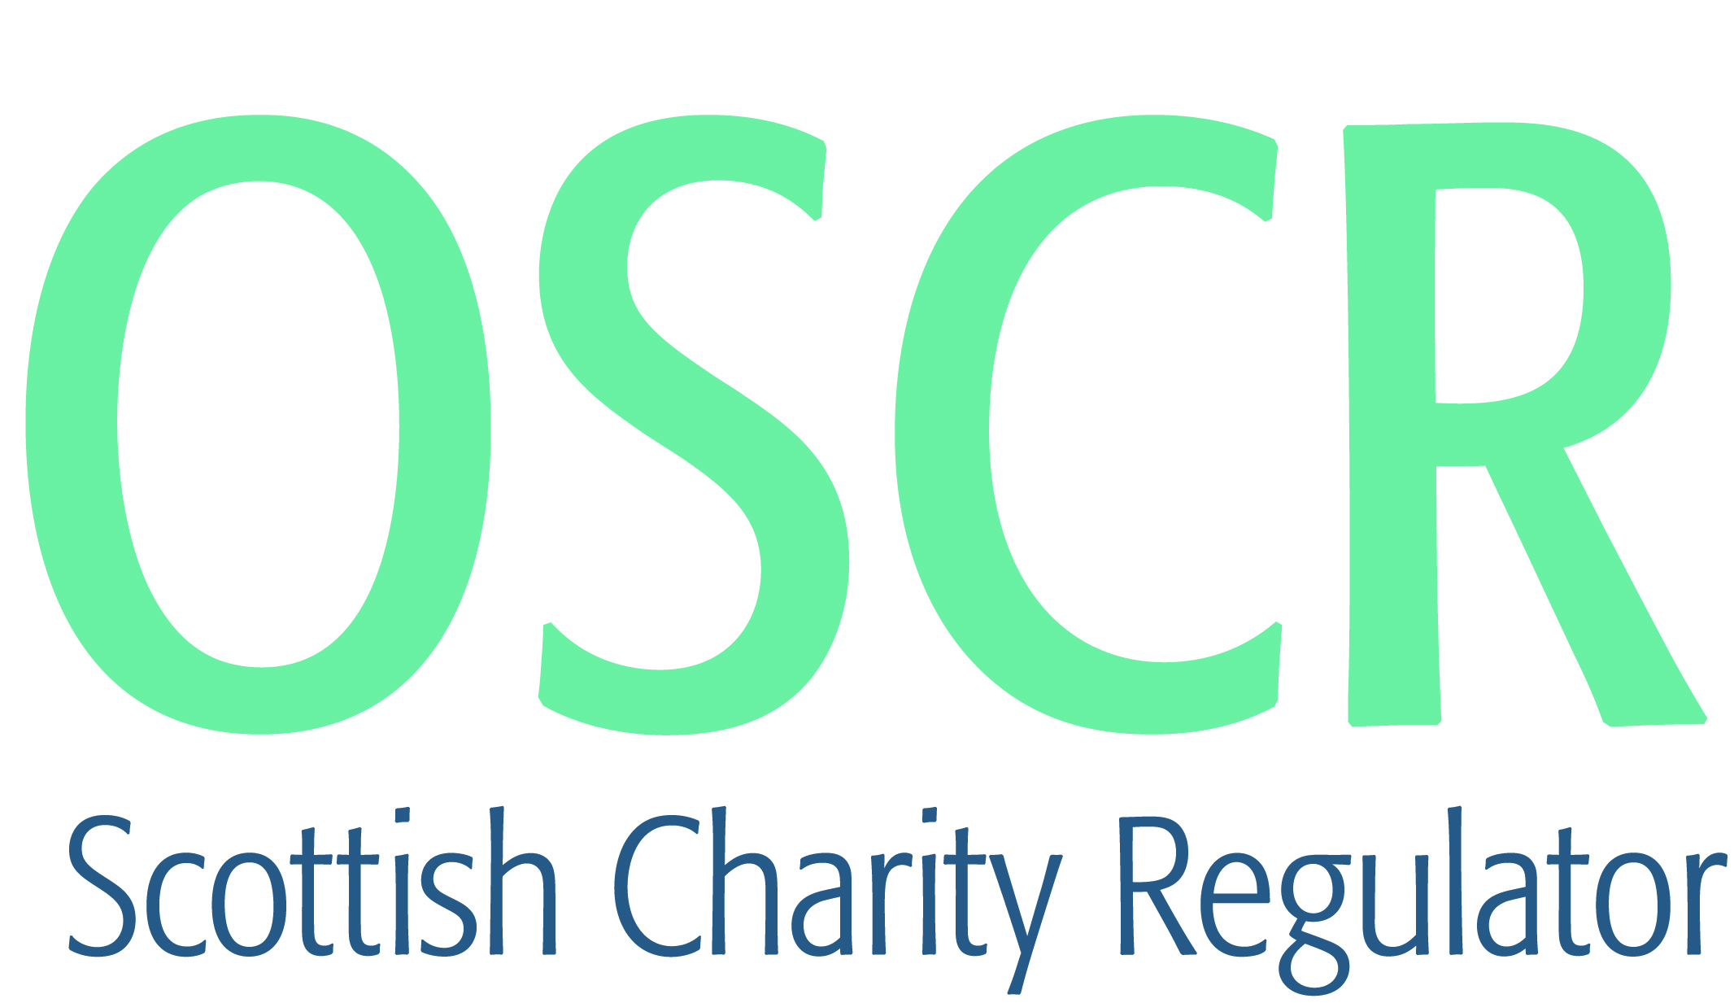

**Charities granted charitable status 1 to 31 December 2019**

|  |  |  |
| --- | --- | --- |
| **Charity Number** | **Charity Name** | **Constitutional Form** |
| [**SC049803**](https://www.oscr.org.uk/search-charity-register/charity-extract/?charitynumber=SC049803) | **Admiralty Gateway Charitable Trust** | **SCIO** |
| [**SC049816**](https://www.oscr.org.uk/search-charity-register/charity-extract/?charitynumber=SC049816) | **Ajyal School** | **SCIO** |
| [**SC049824**](https://www.oscr.org.uk/search-charity-register/charity-extract/?charitynumber=SC049824) | **Auchtermuchty Bellvue Colts Football Club** | **SCIO** |
| [**SC049818**](https://www.oscr.org.uk/search-charity-register/charity-extract/?charitynumber=SC049818) | **Badenoch Heritage (SCIO)** | **SCIO** |
| [**SC049807**](https://www.oscr.org.uk/search-charity-register/charity-extract/?charitynumber=SC049807) | **Birds of Paradise** | **Trust** |
| [**SC049808**](https://www.oscr.org.uk/search-charity-register/charity-extract/?charitynumber=SC049808) | **Blueskate Peterhead** | **SCIO** |
| [**SC049822**](https://www.oscr.org.uk/search-charity-register/charity-extract/?charitynumber=SC049822) | **Breathe Easy Clyde Valley Support Group** | **Unincorporated Association** |
| [**SC049794**](https://www.oscr.org.uk/search-charity-register/charity-extract/?charitynumber=SC049794) | **Castleview Primary School Parents and Carers** | **Unincorporated Association** |
| [**SC049833**](https://www.oscr.org.uk/search-charity-register/charity-extract/?charitynumber=SC049833) | **Cattanach** | **SCIO** |
| [**SC049812**](https://www.oscr.org.uk/search-charity-register/charity-extract/?charitynumber=SC049812) | **Coastal Creations ( SCIO)** | **SCIO** |
| [**SC049821**](https://www.oscr.org.uk/search-charity-register/charity-extract/?charitynumber=SC049821) | **Combined Productions** | **SCIO** |
| [**SC049797**](https://www.oscr.org.uk/search-charity-register/charity-extract/?charitynumber=SC049797) | **Craigerne Residents Association (2002)** | **SCIO** |
| [**SC049801**](https://www.oscr.org.uk/search-charity-register/charity-extract/?charitynumber=SC049801) | **Dileas Trust** | **Trust** |
| [**SC049831**](https://www.oscr.org.uk/search-charity-register/charity-extract/?charitynumber=SC049831) | **Dundee Hawkhill Harriers Athletics Club** | **SCIO** |
| [**SC049809**](https://www.oscr.org.uk/search-charity-register/charity-extract/?charitynumber=SC049809) | **Dyce and Stoneywood Community Association** | **Unincorporated Association** |
| [**SC049829**](https://www.oscr.org.uk/search-charity-register/charity-extract/?charitynumber=SC049829) | **Excel** | **SCIO** |
| [**SC049830**](https://www.oscr.org.uk/search-charity-register/charity-extract/?charitynumber=SC049830) | **Friends of Pencaitland Parks** | **SCIO** |
| [**SC049806**](https://www.oscr.org.uk/search-charity-register/charity-extract/?charitynumber=SC049806) | **Giffnock Synagogue** | **SCIO** |
| [**SC049835**](https://www.oscr.org.uk/search-charity-register/charity-extract/?charitynumber=SC049835) | **Glenrothes Art Club (SCIO)** | **SCIO** |
| [**SC049804**](https://www.oscr.org.uk/search-charity-register/charity-extract/?charitynumber=SC049804) | **Godfrey's Voice SCIO** | **SCIO** |
| [**SC049799**](https://www.oscr.org.uk/search-charity-register/charity-extract/?charitynumber=SC049799) | **Ithihas** | **Trust** |
| [**SC049790**](https://www.oscr.org.uk/search-charity-register/charity-extract/?charitynumber=SC049790) | **JSMMcN Charitable Trust** | **Trust** |
| [**SC049828**](https://www.oscr.org.uk/search-charity-register/charity-extract/?charitynumber=SC049828) | **Langmuir Family Foundation** | **SCIO** |
| [**SC049802**](https://www.oscr.org.uk/search-charity-register/charity-extract/?charitynumber=SC049802) | **Leukaemia Care** | **Company** |
| [**SC049815**](https://www.oscr.org.uk/search-charity-register/charity-extract/?charitynumber=SC049815) | **North West Glasgow Voluntary Sector Network SCIO** | **SCIO** |
| [**SC049834**](https://www.oscr.org.uk/search-charity-register/charity-extract/?charitynumber=SC049834) | **Pals of the Privies(SCIO)** | **SCIO** |
| [**SC049817**](https://www.oscr.org.uk/search-charity-register/charity-extract/?charitynumber=SC049817) | **Pause - Creating Space for Change** | **Company** |
| [**SC049805**](https://www.oscr.org.uk/search-charity-register/charity-extract/?charitynumber=SC049805) | **Reach Charity Limited** | **Company** |
| [**SC049813**](https://www.oscr.org.uk/search-charity-register/charity-extract/?charitynumber=SC049813) | **Release The Fire Ministries** | **SCIO** |
| [**SC049796**](https://www.oscr.org.uk/search-charity-register/charity-extract/?charitynumber=SC049796) | **Scotia Amateur Swimming Club** | **SCIO** |
| [**SC049792**](https://www.oscr.org.uk/search-charity-register/charity-extract/?charitynumber=SC049792) | **Send a Cow** | **Company** |
| [**SC049811**](https://www.oscr.org.uk/search-charity-register/charity-extract/?charitynumber=SC049811) | **Shetland Gymnastics Club** | **SCIO** |
| [**SC049827**](https://www.oscr.org.uk/search-charity-register/charity-extract/?charitynumber=SC049827) | **South Nesting Boating Club (SCIO)** | **SCIO** |
| [**SC049795**](https://www.oscr.org.uk/search-charity-register/charity-extract/?charitynumber=SC049795) | **Southside Church SCIO** | **SCIO** |
| [**SC049820**](https://www.oscr.org.uk/search-charity-register/charity-extract/?charitynumber=SC049820) | **Sports Chaplaincy UK** | **CIO** |
| [**SC049814**](https://www.oscr.org.uk/search-charity-register/charity-extract/?charitynumber=SC049814) | **Spott Community Association (2019)** | **SCIO** |
| [**SC049810**](https://www.oscr.org.uk/search-charity-register/charity-extract/?charitynumber=SC049810) | **The Aplastic Anaemia Trust** | **Company** |
| [**SC049832**](https://www.oscr.org.uk/search-charity-register/charity-extract/?charitynumber=SC049832) | **The Dunoon Project Ltd** | **Company** |
| [**SC049825**](https://www.oscr.org.uk/search-charity-register/charity-extract/?charitynumber=SC049825) | **The Raymond Fernie Foundation** | **Unincorporated Association** |
| [**SC049798**](https://www.oscr.org.uk/search-charity-register/charity-extract/?charitynumber=SC049798) | **The Redeemed Christian Church Of God - The Throne Of Grace Church** | **Unincorporated Association** |
| [**SC049793**](https://www.oscr.org.uk/search-charity-register/charity-extract/?charitynumber=SC049793) | **The Society of Occupational Medicine** | **Company** |
| [**SC049819**](https://www.oscr.org.uk/search-charity-register/charity-extract/?charitynumber=SC049819) | **The South Lanarkshire Charitable Trust** | **Trust** |
| [**SC049823**](https://www.oscr.org.uk/search-charity-register/charity-extract/?charitynumber=SC049823) | **The South Lanarkshire Educational Trust** | **Trust** |
| [**SC049826**](https://www.oscr.org.uk/search-charity-register/charity-extract/?charitynumber=SC049826) | **Three Streams SCIO** | **SCIO** |
| [**SC049800**](https://www.oscr.org.uk/search-charity-register/charity-extract/?charitynumber=SC049800) | **West Highland Community Rail Partnership** | **SCIO** |