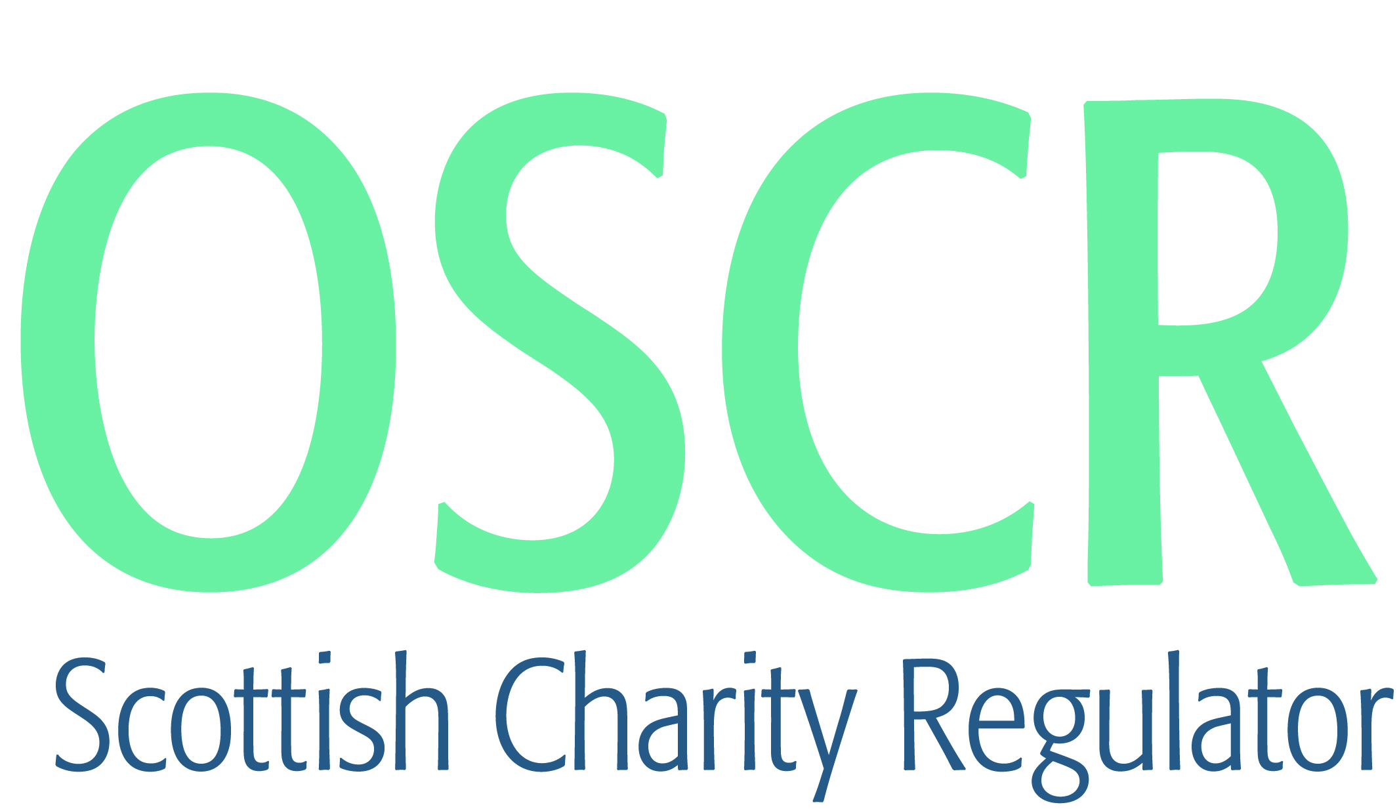

**Charities granted charitable status 1 to 31 July 2019**

|  |  |  |
| --- | --- | --- |
| **Charity Number** | **Charity Name** | **Constitutional Form** |
| [**SC049461**](https://www.oscr.org.uk/search-charity-register/charity-extract/?charitynumber=SC049461) | **(Polish) Combatants Memorial Group in Scotland** | **SCIO** |
| [**SC049427**](https://www.oscr.org.uk/search-charity-register/charity-extract/?charitynumber=SC049427) | **12th Perthshire Scout Group** | **Unincorporated Association** |
| [**SC049426**](https://www.oscr.org.uk/search-charity-register/charity-extract/?charitynumber=SC049426) | **1st Beauly Rainbow Unit** | **Unincorporated Association** |
| [**SC049470**](https://www.oscr.org.uk/search-charity-register/charity-extract/?charitynumber=SC049470) | **1st Inchinnan Brownie Unit** | **Unincorporated Association** |
| [**SC049467**](https://www.oscr.org.uk/search-charity-register/charity-extract/?charitynumber=SC049467) | **2nd Whitecraigs Rainbow Unit** | **Unincorporated Association** |
| [**SC049466**](https://www.oscr.org.uk/search-charity-register/charity-extract/?charitynumber=SC049466) | **6th South Queensferry Rainbow Unit** | **Unincorporated Association** |
| [**SC049457**](https://www.oscr.org.uk/search-charity-register/charity-extract/?charitynumber=SC049457) | **Allander Evangelical Church 2019** | **SCIO** |
| [**SC049446**](https://www.oscr.org.uk/search-charity-register/charity-extract/?charitynumber=SC049446) | **Astronomical Society of Glasgow SCIO** | **SCIO** |
| [**SC049429**](https://www.oscr.org.uk/search-charity-register/charity-extract/?charitynumber=SC049429) | **AYRSHIRE MUSLIM EDUCATION CENTRE** | **SCIO** |
| [**SC049479**](https://www.oscr.org.uk/search-charity-register/charity-extract/?charitynumber=SC049479) | **Baillie Braid for Your Home Ltd** | **Company** |
| [**SC049436**](https://www.oscr.org.uk/search-charity-register/charity-extract/?charitynumber=SC049436) | **Border Kayak & Canoe Club (SCIO)** | **SCIO** |
| [**SC049497**](https://www.oscr.org.uk/search-charity-register/charity-extract/?charitynumber=SC049497) | **Breathe Easy Fife (SCIO)** | **SCIO** |
| [**SC049477**](https://www.oscr.org.uk/search-charity-register/charity-extract/?charitynumber=SC049477) | **Breathe Easy Perthshire** | **SCIO** |
| [**SC049432**](https://www.oscr.org.uk/search-charity-register/charity-extract/?charitynumber=SC049432) | **Brink Literacy Project** | **Company** |
| [**SC049480**](https://www.oscr.org.uk/search-charity-register/charity-extract/?charitynumber=SC049480) | **Buchan District Scout Council** | **Unincorporated Association** |
| [**SC049474**](https://www.oscr.org.uk/search-charity-register/charity-extract/?charitynumber=SC049474) | **Chartered Institute of Library and Information Professionals** | **Statutory Corporation** |
| [**SC049482**](https://www.oscr.org.uk/search-charity-register/charity-extract/?charitynumber=SC049482) | **City of Edinburgh Gymnastics Club** | **Company** |
| [**SC049496**](https://www.oscr.org.uk/search-charity-register/charity-extract/?charitynumber=SC049496) | **Colinton Village Enterprise SCIO** | **SCIO** |
| [**SC049478**](https://www.oscr.org.uk/search-charity-register/charity-extract/?charitynumber=SC049478) | **Community Out West Trust** | **Company** |
| [**SC049488**](https://www.oscr.org.uk/search-charity-register/charity-extract/?charitynumber=SC049488) | **Conscious Edinburgh** | **SCIO** |
| [**SC049425**](https://www.oscr.org.uk/search-charity-register/charity-extract/?charitynumber=SC049425) | **Cooper Park Bowling Club** | **SCIO** |
| [**SC049442**](https://www.oscr.org.uk/search-charity-register/charity-extract/?charitynumber=SC049442) | **Cullen Men's Shed** | **SCIO** |
| [**SC049484**](https://www.oscr.org.uk/search-charity-register/charity-extract/?charitynumber=SC049484) | **Dundee People's Piano SCIO** | **SCIO** |
| [**SC049499**](https://www.oscr.org.uk/search-charity-register/charity-extract/?charitynumber=SC049499) | **Dunoon Jazz Festival Community Trust (SCIO)** | **SCIO** |
| [**SC049449**](https://www.oscr.org.uk/search-charity-register/charity-extract/?charitynumber=SC049449) | **Dynamite Arts** | **SCIO** |
| [**SC049468**](https://www.oscr.org.uk/search-charity-register/charity-extract/?charitynumber=SC049468) | **East Inverness Sports Hub** | **SCIO** |
| [**SC049469**](https://www.oscr.org.uk/search-charity-register/charity-extract/?charitynumber=SC049469) | **East Neuk Mens Shed** | **SCIO** |
| [**SC049454**](https://www.oscr.org.uk/search-charity-register/charity-extract/?charitynumber=SC049454) | **Edina Hibs** | **Unincorporated Association** |
| [**SC049487**](https://www.oscr.org.uk/search-charity-register/charity-extract/?charitynumber=SC049487) | **Falkland Bowling Club** | **Unincorporated Association** |
| [**SC049452**](https://www.oscr.org.uk/search-charity-register/charity-extract/?charitynumber=SC049452) | **Fed Up Community Cafe** | **SCIO** |
| [**SC049447**](https://www.oscr.org.uk/search-charity-register/charity-extract/?charitynumber=SC049447) | **Fèis a' Bhaile** | **Unincorporated Association** |
| [**SC049435**](https://www.oscr.org.uk/search-charity-register/charity-extract/?charitynumber=SC049435) | **Folklórny súbor Lipa (SCIO)** | **SCIO** |
| [**SC049450**](https://www.oscr.org.uk/search-charity-register/charity-extract/?charitynumber=SC049450) | **Fraserburgh and District Men's Shed** | **SCIO** |
| [**SC049485**](https://www.oscr.org.uk/search-charity-register/charity-extract/?charitynumber=SC049485) | **Friends of Knockhill Park** | **Unincorporated Association** |
| [**SC049421**](https://www.oscr.org.uk/search-charity-register/charity-extract/?charitynumber=SC049421) | **Galloway Community Transport (SCIO)** | **SCIO** |
| [**SC049433**](https://www.oscr.org.uk/search-charity-register/charity-extract/?charitynumber=SC049433) | **GambleAware** | **Company** |
| [**SC049489**](https://www.oscr.org.uk/search-charity-register/charity-extract/?charitynumber=SC049489) | **Glasgow Grace Church** | **SCIO** |
| [**SC049440**](https://www.oscr.org.uk/search-charity-register/charity-extract/?charitynumber=SC049440) | **Global Family Care Network (SCIO)** | **SCIO** |
| [**SC049445**](https://www.oscr.org.uk/search-charity-register/charity-extract/?charitynumber=SC049445) | **Healing Hearts Global SCIO** | **SCIO** |
| [**SC049441**](https://www.oscr.org.uk/search-charity-register/charity-extract/?charitynumber=SC049441) | **Homeless Veterans Project (SCIO)** | **SCIO** |
| [**SC049462**](https://www.oscr.org.uk/search-charity-register/charity-extract/?charitynumber=SC049462) | **House of Prayer for all Nations - Europe Ltd** | **Company** |
| [**SC049424**](https://www.oscr.org.uk/search-charity-register/charity-extract/?charitynumber=SC049424) | **Hurlford & Crookedholm ELCS (SCIO)** | **SCIO** |
| [**SC049418**](https://www.oscr.org.uk/search-charity-register/charity-extract/?charitynumber=SC049418) | **Invergordon Development Trust** | **SCIO** |
| [**SC049430**](https://www.oscr.org.uk/search-charity-register/charity-extract/?charitynumber=SC049430) | **Join The Dots** | **SCIO** |
| [**SC049439**](https://www.oscr.org.uk/search-charity-register/charity-extract/?charitynumber=SC049439) | **Killin Music Festival Trust** | **SCIO** |
| [**SC049463**](https://www.oscr.org.uk/search-charity-register/charity-extract/?charitynumber=SC049463) | **Launch It Trust Paisley** | **Company** |
| [**SC049472**](https://www.oscr.org.uk/search-charity-register/charity-extract/?charitynumber=SC049472) | **Love Po SCIO** | **SCIO** |
| [**SC049494**](https://www.oscr.org.uk/search-charity-register/charity-extract/?charitynumber=SC049494) | **Lybster Community Hall** | **SCIO** |
| [**SC049483**](https://www.oscr.org.uk/search-charity-register/charity-extract/?charitynumber=SC049483) | **Men Matter Scotland** | **SCIO** |
| [**SC049486**](https://www.oscr.org.uk/search-charity-register/charity-extract/?charitynumber=SC049486) | **Monifieth Grange Bowling Club** | **Unincorporated Association** |
| [**SC049438**](https://www.oscr.org.uk/search-charity-register/charity-extract/?charitynumber=SC049438) | **Music For You** | **SCIO** |
| [**SC049431**](https://www.oscr.org.uk/search-charity-register/charity-extract/?charitynumber=SC049431) | **National Kidney Federation** | **Company** |
| [**SC049492**](https://www.oscr.org.uk/search-charity-register/charity-extract/?charitynumber=SC049492) | **Nigerian Open Resources for Education (NOER) SCIO** | **SCIO** |
| [**SC049465**](https://www.oscr.org.uk/search-charity-register/charity-extract/?charitynumber=SC049465) | **Pittenweem Tennis Club Ltd** | **Company** |
| [**SC049471**](https://www.oscr.org.uk/search-charity-register/charity-extract/?charitynumber=SC049471) | **Polish Wolves (SCIO)** | **SCIO** |
| [**SC049459**](https://www.oscr.org.uk/search-charity-register/charity-extract/?charitynumber=SC049459) | **Pyjama Fairies** | **CIO** |
| [**SC049491**](https://www.oscr.org.uk/search-charity-register/charity-extract/?charitynumber=SC049491) | **Queen Margaret Hospice Garden Group** | **Unincorporated Association** |
| [**SC049473**](https://www.oscr.org.uk/search-charity-register/charity-extract/?charitynumber=SC049473) | **Queenslove Foundation** | **Company** |
| [**SC049490**](https://www.oscr.org.uk/search-charity-register/charity-extract/?charitynumber=SC049490) | **RCCG Shepherd's House Arbroath** | **Unincorporated Association** |
| [**SC049455**](https://www.oscr.org.uk/search-charity-register/charity-extract/?charitynumber=SC049455) | **Rokzkool Academy SCIO** | **SCIO** |
| [**SC049420**](https://www.oscr.org.uk/search-charity-register/charity-extract/?charitynumber=SC049420) | **Scottish Allotments and Gardens Society** | **SCIO** |
| [**SC049423**](https://www.oscr.org.uk/search-charity-register/charity-extract/?charitynumber=SC049423) | **Scottish Mental Health Co-operative** | **Company** |
| [**SC049437**](https://www.oscr.org.uk/search-charity-register/charity-extract/?charitynumber=SC049437) | **St John's Town of Dalry Town Hall SCIO** | **SCIO** |
| [**SC049453**](https://www.oscr.org.uk/search-charity-register/charity-extract/?charitynumber=SC049453) | **Standing Together Against Mental Health and Adversity** | **SCIO** |
| [**SC049475**](https://www.oscr.org.uk/search-charity-register/charity-extract/?charitynumber=SC049475) | **Stirling & District Men's Shed** | **SCIO** |
| [**SC049456**](https://www.oscr.org.uk/search-charity-register/charity-extract/?charitynumber=SC049456) | **Stonehaven and District Lions Club (SCIO)** | **SCIO** |
| [**SC049456**](https://www.oscr.org.uk/search-charity-register/charity-extract/?charitynumber=SC049456) | **Supporting our Communities (SOC)** | **SCIO** |
| [**SC049443**](https://www.oscr.org.uk/search-charity-register/charity-extract/?charitynumber=SC049443) | **SWiT** | **SCIO** |
| [**SC049444**](https://www.oscr.org.uk/search-charity-register/charity-extract/?charitynumber=SC049444) | **Sylvia Fleming's Wildlife Trust** | **Trust** |
| [**SC049460**](https://www.oscr.org.uk/search-charity-register/charity-extract/?charitynumber=SC049460) | **The Didima Charitable Trust** | **Trust** |
| [**SC049464**](https://www.oscr.org.uk/search-charity-register/charity-extract/?charitynumber=SC049464) | **The Jasmine Foundation** | **Trust** |
| [**SC049422**](https://www.oscr.org.uk/search-charity-register/charity-extract/?charitynumber=SC049422) | **The Lodge Alloa No69 Benevolent Fund** | **Unincorporated Association** |
| [**SC049434**](https://www.oscr.org.uk/search-charity-register/charity-extract/?charitynumber=SC049434) | **The Nepal Volunteer Programme SCIO** | **SCIO** |
| [**SC049448**](https://www.oscr.org.uk/search-charity-register/charity-extract/?charitynumber=SC049448) | **The Potter's House Christian Fellowship Church Glasgow Scotland SCIO** | **SCIO** |
| [**SC049481**](https://www.oscr.org.uk/search-charity-register/charity-extract/?charitynumber=SC049481) | **The Rotary Club of Glenrothes Charitable Trust Fund** | **Trust** |
| [**SC049495**](https://www.oscr.org.uk/search-charity-register/charity-extract/?charitynumber=SC049495) | **The Vegan Society** | **Company** |
| [**SC049493**](https://www.oscr.org.uk/search-charity-register/charity-extract/?charitynumber=SC049493) | **The WHY Project** | **SCIO** |
| [**SC049476**](https://www.oscr.org.uk/search-charity-register/charity-extract/?charitynumber=SC049476) | **Vocational Training Charitable Trust** | **Company** |
| [**SC049451**](https://www.oscr.org.uk/search-charity-register/charity-extract/?charitynumber=SC049451) | **WEST LOTHIAN RIDING FOR THE DISABLED** | **SCIO** |
| [**SC049458**](https://www.oscr.org.uk/search-charity-register/charity-extract/?charitynumber=SC049458) | **Wrigley and The Reel Life Foundation SCIO** | **SCIO** |