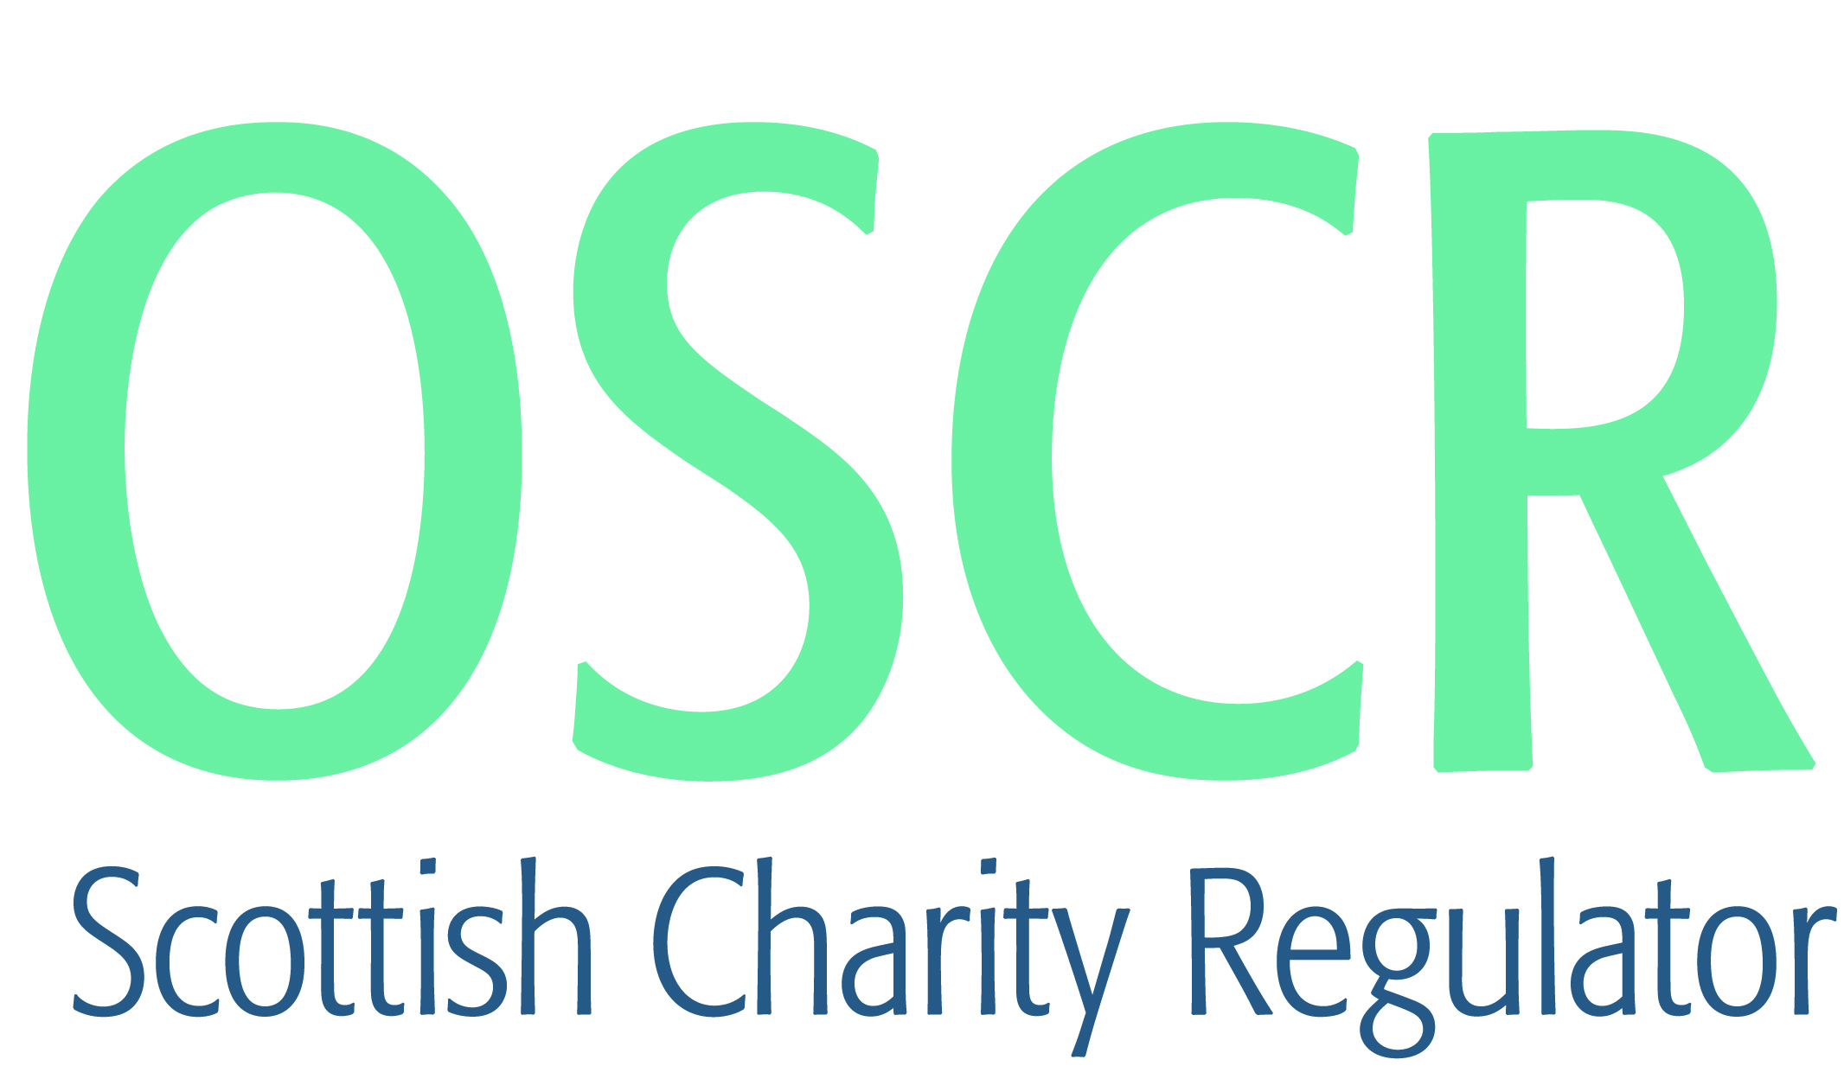

**Charities granted charitable status 1 to 30 April 2019**

|  |  |  |
| --- | --- | --- |
| **Charity Number** | **Charity Name** | **Constitutional Form** |
| [**SC049239**](https://www.oscr.org.uk/search-charity-register/charity-extract/?charitynumber=SC049239) | **134th A City of Edinburgh Brownie Unit** | **Unincorporated Association** |
| [**SC049261**](https://www.oscr.org.uk/search-charity-register/charity-extract/?charitynumber=SC049261) | **175th City of Edinburgh Brownie Unit** | **Unincorporated Association** |
| [**SC049245**](https://www.oscr.org.uk/search-charity-register/charity-extract/?charitynumber=SC049245) | **175th City of Edinburgh Rainbow Unit** | **Unincorporated Association** |
| [**SC049240**](https://www.oscr.org.uk/search-charity-register/charity-extract/?charitynumber=SC049240) | **1st Badenoch & Strathspey Ranger Unit** | **Unincorporated Association** |
| [**SC049250**](https://www.oscr.org.uk/search-charity-register/charity-extract/?charitynumber=SC049250) | **1st Burnside Brownie Unit** | **Unincorporated Association** |
| [**SC049262**](https://www.oscr.org.uk/search-charity-register/charity-extract/?charitynumber=SC049262) | **1st Kingussie Rainbow Unit** | **Unincorporated Association** |
| [**SC049257**](https://www.oscr.org.uk/search-charity-register/charity-extract/?charitynumber=SC049257) | **1st Milton of Leys Brownie Unit** | **Unincorporated Association** |
| [**SC049258**](https://www.oscr.org.uk/search-charity-register/charity-extract/?charitynumber=SC049258) | **1st Milton of Leys Rainbow Unit** | **Unincorporated Association** |
| [**SC049215**](https://www.oscr.org.uk/search-charity-register/charity-extract/?charitynumber=SC049215) | **1st Nairn Brownie Unit** | **Unincorporated Association** |
| [**SC049185**](https://www.oscr.org.uk/search-charity-register/charity-extract/?charitynumber=SC049185) | **20th Perth Guide Unit** | **Unincorporated Association** |
| [**SC049184**](https://www.oscr.org.uk/search-charity-register/charity-extract/?charitynumber=SC049184) | **20th Perth Rainbow Unit** | **Unincorporated Association** |
| [**SC049232**](https://www.oscr.org.uk/search-charity-register/charity-extract/?charitynumber=SC049232) | **2nd Kemnay Brownie Unit** | **Unincorporated Association** |
| [**SC049241**](https://www.oscr.org.uk/search-charity-register/charity-extract/?charitynumber=SC049241) | **3rd Killermont Rainbow Unit** | **Unincorporated Association** |
| [**SC049212**](https://www.oscr.org.uk/search-charity-register/charity-extract/?charitynumber=SC049212) | **4th Arbroath Brownie Unit** | **Unincorporated Association** |
| [**SC049210**](https://www.oscr.org.uk/search-charity-register/charity-extract/?charitynumber=SC049210) | **4th Arbroath Rainbow Unit** | **Unincorporated Association** |
| [**SC049208**](https://www.oscr.org.uk/search-charity-register/charity-extract/?charitynumber=SC049208) | **Al Masaar** | **Unincorporated Association** |
| [**SC049226**](https://www.oscr.org.uk/search-charity-register/charity-extract/?charitynumber=SC049226) | **AYDAP Scotland** | **SCIO** |
| [**SC049231**](https://www.oscr.org.uk/search-charity-register/charity-extract/?charitynumber=SC049231) | **Bo'ness United Community Football Club (BUCFC)** | **SCIO** |
| [**SC049251**](https://www.oscr.org.uk/search-charity-register/charity-extract/?charitynumber=SC049251) | **Caring Internationally** | **Unincorporated Association** |
| [**SC049223**](https://www.oscr.org.uk/search-charity-register/charity-extract/?charitynumber=SC049223) | **Community Foodbank - Skye and Lochalsh** | **Unincorporated Association** |
| [**SC049192**](https://www.oscr.org.uk/search-charity-register/charity-extract/?charitynumber=SC049192) | **Constitution for Scotland** | **SCIO** |
| [**SC049230**](https://www.oscr.org.uk/search-charity-register/charity-extract/?charitynumber=SC049230) | **CR Cats SCIO** | **SCIO** |
| [**SC049189**](https://www.oscr.org.uk/search-charity-register/charity-extract/?charitynumber=SC049189) | **Crail Community Partnership** | **SCIO** |
| [**SC049198**](https://www.oscr.org.uk/search-charity-register/charity-extract/?charitynumber=SC049198) | **Dawson Sports Development Association SCIO** | **SCIO** |
| [**SC049244**](https://www.oscr.org.uk/search-charity-register/charity-extract/?charitynumber=SC049244) | **Depaul UK** | **Company** |
| [**SC049260**](https://www.oscr.org.uk/search-charity-register/charity-extract/?charitynumber=SC049260) | **Dunbar on Air (SCIO)** | **SCIO** |
| [**SC049236**](https://www.oscr.org.uk/search-charity-register/charity-extract/?charitynumber=SC049236) | **Edinburgh Global Partnership SCIO** | **SCIO** |
| [**SC049207**](https://www.oscr.org.uk/search-charity-register/charity-extract/?charitynumber=SC049207) | **Emergency Community Rescue** | **SCIO** |
| [**SC049248**](https://www.oscr.org.uk/search-charity-register/charity-extract/?charitynumber=SC049248) | **Families of Auchinairn Coming Together (SCIO)** | **SCIO** |
| [**SC049191**](https://www.oscr.org.uk/search-charity-register/charity-extract/?charitynumber=SC049191) | **Finderne Development Trust** | **Company** |
| [**SC049224**](https://www.oscr.org.uk/search-charity-register/charity-extract/?charitynumber=SC049224) | **Friends of Luss Church** | **SCIO** |
| [**SC049235**](https://www.oscr.org.uk/search-charity-register/charity-extract/?charitynumber=SC049235) | **Girlguiding Western District** | **Unincorporated Association** |
| [**SC049254**](https://www.oscr.org.uk/search-charity-register/charity-extract/?charitynumber=SC049254) | **Glasgow Deaf Club** | **SCIO** |
| [**SC049205**](https://www.oscr.org.uk/search-charity-register/charity-extract/?charitynumber=SC049205) | **Hawick Ex-Service Association** | **SCIO** |
| [**SC049249**](https://www.oscr.org.uk/search-charity-register/charity-extract/?charitynumber=SC049249) | **Highland Granite Pipes & Drums** | **Unincorporated Association** |
| [**SC049228**](https://www.oscr.org.uk/search-charity-register/charity-extract/?charitynumber=SC049228) | **Historic Hilton Trust (HHT) (SCIO)** | **SCIO** |
| [**SC049218**](https://www.oscr.org.uk/search-charity-register/charity-extract/?charitynumber=SC049218) | **Holyword City Church Glasgow** | **SCIO** |
| [**SC049209**](https://www.oscr.org.uk/search-charity-register/charity-extract/?charitynumber=SC049209) | **I.M.P.A.C.T. FIFE ( inspiring more parents and carers together)** | **Company** |
| [**SC049263**](https://www.oscr.org.uk/search-charity-register/charity-extract/?charitynumber=SC049263) | **Icarus Online SCIO** | **SCIO** |
| [**SC049256**](https://www.oscr.org.uk/search-charity-register/charity-extract/?charitynumber=SC049256) | **Inland Reach-out Networks** | **Unincorporated Association** |
| [**SC049196**](https://www.oscr.org.uk/search-charity-register/charity-extract/?charitynumber=SC049196) | **Inspire Community Music** | **SCIO** |
| [**SC049203**](https://www.oscr.org.uk/search-charity-register/charity-extract/?charitynumber=SC049203) | **Inverness Snowsports Centre** | **Company** |
| [**SC049238**](https://www.oscr.org.uk/search-charity-register/charity-extract/?charitynumber=SC049238) | **Islay Youth Football Club (SCIO)** | **SCIO** |
| [**SC049233**](https://www.oscr.org.uk/search-charity-register/charity-extract/?charitynumber=SC049233) | **Knightswood Baptist Church SCIO** | **SCIO** |
| [**SC049200**](https://www.oscr.org.uk/search-charity-register/charity-extract/?charitynumber=SC049200) | **Lossiemouth Friends of Guiding** | **Unincorporated Association** |
| [**SC049247**](https://www.oscr.org.uk/search-charity-register/charity-extract/?charitynumber=SC049247) | **Make It Happen Club (SCIO)** | **SCIO** |
| [**SC049242**](https://www.oscr.org.uk/search-charity-register/charity-extract/?charitynumber=SC049242) | **Menstrie Community Action Group Ltd** | **Company** |
| [**SC049253**](https://www.oscr.org.uk/search-charity-register/charity-extract/?charitynumber=SC049253) | **Moray Baby Bank** | **SCIO** |
| [**SC049214**](https://www.oscr.org.uk/search-charity-register/charity-extract/?charitynumber=SC049214) | **Nature 4 Health** | **Unincorporated Association** |
| [**SC049259**](https://www.oscr.org.uk/search-charity-register/charity-extract/?charitynumber=SC049259) | **Nunton Steading SCIO** | **SCIO** |
| [**SC049202**](https://www.oscr.org.uk/search-charity-register/charity-extract/?charitynumber=SC049202) | **Obesity UK** | **Company** |
| [**SC049227**](https://www.oscr.org.uk/search-charity-register/charity-extract/?charitynumber=SC049227) | **Opportunities Zambia (SCIO)** | **SCIO** |
| [**SC049216**](https://www.oscr.org.uk/search-charity-register/charity-extract/?charitynumber=SC049216) | **Oxenfoord International SCIO** | **SCIO** |
| [**SC049220**](https://www.oscr.org.uk/search-charity-register/charity-extract/?charitynumber=SC049220) | **Oyne Victoria Hall (SCIO)** | **SCIO** |
| [**SC049193**](https://www.oscr.org.uk/search-charity-register/charity-extract/?charitynumber=SC049193) | **Paisley FM (2017) Limited** | **Company** |
| [**SC049225**](https://www.oscr.org.uk/search-charity-register/charity-extract/?charitynumber=SC049225) | **Paisley Museum Reimagined Ltd** | **Company** |
| [**SC049190**](https://www.oscr.org.uk/search-charity-register/charity-extract/?charitynumber=SC049190) | **Perth Bridge Club** | **SCIO** |
| [**SC049199**](https://www.oscr.org.uk/search-charity-register/charity-extract/?charitynumber=SC049199) | **SAPC Community Sports Hub SCIO** | **SCIO** |
| [**SC049197**](https://www.oscr.org.uk/search-charity-register/charity-extract/?charitynumber=SC049197) | **Scottish Doberman Rescue (SCIO)** | **SCIO** |
| [**SC049206**](https://www.oscr.org.uk/search-charity-register/charity-extract/?charitynumber=SC049206) | **Scottish Documentary Institute** | **Company** |
| [**SC049229**](https://www.oscr.org.uk/search-charity-register/charity-extract/?charitynumber=SC049229) | **Scottish Muslim Education** | **SCIO** |
| [**SC049187**](https://www.oscr.org.uk/search-charity-register/charity-extract/?charitynumber=SC049187) | **Scottish Women Inventing Music (SCIO)** | **SCIO** |
| [**SC049195**](https://www.oscr.org.uk/search-charity-register/charity-extract/?charitynumber=SC049195) | **SEAchange- Slains Environmental Action for change SCIO** | **SCIO** |
| [**SC049222**](https://www.oscr.org.uk/search-charity-register/charity-extract/?charitynumber=SC049222) | **Shetland Indoor Arena Limited** | **Company** |
| [**SC049219**](https://www.oscr.org.uk/search-charity-register/charity-extract/?charitynumber=SC049219) | **Skeld & District Community Hall SCIO** | **SCIO** |
| [**SC049264**](https://www.oscr.org.uk/search-charity-register/charity-extract/?charitynumber=SC049264) | **Someone Else's Addiction (SCIO)** | **SCIO** |
| [**SC049186**](https://www.oscr.org.uk/search-charity-register/charity-extract/?charitynumber=SC049186) | **Special Olympics Grampian Area (SOGA) SCIO** | **SCIO** |
| [**SC049237**](https://www.oscr.org.uk/search-charity-register/charity-extract/?charitynumber=SC049237) | **Stonehouse Men's Shed** | **SCIO** |
| [**SC049234**](https://www.oscr.org.uk/search-charity-register/charity-extract/?charitynumber=SC049234) | **Tartan Ribbon Re-Creations SCIO** | **SCIO** |
| [**SC049225**](https://www.oscr.org.uk/search-charity-register/charity-extract/?charitynumber=SC049225) | **Tayside Dynamos PowerChair Football Club** | **SCIO** |
| [**SC049188**](https://www.oscr.org.uk/search-charity-register/charity-extract/?charitynumber=SC049188) | **The Den@Heartland Kids' Club** | **SCIO** |
| [**SC049252**](https://www.oscr.org.uk/search-charity-register/charity-extract/?charitynumber=SC049252) | **The King's Church (SCIO)** | **SCIO** |
| [**SC049194**](https://www.oscr.org.uk/search-charity-register/charity-extract/?charitynumber=SC049194) | **The Kirk Murdoch Charitable Trust** | **Trust** |
| [**SC049211**](https://www.oscr.org.uk/search-charity-register/charity-extract/?charitynumber=SC049211) | **The Presence Factory** | **Unincorporated Association** |
| [**SC049246**](https://www.oscr.org.uk/search-charity-register/charity-extract/?charitynumber=SC049246) | **The River of Life Church (Dumfries)** | **SCIO** |
| [**SC049201**](https://www.oscr.org.uk/search-charity-register/charity-extract/?charitynumber=SC049201) | **The Sally Grant Care Trust** | **SCIO** |
| [**SC049221**](https://www.oscr.org.uk/search-charity-register/charity-extract/?charitynumber=SC049221) | **The Tingwall Agricultural Museum and Heritage Centre SCIO** | **SCIO** |
| [**SC049217**](https://www.oscr.org.uk/search-charity-register/charity-extract/?charitynumber=SC049217) | **The Women's Fund for Scotland** | **SCIO** |
| [**SC049213**](https://www.oscr.org.uk/search-charity-register/charity-extract/?charitynumber=SC049213) | **Ullapool Sea Savers SCIO** | **SCIO** |
| [**SC049204**](https://www.oscr.org.uk/search-charity-register/charity-extract/?charitynumber=SC049204) | **West Fife Islamic Education and Welfare Centre Ltd** | **Company** |
| [**SC049243**](https://www.oscr.org.uk/search-charity-register/charity-extract/?charitynumber=SC049243) | **Westhill and District Public Hall SCIO** | **SCIO** |