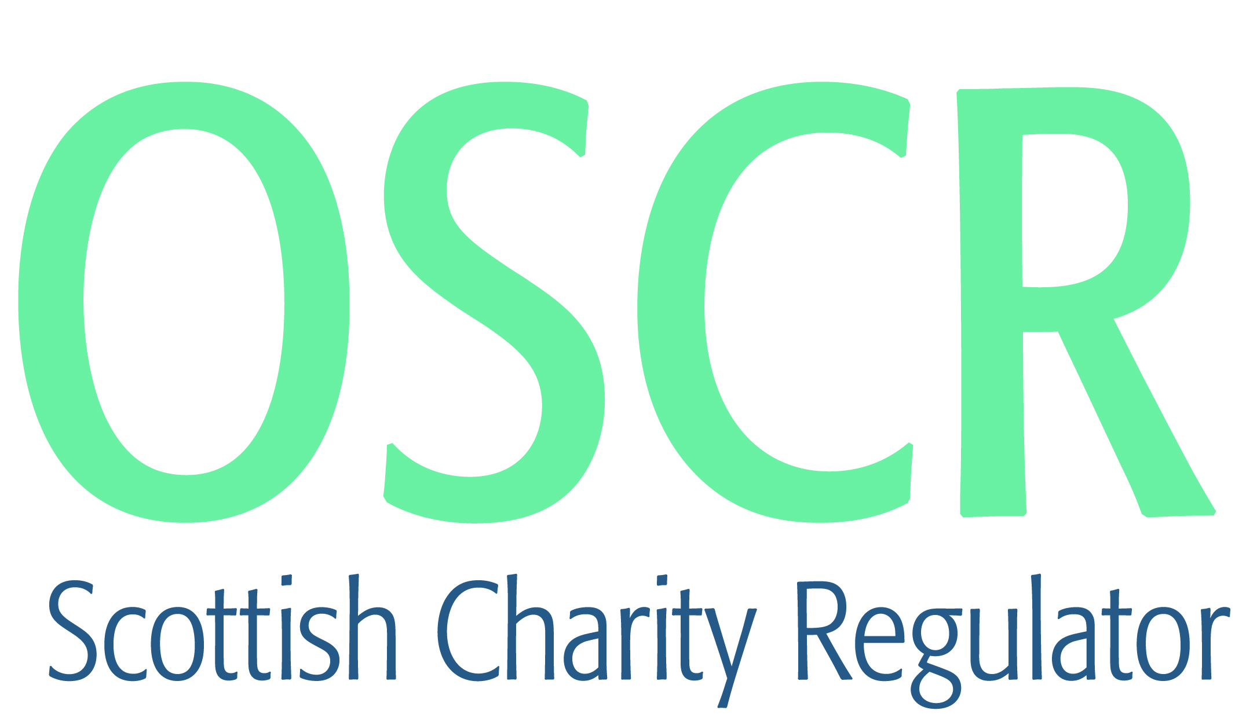

**Charities granted charitable status 1 to 31 October 2018**

|  |  |  |
| --- | --- | --- |
| **Charity Number** | **Charity Name** | **Constitutional Form** |
|  |  |  |
| [**SC048736**](https://www.oscr.org.uk/search-charity-register/charity-extract/?charitynumber=SC048736) | **10th Inverness Boys Brigade** | **Unincorporated Association** |
| [**SC048765**](https://www.oscr.org.uk/search-charity-register/charity-extract/?charitynumber=SC048765) | **1st Inverness Rainbow Unit** | **Unincorporated Association** |
| [**SC048767**](https://www.oscr.org.uk/search-charity-register/charity-extract/?charitynumber=SC048767) | **1st Lhanbryde and Urquhart Senior Section Unit** | **Unincorporated Association** |
| [**SC048745**](https://www.oscr.org.uk/search-charity-register/charity-extract/?charitynumber=SC048745) | **1st Orwell Senior Section Unit** | **Unincorporated Association** |
| [**SC048748**](https://www.oscr.org.uk/search-charity-register/charity-extract/?charitynumber=SC048748) | **1st Step Development Ventures SCIO** | **SCIO** |
| [**SC048746**](https://www.oscr.org.uk/search-charity-register/charity-extract/?charitynumber=SC048746) | **1st Strathaven Brownie Unit** | **Unincorporated Association** |
| [**SC048787**](https://www.oscr.org.uk/search-charity-register/charity-extract/?charitynumber=SC048787) | **1st Winchburgh Brownie Unit** | **Unincorporated Association** |
| [**SC048768**](https://www.oscr.org.uk/search-charity-register/charity-extract/?charitynumber=SC048768) | **20th Perth Brownie Unit** | **Unincorporated Association** |
| [**SC048766**](https://www.oscr.org.uk/search-charity-register/charity-extract/?charitynumber=SC048766) | **3rd Alford Brownie Unit** | **Unincorporated Association** |
| [**SC048744**](https://www.oscr.org.uk/search-charity-register/charity-extract/?charitynumber=SC048744) | **4th Stepps Brownie Unit** | **Unincorporated Association** |
| [**SC048788**](https://www.oscr.org.uk/search-charity-register/charity-extract/?charitynumber=SC048788) | **AberNecessities SCIO** | **SCIO** |
| [**SC048769**](https://www.oscr.org.uk/search-charity-register/charity-extract/?charitynumber=SC048769) | **AL-NOOR CAMBUSLAND COMMUNITY CENTRE** | **SCIO** |
| [**SC048760**](https://www.oscr.org.uk/search-charity-register/charity-extract/?charitynumber=SC048760) | **Archway Charitable Trust** | **SCIO** |
| [**SC048749**](https://www.oscr.org.uk/search-charity-register/charity-extract/?charitynumber=SC048749) | **Belarusian International Public Charitable Organisation - Helping Hands- British Branch** | **Unincorporated Association** |
| [**SC048752**](https://www.oscr.org.uk/search-charity-register/charity-extract/?charitynumber=SC048752) | **Bethlehem Care and Hospice Trust** | **Trust** |
| [**SC048789**](https://www.oscr.org.uk/search-charity-register/charity-extract/?charitynumber=SC048789) | **Boddam Recreation Trust SCIO** | **SCIO** |
| [**SC048797**](https://www.oscr.org.uk/search-charity-register/charity-extract/?charitynumber=SC048797) | **Chernobyl's Angels of Hope** | **Unincorporated Association** |
| [**SC048772**](https://www.oscr.org.uk/search-charity-register/charity-extract/?charitynumber=SC048772) | **Cluny School Fund** | **Unincorporated Association** |
| [**SC048759**](https://www.oscr.org.uk/search-charity-register/charity-extract/?charitynumber=SC048759) | **Comboni Missionary Sisters CIO** | **CIO** |
| [**SC048796**](https://www.oscr.org.uk/search-charity-register/charity-extract/?charitynumber=SC048796) | **Dalwhinnie Community Development Trust** | **SCIO** |
| [**SC048762**](https://www.oscr.org.uk/search-charity-register/charity-extract/?charitynumber=SC048762) | **Dufftown Kids Cabin** | **SCIO** |
| [**SC048738**](https://www.oscr.org.uk/search-charity-register/charity-extract/?charitynumber=SC048738) | **Dundee & Angus Advice Centre for Europeans** | **SCIO** |
| [**SC048747**](https://www.oscr.org.uk/search-charity-register/charity-extract/?charitynumber=SC048747) | **Dundee Madsons Basketball Club** | **SCIO** |
| [**SC048735**](https://www.oscr.org.uk/search-charity-register/charity-extract/?charitynumber=SC048735) | **Dundonald Community Sports, Recreation and Heritage Association** | **SCIO** |
| [**SC048798**](https://www.oscr.org.uk/search-charity-register/charity-extract/?charitynumber=SC048798) | **Dunfermline Reign Basketball Club** | **SCIO** |
| [**SC048792**](https://www.oscr.org.uk/search-charity-register/charity-extract/?charitynumber=SC048792) | **Glasgow Minds** | **Unincorporated Association** |
| [**SC048781**](https://www.oscr.org.uk/search-charity-register/charity-extract/?charitynumber=SC048781) | **Glenriddell Hall Committee** | **Unincorporated Association** |
| [**SC048782**](https://www.oscr.org.uk/search-charity-register/charity-extract/?charitynumber=SC048782) | **Hawick Cycling Club** | **SCIO** |
| [**SC048779**](https://www.oscr.org.uk/search-charity-register/charity-extract/?charitynumber=SC048779) | **Heads Up Mid Argyll** | **SCIO** |
| [**SC048784**](https://www.oscr.org.uk/search-charity-register/charity-extract/?charitynumber=SC048784) | **Healing for the Heart SCIO** | **SCIO** |
| [**SC048794**](https://www.oscr.org.uk/search-charity-register/charity-extract/?charitynumber=SC048794) | **Jung Shim** | **Company** |
| [**SC048757**](https://www.oscr.org.uk/search-charity-register/charity-extract/?charitynumber=SC048757) | **Lady Flora Hastings Trust** | **SCIO** |
| [**SC048763**](https://www.oscr.org.uk/search-charity-register/charity-extract/?charitynumber=SC048763) | **Levern Valley Defibrillator Community Partnership (SCIO)** | **SCIO** |
| [**SC048778**](https://www.oscr.org.uk/search-charity-register/charity-extract/?charitynumber=SC048778) | **Life Changing Ministries International Church South Cheshire Trust** | **Trust** |
| [**SC048780**](https://www.oscr.org.uk/search-charity-register/charity-extract/?charitynumber=SC048780) | **Mallaig & District Newspaper SCIO** | **SCIO** |
| [**SC048777**](https://www.oscr.org.uk/search-charity-register/charity-extract/?charitynumber=SC048777) | **Marie Collins Foundation** | **Company** |
| [**SC048761**](https://www.oscr.org.uk/search-charity-register/charity-extract/?charitynumber=SC048761) | **New Cumnock Development Trust** | **Company** |
| [**SC048791**](https://www.oscr.org.uk/search-charity-register/charity-extract/?charitynumber=SC048791) | **North Highlands Refuge** | **Company** |
| [**SC048764**](https://www.oscr.org.uk/search-charity-register/charity-extract/?charitynumber=SC048764) | **OutPost Arts** | **SCIO** |
| [**SC048741**](https://www.oscr.org.uk/search-charity-register/charity-extract/?charitynumber=SC048741) | **Papdale East Play Park Association (PEPA)** | **SCIO** |
| [**SC048785**](https://www.oscr.org.uk/search-charity-register/charity-extract/?charitynumber=SC048785) | **Refresh Community Church** | **SCIO** |
| [**SC048775**](https://www.oscr.org.uk/search-charity-register/charity-extract/?charitynumber=SC048775) | **Rising Sun Healing and Spiritual Centre** | **SCIO** |
| [**SC048758**](https://www.oscr.org.uk/search-charity-register/charity-extract/?charitynumber=SC048758) | **Road to The Isles Facilities Group SCIO** | **SCIO** |
| [**SC048795**](https://www.oscr.org.uk/search-charity-register/charity-extract/?charitynumber=SC048795) | **Royal British Legion Industries Ltd** | **Company** |
| [**SC048790**](https://www.oscr.org.uk/search-charity-register/charity-extract/?charitynumber=SC048790) | **Sarbat Da Bhala** | **SCIO** |
| [**SC048771**](https://www.oscr.org.uk/search-charity-register/charity-extract/?charitynumber=SC048771) | **Small Scales Reptile Rescue** | **SCIO** |
| [**SC048793**](https://www.oscr.org.uk/search-charity-register/charity-extract/?charitynumber=SC048793) | **South Community Recovery Network SCIO** | **SCIO** |
| [**SC048750**](https://www.oscr.org.uk/search-charity-register/charity-extract/?charitynumber=SC048750) | **St Peters Football Club** | **SCIO** |
| [**SC048737**](https://www.oscr.org.uk/search-charity-register/charity-extract/?charitynumber=SC048737) | **Stewarton Tennis and Sports Club** | **SCIO** |
| [**SC048756**](https://www.oscr.org.uk/search-charity-register/charity-extract/?charitynumber=SC048756) | **Street Soccer (Scotland) Limited** | **Company** |
| [**SC048776**](https://www.oscr.org.uk/search-charity-register/charity-extract/?charitynumber=SC048776) | **Tergar Edinburgh** | **SCIO** |
| [**SC048774**](https://www.oscr.org.uk/search-charity-register/charity-extract/?charitynumber=SC048774) | **The Brilliant Club** | **Company** |
| [**SC048755**](https://www.oscr.org.uk/search-charity-register/charity-extract/?charitynumber=SC048755) | **The Cats Whiskers** | **SCIO** |
| [**SC048742**](https://www.oscr.org.uk/search-charity-register/charity-extract/?charitynumber=SC048742) | **The Light Beam Foundation** | **SCIO** |
| [**SC048753**](https://www.oscr.org.uk/search-charity-register/charity-extract/?charitynumber=SC048753) | **The Living Room Project SCIO** | **SCIO** |
| [**SC048739**](https://www.oscr.org.uk/search-charity-register/charity-extract/?charitynumber=SC048739) | **The Night With** | **SCIO** |
| [**SC048783**](https://www.oscr.org.uk/search-charity-register/charity-extract/?charitynumber=SC048783) | **The Pine Project** | **SCIO** |
| [**SC048770**](https://www.oscr.org.uk/search-charity-register/charity-extract/?charitynumber=SC048770) | **The Redeemed Christian Church of God - In HIS Presence** | **Unincorporated Association** |
| [**SC048786**](https://www.oscr.org.uk/search-charity-register/charity-extract/?charitynumber=SC048786) | **The Romanian Community Centre in Edinburgh** | **SCIO** |
| [**SC048751**](https://www.oscr.org.uk/search-charity-register/charity-extract/?charitynumber=SC048751) | **The William Laidlaw Memorial Hall** | **Trust** |
| [**SC048773**](https://www.oscr.org.uk/search-charity-register/charity-extract/?charitynumber=SC048773) | **Thistle Boxer Rescue** | **Trust** |
| [**SC048740**](https://www.oscr.org.uk/search-charity-register/charity-extract/?charitynumber=SC048740) | **Villa Park Football Club (SCIO)** | **SCIO** |
| [**SC048743**](https://www.oscr.org.uk/search-charity-register/charity-extract/?charitynumber=SC048743) | **Yes I Can Foundation** | **Unincorporated Association** |
| [**SC048754**](https://www.oscr.org.uk/search-charity-register/charity-extract/?charitynumber=SC048754) | **Youth Initiatives Scotland (SCIO)** | **SCIO** |