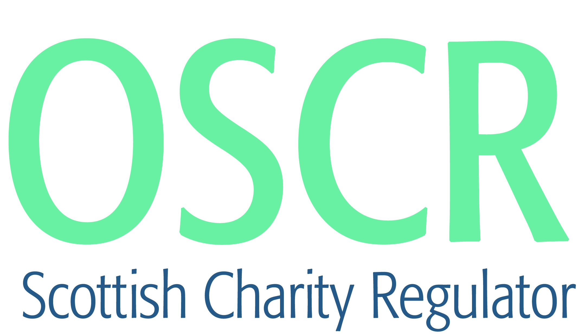

**Charities granted charitable status 1 to 30 September 2018**

|  |  |  |
| --- | --- | --- |
| **Charity Number** | **Charity Name** | **Constitutional Form** |
| [**SC048705**](https://www.oscr.org.uk/search-charity-register/charity-extract/?charitynumber=SC048705) | **198th City of Edinburgh Brownie Unit** | **Unincorporated Association** |
| [**SC048682**](https://www.oscr.org.uk/search-charity-register/charity-extract/?charitynumber=SC048682) | **2nd Bothwell Rainbow Unit** | **Unincorporated Association** |
| [**SC048687**](https://www.oscr.org.uk/search-charity-register/charity-extract/?charitynumber=SC048687) | **2nd Elgin Brownie Unit** | **Unincorporated Association** |
| [**SC048718**](https://www.oscr.org.uk/search-charity-register/charity-extract/?charitynumber=SC048718) | **3rd Bridge of Allan Brownie Unit** | **Unincorporated Association** |
| [**SC048683**](https://www.oscr.org.uk/search-charity-register/charity-extract/?charitynumber=SC048683) | **5th Alness Brownies** | **Unincorporated Association** |
| [**SC048730**](https://www.oscr.org.uk/search-charity-register/charity-extract/?charitynumber=SC048730) | **Admiral Ramsay Museum (SCIO)** | **SCIO** |
| [**SC048698**](https://www.oscr.org.uk/search-charity-register/charity-extract/?charitynumber=SC048698) | **Advie Hall and Children's Fund** | **SCIO** |
| [**SC048679**](https://www.oscr.org.uk/search-charity-register/charity-extract/?charitynumber=SC048679) | **Agrigento SCIO** | **SCIO** |
| [**SC048689**](https://www.oscr.org.uk/search-charity-register/charity-extract/?charitynumber=SC048689) | **Alva Development Trust** | **Company** |
| [**SC048728**](https://www.oscr.org.uk/search-charity-register/charity-extract/?charitynumber=SC048728) | **Assumption Studios** | **Company** |
| [**SC048684**](https://www.oscr.org.uk/search-charity-register/charity-extract/?charitynumber=SC048684) | **Baltic Street Adventure Playground SCIO** | **SCIO** |
| [**SC048721**](https://www.oscr.org.uk/search-charity-register/charity-extract/?charitynumber=SC048721) | **Buckie Community Theatre (SCIO)** | **SCIO** |
| [**SC048734**](https://www.oscr.org.uk/search-charity-register/charity-extract/?charitynumber=SC048734) | **Carefree Kids East Lothian** | **SCIO** |
| [**SC048704**](https://www.oscr.org.uk/search-charity-register/charity-extract/?charitynumber=SC048704) | **Cawdor and West Nairnshire Community Benefit Organisation (SCIO)** | **SCIO** |
| [**SC048700**](https://www.oscr.org.uk/search-charity-register/charity-extract/?charitynumber=SC048700) | **Chickens Unchained Rescue Sanctuary** | **SCIO** |
| [**SC048680**](https://www.oscr.org.uk/search-charity-register/charity-extract/?charitynumber=SC048680) | **Church of Scotland Presbytery of Hamilton** | **Unincorporated Association** |
| [**SC048715**](https://www.oscr.org.uk/search-charity-register/charity-extract/?charitynumber=SC048715) | **City Hearts Aberdeen** | **SCIO** |
| [**SC048720**](https://www.oscr.org.uk/search-charity-register/charity-extract/?charitynumber=SC048720) | **Cultivate Aberdeen SCIO** | **SCIO** |
| [**SC048722**](https://www.oscr.org.uk/search-charity-register/charity-extract/?charitynumber=SC048722) | **Disability Sport Fife (SCIO)** | **SCIO** |
| [**SC048711**](https://www.oscr.org.uk/search-charity-register/charity-extract/?charitynumber=SC048711) | **Drummond Charity Works Africa** | **SCIO** |
| [**SC048672**](https://www.oscr.org.uk/search-charity-register/charity-extract/?charitynumber=SC048672) | **dsdfamilies** | **CIO** |
| [**SC048691**](https://www.oscr.org.uk/search-charity-register/charity-extract/?charitynumber=SC048691) | **Dundee Funeral Support Services** | **SCIO** |
| [**SC048725**](https://www.oscr.org.uk/search-charity-register/charity-extract/?charitynumber=SC048725) | **Dunkeld and Birnam Sport and Leisure Hub** | **SCIO** |
| [**SC048693**](https://www.oscr.org.uk/search-charity-register/charity-extract/?charitynumber=SC048693) | **Edinburgh Athletic Club (SCIO)** | **SCIO** |
| [**SC048712**](https://www.oscr.org.uk/search-charity-register/charity-extract/?charitynumber=SC048712) | **Float Trust SCIO** | **SCIO** |
| [**SC048701**](https://www.oscr.org.uk/search-charity-register/charity-extract/?charitynumber=SC048701) | **Forth Valley Men's Shed** | **SCIO** |
| [**SC048727**](https://www.oscr.org.uk/search-charity-register/charity-extract/?charitynumber=SC048727) | **Friends of Velemegna** | **Trust** |
| [**SC048714**](https://www.oscr.org.uk/search-charity-register/charity-extract/?charitynumber=SC048714) | **Glengarnock Ironworks Bowling and Community Club** | **SCIO** |
| [**SC048719**](https://www.oscr.org.uk/search-charity-register/charity-extract/?charitynumber=SC048719) | **Hilton Family Support** | **SCIO** |
| [**SC048709**](https://www.oscr.org.uk/search-charity-register/charity-extract/?charitynumber=SC048709) | **Inverness Canoe Club** | **SCIO** |
| [**SC048716**](https://www.oscr.org.uk/search-charity-register/charity-extract/?charitynumber=SC048716) | **John O'Groats Development Trust** | **SCIO** |
| [**SC048697**](https://www.oscr.org.uk/search-charity-register/charity-extract/?charitynumber=SC048697) | **Kilsyth Community Church SCIO** | **SCIO** |
| [**SC048692**](https://www.oscr.org.uk/search-charity-register/charity-extract/?charitynumber=SC048692) | **Lyme Disease GNHCT Scotland** | **SCIO** |
| [**SC048696**](https://www.oscr.org.uk/search-charity-register/charity-extract/?charitynumber=SC048696) | **M:ADE (Moray: Arts Development Engagement) SCIO** | **SCIO** |
| [**SC048676**](https://www.oscr.org.uk/search-charity-register/charity-extract/?charitynumber=SC048676) | **Midmar School Fund** | **Unincorporated Association** |
| [**SC048723**](https://www.oscr.org.uk/search-charity-register/charity-extract/?charitynumber=SC048723) | **Museum of Islay Life/Taigh-tasgaidh Muinntir Ìle** | **SCIO** |
| [**SC048733**](https://www.oscr.org.uk/search-charity-register/charity-extract/?charitynumber=SC048733) | **Open Sports Academy (SCIO)** | **SCIO** |
| [**SC048677**](https://www.oscr.org.uk/search-charity-register/charity-extract/?charitynumber=SC048677) | **Our Community Kitchen** | **SCIO** |
| [**SC048695**](https://www.oscr.org.uk/search-charity-register/charity-extract/?charitynumber=SC048695) | **Paws for Autism** | **SCIO** |
| [**SC048717**](https://www.oscr.org.uk/search-charity-register/charity-extract/?charitynumber=SC048717) | **Pro-Start Football Academy SCIO** | **SCIO** |
| [**SC048706**](https://www.oscr.org.uk/search-charity-register/charity-extract/?charitynumber=SC048706) | **Reynolds Memorial Hospital SCIO** | **SCIO** |
| [**SC048688**](https://www.oscr.org.uk/search-charity-register/charity-extract/?charitynumber=SC048688) | **Rosyth Community Projects Ltd** | **Company** |
| [**SC048673**](https://www.oscr.org.uk/search-charity-register/charity-extract/?charitynumber=SC048673) | **Rwanda Scotland Alliance SCIO** | **SCIO** |
| [**SC048707**](https://www.oscr.org.uk/search-charity-register/charity-extract/?charitynumber=SC048707) | **SABASH** | **Unincorporated Association** |
| [**SC048732**](https://www.oscr.org.uk/search-charity-register/charity-extract/?charitynumber=SC048732) | **Seafarers Memorial Group** | **Unincorporated Association** |
| [**SC048690**](https://www.oscr.org.uk/search-charity-register/charity-extract/?charitynumber=SC048690) | **Search and Rescue Dog Association Scotland (SCIO)** | **SCIO** |
| [**SC048681**](https://www.oscr.org.uk/search-charity-register/charity-extract/?charitynumber=SC048681) | **Selkirk Community Shed** | **SCIO** |
| [**SC048703**](https://www.oscr.org.uk/search-charity-register/charity-extract/?charitynumber=SC048703) | **Sporting Force Limited** | **Company** |
| [**SC048694**](https://www.oscr.org.uk/search-charity-register/charity-extract/?charitynumber=SC048694) | **Stardom International Christian Centre (SICC) Scotland** | **Unincorporated Association** |
| [**SC048708**](https://www.oscr.org.uk/search-charity-register/charity-extract/?charitynumber=SC048708) | **The Aarskog Foundation Ltd** | **SCIO** |
| [**SC048699**](https://www.oscr.org.uk/search-charity-register/charity-extract/?charitynumber=SC048699) | **The CHAMP Trust** | **Trust** |
| [**SC048726**](https://www.oscr.org.uk/search-charity-register/charity-extract/?charitynumber=SC048726) | **The Chartered Institute of Building Benevolent Fund** | **Company** |
| [**SC048731**](https://www.oscr.org.uk/search-charity-register/charity-extract/?charitynumber=SC048731) | **The Dean Hatchery & Habitat Trust (SCIO)** | **SCIO** |
| [**SC048702**](https://www.oscr.org.uk/search-charity-register/charity-extract/?charitynumber=SC048702) | **The Haddington Garden Trust SCIO** | **SCIO** |
| [**SC048678**](https://www.oscr.org.uk/search-charity-register/charity-extract/?charitynumber=SC048678) | **The National Emergency Services Memorial** | **Unincorporated Association** |
| [**SC048686**](https://www.oscr.org.uk/search-charity-register/charity-extract/?charitynumber=SC048686) | **The Ribbon of Wildness Group SCIO** | **SCIO** |
| [**SC048710**](https://www.oscr.org.uk/search-charity-register/charity-extract/?charitynumber=SC048710) | **The Stone Church Aberdeen (SCIO)** | **SCIO** |
| [**SC048685**](https://www.oscr.org.uk/search-charity-register/charity-extract/?charitynumber=SC048685) | **The Trustees of the Legion of Mary in Scotland** | **Trust** |
| [**SC048713**](https://www.oscr.org.uk/search-charity-register/charity-extract/?charitynumber=SC048713) | **Time for Inclusive Education** | **SCIO** |
| [**SC048729**](https://www.oscr.org.uk/search-charity-register/charity-extract/?charitynumber=SC048729) | **Torrance Tennis Club SCIO** | **SCIO** |
| [**SC048675**](https://www.oscr.org.uk/search-charity-register/charity-extract/?charitynumber=SC048675) | **Triple Tap Tech** | **Company** |
| [**SC048724**](https://www.oscr.org.uk/search-charity-register/charity-extract/?charitynumber=SC048724) | **Western Isles Women's Aid SCIO** | **SCIO** |