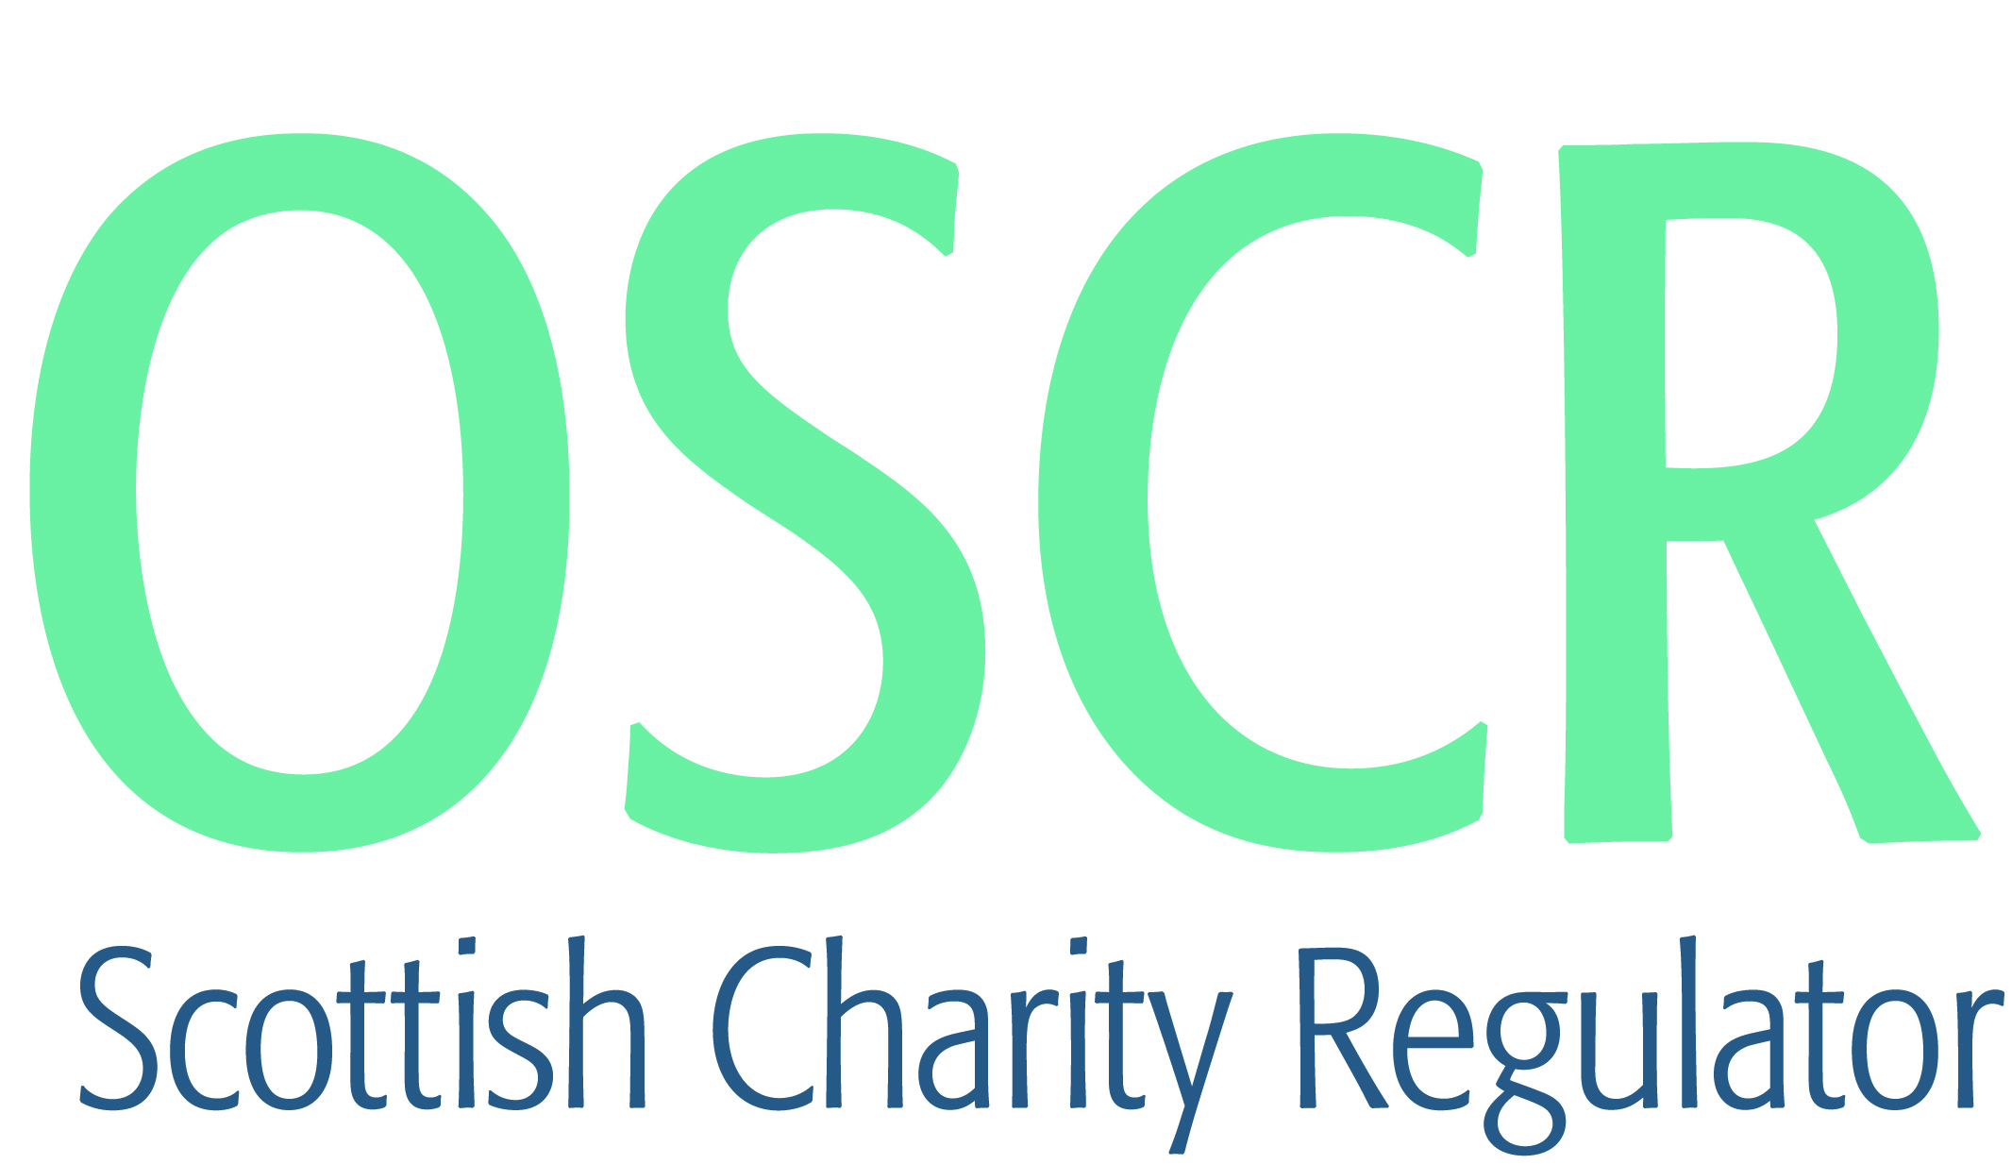

**Charities granted charitable status 1 to 31 July 2018**

|  |  |  |
| --- | --- | --- |
| **Charity Number** | **Charity Name** | **Constitutional Form** |
| [**SC048544**](https://www.oscr.org.uk/search-charity-register/charity-extract/?charitynumber=SC048544) | **1st and 2nd Williamwood Rainbow Unit** | **Unincorporated Association** |
| [**SC048562**](https://www.oscr.org.uk/search-charity-register/charity-extract/?charitynumber=SC048562) | **1st Cornhill Senior Section Unit** | **Unincorporated Association** |
| [**SC048579**](https://www.oscr.org.uk/search-charity-register/charity-extract/?charitynumber=SC048579) | **Aberchirder & District Community Association SCIO** | **SCIO** |
| [**SC048576**](https://www.oscr.org.uk/search-charity-register/charity-extract/?charitynumber=SC048576) | **Aberdeen Multicultural Centre SCIO** | **SCIO** |
| [**SC048549**](https://www.oscr.org.uk/search-charity-register/charity-extract/?charitynumber=SC048549) | **Action Against Age Related Macular Degeneration** | **CIO** |
| [**SC048534**](https://www.oscr.org.uk/search-charity-register/charity-extract/?charitynumber=SC048534) | **Active Life Club (ALC) SCIO** | **SCIO** |
| [**SC048573**](https://www.oscr.org.uk/search-charity-register/charity-extract/?charitynumber=SC048573) | **AKG Charitable Trust** | **SCIO** |
| [**SC048558**](https://www.oscr.org.uk/search-charity-register/charity-extract/?charitynumber=SC048558) | **Allanton Village Hall** | **SCIO** |
| [**SC048521**](https://www.oscr.org.uk/search-charity-register/charity-extract/?charitynumber=SC048521) | **Angus Upcycling Project SCIO** | **SCIO** |
| [**SC048510**](https://www.oscr.org.uk/search-charity-register/charity-extract/?charitynumber=SC048510) | **AOG Central Fraserburgh** | **SCIO** |
| [**SC048505**](https://www.oscr.org.uk/search-charity-register/charity-extract/?charitynumber=SC048505) | **Arngask Hall** | **SCIO** |
| [**SC048587**](https://www.oscr.org.uk/search-charity-register/charity-extract/?charitynumber=SC048587) | **Ayr & District Beekeepers' Association** | **SCIO** |
| [**SC048588**](https://www.oscr.org.uk/search-charity-register/charity-extract/?charitynumber=SC048588) | **Ayr Storm Basketball Club** | **SCIO** |
| [**SC048572**](https://www.oscr.org.uk/search-charity-register/charity-extract/?charitynumber=SC048572) | **Bannockburn & Eastern Villages Community Hub** | **SCIO** |
| [**SC048537**](https://www.oscr.org.uk/search-charity-register/charity-extract/?charitynumber=SC048537) | **Beacon Rhythmic Gymnastics SCIO** | **SCIO** |
| [**SC048569**](https://www.oscr.org.uk/search-charity-register/charity-extract/?charitynumber=SC048569) | **Beauty with a Conscience** | **SCIO** |
| [**SC048513**](https://www.oscr.org.uk/search-charity-register/charity-extract/?charitynumber=SC048513) | **Beveridge Park Bowling Club** | **SCIO** |
| [**SC048516**](https://www.oscr.org.uk/search-charity-register/charity-extract/?charitynumber=SC048516) | **Blacklaw Out of School Care** | **SCIO** |
| [**SC048511**](https://www.oscr.org.uk/search-charity-register/charity-extract/?charitynumber=SC048511) | **Bookends SCIO** | **SCIO** |
| [**SC048574**](https://www.oscr.org.uk/search-charity-register/charity-extract/?charitynumber=SC048574) | **Campsie Football Club** | **Unincorporated Association** |
| [**SC048520**](https://www.oscr.org.uk/search-charity-register/charity-extract/?charitynumber=SC048520) | **Carnoustie Memories** | **Unincorporated Association** |
| [**SC048585**](https://www.oscr.org.uk/search-charity-register/charity-extract/?charitynumber=SC048585) | **Clever-hands Junior Science Group** | **Unincorporated Association** |
| [**SC048571**](https://www.oscr.org.uk/search-charity-register/charity-extract/?charitynumber=SC048571) | **Colony Park Football Club** | **SCIO** |
| [**SC048581**](https://www.oscr.org.uk/search-charity-register/charity-extract/?charitynumber=SC048581) | **Community Mental Wellbeing Support SCIO** | **SCIO** |
| [**SC048551**](https://www.oscr.org.uk/search-charity-register/charity-extract/?charitynumber=SC048551) | **Cultural Awareness & Integration Group (CAIG)** | **Unincorporated Association** |
| [**SC048538**](https://www.oscr.org.uk/search-charity-register/charity-extract/?charitynumber=SC048538) | **Dementia Friendly Prestwick** | **SCIO** |
| [**SC048564**](https://www.oscr.org.uk/search-charity-register/charity-extract/?charitynumber=SC048564) | **Diggin' Ayrshire** | **SCIO** |
| [**SC048556**](https://www.oscr.org.uk/search-charity-register/charity-extract/?charitynumber=SC048556) | **Dundee Spinners' Trust** | **SCIO** |
| [**SC048550**](https://www.oscr.org.uk/search-charity-register/charity-extract/?charitynumber=SC048550) | **Dunfermline Athletic Disabled Supporters' Club** | **SCIO** |
| [**SC048548**](https://www.oscr.org.uk/search-charity-register/charity-extract/?charitynumber=SC048548) | **Eat Up** | **Unincorporated Association** |
| [**SC048553**](https://www.oscr.org.uk/search-charity-register/charity-extract/?charitynumber=SC048553) | **Elder Voice (Blairgowrie & Rattray)** | **Unincorporated Association** |
| [**SC048530**](https://www.oscr.org.uk/search-charity-register/charity-extract/?charitynumber=SC048530) | **Fairview School Parent Council** | **SCIO** |
| [**SC048559**](https://www.oscr.org.uk/search-charity-register/charity-extract/?charitynumber=SC048559) | **FC BRAVE EAGLES** | **SCIO** |
| [**SC048518**](https://www.oscr.org.uk/search-charity-register/charity-extract/?charitynumber=SC048518) | **Foulden & Mordington King George V Memorial Playing Field Association.** | **Unincorporated Association** |
| [**SC048545**](https://www.oscr.org.uk/search-charity-register/charity-extract/?charitynumber=SC048545) | **George & Nellie Whyte Charitable Trust** | **Trust** |
| [**SC048536**](https://www.oscr.org.uk/search-charity-register/charity-extract/?charitynumber=SC048536) | **Glen Brittle Memorial Hut SCIO** | **SCIO** |
| [**SC048539**](https://www.oscr.org.uk/search-charity-register/charity-extract/?charitynumber=SC048539) | **Helping Hand G78** | **SCIO** |
| [**SC048577**](https://www.oscr.org.uk/search-charity-register/charity-extract/?charitynumber=SC048577) | **Inverness Gymnastics Club** | **SCIO** |
| [**SC048523**](https://www.oscr.org.uk/search-charity-register/charity-extract/?charitynumber=SC048523) | **Kids Operating Room** | **Company** |
| [**SC048517**](https://www.oscr.org.uk/search-charity-register/charity-extract/?charitynumber=SC048517) | **Kirkbean Village Hall Management Committee** | **Trust** |
| [**SC048514**](https://www.oscr.org.uk/search-charity-register/charity-extract/?charitynumber=SC048514) | **Laggan Community Hall** | **SCIO** |
| [**SC048560**](https://www.oscr.org.uk/search-charity-register/charity-extract/?charitynumber=SC048560) | **Lanarkshire Deaf Club SCIO** | **SCIO** |
| [**SC048542**](https://www.oscr.org.uk/search-charity-register/charity-extract/?charitynumber=SC048542) | **Larkhall Amateur Boxing Club** | **SCIO** |
| [**SC048583**](https://www.oscr.org.uk/search-charity-register/charity-extract/?charitynumber=SC048583) | **Linlithgow Peace Garden** | **SCIO** |
| [**SC048580**](https://www.oscr.org.uk/search-charity-register/charity-extract/?charitynumber=SC048580) | **Midlothian Foodbank (SCIO)** | **SCIO** |
| [**SC048570**](https://www.oscr.org.uk/search-charity-register/charity-extract/?charitynumber=SC048570) | **Musselburgh Windsor Community Football Club** | **SCIO** |
| [**SC048535**](https://www.oscr.org.uk/search-charity-register/charity-extract/?charitynumber=SC048535) | **Pegasus Vaulting Group (SCIO)** | **SCIO** |
| [**SC048512**](https://www.oscr.org.uk/search-charity-register/charity-extract/?charitynumber=SC048512) | **Perth Road Runners** | **SCIO** |
| [**SC048524**](https://www.oscr.org.uk/search-charity-register/charity-extract/?charitynumber=SC048524) | **Poldrate Arts and Crafts Centre SCIO** | **SCIO** |
| [**SC048508**](https://www.oscr.org.uk/search-charity-register/charity-extract/?charitynumber=SC048508) | **Sanquhar Town Hall SCIO** | **SCIO** |
| [**SC048561**](https://www.oscr.org.uk/search-charity-register/charity-extract/?charitynumber=SC048561) | **Save A Life, Feed The Poor** | **Unincorporated Association** |
| [**SC048519**](https://www.oscr.org.uk/search-charity-register/charity-extract/?charitynumber=SC048519) | **Search and Rescue Aerial Association - Scotland** | **SCIO** |
| [**SC048532**](https://www.oscr.org.uk/search-charity-register/charity-extract/?charitynumber=SC048532) | **Shetland Rape Crisis** | **SCIO** |
| [**SC048565**](https://www.oscr.org.uk/search-charity-register/charity-extract/?charitynumber=SC048565) | **Shiskine Public Hall Community SCIO** | **SCIO** |
| [**SC048531**](https://www.oscr.org.uk/search-charity-register/charity-extract/?charitynumber=SC048531) | **Spring Back** | **SCIO** |
| [**SC048554**](https://www.oscr.org.uk/search-charity-register/charity-extract/?charitynumber=SC048554) | **Springfield and Gretna Community Asset Trust** | **SCIO** |
| [**SC048557**](https://www.oscr.org.uk/search-charity-register/charity-extract/?charitynumber=SC048557) | **Stirling Vineyard Church SCIO** | **SCIO** |
| [**SC048563**](https://www.oscr.org.uk/search-charity-register/charity-extract/?charitynumber=SC048563) | **Survivors Unite** | **SCIO** |
| [**SC048522**](https://www.oscr.org.uk/search-charity-register/charity-extract/?charitynumber=SC048522) | **Tarbrax Common & Village Hall Trust** | **SCIO** |
| [**SC048540**](https://www.oscr.org.uk/search-charity-register/charity-extract/?charitynumber=SC048540) | **Tayvallich Community Hall SCIO** | **SCIO** |
| [**SC048584**](https://www.oscr.org.uk/search-charity-register/charity-extract/?charitynumber=SC048584) | **The Access to Justice Foundation** | **Company** |
| [**SC048582**](https://www.oscr.org.uk/search-charity-register/charity-extract/?charitynumber=SC048582) | **The Alive and Kicking (SCIO)** | **SCIO** |
| [**SC048567**](https://www.oscr.org.uk/search-charity-register/charity-extract/?charitynumber=SC048567) | **The Ellon & District Royal British Legion Pipe Band** | **Unincorporated Association** |
| [**SC048552**](https://www.oscr.org.uk/search-charity-register/charity-extract/?charitynumber=SC048552) | **The Fair Play Foundation** | **SCIO** |
| [**SC048541**](https://www.oscr.org.uk/search-charity-register/charity-extract/?charitynumber=SC048541) | **The Inglis Charitable Trust** | **Trust** |
| [**SC048543**](https://www.oscr.org.uk/search-charity-register/charity-extract/?charitynumber=SC048543) | **The Jenna Moriarty Foundation** | **SCIO** |
| [**SC048566**](https://www.oscr.org.uk/search-charity-register/charity-extract/?charitynumber=SC048566) | **The Kings Link Junior Fund (SCIO)** | **SCIO** |
| [**SC048575**](https://www.oscr.org.uk/search-charity-register/charity-extract/?charitynumber=SC048575) | **The Kirriemuir Landward West Community Grant Scheme** | **SCIO** |
| [**SC048525**](https://www.oscr.org.uk/search-charity-register/charity-extract/?charitynumber=SC048525) | **The Maria Capaldi Lourdes Trust** | **Trust** |
| [**SC048555**](https://www.oscr.org.uk/search-charity-register/charity-extract/?charitynumber=SC048555) | **The Neurological Alliance of Scotland (SCIO)** | **SCIO** |
| [**SC048589**](https://www.oscr.org.uk/search-charity-register/charity-extract/?charitynumber=SC048589) | **The Phaeo and Para Cancer Charity (SCIO)** | **SCIO** |
| [**SC048533**](https://www.oscr.org.uk/search-charity-register/charity-extract/?charitynumber=SC048533) | **The Scotstoun Eagles** | **SCIO** |
| [**SC048506**](https://www.oscr.org.uk/search-charity-register/charity-extract/?charitynumber=SC048506) | **The Student Christian Movement** | **Company** |
| [**SC048529**](https://www.oscr.org.uk/search-charity-register/charity-extract/?charitynumber=SC048529) | **The Three Kings Cullen Association** | **Company** |
| [**SC048509**](https://www.oscr.org.uk/search-charity-register/charity-extract/?charitynumber=SC048509) | **The Youth Branch of the Royal Scottish Country Dance Society** | **Unincorporated Association** |
| [**SC048586**](https://www.oscr.org.uk/search-charity-register/charity-extract/?charitynumber=SC048586) | **Tweedbank Early Learners (SCIO)** | **SCIO** |
| [**SC048515**](https://www.oscr.org.uk/search-charity-register/charity-extract/?charitynumber=SC048515) | **UK Theatre School** | **SCIO** |
| [**SC048547**](https://www.oscr.org.uk/search-charity-register/charity-extract/?charitynumber=SC048547) | **United Nations Association Scotland** | **SCIO** |
| [**SC048527**](https://www.oscr.org.uk/search-charity-register/charity-extract/?charitynumber=SC048527) | **Valleyfield Bowling Club** | **SCIO** |
| [**SC048528**](https://www.oscr.org.uk/search-charity-register/charity-extract/?charitynumber=SC048528) | **Wanlockhead Community Centre SCIO** | **SCIO** |
| [**SC048526**](https://www.oscr.org.uk/search-charity-register/charity-extract/?charitynumber=SC048526) | **Waterbaby Arts SCIO** | **SCIO** |
| [**SC048568**](https://www.oscr.org.uk/search-charity-register/charity-extract/?charitynumber=SC048568) | **West Aberdeen Environmental Protection Association Limited** | **Company** |
| [**SC048546**](https://www.oscr.org.uk/search-charity-register/charity-extract/?charitynumber=SC048546) | **Westbridgend Community Hall Development Association (SCIO)** | **SCIO** |
| [**SC048507**](https://www.oscr.org.uk/search-charity-register/charity-extract/?charitynumber=SC048507) | **Wheels to Heal (SCIO)** | **SCIO** |
| [**SC048578**](https://www.oscr.org.uk/search-charity-register/charity-extract/?charitynumber=SC048578) | **Whiterose Administration & Social Centre (SCIO)** | **SCIO** |