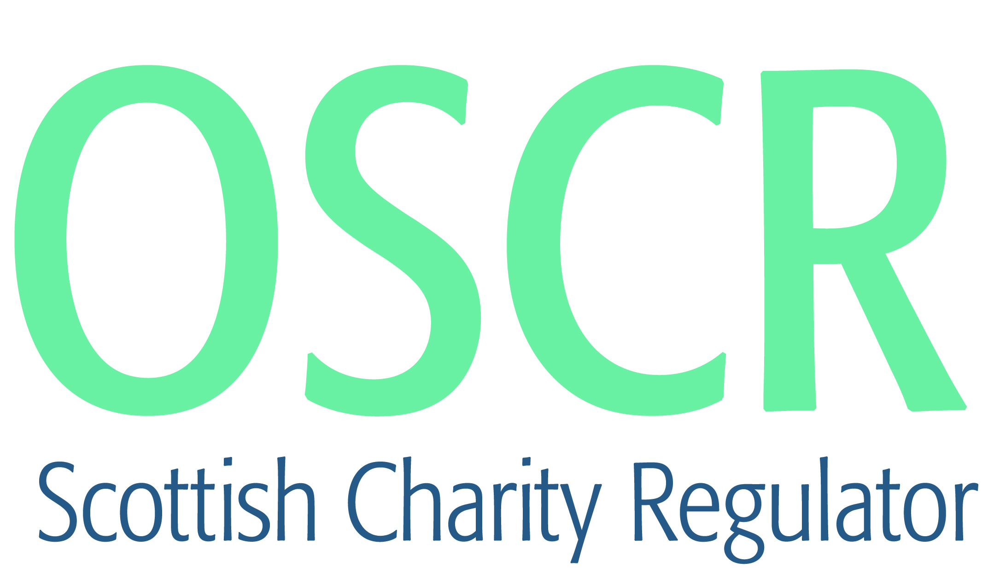

**Charities granted charitable status 1 to 30 June 2018**

|  |  |  |
| --- | --- | --- |
| **Charity Number** | **Charity Name** | **Constitutional Form** |
| [**SC048426**](https://www.oscr.org.uk/search-charity-register/charity-extract/?charitynumber=SC048426) | **1st Lenzie Rainbow Unit** | **Unincorporated Association** |
| [**SC048455**](https://www.oscr.org.uk/search-charity-register/charity-extract/?charitynumber=SC048455) | **1st Macduff Scout Group Council** | **Unincorporated Association** |
| [**SC048496**](https://www.oscr.org.uk/search-charity-register/charity-extract/?charitynumber=SC048496) | **1st Sandhaven Rainbow Unit** | **Unincorporated Association** |
| [**SC048500**](https://www.oscr.org.uk/search-charity-register/charity-extract/?charitynumber=SC048500) | **2nd Cawdor Rainbow Unit** | **Unincorporated Association** |
| [**SC048499**](https://www.oscr.org.uk/search-charity-register/charity-extract/?charitynumber=SC048499) | **3rd Oldmeldrum Rainbow Unit** | **Unincorporated Association** |
| [**SC048487**](https://www.oscr.org.uk/search-charity-register/charity-extract/?charitynumber=SC048487) | **A Sterling Language Project** | **SCIO** |
| [**SC048457**](https://www.oscr.org.uk/search-charity-register/charity-extract/?charitynumber=SC048457) | **ADA** | **SCIO** |
| [**SC048430**](https://www.oscr.org.uk/search-charity-register/charity-extract/?charitynumber=SC048430) | **Aden Community Allotment Association SCIO** | **SCIO** |
| [**SC048480**](https://www.oscr.org.uk/search-charity-register/charity-extract/?charitynumber=SC048480) | **Arran Development Trust** | **Company** |
| [**SC048490**](https://www.oscr.org.uk/search-charity-register/charity-extract/?charitynumber=SC048490) | **Auchterarder Community Sports and Recreation** | **SCIO** |
| [**SC048466**](https://www.oscr.org.uk/search-charity-register/charity-extract/?charitynumber=SC048466) | **Autism Specific Knowledge SCIO** | **SCIO** |
| [**SC048495**](https://www.oscr.org.uk/search-charity-register/charity-extract/?charitynumber=SC048495) | **Ayr & District Flower Show** | **Company** |
| [**SC048444**](https://www.oscr.org.uk/search-charity-register/charity-extract/?charitynumber=SC048444) | **Bathgate Thistle Community Football Club** | **SCIO** |
| [**SC048502**](https://www.oscr.org.uk/search-charity-register/charity-extract/?charitynumber=SC048502) | **Carrbridge Village Hall** | **SCIO** |
| [**SC048458**](https://www.oscr.org.uk/search-charity-register/charity-extract/?charitynumber=SC048458) | **Cavernoma Alliance UK** | **Unincorporated Association** |
| [**SC048488**](https://www.oscr.org.uk/search-charity-register/charity-extract/?charitynumber=SC048488) | **Cockburnspath Allotment Association SCIO** | **SCIO** |
| [**SC048492**](https://www.oscr.org.uk/search-charity-register/charity-extract/?charitynumber=SC048492) | **Dundee Howff Conservation Group (SCIO)** | **SCIO** |
| [**SC048478**](https://www.oscr.org.uk/search-charity-register/charity-extract/?charitynumber=SC048478) | **Dynamic Gymnastics** | **Company** |
| [**SC048489**](https://www.oscr.org.uk/search-charity-register/charity-extract/?charitynumber=SC048489) | **Ek Onkar Gurdwara Sahib Trust** | **Trust** |
| [**SC048460**](https://www.oscr.org.uk/search-charity-register/charity-extract/?charitynumber=SC048460) | **Elgin & District Men's Shed** | **SCIO** |
| [**SC048440**](https://www.oscr.org.uk/search-charity-register/charity-extract/?charitynumber=SC048440) | **Elgin Town Hall for the Community** | **Company** |
| [**SC048437**](https://www.oscr.org.uk/search-charity-register/charity-extract/?charitynumber=SC048437) | **Evangelical Believers Outreach Ministries International** | **Unincorporated Association** |
| [**SC048434**](https://www.oscr.org.uk/search-charity-register/charity-extract/?charitynumber=SC048434) | **Existing Homes Alliance Scotland** | **SCIO** |
| [**SC048485**](https://www.oscr.org.uk/search-charity-register/charity-extract/?charitynumber=SC048485) | **Fair Isle Marine Research Organisation (SCIO)** | **SCIO** |
| [**SC048470**](https://www.oscr.org.uk/search-charity-register/charity-extract/?charitynumber=SC048470) | **Feeding Britain** | **CIO** |
| [**SC048459**](https://www.oscr.org.uk/search-charity-register/charity-extract/?charitynumber=SC048459) | **Fishermen's Hall Trust** | **SCIO** |
| [**SC048429**](https://www.oscr.org.uk/search-charity-register/charity-extract/?charitynumber=SC048429) | **Friends of Clark's Little Ark** | **SCIO** |
| [**SC048431**](https://www.oscr.org.uk/search-charity-register/charity-extract/?charitynumber=SC048431) | **Glenfinnan Community Facilities SCIO** | **SCIO** |
| [**SC048475**](https://www.oscr.org.uk/search-charity-register/charity-extract/?charitynumber=SC048475) | **Heinrich Steinmeyer Legacy Fund** | **SCIO** |
| [**SC048427**](https://www.oscr.org.uk/search-charity-register/charity-extract/?charitynumber=SC048427) | **Humanity Uplifting People (HUP) (SCIO)** | **SCIO** |
| [**SC048452**](https://www.oscr.org.uk/search-charity-register/charity-extract/?charitynumber=SC048452) | **Huntly Christian Fellowship** | **SCIO** |
| [**SC048469**](https://www.oscr.org.uk/search-charity-register/charity-extract/?charitynumber=SC048469) | **Inshes Community Association** | **Company** |
| [**SC048493**](https://www.oscr.org.uk/search-charity-register/charity-extract/?charitynumber=SC048493) | **Inverlochy Village Hall SCIO** | **SCIO** |
| [**SC048484**](https://www.oscr.org.uk/search-charity-register/charity-extract/?charitynumber=SC048484) | **Justness** | **SCIO** |
| [**SC048483**](https://www.oscr.org.uk/search-charity-register/charity-extract/?charitynumber=SC048483) | **Kelton Nursery SCIO** | **SCIO** |
| [**SC048449**](https://www.oscr.org.uk/search-charity-register/charity-extract/?charitynumber=SC048449) | **Kemback Hall** | **SCIO** |
| [**SC048451**](https://www.oscr.org.uk/search-charity-register/charity-extract/?charitynumber=SC048451) | **Killin & District Volunteer Car Scheme** | **SCIO** |
| [**SC048486**](https://www.oscr.org.uk/search-charity-register/charity-extract/?charitynumber=SC048486) | **Kingston Gymnastics Club** | **SCIO** |
| [**SC048447**](https://www.oscr.org.uk/search-charity-register/charity-extract/?charitynumber=SC048447) | **Largo Communities Together** | **SCIO** |
| [**SC048456**](https://www.oscr.org.uk/search-charity-register/charity-extract/?charitynumber=SC048456) | **Lindean Village Hall** | **Trust** |
| [**SC048392**](https://www.oscr.org.uk/search-charity-register/charity-extract/?charitynumber=SC048392) | **Lochee Baptist Chapel** | **SCIO** |
| [**SC048474**](https://www.oscr.org.uk/search-charity-register/charity-extract/?charitynumber=SC048474) | **Longmore Community Hall** | **SCIO** |
| [**SC048503**](https://www.oscr.org.uk/search-charity-register/charity-extract/?charitynumber=SC048503) | **Longriggend Village Association** | **SCIO** |
| [**SC048479**](https://www.oscr.org.uk/search-charity-register/charity-extract/?charitynumber=SC048479) | **Madad Foundation International** | **SCIO** |
| [**SC048435**](https://www.oscr.org.uk/search-charity-register/charity-extract/?charitynumber=SC048435) | **Menopause Cafe** | **SCIO** |
| [**SC048439**](https://www.oscr.org.uk/search-charity-register/charity-extract/?charitynumber=SC048439) | **Nairn Bowling Club** | **SCIO** |
| [**SC048450**](https://www.oscr.org.uk/search-charity-register/charity-extract/?charitynumber=SC048450) | **North East Rider Volunteers Scotland SCIO** | **SCIO** |
| [**SC048424**](https://www.oscr.org.uk/search-charity-register/charity-extract/?charitynumber=SC048424) | **Nurture Parents** | **SCIO** |
| [**SC048461**](https://www.oscr.org.uk/search-charity-register/charity-extract/?charitynumber=SC048461) | **Oxgangs Community Church** | **SCIO** |
| [**SC048501**](https://www.oscr.org.uk/search-charity-register/charity-extract/?charitynumber=SC048501) | **Paws Here To Help (SCIO)** | **SCIO** |
| [**SC048463**](https://www.oscr.org.uk/search-charity-register/charity-extract/?charitynumber=SC048463) | **Peterhead Area Community Trust (SCIO)** | **SCIO** |
| [**SC048446**](https://www.oscr.org.uk/search-charity-register/charity-extract/?charitynumber=SC048446) | **Pumpherston United Football Club** | **Unincorporated Association** |
| [**SC048428**](https://www.oscr.org.uk/search-charity-register/charity-extract/?charitynumber=SC048428) | **Scot Nepal Club** | **Unincorporated Association** |
| [**SC048491**](https://www.oscr.org.uk/search-charity-register/charity-extract/?charitynumber=SC048491) | **Scottish Para-Football** | **SCIO** |
| [**SC048465**](https://www.oscr.org.uk/search-charity-register/charity-extract/?charitynumber=SC048465) | **Scottish Schools Debating** | **SCIO** |
| [**SC048497**](https://www.oscr.org.uk/search-charity-register/charity-extract/?charitynumber=SC048497) | **Serendipity** | **Unincorporated Association** |
| [**SC048438**](https://www.oscr.org.uk/search-charity-register/charity-extract/?charitynumber=SC048438) | **Skills Exchange SCIO** | **SCIO** |
| [**SC048441**](https://www.oscr.org.uk/search-charity-register/charity-extract/?charitynumber=SC048441) | **Souhrudam** | **SCIO** |
| [**SC048467**](https://www.oscr.org.uk/search-charity-register/charity-extract/?charitynumber=SC048467) | **Speyside Fields For Wildlife** | **Unincorporated Association** |
| [**SC048481**](https://www.oscr.org.uk/search-charity-register/charity-extract/?charitynumber=SC048481) | **St Boswells Village Hall** | **SCIO** |
| [**SC048453**](https://www.oscr.org.uk/search-charity-register/charity-extract/?charitynumber=SC048453) | **St Clare Hall** | **Trust** |
| [**SC048436**](https://www.oscr.org.uk/search-charity-register/charity-extract/?charitynumber=SC048436) | **Stornoway Community Mosque Trust** | **Unincorporated Association** |
| [**SC048432**](https://www.oscr.org.uk/search-charity-register/charity-extract/?charitynumber=SC048432) | **Stornoway Rugby Football Club SCIO** | **SCIO** |
| [**SC048482**](https://www.oscr.org.uk/search-charity-register/charity-extract/?charitynumber=SC048482) | **The Alcohol Education Trust** | **Unincorporated Association** |
| [**SC048476**](https://www.oscr.org.uk/search-charity-register/charity-extract/?charitynumber=SC048476) | **The Colinton Tunnel** | **SCIO** |
| [**SC048471**](https://www.oscr.org.uk/search-charity-register/charity-extract/?charitynumber=SC048471) | **The Gospel of Grace International Ministry (WaterCourse Sanctuary)** | **Unincorporated Association** |
| [**SC048433**](https://www.oscr.org.uk/search-charity-register/charity-extract/?charitynumber=SC048433) | **The Kishorn Community Trust** | **SCIO** |
| [**SC048472**](https://www.oscr.org.uk/search-charity-register/charity-extract/?charitynumber=SC048472) | **The National Film and Television School** | **Company** |
| [**SC048462**](https://www.oscr.org.uk/search-charity-register/charity-extract/?charitynumber=SC048462) | **The North Berwick Trust Ltd** | **Company** |
| [**SC048498**](https://www.oscr.org.uk/search-charity-register/charity-extract/?charitynumber=SC048498) | **The One Health Foundation** | **SCIO** |
| [**SC048473**](https://www.oscr.org.uk/search-charity-register/charity-extract/?charitynumber=SC048473) | **The Re-start Foundation SCIO** | **SCIO** |
| [**SC048464**](https://www.oscr.org.uk/search-charity-register/charity-extract/?charitynumber=SC048464) | **The Rooney Family Foundation** | **Company** |
| [**SC048448**](https://www.oscr.org.uk/search-charity-register/charity-extract/?charitynumber=SC048448) | **The Ship Yard Trust SCIO** | **SCIO** |
| [**SC048477**](https://www.oscr.org.uk/search-charity-register/charity-extract/?charitynumber=SC048477) | **The Step Up Trust** | **Trust** |
| [**SC048504**](https://www.oscr.org.uk/search-charity-register/charity-extract/?charitynumber=SC048504) | **Tillicoultry Primary School Parent Council** | **Unincorporated Association** |
| [**SC048454**](https://www.oscr.org.uk/search-charity-register/charity-extract/?charitynumber=SC048454) | **VERSE Stories** | **SCIO** |
| [**SC048468**](https://www.oscr.org.uk/search-charity-register/charity-extract/?charitynumber=SC048468) | **West Kilbride Civic Society SCIO** | **SCIO** |
| [**SC048445**](https://www.oscr.org.uk/search-charity-register/charity-extract/?charitynumber=SC048445) | **Works+** | **SCIO** |
| [**SC048494**](https://www.oscr.org.uk/search-charity-register/charity-extract/?charitynumber=SC048494) | **YMCA Edinburgh** | **SCIO** |
| [**SC048442**](https://www.oscr.org.uk/search-charity-register/charity-extract/?charitynumber=SC048442) | **You Are My Sunshine** | **SCIO** |
| [**SC048443**](https://www.oscr.org.uk/search-charity-register/charity-extract/?charitynumber=SC048443) | **Youth Impact** | **Unincorporated Association** |
| [**SC048425**](https://www.oscr.org.uk/search-charity-register/charity-extract/?charitynumber=SC048425) | **Youth Support Trust Scotland** | **Company** |