Interim Safeguarding Guidance:
Keeping vulnerable beneficiaries safe

1. Introduction
2. What is safeguarding?
3. Charity Trustees’ duties
4. OSCR’s regulatory role

1. Introduction

What this guidance covers
In this guidance we concentrate on safeguarding ‘vulnerable beneficiaries’, by which we mean children and vulnerable (or protected) adults. For the purposes of this guidance:

- A child is anyone under 18 years of age.
- A vulnerable adult is anyone over 16 years of age who is unable to safeguard themselves, their property and their rights
Charities have a wider responsibility to protect their staff, volunteers and beneficiaries in general. It’s important that charities consider how to promote wellbeing and welfare of all the individuals they work with. However, this guidance focuses on the safeguarding of vulnerable beneficiaries. Many charities may have vulnerable beneficiaries who also work for the charity as volunteers or paid staff. In these circumstances the safeguarding of those staff and volunteers needs to be considered alongside the employment and volunteering responsibilities of the charity.

In this guidance we look at what’s meant by safeguarding and highlight key steps that charity trustees can take to make sure that it is considered in an appropriate way for their charity.

The guidance also looks at how the charity trustee duties as set out in the Charities and Trustee Investment (Scotland) Act 2005 (the 2005 Act) can relate to safeguarding issues.

What this guidance does not cover
This guidance looks at the general principles of safeguarding; it doesn’t cover detailed requirements for different types of charities, such as those working overseas or in the care sector.

The guidance doesn’t cover wider employment law issues such as allegations of sexual misconduct or harassment in the workplace. However, charity trustees do have a duty to create a workplace that is safe and secure for all. This includes having appropriate human resource policies, and ensuring that those working and volunteering for the charity are able to raise concerns and have them dealt with in an appropriate way. It also means working to promote and create a culture in which staff and volunteers can work effectively.

Who is the guidance for?
This guidance is aimed at charity trustees of charities with vulnerable beneficiaries and people working with those charity trustees.

How to use the guidance
The glossary provides you with further information, definitions and descriptions of key terms. We have highlighted these key terms in bold purple type. Clicking on these terms will take you straight to the glossary or the relevant section of guidance. The guidance also contains links to external websites for other sources of information.

Sources of help and advice
OSCR publishes general guidance for charities, but we can’t provide specific advice on the full range of things which can happen in or affect your charity. See the links below to other sources of help and information:

- Charity Commission for England and Wales guidance: trustee safeguarding duties explained – this guidance refers to the law in England and Wales, it is most relevant for cross-border charities registered with both the Commission and OSCR
- The Care Inspectorate’s guidance hub contains information about working with children and vulnerable adults
- The Health and Social Care Standards have been developed to ensure everyone in Scotland receives the same high quality of care no matter where they live
- Disclosure Scotland has information on background checks and the Protecting Vulnerable Groups (PVG) Scheme
- The NSPCC have a free safeguarding tool for those working with children and young people, which includes an example safeguarding policy and self-assessment tool
- Scotland's International Development Alliance gives members access to relevant information on safeguarding through the resources section on their website
- Volunteer Scotland provide free disclosure check services for voluntary sector organisations, including PVG applications for volunteers and paid staff. Volunteer Scotland also provide advice and guidance.

2. What is safeguarding?
Safeguarding is the action that an organisation takes to promote the welfare of children and vulnerable adults to protect them from harm including physical, emotional, sexual and financial harm and neglect. This includes making sure that the appropriate policies, practices and procedures are put in place. Safeguarding includes child protection but goes further and extends to all vulnerable beneficiaries.
Charities working with children and vulnerable or protected adults, referred to in this guidance as vulnerable beneficiaries, must do all they can to keep these beneficiaries safe and protected from harm.
Charity trustees must always act in the interests of the charity and where a charity has vulnerable beneficiaries this duty includes making sure that the appropriate safeguarding measures are put in place to prevent and protect them from harm. The risk of harm may never entirely disappear, but the better the safeguards adopted the better able charities are to mitigate those risks.
Ways to protect vulnerable beneficiaries include:
- having in place policies and procedures that will help make sure that children and vulnerable adults are protected from harm
- making sure those policies and procedures are implemented and understood by everyone in the charity
- having clear lines of responsibility and accountability within the charity to deal with any safeguarding issues
- making sure that staff and volunteers are trained to identify potential harm, know what action to take and are clear about how, when and who to report to.
Charities may be set up to help vulnerable groups either in Scotland, elsewhere in the UK or overseas. These individuals may be vulnerable to abuse due to their life circumstances or because of their age, health, physical or mental abilities. Individuals who rely on others to help them with personal and intimate care can be particularly vulnerable.
Why does it matter?
Individuals have the right to live in safety, with dignity, free from abuse and neglect. Safeguarding comes from rights-based approach to protecting individuals and this is at the heart of what many charities do.

Charities are trusted to help some of the most vulnerable people in society who require the most protection. When working with vulnerable beneficiaries charities should be able to demonstrate that they can keep them safe.
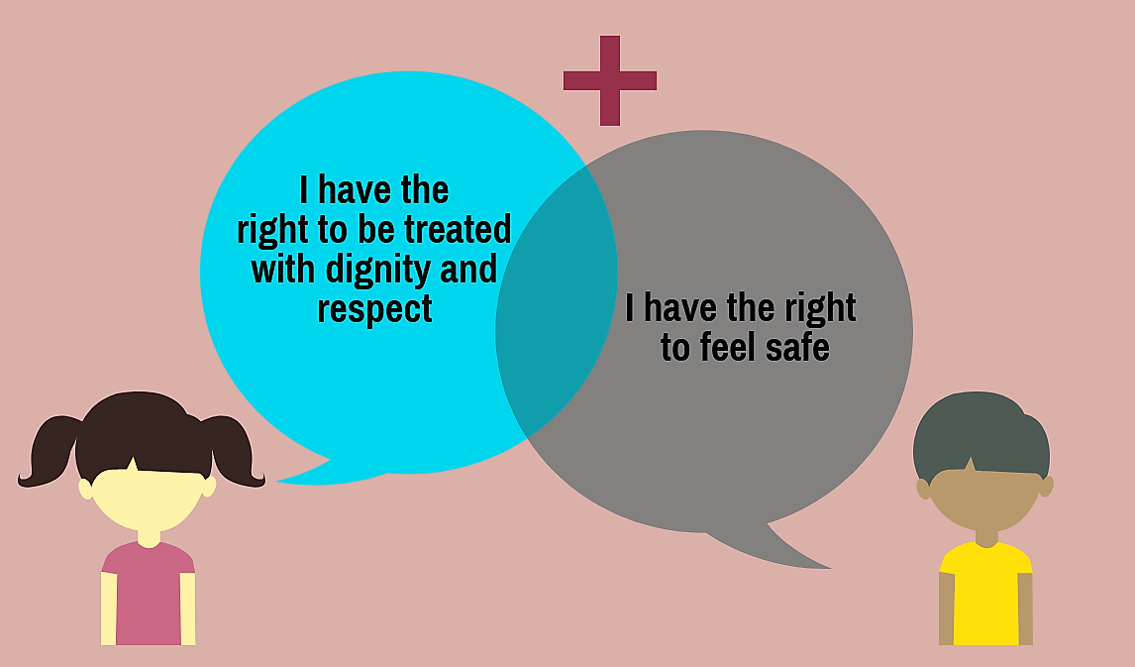
It is in the interests of the charity to promote a safe environment and culture for all. If charities fail to report and follow up on safeguarding concerns it undermines public trust and sends a message that such behaviours are tolerated.
Where a charity works with vulnerable beneficiaries it is important that charity trustees develop an organisational culture that has safeguarding at its core. Public trust and confidence in your charity and the reputation of the wider sector can be harmed if safeguarding concerns are not responded to appropriately. A charity’s reputation is one of its most valuable assets and the public have the right to expect the highest standards of governance and have confidence in any charity that they come into contact with.

3. Charity Trustees’ duties

The legal duty of all charity trustees is to act in the interests of their charity and in particular to act with care and diligence. Charities should have the appropriate mechanisms in place to make sure that a safe environment is created for staff, beneficiaries and volunteers. Charity trustees have a collective responsibility for safeguarding even if certain aspects of the work are delegated to staff. Ultimately, charity trustees are accountable for all that happens within their charity.

Charity trustee general duties:

1. You must act in the interests of the charity

1.1 You must operate in a manner consistent with the charity’s purpose

1.2 You must act with care and diligence

1.3 You must manage any conflict of interest between the charity and any person or organisation who appoints charity trustees.

Safeguarding vulnerable beneficiaries is a key governance priority. Any failure by charity trustees to manage safeguarding risks adequately can be a failure in charity trustee duties and would be of serious regulatory concern to OSCR. We may consider this to be misconduct in the administration of the charity. See section 4 for details on OSCR’s role.
Charity trustees need to be aware of and alert to the risk that their charity may be targeted by those who want to gain access to children or vulnerable adults. While the risks may never fully disappear, having the correct procedures and adequate checks in place will mean that if things do go wrong the charity is best placed to deal with it.

Charity Trustees should take these practical safeguarding steps:

- Know your duties in terms of charity law: read our Guidance and Good Practice for Charity Trustees, and understand how, in your charity the role of a charity trustee relates to safeguarding
- Know what specific statutory duties you have to comply with because of the nature of your charity’s activities including where necessary carrying out Disclosure Scotland checks

- Make sure charity trustees are appropriately trained in safeguarding so that they’re able to make informed decisions that affect vulnerable beneficiaries

- Be alert to the possibility of the charity being targeted as an access point to children or vulnerable adults and the ways you can manage those risks
- Have adequate safeguarding policies and procedures appropriate for your charity’s activities that reflect both the law and best practice. For example, charities working with children should have a child protection policy in place. Review and assess safeguarding risks and policies regularly, particularly where there are changes in circumstances or activities
- Make sure safeguarding policies and procedures are properly implemented. All staff and volunteers should receive safeguarding training and go on regular refresher courses and be clear about:
- what abuse is
- how to spot it
- how to respond to concerns about and from vulnerable beneficiaries
- who to report concerns to

- Make sure the principal themes of safeguarding are embedded in the culture of your charity encouraging a safe environment so that anyone who has a concern feels able to report it as soon as abuse is identified or suspected
- Have in place procedures for staff, volunteers and beneficiaries to raise concerns with clear:
  - lines of accountability
  - systems of reporting
  - actions to be taken

- Make sure all concerns reported are appropriately and sensitively investigated and promptly acted on
- If incidents do occur, reflect and learn from them. This may include making changes to your policy if needed, seeking feedback from beneficiaries and showing your commitment to safeguarding by publishing your safeguarding policy.

These steps are vital, given that charities are accountable to the public and must provide public benefit.

Whistleblowing and the Public Interest Disclosure Act 1998 (PIDA)
PIDA protects paid workers from unfair dismissal or treatment from their employer if they report wrongdoing. We consider it best practice for charities that employ people to have whistleblowing procedures in place so that concerns can be raised by staff openly and safely.

More information on whistleblowing and PIDA can be found in our guidance and on the UK Government website.

Sharing information with other agencies
Charity trustees should liaise and work with other organisations to prevent those individuals who actively target charities in order to abuse children and vulnerable adults from doing so. This may include sharing information or making referrals to social services or other relevant agencies and also the prompt reporting of incidents to Police Scotland.

Making a referral to Disclosure Scotland: If an organisation or employer has employees or volunteers doing 'regulated work', they have a duty to report any harmful behaviour that might affect whether the person is allowed to work with children or protected adults. This applies whether the person is a member of the PVG Scheme or not. This is called making a referral.

Making appropriate referrals is one of the ways charity trustees can demonstrate that they are complying with the duty to act with care and diligence.
Safe recruitment (staff and volunteers)
Charities working with vulnerable beneficiaries should seek to prevent harm and abuse with a rigorous recruitment and interview process for new staff and volunteers. Charity trustees must have safe recruitment practices within their charities to make sure that only suitable people have contact with vulnerable beneficiaries.

Some people are not allowed by law to be a charity trustee. Every charity trustee must make sure that he or she is not breaking the law by being a charity trustee.

Types of disclosure
You may need a criminal record check from Disclosure Scotland if you're applying for paid or unpaid work, including volunteering with a charity. The type of check to be used depends on the voluntary or paid work you're doing or the role you are carrying out. Disclosure Scotland provide:
- Basic disclosure
- Standard disclosure
- Enhanced disclosure
- Protecting Vulnerable Groups (PVG) Scheme

PVG checks
The Protection of Vulnerable Groups (Scotland) Act 2007 (PVG Act) sets out the legal framework for the vetting and barring scheme for those working with children and protected adults in Scotland, known as the PVG scheme.

Charities have a responsibility to make sure that any trustees, employees and volunteers that work with vulnerable beneficiaries are suitable for the role and that they obtain appropriate checks to prove this.

The PVG scheme applies only to 'regulated work'. There are two types of regulated work – work with children and work with protected adults. Regulated work may include:
- caring responsibilities
- teaching or supervising children and/or protected adults
- providing personal services to children and/or protected adults
- having unsupervised contact with children and/or protected adults.
The PVG scheme also applies to regulated work carried out in other countries, for example, when a charity sends a volunteer overseas to work in a school.

More information on how the PVG scheme works can be found at Disclosure Scotland. It is good practice to notify Disclosure Scotland when an individual on the scheme leaves an organisation.
Volunteer Scotland provide a range of support with the PVG scheme for voluntary sector organisations, including free training, guidance and a helpline.
In addition to the PVG scheme, charity trustees should consider if their recruitment policy and processes are robust and meet best practice – see the Safer recruitment through better recruitment guidance.
Working with partners overseas, in Scotland or elsewhere in the UK
Charities working overseas often work with the poorest and most vulnerable people. Charities can be working with people who are simply trying to survive following devastating man made or natural disasters. Charity trustees should be alive to the fact that some individuals may exploit weaknesses in a charity’s safeguarding practices particularly in the face of immense pressure to deliver aid and save lives.
Charities that work with partner organisations both in Scotland, elsewhere in the UK or overseas should make sure that:
- those organisations have appropriate safeguarding policies in place for the nature of the work and the area they operate in
- that these policies are properly implemented in practice and regularly reviewed
- when giving grants to overseas organisations appropriate due diligence checks are made on the recipient body.
Charity trustees also need to be aware that vulnerable beneficiaries overseas can face different or additional risks of abuse or exploitation and safeguarding policies and procedures should take account of any additional factors that are necessary in the circumstances.
Remember, the PVG scheme applies where charities send individuals to other countries to do regulated work. This is set out in an amendment to section 73 of the PVG Act – the Protection of Vulnerable Groups (Scotland) Act 2007 (Prescribed Purposes for Consideration of Suitability) Regulations 2010/381.
In terms of international safeguarding issues, OSCR has no direct regulatory remit over charities’ overseas partners or not-for-profit organisations. Where a charity registered in Scotland supports, or works closely with overseas partners, we will hold the charity to account over the suitability and management of that relationship, including its supervision of safeguarding risks.
What should a safeguarding policy contain?
The contents and detail of a charity’s safeguarding policy will depend on the charity’s activities with vulnerable beneficiaries and the level of risk.

Where the risks are higher, for example in charities where activities with vulnerable beneficiaries are core to the charity’s purpose, charity trustees will need to do more to fulfil their legal duties and make sure their policy is appropriate for their operations. The policy should always include requirements for the charity’s trustees, staff and volunteers to learn about protection issues in accordance with the relevant statutory guidance and within the context of their own roles and responsibilities.
OSCR can’t advise charities on what specific information to include in a policy, but we would expect, as a minimum, policies are:
- agreed by the charity trustees
- regularly updated
- reflect statutory guidance and national and local practice
- supported by an implementation plan.
The policy should be publicly available, to provide reassurance and enable constructive feedback from beneficiaries and other stakeholders.
The NSPCC has tips for writing a safeguarding policy when working with children.
4. OSCR’s regulatory role
OSCR’s role is to make sure that charities comply with the requirements of Scottish charity law and that charity trustees run charities in line with their legal duties.
In the context of safeguarding, our focus is to make sure that charity trustees deal appropriately with any alleged safeguarding concerns affecting their charity. We look to see that charity trustees take steps to protect vulnerable beneficiaries from harm and minimise the risk of abuse.

OSCR is not responsible for dealing with incidents of actual abuse and does not oversee safeguarding legislation. Where incidents of abuse are alleged, it’s the role of the police to investigate whether a criminal offence may have been committed. We can and do refer any concerns we have to the Crown Office and Procurator Fiscal Service or other relevant agencies. We will give the highest priority to any case where there is a live risk of harm.

When we receive a concern about a charity we assess it in line with our Inquiry Policy. The policy sets out the matters that OSCR can and can’t deal with and explains how we assess concerns to decide if we can take them forward.

Reporting Safeguarding incidents to OSCR under the Notifiable Events Regime
OSCR’s notifiable events scheme requires charity trustees to report events that are likely to have a significant impact on their charity. When there has been a significant incident involving a child or a vulnerable adult, then this should be reported to us.

Reporting demonstrates that charity trustees have identified a serious risk to their charity and that they are taking appropriate action to deal with it and protect the charity from further harm.

When reporting, trustees should be as transparent as possible about the facts of the case and the actions being taken. This will allow us to assess if the appropriate actions are being taken in any given case.

There is no legal requirement to report a notifiable event. However, it is an important way for charity trustees to reassure us that they are on top of the issues they are facing. Ultimately, we may become concerned if there has been a matter that has not been reported to us; especially if it goes on to have a negative impact on the individual charity or the wider charity sector. Where something significant has happened within a charity and this has not been reported to us in full, we will take this into account if we have to open an inquiry. Ultimately, this could be considered to be misconduct.

Reporting a notifiable event helps OSCR to assess the volume and impact of safeguarding incidents within charities and to understand the risks facing the sector as a whole. This helps us to decide how we can better support charities through our guidance and assess where we need to focus our activities.

You can email us at notifiable@oscr.org.uk outlining the following:
- What the event is and how it has (or may have) a serious impact on the charity. We need enough details to understand the event, but please don’t worry about having a final polished report. If the information is clear and gives us what we need, we are not worried about the format. We will ask for more information if we need it.
- What action (if any) has already been taken?
- What further plans the charity trustees have in place to deal with the event?
- What plans the charity trustees have in place to mitigate similar things happening in the future.
If you’re not sure whether to report something as a notifiable event please contact us.
Beyond safeguarding
Making sure vulnerable beneficiaries are safe and secure is fundamental to many of Scotland’s charities. Those set up to support vulnerable beneficiaries often go further than just protection, they create an environment in which individuals have the potential to flourish.
While this guidance concentrates on working with vulnerable beneficiaries, there are wider issues that all charity trustees need to think about: Creating a culture in their charity that allows all those that work, volunteer and benefit from their activities to do so in a safe and secure environment.

