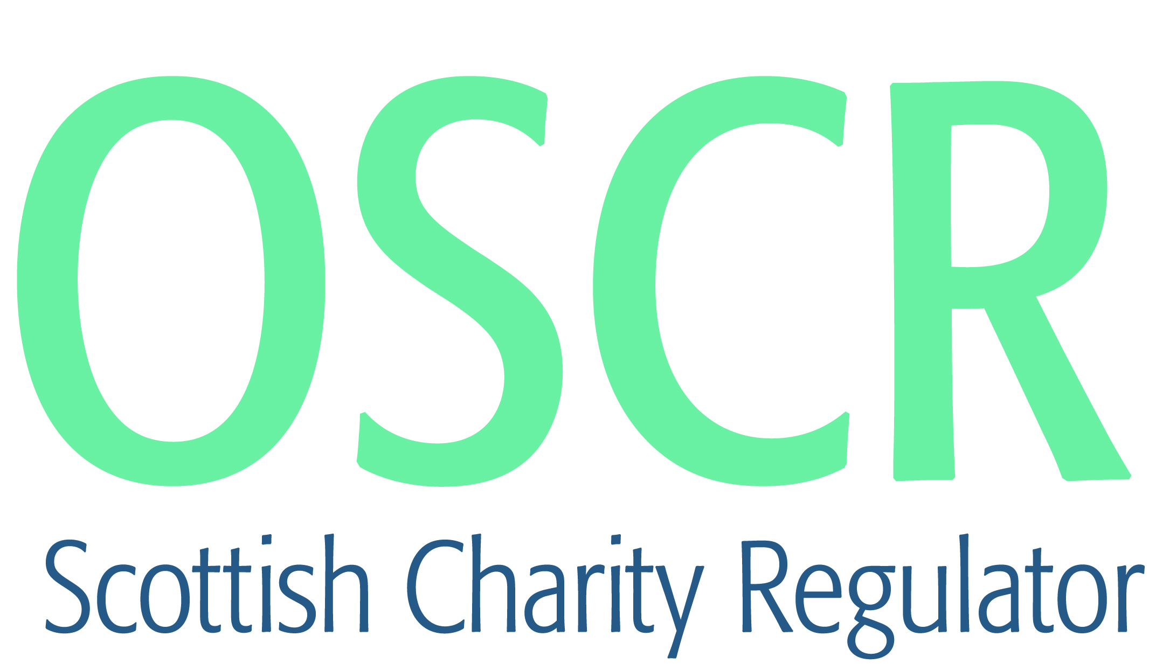

**Charities granted charitable status 1 to 30 April 2018**

|  |  |  |
| --- | --- | --- |
| **Charity Number** | **Charity Name** | **Constitutional Form** |
| [SC048341](https://www.oscr.org.uk/search-charity-register/charity-extract/?charitynumber=SC048341) | 18th City of Edinburgh Brownie Unit | Unincorporated Association |
| [SC048265](https://www.oscr.org.uk/search-charity-register/charity-extract/?charitynumber=SC048265) | 1st Methlick Senior Section Unit | Unincorporated Association |
| [SC048321](https://www.oscr.org.uk/search-charity-register/charity-extract/?charitynumber=SC048321) | 1st Peterhead Guide Unit | Unincorporated Association |
| [SC048343](https://www.oscr.org.uk/search-charity-register/charity-extract/?charitynumber=SC048343) | 202nd City of Edinburgh Guide Unit | Unincorporated Association |
| [SC048311](https://www.oscr.org.uk/search-charity-register/charity-extract/?charitynumber=SC048311) | 2nd Bridge of Allan Rainbow Unit | Unincorporated Association |
| [SC048306](https://www.oscr.org.uk/search-charity-register/charity-extract/?charitynumber=SC048306) | 4th Lenzie Brownie Unit | Unincorporated Association |
| [SC048304](https://www.oscr.org.uk/search-charity-register/charity-extract/?charitynumber=SC048304) | Aberdeen Samaritans SCIO | SCIO |
| [SC048258](https://www.oscr.org.uk/search-charity-register/charity-extract/?charitynumber=SC048258) | ACE RaceRunning | SCIO |
| [SC048317](https://www.oscr.org.uk/search-charity-register/charity-extract/?charitynumber=SC048317) | Action Against Hunger (UK) Ltd | Company |
| [SC048297](https://www.oscr.org.uk/search-charity-register/charity-extract/?charitynumber=SC048297) | ActiveNess Ltd | Company |
| [SC048267](https://www.oscr.org.uk/search-charity-register/charity-extract/?charitynumber=SC048267) | Ama‑zing Harmonies | SCIO |
| [SC048282](https://www.oscr.org.uk/search-charity-register/charity-extract/?charitynumber=SC048282) | Army Families Federation | CIO |
| [SC048287](https://www.oscr.org.uk/search-charity-register/charity-extract/?charitynumber=SC048287) | Aultnagar Estates | SCIO |
| [SC048274](https://www.oscr.org.uk/search-charity-register/charity-extract/?charitynumber=SC048274) | B.A.D. Foundation | SCIO |
| [SC048270](https://www.oscr.org.uk/search-charity-register/charity-extract/?charitynumber=SC048270) | Banton & Kelvinhead Community Centre Association | SCIO |
| [SC048318](https://www.oscr.org.uk/search-charity-register/charity-extract/?charitynumber=SC048318) | Belhelvie Community First Responders | SCIO |
| [SC048295](https://www.oscr.org.uk/search-charity-register/charity-extract/?charitynumber=SC048295) | Bread Over Bombs (Glasgow)[SCIO] | SCIO |
| [SC048332](https://www.oscr.org.uk/search-charity-register/charity-extract/?charitynumber=SC048332) | Breast Friends and Family (SCIO) | SCIO |
| [SC048285](https://www.oscr.org.uk/search-charity-register/charity-extract/?charitynumber=SC048285) | Brechin City Hall Users Group | SCIO |
| [SC048281](https://www.oscr.org.uk/search-charity-register/charity-extract/?charitynumber=SC048281) | Buddhist Prison Chaplaincy Scotland | SCIO |
| [SC048307](https://www.oscr.org.uk/search-charity-register/charity-extract/?charitynumber=SC048307) | Cairngorms Archive Trust (SCIO) | SCIO |
| [SC048313](https://www.oscr.org.uk/search-charity-register/charity-extract/?charitynumber=SC048313) | CanDu (Dundee Cancer Support Network) SCIO | SCIO |
| [SC048320](https://www.oscr.org.uk/search-charity-register/charity-extract/?charitynumber=SC048320) | Casa de Espana de Aberdeen (CEA) | Unincorporated Association |
| [SC048345](https://www.oscr.org.uk/search-charity-register/charity-extract/?charitynumber=SC048345) | City of Edinburgh Lions Club | SCIO |
| [SC048329](https://www.oscr.org.uk/search-charity-register/charity-extract/?charitynumber=SC048329) | Cumbernauld Amateur Athletics Club | SCIO |
| [SC048309](https://www.oscr.org.uk/search-charity-register/charity-extract/?charitynumber=SC048309) | Dorward House, Montrose | Company |
| [SC048264](https://www.oscr.org.uk/search-charity-register/charity-extract/?charitynumber=SC048264) | Dunbar Dementia Network SCIO | SCIO |
| [SC048271](https://www.oscr.org.uk/search-charity-register/charity-extract/?charitynumber=SC048271) | Dundonald Gymnastics Club (DGC) | SCIO |
| [SC048316](https://www.oscr.org.uk/search-charity-register/charity-extract/?charitynumber=SC048316) | East Kilbride Men's Shed | SCIO |
| [SC048275](https://www.oscr.org.uk/search-charity-register/charity-extract/?charitynumber=SC048275) | Edinburgh Jewish Cultural Centre SCIO | SCIO |
| [SC048292](https://www.oscr.org.uk/search-charity-register/charity-extract/?charitynumber=SC048292) | Edinburgh Protestant Institute | Unincorporated Association |
| [SC048266](https://www.oscr.org.uk/search-charity-register/charity-extract/?charitynumber=SC048266) | Epilogue Theatre | Unincorporated Association |
| [SC048298](https://www.oscr.org.uk/search-charity-register/charity-extract/?charitynumber=SC048298) | Fife Dog Rescue and Rehoming (SCIO) | SCIO |
| [SC048333](https://www.oscr.org.uk/search-charity-register/charity-extract/?charitynumber=SC048333) | FND Hope UK | CIO |
| [SC048272](https://www.oscr.org.uk/search-charity-register/charity-extract/?charitynumber=SC048272) | Freedom Fighters (Community Action Initiative) | SCIO |
| [SC048322](https://www.oscr.org.uk/search-charity-register/charity-extract/?charitynumber=SC048322) | Friends of Falkirk War Memorial SCIO | SCIO |
| [SC048261](https://www.oscr.org.uk/search-charity-register/charity-extract/?charitynumber=SC048261) | Friends of Forthview | SCIO |
| [SC048327](https://www.oscr.org.uk/search-charity-register/charity-extract/?charitynumber=SC048327) | Friends of Maud Railway Museum (SCIO) | SCIO |
| [SC048301](https://www.oscr.org.uk/search-charity-register/charity-extract/?charitynumber=SC048301) | Friends of Seaview | SCIO |
| [SC048290](https://www.oscr.org.uk/search-charity-register/charity-extract/?charitynumber=SC048290) | Gatehouse of Fleet Festival Group | SCIO |
| [SC048314](https://www.oscr.org.uk/search-charity-register/charity-extract/?charitynumber=SC048314) | Girlguiding Blairgowrie and Rattray District | Unincorporated Association |
| [SC048302](https://www.oscr.org.uk/search-charity-register/charity-extract/?charitynumber=SC048302) | Golden Angel Foundation SCIO | SCIO |
| [SC048340](https://www.oscr.org.uk/search-charity-register/charity-extract/?charitynumber=SC048340) | Grace Baptist Partnership | Trust |
| [SC048276](https://www.oscr.org.uk/search-charity-register/charity-extract/?charitynumber=SC048276) | Guardbridge Community Development Trust | Company |
| [SC048278](https://www.oscr.org.uk/search-charity-register/charity-extract/?charitynumber=SC048278) | Hear My Music | Company |
| [SC048331](https://www.oscr.org.uk/search-charity-register/charity-extract/?charitynumber=SC048331) | JMS Advice | SCIO |
| [SC048289](https://www.oscr.org.uk/search-charity-register/charity-extract/?charitynumber=SC048289) | Letham 4 All SCIO | SCIO |
| [SC048279](https://www.oscr.org.uk/search-charity-register/charity-extract/?charitynumber=SC048279) | Loudon Pond and Ponfeigh Glen Association | Unincorporated Association |
| [SC048268](https://www.oscr.org.uk/search-charity-register/charity-extract/?charitynumber=SC048268) | Make 2nds Count | SCIO |
| [SC048344](https://www.oscr.org.uk/search-charity-register/charity-extract/?charitynumber=SC048344) | Mormond Thistle Football Club (SCIO) | SCIO |
| [SC048299](https://www.oscr.org.uk/search-charity-register/charity-extract/?charitynumber=SC048299) | Music Broth | SCIO |
| [SC048323](https://www.oscr.org.uk/search-charity-register/charity-extract/?charitynumber=SC048323) | Neilston Community Sport Hub | SCIO |
| [SC048315](https://www.oscr.org.uk/search-charity-register/charity-extract/?charitynumber=SC048315) | North East Fife Community Hub | Company |
| [SC048330](https://www.oscr.org.uk/search-charity-register/charity-extract/?charitynumber=SC048330) | npower Foundation | CIO |
| [SC048303](https://www.oscr.org.uk/search-charity-register/charity-extract/?charitynumber=SC048303) | Portgordon Community Church | SCIO |
| [SC048319](https://www.oscr.org.uk/search-charity-register/charity-extract/?charitynumber=SC048319) | Pulse Health Improvement SCIO | SCIO |
| [SC048284](https://www.oscr.org.uk/search-charity-register/charity-extract/?charitynumber=SC048284) | Re‑ Tweed | SCIO |
| [SC048262](https://www.oscr.org.uk/search-charity-register/charity-extract/?charitynumber=SC048262) | Recycle Rebuild (SCIO) | SCIO |
| [SC048326](https://www.oscr.org.uk/search-charity-register/charity-extract/?charitynumber=SC048326) | Reel People Scotland (SCIO) | SCIO |
| [SC048312](https://www.oscr.org.uk/search-charity-register/charity-extract/?charitynumber=SC048312) | Riviera Community Enterprises | SCIO |
| [SC048300](https://www.oscr.org.uk/search-charity-register/charity-extract/?charitynumber=SC048300) | Rousay,Egilsay & Wyre Heritage SCIO | SCIO |
| [SC048291](https://www.oscr.org.uk/search-charity-register/charity-extract/?charitynumber=SC048291) | SafeLives | Company |
| [SC048288](https://www.oscr.org.uk/search-charity-register/charity-extract/?charitynumber=SC048288) | Scottish Wider Access Programme (West) SCIO | SCIO |
| [SC048335](https://www.oscr.org.uk/search-charity-register/charity-extract/?charitynumber=SC048335) | SMART Denny | SCIO |
| [SC048334](https://www.oscr.org.uk/search-charity-register/charity-extract/?charitynumber=SC048334) | South of Scotland Beekeepers Association | SCIO |
| [SC048337](https://www.oscr.org.uk/search-charity-register/charity-extract/?charitynumber=SC048337) | South West Scotland RnR (SCIO) | SCIO |
| [SC048280](https://www.oscr.org.uk/search-charity-register/charity-extract/?charitynumber=SC048280) | Speak Out Scotland [SCIO] | SCIO |
| [SC048346](https://www.oscr.org.uk/search-charity-register/charity-extract/?charitynumber=SC048346) | St Andrews Men's Shed | SCIO |
| [SC048273](https://www.oscr.org.uk/search-charity-register/charity-extract/?charitynumber=SC048273) | Steps to Hope SCIO | SCIO |
| [SC048338](https://www.oscr.org.uk/search-charity-register/charity-extract/?charitynumber=SC048338) | Sunshine Club | Company |
| [SC048296](https://www.oscr.org.uk/search-charity-register/charity-extract/?charitynumber=SC048296) | Survivors of Human Trafficking in Scotland | Company |
| [SC048324](https://www.oscr.org.uk/search-charity-register/charity-extract/?charitynumber=SC048324) | Swanson Family Charity (in memory of Ron & Mary Swanson) SCIO | SCIO |
| [SC048336](https://www.oscr.org.uk/search-charity-register/charity-extract/?charitynumber=SC048336) | Swimming Trust | Trust |
| [SC048269](https://www.oscr.org.uk/search-charity-register/charity-extract/?charitynumber=SC048269) | Taigh Baile Limited | Company |
| [SC048342](https://www.oscr.org.uk/search-charity-register/charity-extract/?charitynumber=SC048342) | The Academy of the Rhins Educational Trust SCIO | SCIO |
| [SC048339](https://www.oscr.org.uk/search-charity-register/charity-extract/?charitynumber=SC048339) | The Ballantrae Trust | Company |
| [SC048259](https://www.oscr.org.uk/search-charity-register/charity-extract/?charitynumber=SC048259) | The Community of All Hallows at Ditchingham in Norfolk | Unincorporated Association |
| [SC048310](https://www.oscr.org.uk/search-charity-register/charity-extract/?charitynumber=SC048310) | The Eastern Europe Cultural and Education Centre | SCIO |
| [SC048283](https://www.oscr.org.uk/search-charity-register/charity-extract/?charitynumber=SC048283) | The Fair Trial Project | SCIO |
| [SC048294](https://www.oscr.org.uk/search-charity-register/charity-extract/?charitynumber=SC048294) | The Finnish Language Club of Edinburgh SCIO | SCIO |
| [SC048256](https://www.oscr.org.uk/search-charity-register/charity-extract/?charitynumber=SC048256) | The Green Travel Trust | SCIO |
| [SC048255](https://www.oscr.org.uk/search-charity-register/charity-extract/?charitynumber=SC048255) | The Lade Centre | SCIO |
| [SC048325](https://www.oscr.org.uk/search-charity-register/charity-extract/?charitynumber=SC048325) | The Richard Henry Charitable Trust | Trust |
| [SC048293](https://www.oscr.org.uk/search-charity-register/charity-extract/?charitynumber=SC048293) | The Sinclair Family Trust | Trust |
| [SC048305](https://www.oscr.org.uk/search-charity-register/charity-extract/?charitynumber=SC048305) | The Wu Xianhong Foundation | Company |
| [SC048263](https://www.oscr.org.uk/search-charity-register/charity-extract/?charitynumber=SC048263) | Togs SCIO | SCIO |
| [SC048308](https://www.oscr.org.uk/search-charity-register/charity-extract/?charitynumber=SC048308) | Tommy's Honour Education Trust | SCIO |
| [SC048277](https://www.oscr.org.uk/search-charity-register/charity-extract/?charitynumber=SC048277) | UIC Church | SCIO |
| [SC048328](https://www.oscr.org.uk/search-charity-register/charity-extract/?charitynumber=SC048328) | Vics in the Community | SCIO |
| [SC048286](https://www.oscr.org.uk/search-charity-register/charity-extract/?charitynumber=SC048286) | We Are Martial Arts | SCIO |