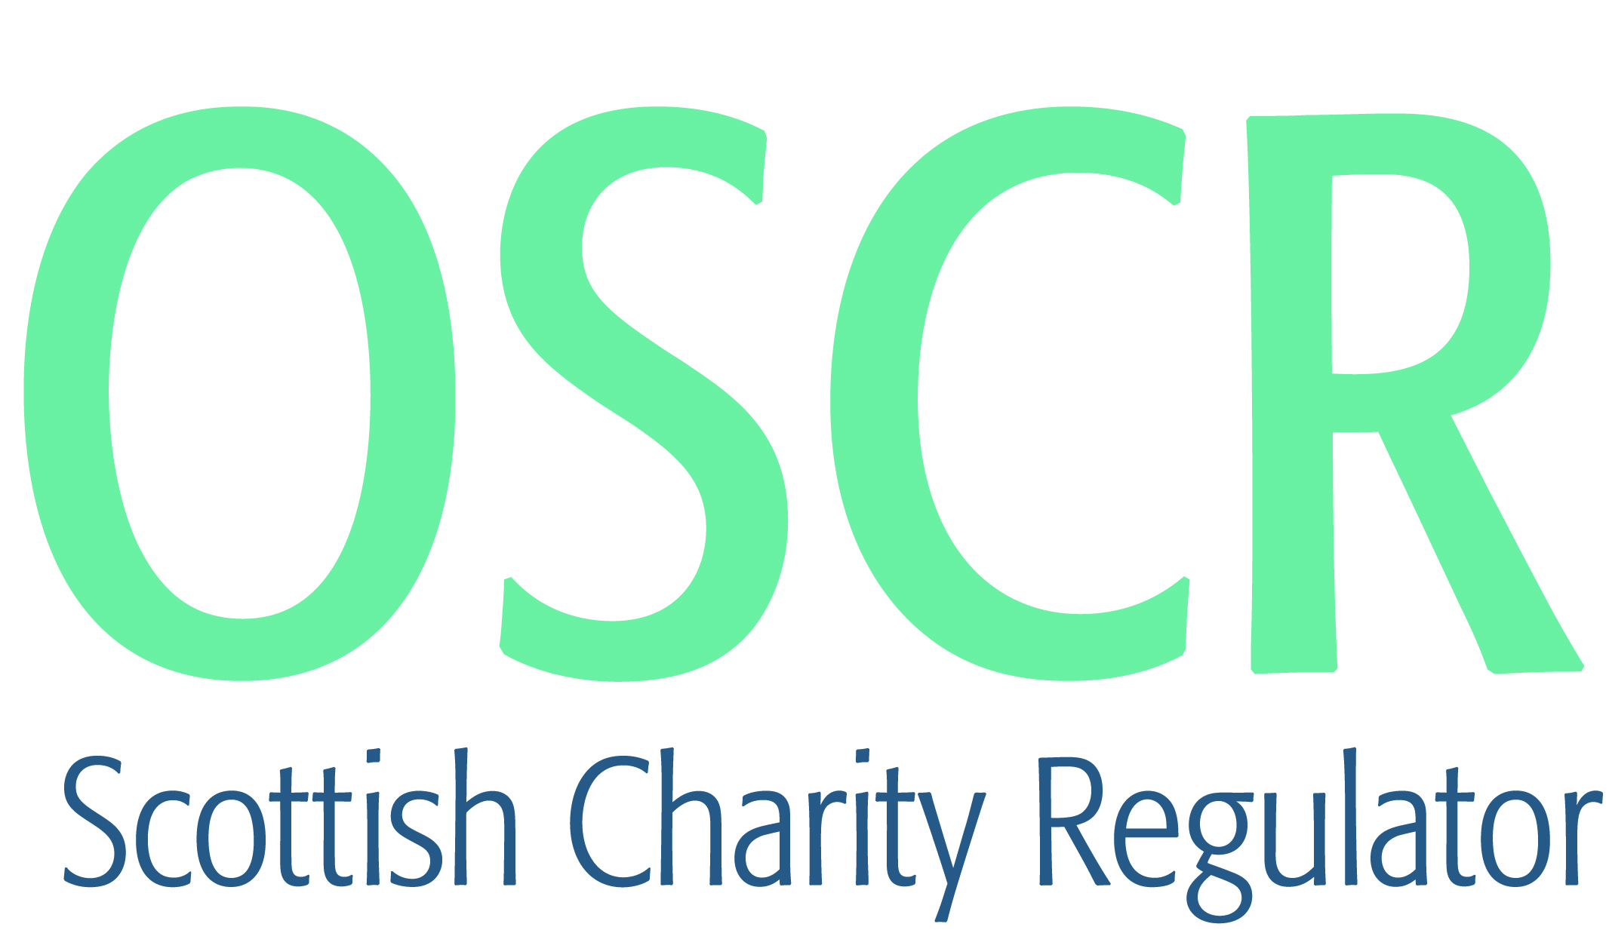

**Charities granted charitable status 1 to 31 March 2018**

|  |  |  |
| --- | --- | --- |
| **Charity Number** | **Charity Name** | **Constitutional Form** |
| [SC048205](https://www.oscr.org.uk/search-charity-register/charity-extract/?charitynumber=SC048205) | 117th City of Edinburgh Brownie Unit | Unincorporated Association |
| [SC048204](https://www.oscr.org.uk/search-charity-register/charity-extract/?charitynumber=SC048204) | 11th Bearsden Brownie Unit | Unincorporated Association |
| [SC048251](https://www.oscr.org.uk/search-charity-register/charity-extract/?charitynumber=SC048251) | 137th City of Edinburgh Rainbow Unit | Unincorporated Association |
| [SC048250](https://www.oscr.org.uk/search-charity-register/charity-extract/?charitynumber=SC048250) | 1st Bonkle Guide Unit | Unincorporated Association |
| [SC048221](https://www.oscr.org.uk/search-charity-register/charity-extract/?charitynumber=SC048221) | 1st Muchalls and Newtonhill Brownie Unit | Unincorporated Association |
| [SC048213](https://www.oscr.org.uk/search-charity-register/charity-extract/?charitynumber=SC048213) | 4th Peterhead Brownie Unit | Unincorporated Association |
| [SC048228](https://www.oscr.org.uk/search-charity-register/charity-extract/?charitynumber=SC048228) | 50th City of Dundee Guide Unit | Unincorporated Association |
| [SC048189](https://www.oscr.org.uk/search-charity-register/charity-extract/?charitynumber=SC048189) | Abbie's Sparkle Foundation (SCIO) | SCIO |
| [SC048201](https://www.oscr.org.uk/search-charity-register/charity-extract/?charitynumber=SC048201) | Advocacy Shetland SCIO | SCIO |
| [SC048200](https://www.oscr.org.uk/search-charity-register/charity-extract/?charitynumber=SC048200) | Arab Referentiality | Unincorporated Association |
| [SC048197](https://www.oscr.org.uk/search-charity-register/charity-extract/?charitynumber=SC048197) | ArtSquat | SCIO |
| [SC048224](https://www.oscr.org.uk/search-charity-register/charity-extract/?charitynumber=SC048224) | Balmaclellan Village Hall | SCIO |
| [SC048181](https://www.oscr.org.uk/search-charity-register/charity-extract/?charitynumber=SC048181) | Billboard Junction SCIO | SCIO |
| [SC048260](https://www.oscr.org.uk/search-charity-register/charity-extract/?charitynumber=SC048260) | Bonnymuir Green Community Trust | Company |
| [SC048232](https://www.oscr.org.uk/search-charity-register/charity-extract/?charitynumber=SC048232) | Bonnyton Community Association | SCIO |
| [SC048231](https://www.oscr.org.uk/search-charity-register/charity-extract/?charitynumber=SC048231) | Bowmore Primary School Parent Council | Unincorporated Association |
| [SC048173](https://www.oscr.org.uk/search-charity-register/charity-extract/?charitynumber=SC048173) | Broch Community First Responders | SCIO |
| [SC048195](https://www.oscr.org.uk/search-charity-register/charity-extract/?charitynumber=SC048195) | Butterfly Day Centre SCIO | SCIO |
| [SC048191](https://www.oscr.org.uk/search-charity-register/charity-extract/?charitynumber=SC048191) | Carnoustie High School Former Pupils' Rugby Football Club | SCIO |
| [SC048212](https://www.oscr.org.uk/search-charity-register/charity-extract/?charitynumber=SC048212) | Charlotte Baptist Chapel Limited | Company |
| [SC048193](https://www.oscr.org.uk/search-charity-register/charity-extract/?charitynumber=SC048193) | Community Leisure Services Partnership | CIO |
| [SC048238](https://www.oscr.org.uk/search-charity-register/charity-extract/?charitynumber=SC048238) | Crieff Museum | SCIO |
| [SC048211](https://www.oscr.org.uk/search-charity-register/charity-extract/?charitynumber=SC048211) | Currie Community Centre | SCIO |
| [SC048246](https://www.oscr.org.uk/search-charity-register/charity-extract/?charitynumber=SC048246) | Deeside Bike Collective | SCIO |
| [SC048247](https://www.oscr.org.uk/search-charity-register/charity-extract/?charitynumber=SC048247) | Dulnain Bridge Community Development Trust (SCIO) | SCIO |
| [SC048209](https://www.oscr.org.uk/search-charity-register/charity-extract/?charitynumber=SC048209) | Ecclefechan Village Hall | Unincorporated Association |
| [SC048236](https://www.oscr.org.uk/search-charity-register/charity-extract/?charitynumber=SC048236) | Edinburgh Tenants Federation | SCIO |
| [SC048237](https://www.oscr.org.uk/search-charity-register/charity-extract/?charitynumber=SC048237) | Eileidh Rose Puddles Project SCIO | SCIO |
| [SC048257](https://www.oscr.org.uk/search-charity-register/charity-extract/?charitynumber=SC048257) | El Shaddai Universal Ministries | Unincorporated Association |
| [SC048210](https://www.oscr.org.uk/search-charity-register/charity-extract/?charitynumber=SC048210) | Encephalitis Support Group | Company |
| [SC048248](https://www.oscr.org.uk/search-charity-register/charity-extract/?charitynumber=SC048248) | Ewen's Room | SCIO |
| [SC048208](https://www.oscr.org.uk/search-charity-register/charity-extract/?charitynumber=SC048208) | Fife Cricket & Sports Association | SCIO |
| [SC048252](https://www.oscr.org.uk/search-charity-register/charity-extract/?charitynumber=SC048252) | Full Options | SCIO |
| [SC048171](https://www.oscr.org.uk/search-charity-register/charity-extract/?charitynumber=SC048171) | Furnace Community SCIO | SCIO |
| [SC048234](https://www.oscr.org.uk/search-charity-register/charity-extract/?charitynumber=SC048234) | Fusion Scotland | SCIO |
| [SC048187](https://www.oscr.org.uk/search-charity-register/charity-extract/?charitynumber=SC048187) | Gardenstown Community Hub Association | Unincorporated Association |
| [SC048180](https://www.oscr.org.uk/search-charity-register/charity-extract/?charitynumber=SC048180) | GFG Foundation | Company |
| [SC048244](https://www.oscr.org.uk/search-charity-register/charity-extract/?charitynumber=SC048244) | Girvan Traditional Folk Festival | SCIO |
| [SC048177](https://www.oscr.org.uk/search-charity-register/charity-extract/?charitynumber=SC048177) | Glad Radio SCIO | SCIO |
| [SC048245](https://www.oscr.org.uk/search-charity-register/charity-extract/?charitynumber=SC048245) | Good Turns Ltd | Company |
| [SC048186](https://www.oscr.org.uk/search-charity-register/charity-extract/?charitynumber=SC048186) | Hamiltonhill Claypits Local Nature Reserve Management Group (HCLNR) | SCIO |
| [SC048192](https://www.oscr.org.uk/search-charity-register/charity-extract/?charitynumber=SC048192) | Hand of Solace | SCIO |
| [SC048178](https://www.oscr.org.uk/search-charity-register/charity-extract/?charitynumber=SC048178) | Haugh of Urr Nursery SCIO | SCIO |
| [SC048176](https://www.oscr.org.uk/search-charity-register/charity-extract/?charitynumber=SC048176) | Helensburgh Amateur Athletic Club | SCIO |
| [SC048243](https://www.oscr.org.uk/search-charity-register/charity-extract/?charitynumber=SC048243) | Helensburgh First Aid | Unincorporated Association |
| [SC048240](https://www.oscr.org.uk/search-charity-register/charity-extract/?charitynumber=SC048240) | Iolaire Centre Ltd | Company |
| [SC048241](https://www.oscr.org.uk/search-charity-register/charity-extract/?charitynumber=SC048241) | Jessica's Memory (SCIO) | SCIO |
| [SC048225](https://www.oscr.org.uk/search-charity-register/charity-extract/?charitynumber=SC048225) | Kalewater Community Company | Company |
| [SC048219](https://www.oscr.org.uk/search-charity-register/charity-extract/?charitynumber=SC048219) | Kats Mission (Fundraiser) | Unincorporated Association |
| [SC048182](https://www.oscr.org.uk/search-charity-register/charity-extract/?charitynumber=SC048182) | Kilbarchan AAC | SCIO |
| [SC048179](https://www.oscr.org.uk/search-charity-register/charity-extract/?charitynumber=SC048179) | Lyn's Small Animal Rehoming | SCIO |
| [SC048222](https://www.oscr.org.uk/search-charity-register/charity-extract/?charitynumber=SC048222) | Made For His Praise | SCIO |
| [SC048202](https://www.oscr.org.uk/search-charity-register/charity-extract/?charitynumber=SC048202) | Magic Breakfast | Company |
| [SC048199](https://www.oscr.org.uk/search-charity-register/charity-extract/?charitynumber=SC048199) | Midlem Village Hall SCIO | SCIO |
| [SC048253](https://www.oscr.org.uk/search-charity-register/charity-extract/?charitynumber=SC048253) | My Church | SCIO |
| [SC048196](https://www.oscr.org.uk/search-charity-register/charity-extract/?charitynumber=SC048196) | Nairn Coastal Rowing Club | SCIO |
| [SC048242](https://www.oscr.org.uk/search-charity-register/charity-extract/?charitynumber=SC048242) | North Lanarkshire Disability Forum (SCIO) | SCIO |
| [SC048239](https://www.oscr.org.uk/search-charity-register/charity-extract/?charitynumber=SC048239) | Nourish (Scotland) | Company |
| [SC048218](https://www.oscr.org.uk/search-charity-register/charity-extract/?charitynumber=SC048218) | Oban Lorne Rugby Football Club SCIO | SCIO |
| [SC048214](https://www.oscr.org.uk/search-charity-register/charity-extract/?charitynumber=SC048214) | Objet-a Creative Studio | SCIO |
| [SC048254](https://www.oscr.org.uk/search-charity-register/charity-extract/?charitynumber=SC048254) | Orkney Yole Association | Unincorporated Association |
| [SC048226](https://www.oscr.org.uk/search-charity-register/charity-extract/?charitynumber=SC048226) | Peebles and District Men's Shed | SCIO |
| [SC048220](https://www.oscr.org.uk/search-charity-register/charity-extract/?charitynumber=SC048220) | Peebles Rugby and Community Sports Club SCIO | SCIO |
| [SC048183](https://www.oscr.org.uk/search-charity-register/charity-extract/?charitynumber=SC048183) | Perth Autism Support SCIO | SCIO |
| [SC048175](https://www.oscr.org.uk/search-charity-register/charity-extract/?charitynumber=SC048175) | Prevent UK and Overseas | Trust |
| [SC048207](https://www.oscr.org.uk/search-charity-register/charity-extract/?charitynumber=SC048207) | Safe Families for Children | Company |
| [SC048206](https://www.oscr.org.uk/search-charity-register/charity-extract/?charitynumber=SC048206) | Samaritans of Dunfermline SCIO | SCIO |
| [SC048188](https://www.oscr.org.uk/search-charity-register/charity-extract/?charitynumber=SC048188) | SCILL- Supporting children in learning for life (SCIO) | SCIO |
| [SC048184](https://www.oscr.org.uk/search-charity-register/charity-extract/?charitynumber=SC048184) | Scottish Tenpin Bowling SCIO | SCIO |
| [SC048172](https://www.oscr.org.uk/search-charity-register/charity-extract/?charitynumber=SC048172) | SEED FOR LIFE, FEED FOR LIFE SCIO | SCIO |
| [SC048249](https://www.oscr.org.uk/search-charity-register/charity-extract/?charitynumber=SC048249) | Spean Bridge Community Centre (SCIO) | SCIO |
| [SC048227](https://www.oscr.org.uk/search-charity-register/charity-extract/?charitynumber=SC048227) | Sped Lead Tonderai Charity SCIO | SCIO |
| [SC048229](https://www.oscr.org.uk/search-charity-register/charity-extract/?charitynumber=SC048229) | Spotlights Community Youth Theatre | SCIO |
| [SC048230](https://www.oscr.org.uk/search-charity-register/charity-extract/?charitynumber=SC048230) | Star Village Social Committee | SCIO |
| [SC048198](https://www.oscr.org.uk/search-charity-register/charity-extract/?charitynumber=SC048198) | The British Kidney Patient Association | Company |
| [SC048203](https://www.oscr.org.uk/search-charity-register/charity-extract/?charitynumber=SC048203) | The Family Holiday Association | Company |
| [SC048194](https://www.oscr.org.uk/search-charity-register/charity-extract/?charitynumber=SC048194) | The Helminth Conference | SCIO |
| [SC048190](https://www.oscr.org.uk/search-charity-register/charity-extract/?charitynumber=SC048190) | The Hutchison Vale Foundation | SCIO |
| [SC048233](https://www.oscr.org.uk/search-charity-register/charity-extract/?charitynumber=SC048233) | The Juniper Trust | Company |
| [SC048223](https://www.oscr.org.uk/search-charity-register/charity-extract/?charitynumber=SC048223) | The Kupata Project | SCIO |
| [SC048174](https://www.oscr.org.uk/search-charity-register/charity-extract/?charitynumber=SC048174) | The Merry Poppins Community Centre | Unincorporated Association |
| [SC048185](https://www.oscr.org.uk/search-charity-register/charity-extract/?charitynumber=SC048185) | The Royal Marines Charity | Company |
| [SC048235](https://www.oscr.org.uk/search-charity-register/charity-extract/?charitynumber=SC048235) | The Vanessa Nias Charitable Trust | SCIO |
| [SC048217](https://www.oscr.org.uk/search-charity-register/charity-extract/?charitynumber=SC048217) | Touch Trust (Dunfermline) | Trust |
| [SC048170](https://www.oscr.org.uk/search-charity-register/charity-extract/?charitynumber=SC048170) | Urology Research and Training Unit | Trust |
| [SC048215](https://www.oscr.org.uk/search-charity-register/charity-extract/?charitynumber=SC048215) | West of Scotland Padel | SCIO |
| [SC048216](https://www.oscr.org.uk/search-charity-register/charity-extract/?charitynumber=SC048216) | Wrigley and the Reel Life Foundation | Unincorporated Association |