Using OSCR Online to submit an annual return
Every year, every charity registered in Scotland must send us their:
1. Annual accounts
2. Trustees’ Annual Report
3. External scrutiny report, and
4. Online annual return.

Charities must submit this information to us within 9 months of their accounting ‘year end’.
Every charity in Scotland should use our online services. There are many advantages to using our online services and if your charity has not already done so, you can sign up to use OSCR Online here.
More information on our online services can be found on our FAQs page.
This guidance explains how to use OSCR Online to submit this information.

Logging into OSCR Online
1. Click here to sign in to OSCR Online.
2. Log in using your charity number and password.
If you have forgotten your password, insert your charity number then click ‘Reset Password’ and you’ll be asked to provide your email address. When you put in your email address on the reset screen please note that the box is case sensitive. After you do this an email is sent with a link that allows you to set a new password. This facility can only be used if it is the email address we hold on file.
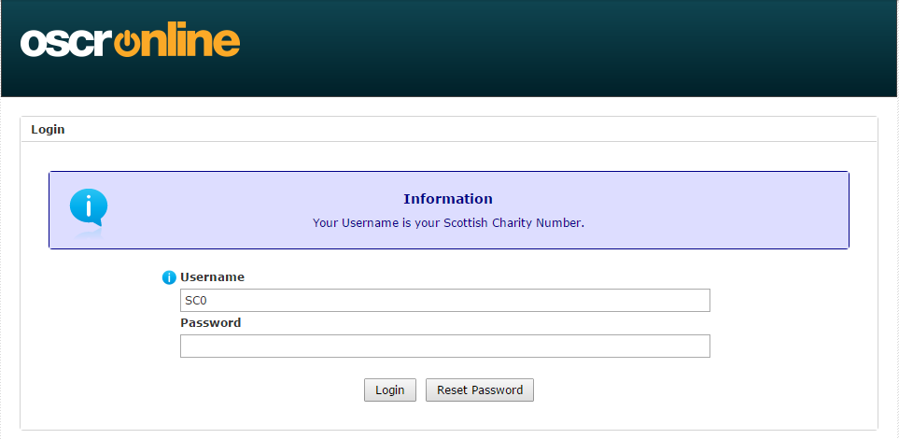
3. After you have logged in, select ‘Click here to complete your Annual Return’ to start the process.
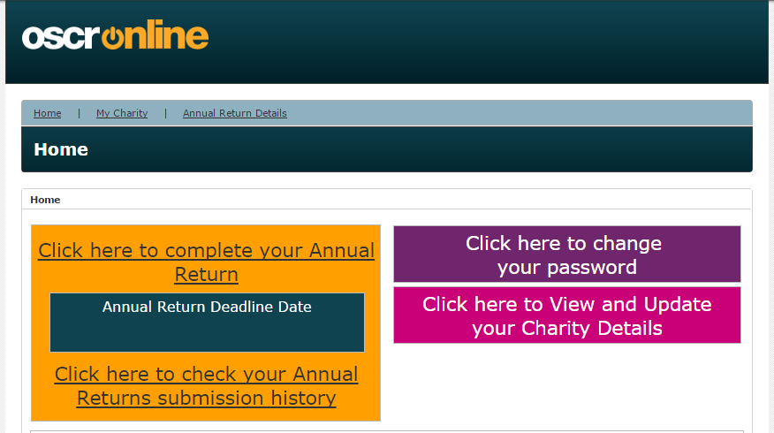
6 things to know before you start your online annual return
1. The ‘i’ symbol will give you a more detailed explanation of a question.
2. Answers to questions with this symbol will appear on the Scottish charity register.
3. If you don’t know the answer to a question, or if you want to come back later, please click ‘Save’ at the bottom of the screen.
The online annual return will be saved as ‘Draft’. You can retrieve the saved online annual return and complete the remainder on another day.
4. Only put whole numbers in boxes where a number is required, you don't have to put in pence or a pound sign.
5. The online system will only ask you the questions your charity needs to answer.
After completing Section A, charities with a gross income of £25,000 or more will have to fill in Section B and charities with a gross income of £250,000 or more will have to complete Sections B and C.

6. If you publish your accounts on your own website, please send us the link when asked in the online annual return, as this is the best way of us sharing your accounts with the public.

Completing an online annual return: Key Charity Details
This information will already be filled in using the information we hold about your charity.
Charity Number
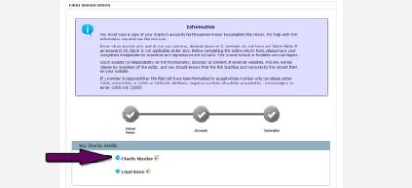
You will see that on this page the charity number will already be filled in. Each Scottish charity has a six-digit reference number with the prefix SC followed by a zero and then five digits (SC0xxxxx). This number is shown on the Scottish Charity Register

Legal Name
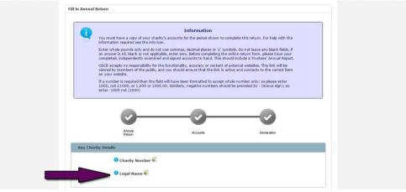
The legal name of your charity is shown on the Scottish Charity Register. You must seek OSCR’s consent if you want to change your charity’s name – guidance about this can be found on our website at http://www.oscr.org.uk/charities/managing-yourcharity/making-changes-to-your-charity
If your charity changes it name and we give our consent, the ‘Legal Name’ will be updated and a field will appear titled ‘Former Legal Name’ with the former name.
Completing an online annual return: Section A
There are different questions on an online annual return depending on the size of the charity, but every charity must answer Section A.
Section A is spread across two pages. After that, questions that don't apply to your charity won't appear on your online annual return.
If you are a Cross Border charity or a Registered Social Landlord, some of the questions may not appear because they are not relevant.
If something isn't right, you won't be able to continue after you click ‘Save & next’ and there will be an error message in red next to the question that needs changed.
Confirm principal contact details/supply changes
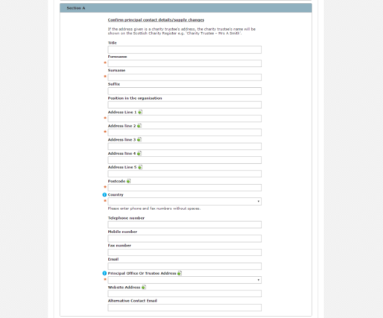
The initial questions in Section A will already be filled in using the information we hold about your charity.
This includes the contact details for your charity’s principal contact.
If you need to make changes to the contact details, you can do so where indicated on the form.
A SCIO’s contact must live in Scotland.
Please enter phone and fax numbers without spaces.
There are a few questions on this page that we would like to explain further.
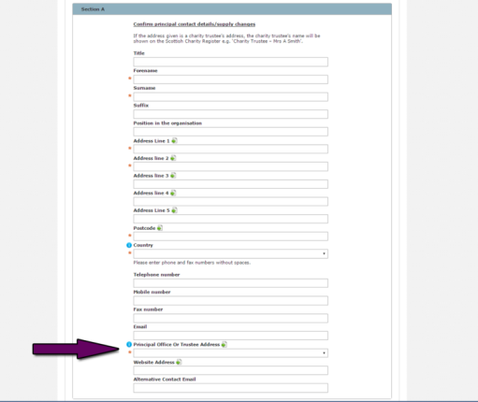
The Scottish Charity Register must contain a separate entry for each charity. This should contain the address of the principal office of the charity. Where the charity does not have a principal office, you will need to supply the name and address of one of its charity trustees. This information will be shown on the Scottish Charity Register (for example ‘Charity Trustee – Mrs A Smith’).
The Principal Office or Trustee Address must be an address at which you will be able to deal with all official notices and letters which you receive from OSCR. If you use a PO Box number, you must still provide a physical address and postcode.
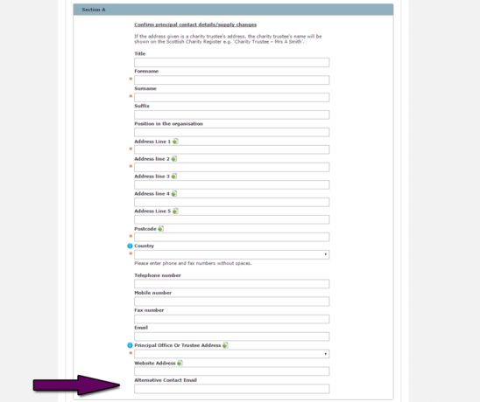
We can use the Alternative Contact Email to get in touch with the charity if there are any problems with the principal email address.
When all of the details are complete and correct, hit ‘Save & Next’.
1. Accounting Reference Date
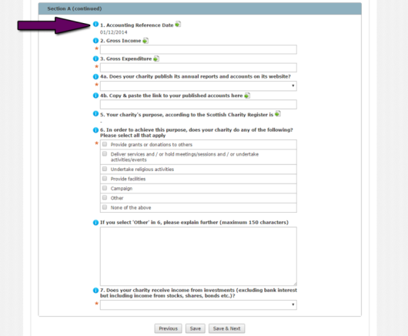
This is the date of your charity’s financial year end, sometimes known as the year end date or period end date. This information is shown on the Scottish Charity Register. This information will already be filled in.
Changing your Accounting Reference Date will change the date your annual return and accounts are due (the deadline is 9 months following your year end date). If you want to change the Accounting Reference Date, save your progress, go to ‘Home’ then ‘Click here to View and Update your Charity Details’ and finally ‘Update’ and make the necessary change.
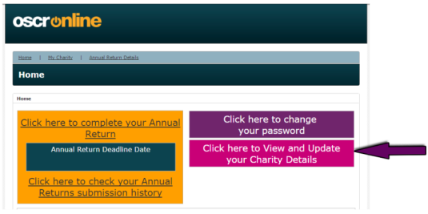
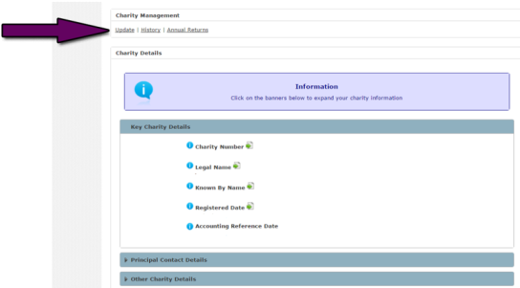
2. Gross Income
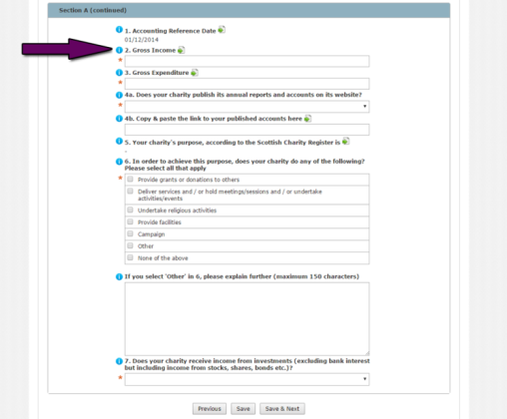
This is the total income from:
- total receipts if your charity prepares receipts and payments accounts
OR
- the Statement of Financial Activities if your charity is preparing accrued accounts.
Receipt of any donated asset which legally has to be held within a permanent or expendable endowment fund should not be included.
3. Gross Expenditure
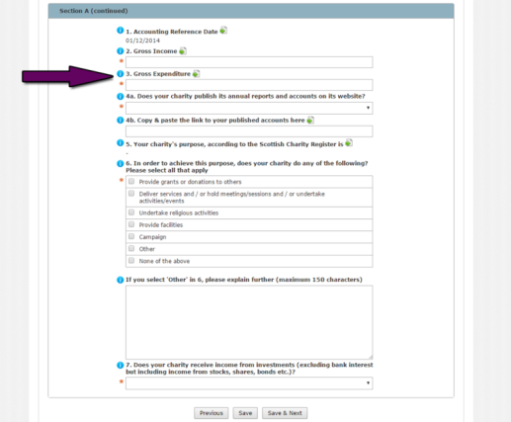
This is the total expenditure from:
- total payments if your charity prepares receipts and payments accounts
OR
- the Statement of Financial Activities if your charity is preparing accrued accounts.
4a. Does your charity publish its annual reports and accounts on its website?
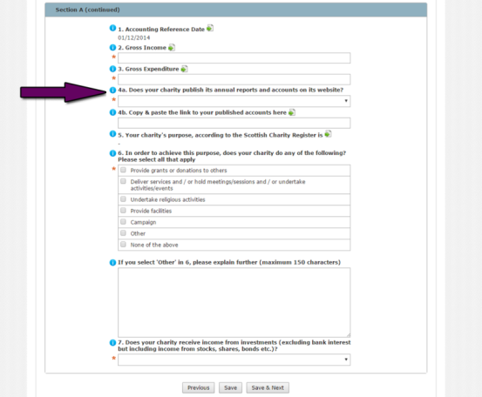
If you publish the accounts on your charity’s own website answer ‘yes’ to this question and insert the direct link in section 4b. OSCR will include this link to your accounts information on your charity’s register entry.
It is a great way of you reaching a wider public, as you can also include other information you would like the public to see on the page that contains your accounts.
4b. Copy and paste the link to your published accounts here
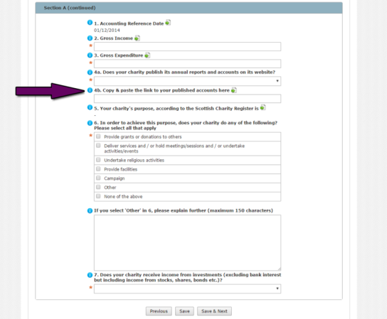
Add the link to where we can find the accounts on your charity’s website.
If you do this, this link will appear in the 'Latest Accounts' column in your charity's entry in the Scottish Charity Register.

This is a great way for a charity to share their reports and accounts on our register. If you do not provide a link, your charity's register extract may contain a set of redacted accounts published by OSCR (depending on its legal form or income threshold), or a link to another regulator that may hold your accounts. Providing a link to us can have the added bonus of your charity using the linked page on your website to share other information about its activities and impact. Please note you will still have to upload accounts later in the online annual return even when you give us a link.
5. & 6. Charitable purpose and activity
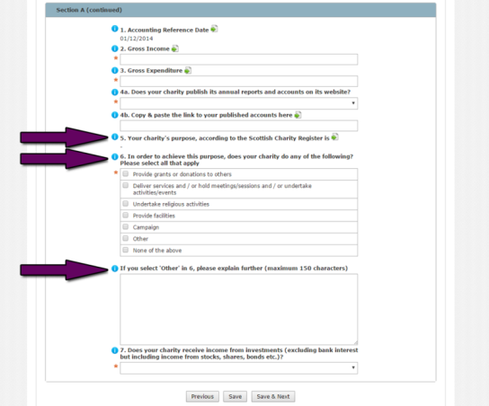
Your charity’s purpose is stated on the charity’s entry on the Scottish Charity Register.
In order to achieve the purposes stated on the Register, does your charity do any of the things in this list? Please tick all the options that apply, and if your charity does any things not listed, please describe these in the space provided under ‘Other’.
7. Does your charity receive income from investments (excluding bank interest but including income from stocks, shares, bonds etc.)?
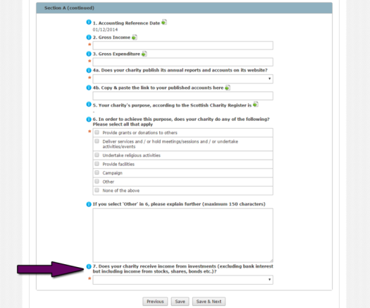
If your charity receives income from investments – for example stocks, shares or bonds, please choose yes. For the purposes of this question, we do not include bank interest as investment income.
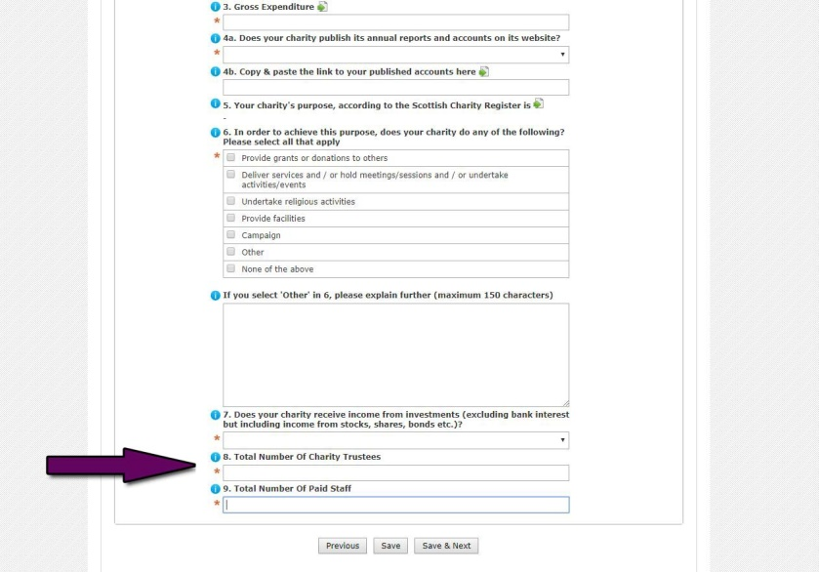
8. & 9. Total Number of Charity Trustees and Paid Staff
A charity trustee is a person having general control or management of the running of a charity. Enter the number of trustees and staff in these questions at the accounting period end date.

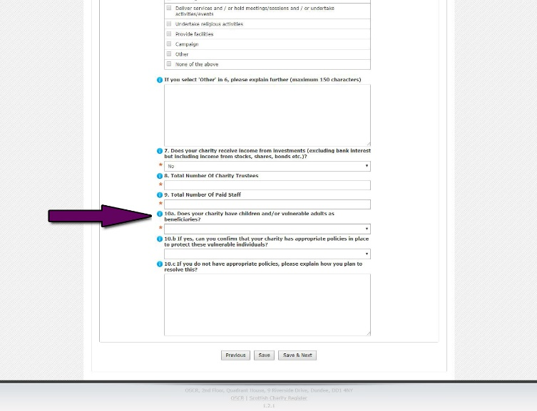
10a, b and c. Safeguarding
Please let us know if your charity has children or vulnerable adults as beneficiaries of your charitable activities.
Read our Safeguarding Guidance for information on what you might need to do depending on your charitable activities

Cross Border Charities
For Cross Border charities, (those registered with both OSCR and the Charity Commission for England and Wales) the Information Return has been replaced by one specific additional Yes/No question on the online annual return. This question is about undertaking activities in Scotland and will only appear if relevant.
Save & next
If your charity has a gross income of less than £25k, when you click ‘Save and Next’ you will be asked to submit the charity’s required documentation.
Click here for instructions on how to submit documentation.
If your charity's gross income is more than £25k, you will be asked more questions on the next page.

Completing an online annual return: Section B
Charities with a gross income of £25,000 or more will now be asked additional questions.
Remember, if you need help, click on the 'i' buttons for question explanations.
B.1 When did the charity trustees last look at and consider the content of the charity's governing document?
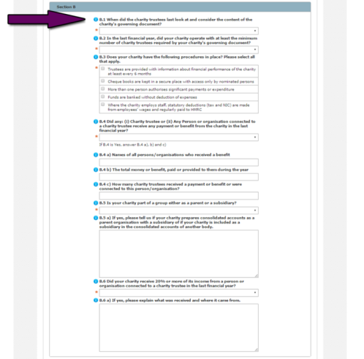
Your charity may know its governing document as a constitution, articles, rules or trust deed. Please tell us when the charity trustees last looked at and thought about the governing document.
B.2 In the last financial year, did your charity operate with at least the minimum number of charity trustees required by your charity's governing document?
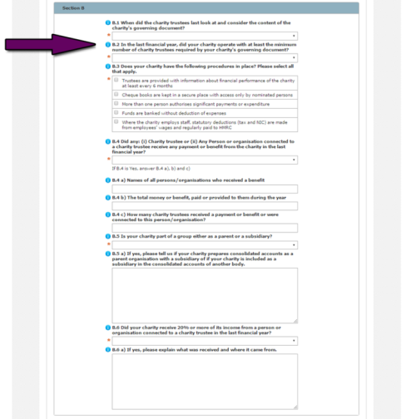
A Scottish Charitable Incorporated Organisation (SCIO) must have at least three charity trustees as stated in the SCIO Regulations. For other legal forms, there is no legal number of charity trustees but it is good practice to have at least three.
Most charity governing documents (your charity may know this document as a constitution, articles, rules or trust deed) will set out a minimum number of charity trustees who must be present to be able to make decisions for the charity.

B.3 Does your charity have the following procedures in place?
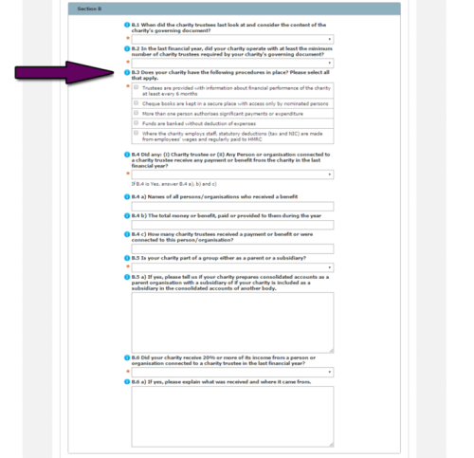
In the box below this question we list basic financial control procedures for charities. They may not be applicable to every charity, however for many these procedures will be an important part of managing the charity’s finances and fulfilling charity trustee duties.
B.4 Did any: (i) Charity trustee or (ii) Any Person or organisation connected to a charity trustee receive any payment or benefit from the charity in the last financial year?
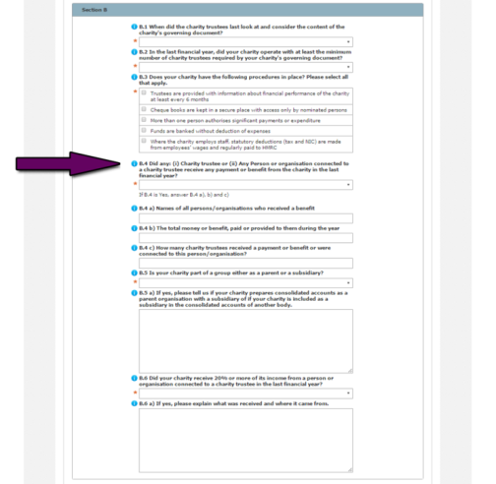
Charity trustees are people involved in the management and control of a charity, you may call yourselves a committee, a board, Directors or something less formal – the charity trustees for the last financial year should be listed in your charity’s Trustees’ Annual Report.
A person or organisation is connected to a charity trustee if they fall into one of the following categories:
- spouses, civil partners and cohabitees of a charity trustee
- child, stepchild, parent, grandchild, grandparent, brother or sister of a charity trustee (and a spouse of any such person)
- an institution controlled by a charity trustee or a person connected with them or two or more trustees/connected persons when taken together
- a corporate body or company in which the charity trustee or a person connected with them has a substantial interest, or
- a Scottish partnership (business) in which the charity trustee or, a person connected with them, is a partner.
Please tell us about any payment or benefit received by a charity trustee or person connected with a charity trustee.
Out of pocket expenses paid to charity trustees, for instance travel expenses to attend meetings, should not be included in this section.

B.5 Is your charity part of a group either as a parent or a subsidiary?
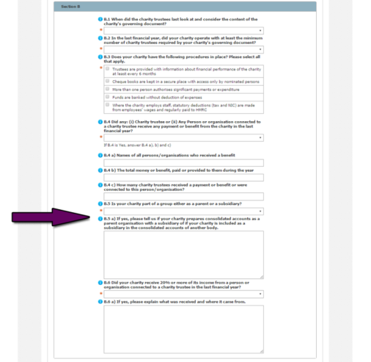
A charity is part of a group if it is:
- a parent (which owns a subsidiary company)
- a subsidiary company or
- a connected trading company.
Where there is a close relationship with an umbrella charity or a number of funds (such as in a Church) this does not mean a charity is part of a group.
Consolidated accounts are accounts which consolidate the results of the group.
If you are a parent charity and prepare consolidated accounts these should be submitted and used to prepare your online annual return. If you are a subsidiary or connected company you should submit your own individual accounts.
B.6 Did your charity receive 20% or more of its income from a person or organisation connected to a charity trustee in the last financial year?
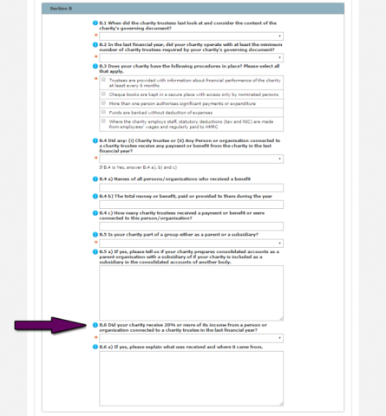
Where your charity has received 20% or more of its income from a person or organisation connected to a charity trustee in the last financial year, please provide the details requested on the form.
You can find the definition of a person or organisation that is connected to a charity trustee in B.4.
Save & Next
Click ‘Save & Next’.
If your charity has a gross income of £25,000 or more but less than £250,000 you will now be asked to submit your required documentation.
Click here for instructions on how to submit documentation.
If your charity has a gross income of £250,000 or more, you will be asked to complete Section C

Completing an online annual return: Section C
Charities with a gross income of £250,000 or more will now be asked additional questions.
The headings of C1 – C10 are per a SORP compliant Statement of Financial Activities (SoFA) which you should legally be preparing at this income level.
Remember, if you need help, click on the 'i' buttons for question explanations.
C.1 Donations and legacies
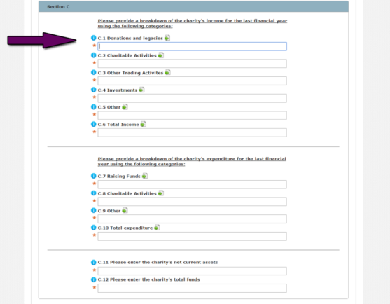
This is the ‘voluntary income’ of the charity. Where a charity receives a gift for which there is no expectation of a benefit it should be included here.
This category includes:
- donations and gifts made by individuals or companies
- legacies – money or property left to a charity in a will
- general grants
- membership subscriptions and sponsorships where there is no benefit
- donated goods, services and facilities and,
- gift aid.
C.2 Charitable Activities
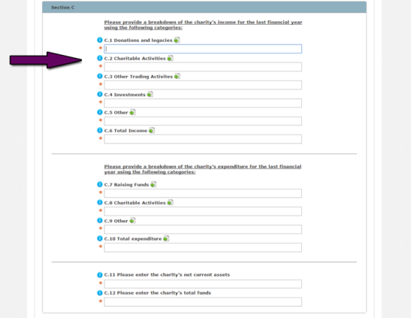
This is income which is received through carrying out a charitable activity. This will mainly be trading which is within the charity’s purpose(s), such as:
- sales from a workshop whose purpose is to provide employment training,
- admission charges received by a heritage charity, or
- fees charged for admission to a play by a theatre group.
Income which is ancillary to a charity’s activities, such as the selling of ice cream by the theatre group at their play, should also be included here.
C.3 Other Trading Activities
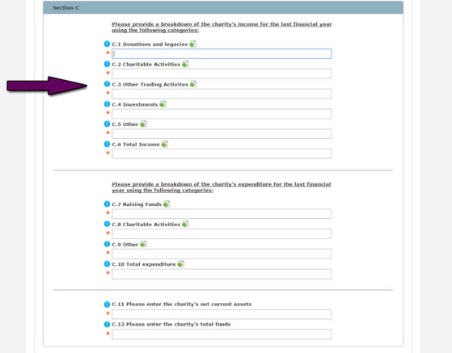
This includes income from trading activities which are not within the charitable purpose(s) and income from fundraising events.
Any income from the sale of donated goods should also be included here.
C.4 Investments
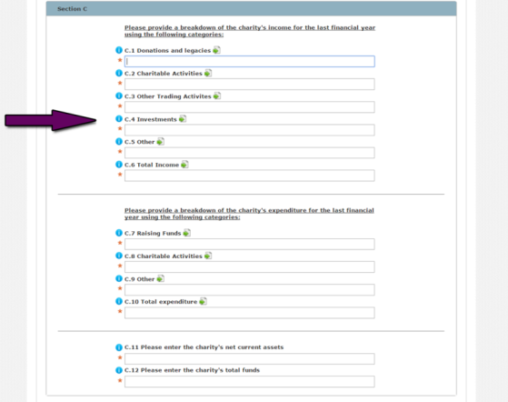

Income received from assets held by the charity for investment purposes. This includes interest received, dividend income and rental income on investment properties.
C.5 Other
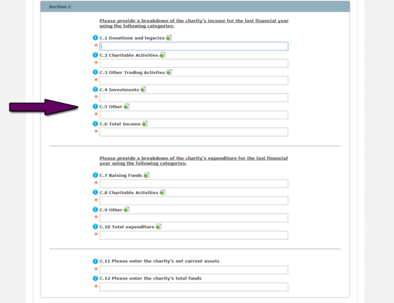
Any items which cannot be classified under the income headings. Gains on sale of fixed assets will be shown here.
C.6 Total Income
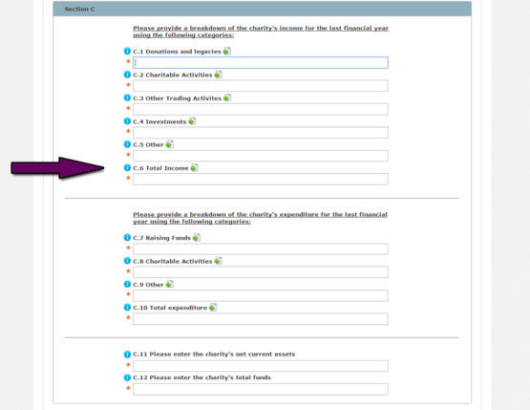
This is the total income of the charity for the period as shown in the accounts.
C.7 Raising Funds
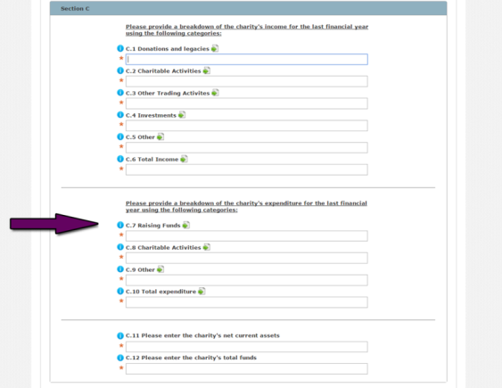

This is all the money spent by the charity to generate funds for its charitable purposes.
This includes costs of seeking donations, costs associated with a fundraising event, operation of charity shops, the operation of a trading company and advertising costs.
C.8 Charitable Activities
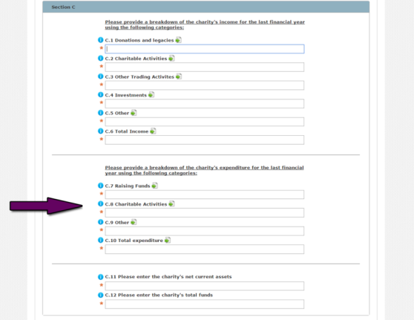
This is the money that the charity spends on carrying out its charitable activities.
Charities may carry out their activities through direct service provision, grant provision or a combination of both.
All costs relating to this should be included here, including any support or governance costs which relate to the charitable activities.
C.9 Other
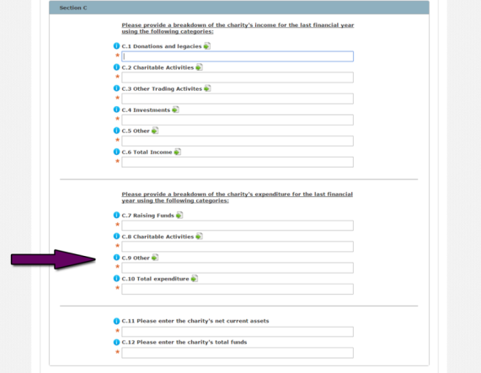
Any items which cannot be classified under the expenditure headings. Generally there should be no requirement to use this.
C.10 Total expenditure
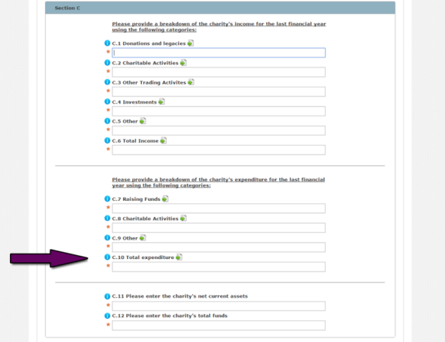
This is the total expenditure of the charity for the period as shown in the accounts.
C.11 Please enter the charity's net current assets
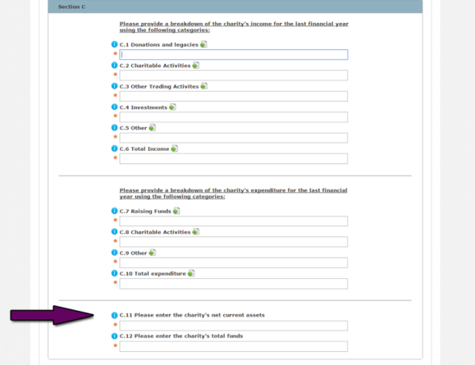
At this income level you are required to prepare fully accrued accounts and this field will normally be cash and bank balances plus debtors plus other current assets minus liabilities payable within one year.
C.12 Please enter the charity's total funds
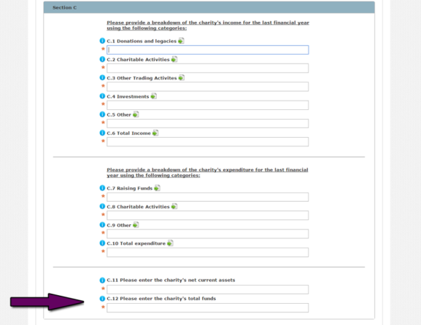
At this income level you are required to prepare fully accrued accounts and this field will be clear from the balance sheet. It will normally be net current assets plus fixed assets and long-term investments, less any long-term liabilities.
Save & Next
Once you have completed the questions, click ‘Save & Next’.
You will now be asked to submit your required documentation.
Click here for instructions on how to submit documentation.

Completing an online annual return: Sending documentation
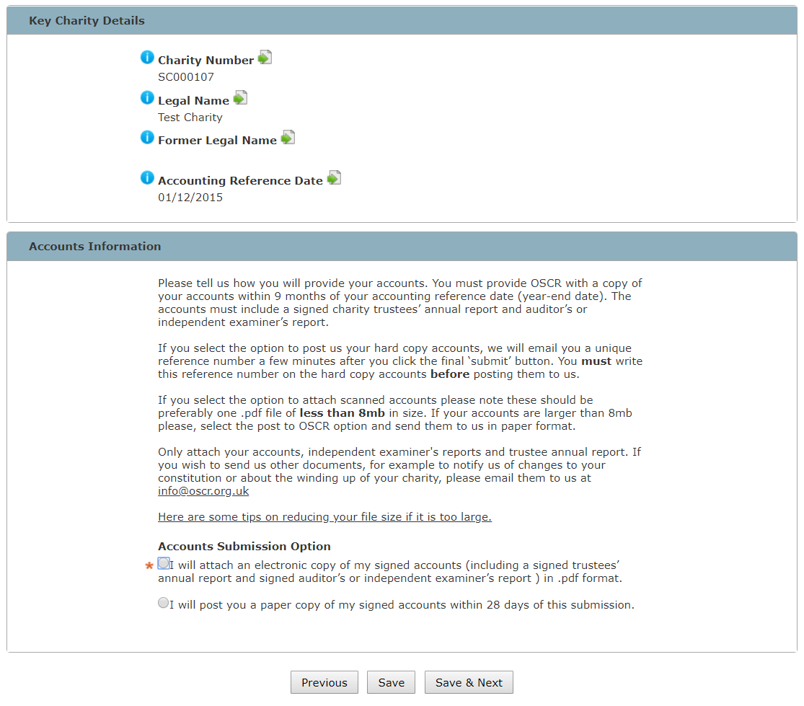
In this section, you will be asked to tell us how you will submit your required additional documentation.
You should submit the following:
- A signed copy of the charity’s appropriate accounts
- A signed Trustees’ annual report
- A signed auditor or independent examination report.
All other documentation should be sent to OSCR by email to info@oscr.org.uk. Notifications, constitutions, consent etc. should NOT be attached to OSCR Online.
There are some templates for these documents on our website in the Receipts and Payments Accounts section. These templates apply to all non-company charities whose gross annual income is less than £250,000 (£100,000 for periods starting before 1 April 2011) and where there is no requirement within the charity's governing document or by funders to prepare accrued accounts.
We recommend that you send us the required documentation online.
Each document must be less than 8MB in size. For tips on how to reduce file size click here.
Because we require a signature on the documentation however, you may have to print documents off and scan them back into your computer before uploading them.
If you choose to post your documents, we must receive them within 28 days of the online annual return submission. It is your responsibility to make sure we receive the documents.
If you choose to submit your documents online, the next screen will ask you to upload them.
Uploading documentation
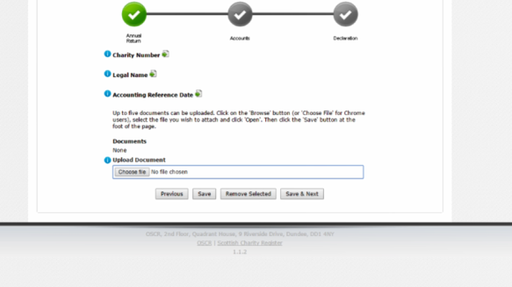
1. Click ‘Choose file’ and choose the document you are going to load
2. Once you have selected the file, click ‘Save’ to add it to the list and add another.
3. When you have uploaded all of your documents, click ‘Save & next’ to continue.

Completing an online annual return: Submission and next steps
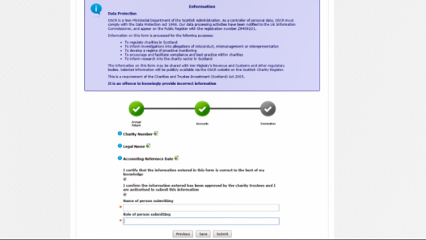
The final screen will ask the person submitting the online annual return to acknowledge and complete a few statement questions.
Once you've answered them and clicked ‘Submit’, the process is complete.
We will use the information you've provided to update the Scottish Charity Register and you’ll get an email when this has been done.
If anything is wrong, we will contact you.

