Trustees’ Annual Report
For the Year Ended 30 September 2025

1. Charity Details
Charity Name: Stornoway Running and Athletics Club
Charity Number: SC051704
Principal Office: Stornoway, Isle of Lewis
Constitution: Scottish Charitable Incorporated Organisation (SCIO), adopted 25 April 2022

2. Trustees at Year End (30 September 2025)
Chairperson: Donald N Macaskill
Vice-Chair Person: Annabel Bain
Treasurer: Patrick Macleod
Secretary: William MacRury
Membership Secretary: Ian Ferris
Welfare Officer: Muriel Macleod
Senior Female Captain: Sarah Maclean
Senior Male Captain: Michael Macmillan
Parent Representative: Susan Macleod
The following individuals contributed to the club’s operations but were co-opted and not trustees:
Fundraising Officer: Sarah Maclean
Senior Representative: Carmen Morrison
Trip Organiser: Dougie Neally
Coaching Co-ordinator: Maureen Stewart

3. Recruitment and Appointment of Trustees
Trustees are appointed from among the members of the organisation. Co-opted trustees may be appointed for their specialist skills. All trustees retire at each AGM but are eligible for re-election.

4. Charitable Purposes
As per the constitution, the club’s charitable purposes are:
- Advancement of public participation in sport and physical activity
- Advancement of education through development of sports coaches

5. Achievements and Performance
During the year ending 30 September 2025, Stornoway Running and Athletics Club (SRAC) continued to deliver on its charitable objectives by promoting athletics and community engagement across the Western Isles. Key achievements include:
- Event Delivery: The club successfully organised the Stornoway Half Marathon and 10K, with 208 and 90 finishers respectively. In addition the mini-marathon had 157 finishers. Hugh Mackenzie trail race was well attended. Junior events included an OGM in April, trips to Benbecula for an OGM and Inverness for the North District T&F Champs in May, Combined Events Champs in June and Western Isles T&F Champs in August. There was also great community and club engagement in the wacky races and XC season.
- Junior Development: The club maintained a strong junior programme with 143 junior members and a waiting list of over 25 children.
- Awards and Recognition: The club celebrated its senior and junior athletes with a comprehensive prizegiving.
- International Representation: Several SRAC athletes participated in the WIIGA squad at the NatWest International Island Games in Orkney.
- The club celebrated it’s 40th Anniversary and gave out special Recognition Awards to Malcolm Bain, Stuart Baird, Jim Bruce, Eve Carrington Maciver, Lewis Macalpine, Murdo Alex Mackenzie, Neil Macrury and Lorraine Morrison, in addition the following Honorary Life Memberships were awarded to Bethany Clement, Norman Ferguson and Donnie Macleod.
- Financial Stewardship: The club received £5,350 in grants, supporting a total income of £41,252 and charitable expenditure of £37,711.

6. Financial Review
The club’s financial position remains stable and well-managed, with the following highlights from the accounts for the year ended 30 September 2025:
- Total Income: £41,252
- Member contributions to events: £20,592
- Memberships/Subscriptions: £14,956
- Kit/Other: £354
- Grants Received: £5,350
- Local Authority: £2,100
- Private Sector: £3,250
- Total Expenditure: £37,004
- Event Costs and Travel: £37,004
- Trustee Remuneration and Expenses: No remuneration or expenses were paid to trustees during the reporting period.
- Reserves Policy: The club maintains unrestricted funds to support ongoing activities in competitive athletics, including travel, accommodation, competition fees, kit, and equipment.

7. Governance and Management
The club is governed by a Board of Trustees elected from the membership. The structure includes members and trustees, with decision-making conducted through AGMs and regular board meetings. The club complies with its constitution and OSCR requirements, maintaining proper records and financial controls.

8. Affiliations
The club is affiliated to Scottish Athletics and complies with its rules and guidance.

9. Public Benefit
SRAC’s activities during the year provided clear public benefit in line with its charitable purposes. The club promoted health and wellbeing through inclusive access to athletics training and events for all age groups. Outreach programmes in schools and holiday clubs encouraged participation among children and young people, including those from rural and disadvantaged areas. The club’s fundraising and charitable giving supported local causes, and its volunteer-led structure ensured community involvement and stewardship. Recognition as Club of the Year and participation in international events demonstrate the club’s positive impact on both local and wider communities.

10. Declaration
This report was approved by the trustees on 22/06/2026 and signed on their behalf by:
Signature: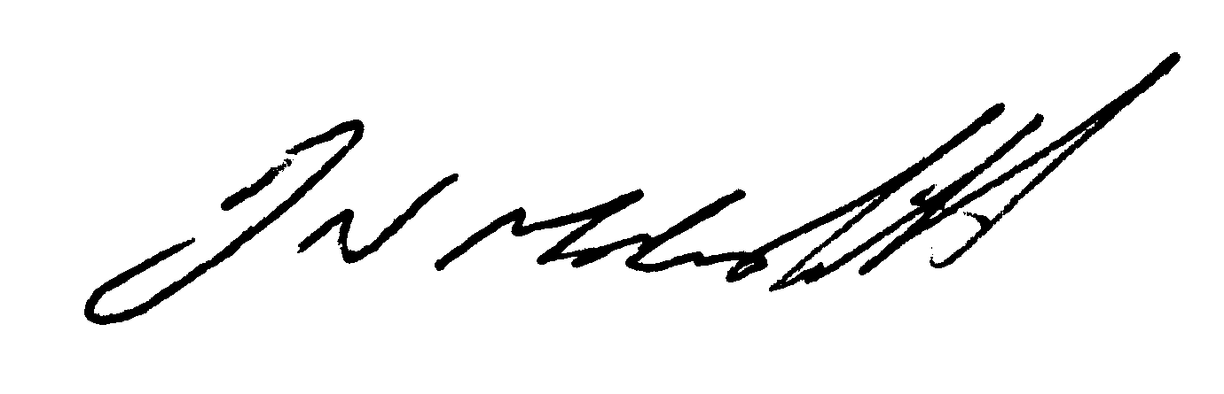
Name: Donald N Macaskill
Position: Chairperson

