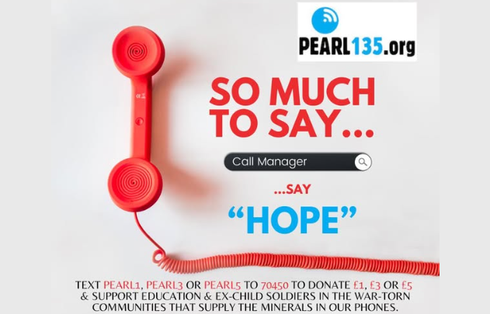

Getting the message of hope out to phone users
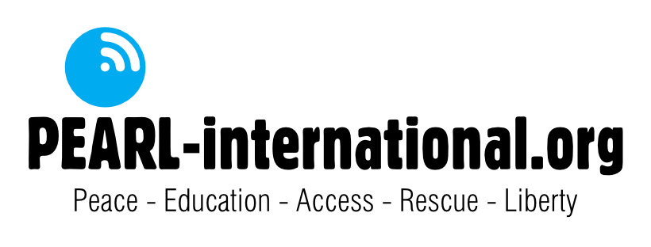

2025
Annual Report
Pearl International (Scottish Charitable Incorporated Organisation SC050711)

Charity Details & Governance

Registered office
23 Lochty Street
Carnoustie
DD7 6EE

Bank Website:
Co-operative bank www.pearl-international.org
Gordon Street
Glasgow

Charity Status
Pearl International was established as a Scottish Charitable Incorporated Organisation on 21 January 2021.

Governance
Pearl International is overseen by a trustees’ team (Board) comprised in 2025 of Rhona Goss, Callum Henderson and Izzy Henderson. New trustees are appointed through application to, and approval by, the present board and must number between 3-12 inclusive.

The governing document is a Scottish Charitable Incorporated Organisation Constitution.
The charity trustees are the organisation’s only members and comprise the organisation’s board.
As of 31st December 2025, the trustees were, Callum Henderson (Treasurer), Rhona Goss (Secretary and Izzy Henderson (Chair).

Mission
The charity’s mission is to transform the impact of the technology we consume by raising awareness of conflict minerals and inspiring responsible choices that fund education and rehabilitate child soldiers, turning cycles of injustice into pathways to peace.

Financial Information
Abbreviated Financial Report 1 January 2025 to 31 December 2025

Notes on finances

Income rose 193% year on year to £5,926
Charitable activity payments (projects in DRC) rose 69% to £5,590

Objectives and activities
The objectives of the charity are:
- The prevention or relief of poverty amongst needy persons through the support of vulnerable children, the rehabilitation of child soldiers and the development of associated, sustainable projects in The Democratic Republic of Congo and such other countries as the trustees decide.
- The advancement of education through supporting access to education and training in The Democratic Republic of Congo and such other countries as the trustees decide.
- The advancement of human rights and conflict resolution through relieving the needs of former child soldiers in The Democratic Republic of Congo and such other countries as the trustees decide.
- The promotion and advocacy of justice, equality and sustainability through raising awareness of the impact of conflict minerals, the exploitation of child soldiers, vulnerable persons and associated issues.

Activities

£4,000 was given to help build the third classroom at Marajeo Primary School.

£150 was also given for the emergency appeal in March 2025 for those displaced by the conflict in which the M23 took over Goma. Funds were used to provide emergency food for those who had lost everything in the displacement and looting which took place during the conflict.

Four classes at Marajeo primary school in Rubaya are now supported by Pearl International, totalling £1440.

The value of the school support given in 2025, both in terms of classroom building and in terms of teacher support was particularly seen in the harrowing days at the start of 2026 when four landslides killed over 1000 people, including many children. The presence of the children in the school rather than in the mines, ensured that, for the daytime landslides, many lives were saved.

The promotion and advocacy of justice, equality and sustainability through awareness raising was carried out consistently through the charity’s social media channels and communications. We are very grateful to Sandra Convery for her help in an overhaul of the Pearl International website. Sandra put a lot of time and effort into this and we are delighted with the result.

Future Plans

Over the coming year the trustees will campaign to furnish the new accommodation for former female child soldiers at Hope Village, to continue building classrooms at Rubaya Marajeo school and to build the charity’s reach to new donors, volunteers and supporters.

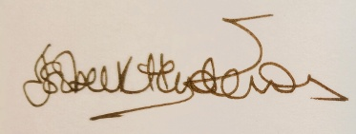

Izzy Henderson (Chair)

