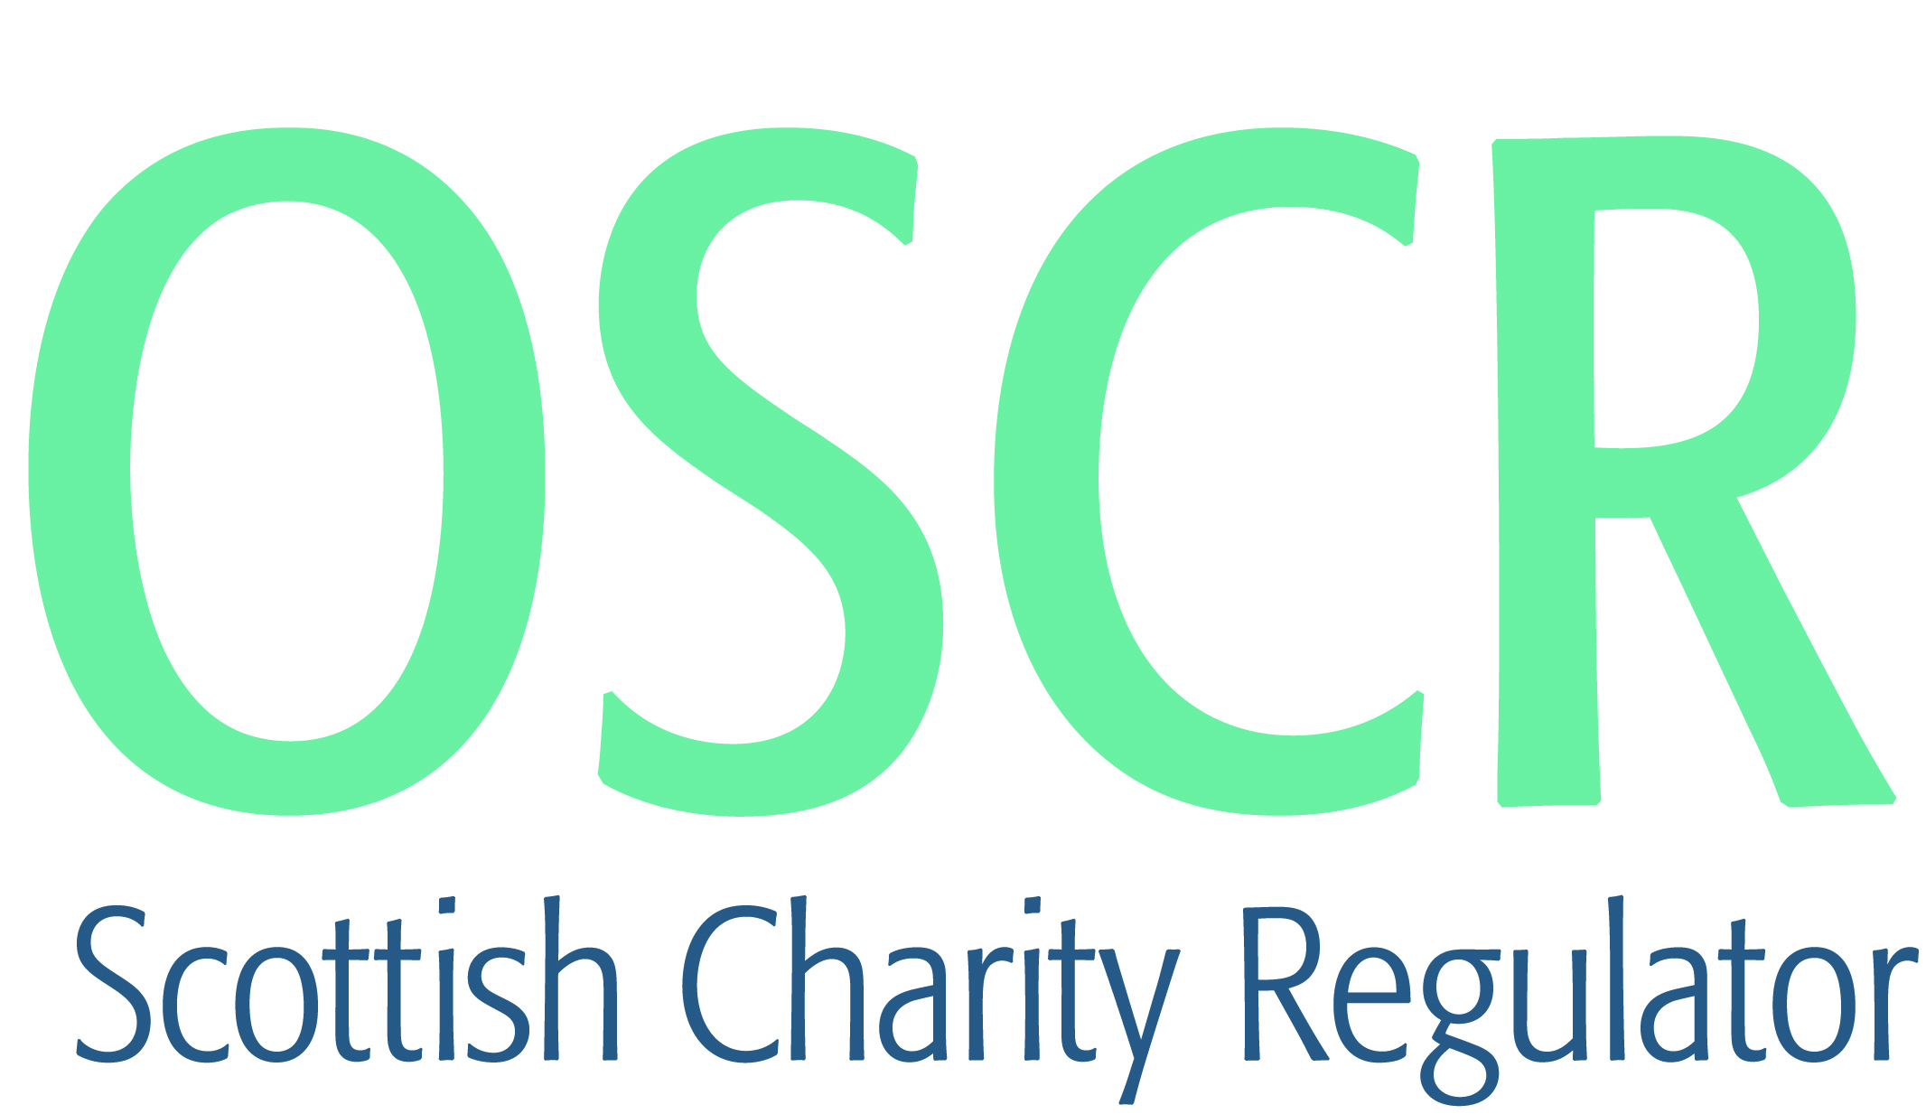

**Charities granted charitable status 1 to 29 February 2020**

|  |  |  |
| --- | --- | --- |
| **Charity Number** | **Charity Name** | **Constitutional Form** |
| [**SC049954**](https://www.oscr.org.uk/search-charity-register/charity-extract/?charitynumber=SC049954) | **1st Dalkeith Rainbows** | **Unincorporated Association** |
| [**SC049964**](https://www.oscr.org.uk/search-charity-register/charity-extract/?charitynumber=SC049964) | **3 Glens Community Care** | **SCIO** |
| [**SC049936**](https://www.oscr.org.uk/search-charity-register/charity-extract/?charitynumber=SC049936) | **3 Good Deeds** | **Unincorporated Association** |
| [**SC049960**](https://www.oscr.org.uk/search-charity-register/charity-extract/?charitynumber=SC049960) | **Abbeygreen New Church** | **Company** |
| [**SC049976**](https://www.oscr.org.uk/search-charity-register/charity-extract/?charitynumber=SC049976) | **Abington Community Development Group** | **SCIO** |
| [**SC049991**](https://www.oscr.org.uk/search-charity-register/charity-extract/?charitynumber=SC049991) | **Alisdair Cameron Trust** | **SCIO** |
| [**SC049959**](https://www.oscr.org.uk/search-charity-register/charity-extract/?charitynumber=SC049959) | **ANYiSO SCIO** | **SCIO** |
| [**SC049969**](https://www.oscr.org.uk/search-charity-register/charity-extract/?charitynumber=SC049969) | **Auchinloch Development Trust (SCIO)** | **SCIO** |
| [**SC049974**](https://www.oscr.org.uk/search-charity-register/charity-extract/?charitynumber=SC049974) | **Blantrye Community Trust** | **SCIO** |
| [**SC049978**](https://www.oscr.org.uk/search-charity-register/charity-extract/?charitynumber=SC049978) | **Buittle Quest** | **SCIO** |
| [**SC049935**](https://www.oscr.org.uk/search-charity-register/charity-extract/?charitynumber=SC049935) | **Busby Amateur Football Club** | **Unincorporated Association** |
| [**SC049961**](https://www.oscr.org.uk/search-charity-register/charity-extract/?charitynumber=SC049961) | **ButeFest SCIO** | **SCIO** |
| [**SC049926**](https://www.oscr.org.uk/search-charity-register/charity-extract/?charitynumber=SC049926) | **CAREA Community Hub** | **Unincorporated Association** |
| [**SC049987**](https://www.oscr.org.uk/search-charity-register/charity-extract/?charitynumber=SC049987) | **Carsphairn Heritage Initiative** | **SCIO** |
| [**SC049927**](https://www.oscr.org.uk/search-charity-register/charity-extract/?charitynumber=SC049927) | **Centre81 Steering Group** | **SCIO** |
| [**SC049982**](https://www.oscr.org.uk/search-charity-register/charity-extract/?charitynumber=SC049982) | **Council of Deans of Health** | **Company** |
| [**SC049934**](https://www.oscr.org.uk/search-charity-register/charity-extract/?charitynumber=SC049934) | **CPISRA (SCIO)** | **SCIO** |
| [**SC049988**](https://www.oscr.org.uk/search-charity-register/charity-extract/?charitynumber=SC049988) | **Disadvantaged Children Cancer Support (SCIO)** | **SCIO** |
| [**SC049916**](https://www.oscr.org.uk/search-charity-register/charity-extract/?charitynumber=SC049916) | **Dumfries Station Trust** | **SCIO** |
| [**SC049914**](https://www.oscr.org.uk/search-charity-register/charity-extract/?charitynumber=SC049914) | **Eco Foodshare Larders** | **SCIO** |
| [**SC049979**](https://www.oscr.org.uk/search-charity-register/charity-extract/?charitynumber=SC049979) | **Edinburgh Southern Orienteering Club** | **SCIO** |
| [**SC049984**](https://www.oscr.org.uk/search-charity-register/charity-extract/?charitynumber=SC049984) | **First Step Group** | **SCIO** |
| [**SC049922**](https://www.oscr.org.uk/search-charity-register/charity-extract/?charitynumber=SC049922) | **First Tier SCIO** | **SCIO** |
| [**SC049970**](https://www.oscr.org.uk/search-charity-register/charity-extract/?charitynumber=SC049970) | **Fletcher's Fund** | **CIO** |
| [**SC049981**](https://www.oscr.org.uk/search-charity-register/charity-extract/?charitynumber=SC049981) | **Forres Osprey Bus SCIO** | **SCIO** |
| [**SC049947**](https://www.oscr.org.uk/search-charity-register/charity-extract/?charitynumber=SC049947) | **Forres Skate Park Initiative [SCIO]** | **SCIO** |
| [**SC049986**](https://www.oscr.org.uk/search-charity-register/charity-extract/?charitynumber=SC049986) | **Forth Valley Pride (SCIO)** | **SCIO** |
| [**SC049949**](https://www.oscr.org.uk/search-charity-register/charity-extract/?charitynumber=SC049949) | **Friends of Fetlar Kirk** | **SCIO** |
| [**SC049938**](https://www.oscr.org.uk/search-charity-register/charity-extract/?charitynumber=SC049938) | **Friends of Hyndhead** | **Unincorporated Association** |
| [**SC049944**](https://www.oscr.org.uk/search-charity-register/charity-extract/?charitynumber=SC049944) | **Glasgow Chinese Badminton Club** | **SCIO** |
| [**SC049990**](https://www.oscr.org.uk/search-charity-register/charity-extract/?charitynumber=SC049990) | **Glenrothes & District Pipe Band 2010** | **Unincorporated Association** |
| [**SC049983**](https://www.oscr.org.uk/search-charity-register/charity-extract/?charitynumber=SC049983) | **Gregarious Chinwag SCIO** | **SCIO** |
| [**SC049952**](https://www.oscr.org.uk/search-charity-register/charity-extract/?charitynumber=SC049952) | **Harom Galamb Scotland** | **SCIO** |
| [**SC049919**](https://www.oscr.org.uk/search-charity-register/charity-extract/?charitynumber=SC049919) | **Heart of Newhaven Community SCIO** | **SCIO** |
| [**SC049933**](https://www.oscr.org.uk/search-charity-register/charity-extract/?charitynumber=SC049933) | **Helensburgh & Lomond Community First Responders** | **Unincorporated Association** |
| [**SC049994**](https://www.oscr.org.uk/search-charity-register/charity-extract/?charitynumber=SC049994) | **Helensburgh Baptist Church SCIO** | **SCIO** |
| [**SC049943**](https://www.oscr.org.uk/search-charity-register/charity-extract/?charitynumber=SC049943) | **Hen Harrier Action** | **Company** |
| [**SC049967**](https://www.oscr.org.uk/search-charity-register/charity-extract/?charitynumber=SC049967) | **Hillcrest Foundation** | **SCIO** |
| [**SC049950**](https://www.oscr.org.uk/search-charity-register/charity-extract/?charitynumber=SC049950) | **Hope Church Aviemore SCIO** | **SCIO** |
| [**SC049918**](https://www.oscr.org.uk/search-charity-register/charity-extract/?charitynumber=SC049918) | **Iconic Ultimate Warrior** | **SCIO** |
| [**SC049955**](https://www.oscr.org.uk/search-charity-register/charity-extract/?charitynumber=SC049955) | **Insh Community Holdings** | **SCIO** |
| [**SC049985**](https://www.oscr.org.uk/search-charity-register/charity-extract/?charitynumber=SC049985) | **Inverawe Community Woodland** | **SCIO** |
| [**SC049923**](https://www.oscr.org.uk/search-charity-register/charity-extract/?charitynumber=SC049923) | **Jed Hearts Here** | **SCIO** |
| [**SC049957**](https://www.oscr.org.uk/search-charity-register/charity-extract/?charitynumber=SC049957) | **Jenny Lee Foundation (SCIO)** | **SCIO** |
| [**SC049946**](https://www.oscr.org.uk/search-charity-register/charity-extract/?charitynumber=SC049946) | **Kinlochleven Community Benefit Fund SCIO** | **SCIO** |
| [**SC049992**](https://www.oscr.org.uk/search-charity-register/charity-extract/?charitynumber=SC049992) | **Korean Language Classes** | **SCIO** |
| [**SC049937**](https://www.oscr.org.uk/search-charity-register/charity-extract/?charitynumber=SC049937) | **Liberton Vaulters** | **SCIO** |
| [**SC049924**](https://www.oscr.org.uk/search-charity-register/charity-extract/?charitynumber=SC049924) | **Links Archers** | **SCIO** |
| [**SC049958**](https://www.oscr.org.uk/search-charity-register/charity-extract/?charitynumber=SC049958) | **Lockerbie Squash & Racketball Club (SCIO)** | **SCIO** |
| [**SC049972**](https://www.oscr.org.uk/search-charity-register/charity-extract/?charitynumber=SC049972) | **Lovebridge Community Church [SCIO]** | **SCIO** |
| [**SC049980**](https://www.oscr.org.uk/search-charity-register/charity-extract/?charitynumber=SC049980) | **McGowan Community Hub** | **SCIO** |
| [**SC049925**](https://www.oscr.org.uk/search-charity-register/charity-extract/?charitynumber=SC049925) | **Moodiesburn Parish Church of Scotland** | **Unincorporated Association** |
| [**SC049929**](https://www.oscr.org.uk/search-charity-register/charity-extract/?charitynumber=SC049929) | **Nairn Family Trust** | **SCIO** |
| [**SC049917**](https://www.oscr.org.uk/search-charity-register/charity-extract/?charitynumber=SC049917) | **New 2 You Ayrshire** | **SCIO** |
| [**SC049928**](https://www.oscr.org.uk/search-charity-register/charity-extract/?charitynumber=SC049928) | **Newton Mearns Islamic Centre** | **SCIO** |
| [**SC049966**](https://www.oscr.org.uk/search-charity-register/charity-extract/?charitynumber=SC049966) | **Noranside Christian Retreat Centre and Monastery** | **SCIO** |
| [**SC049930**](https://www.oscr.org.uk/search-charity-register/charity-extract/?charitynumber=SC049930) | **Northern Pilgrims' Way Group SCIO** | **SCIO** |
| [**SC049971**](https://www.oscr.org.uk/search-charity-register/charity-extract/?charitynumber=SC049971) | **Nurture the Borders SCIO** | **SCIO** |
| [**SC049956**](https://www.oscr.org.uk/search-charity-register/charity-extract/?charitynumber=SC049956) | **Prayer Space Dundee SCIO** | **SCIO** |
| [**SC049945**](https://www.oscr.org.uk/search-charity-register/charity-extract/?charitynumber=SC049945) | **Raise Lanka (SCIO)** | **SCIO** |
| [**SC049975**](https://www.oscr.org.uk/search-charity-register/charity-extract/?charitynumber=SC049975) | **Renew Wellbeing** | **CIO** |
| [**SC049977**](https://www.oscr.org.uk/search-charity-register/charity-extract/?charitynumber=SC049977) | **Reuse and Thrive** | **SCIO** |
| [**SC049973**](https://www.oscr.org.uk/search-charity-register/charity-extract/?charitynumber=SC049973) | **Robert Burns Ellisland Trust (SCIO)** | **SCIO** |
| [**SC049911**](https://www.oscr.org.uk/search-charity-register/charity-extract/?charitynumber=SC049911) | **Scran Academy SCIO** | **SCIO** |
| [**SC049920**](https://www.oscr.org.uk/search-charity-register/charity-extract/?charitynumber=SC049920) | **Strathaven Evangelical Church (SCIO)** | **SCIO** |
| [**SC049951**](https://www.oscr.org.uk/search-charity-register/charity-extract/?charitynumber=SC049951) | **Strength and Honour** | **SCIO** |
| [**SC049931**](https://www.oscr.org.uk/search-charity-register/charity-extract/?charitynumber=SC049931) | **Temple Old Kirk Friends [SCIO]** | **SCIO** |
| [**SC049915**](https://www.oscr.org.uk/search-charity-register/charity-extract/?charitynumber=SC049915) | **The Aeromodellers Association(Scotland) Ltd** | **Unincorporated Association** |
| [**SC049921**](https://www.oscr.org.uk/search-charity-register/charity-extract/?charitynumber=SC049921) | **The Batchelor Trust** | **Trust** |
| [**SC049941**](https://www.oscr.org.uk/search-charity-register/charity-extract/?charitynumber=SC049941) | **The Cellardyke Trust [SCIO]** | **SCIO** |
| [**SC049948**](https://www.oscr.org.uk/search-charity-register/charity-extract/?charitynumber=SC049948) | **The Children's Cancer and Leukaemia Group** | **CIO** |
| [**SC049932**](https://www.oscr.org.uk/search-charity-register/charity-extract/?charitynumber=SC049932) | **The Clay Studio (Inverness)** | **SCIO** |
| [**SC049989**](https://www.oscr.org.uk/search-charity-register/charity-extract/?charitynumber=SC049989) | **The Flourishing Well** | **Unincorporated Association** |
| [**SC049953**](https://www.oscr.org.uk/search-charity-register/charity-extract/?charitynumber=SC049953) | **The Forest Policy Group (SCIO)** | **SCIO** |
| [**SC049965**](https://www.oscr.org.uk/search-charity-register/charity-extract/?charitynumber=SC049965) | **The Murgitroyd Foundation** | **Trust** |
| [**SC049968**](https://www.oscr.org.uk/search-charity-register/charity-extract/?charitynumber=SC049968) | **The Orthodox Monastery of all Celtic Saints** | **SCIO** |
| [**SC049962**](https://www.oscr.org.uk/search-charity-register/charity-extract/?charitynumber=SC049962) | **The Well Community Church (Crookston Castle) (SCIO)** | **SCIO** |
| [**SC049942**](https://www.oscr.org.uk/search-charity-register/charity-extract/?charitynumber=SC049942) | **Wester Ross Radio Ltd** | **Company** |
| [**SC049939**](https://www.oscr.org.uk/search-charity-register/charity-extract/?charitynumber=SC049939) | **Wigtown Bay Coastal Rowing Club (SCIO)** | **SCIO** |
| [**SC049993**](https://www.oscr.org.uk/search-charity-register/charity-extract/?charitynumber=SC049993) | **Wouldn't Change A Thing** | **Company** |
| [**SC049940**](https://www.oscr.org.uk/search-charity-register/charity-extract/?charitynumber=SC049940) | **Zimbabwe Scotland Society** | **Unincorporated Association** |