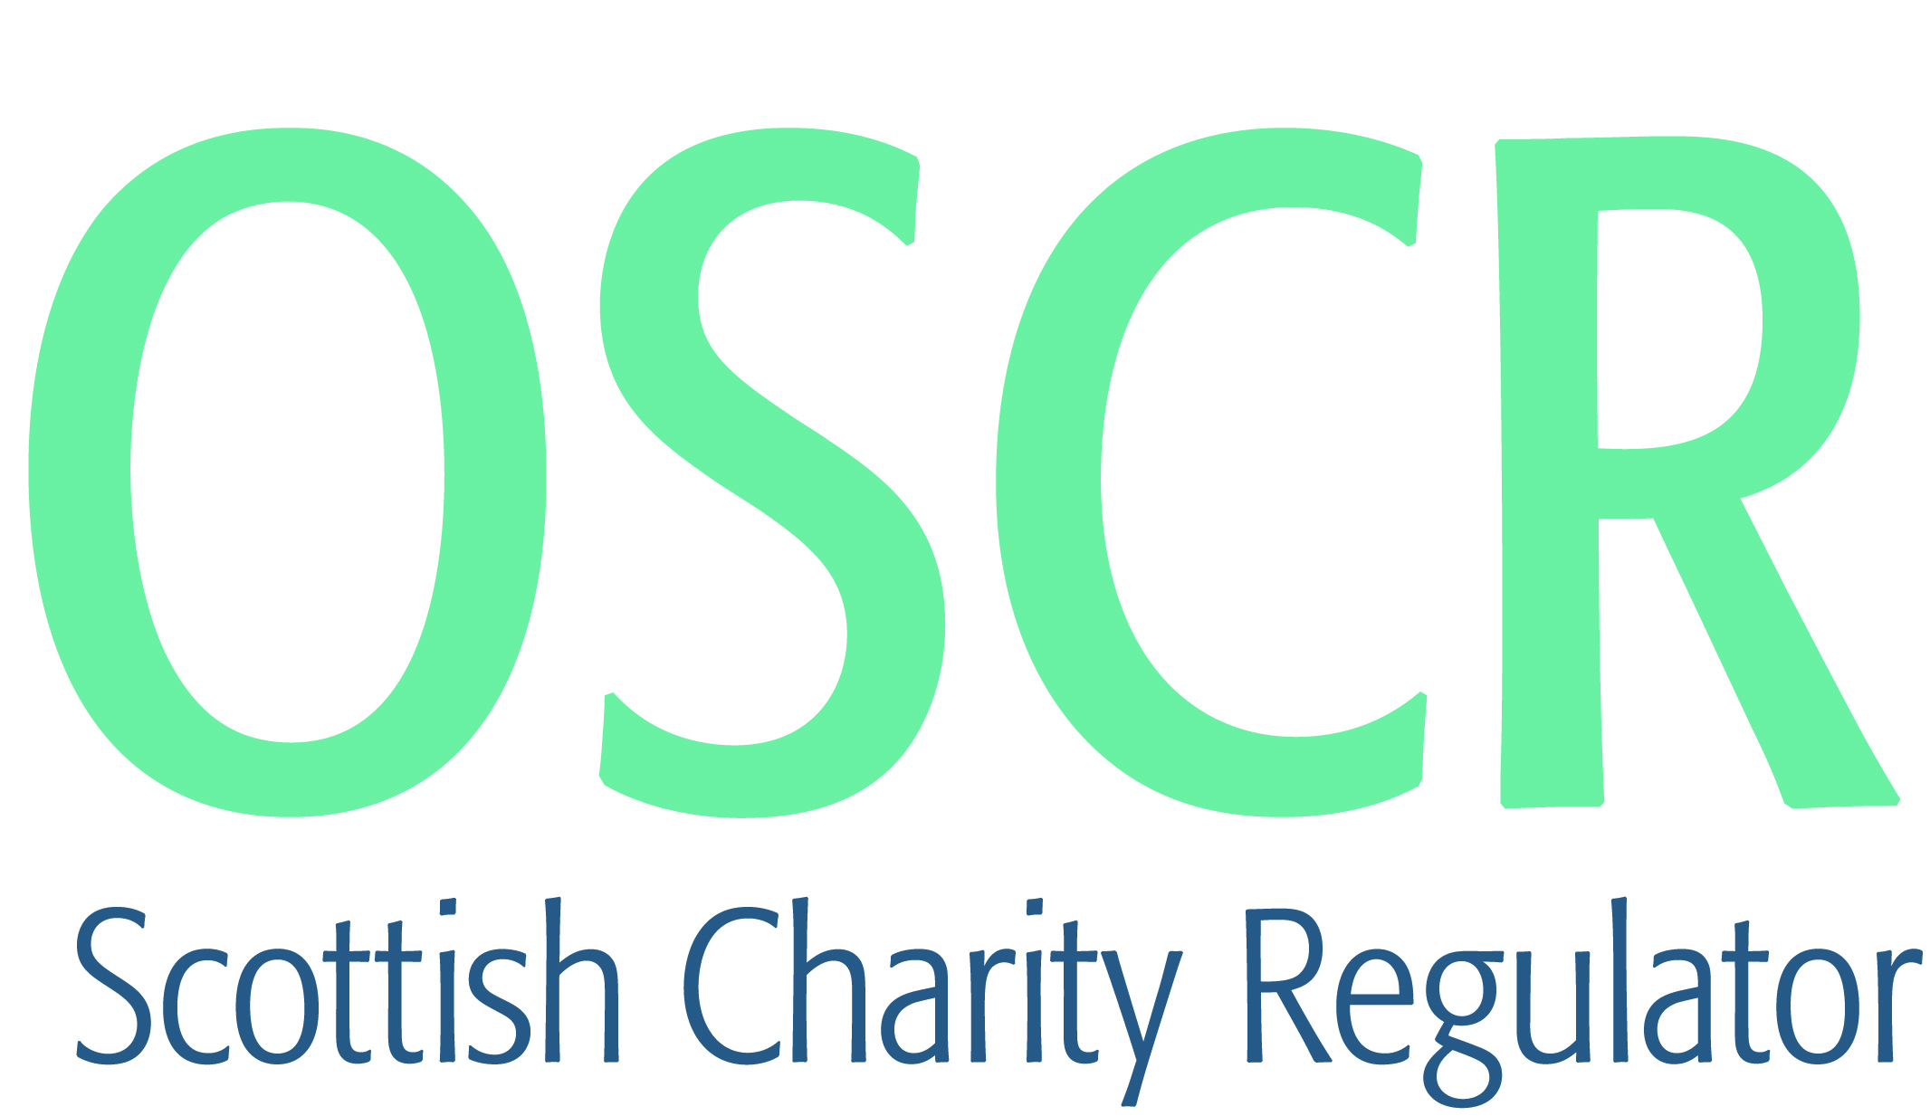

**Charities granted charitable status 1 to 30 September 2021**

|  |  |  |
| --- | --- | --- |
| **Charity Number** | **Charity name** | **Legal form** |
| [SC051230](https://www.oscr.org.uk/search-charity-register/charity-extract/?charitynumber=SC051230) | Jung Shim Ltd | Company |
| [SC051231](https://www.oscr.org.uk/search-charity-register/charity-extract/?charitynumber=SC051231) | Nnanyelugo Inc | SCIO |
| [SC051232](https://www.oscr.org.uk/search-charity-register/charity-extract/?charitynumber=SC051232) | Knocknagael Limited | Company |
| [SC051233](https://www.oscr.org.uk/search-charity-register/charity-extract/?charitynumber=SC051233) | 1st Fife Virtual Guide Unit | UnincorporatedAssociation |
| [SC051234](https://www.oscr.org.uk/search-charity-register/charity-extract/?charitynumber=SC051234) | Reuse Scotland SCIO | SCIO |
| [SC051235](https://www.oscr.org.uk/search-charity-register/charity-extract/?charitynumber=SC051235) | Dalbeattie and District Lions Club | SCIO |
| [SC051236](https://www.oscr.org.uk/search-charity-register/charity-extract/?charitynumber=SC051236) | Morvern Games and Gala Week | SCIO |
| [SC051237](https://www.oscr.org.uk/search-charity-register/charity-extract/?charitynumber=SC051237) | The Peregrine Ardnamurchan Charitable Trust | Trust |
| [SC051238](https://www.oscr.org.uk/search-charity-register/charity-extract/?charitynumber=SC051238) | Chirnside Common Good Association (SCIO) | SCIO |
| [SC051239](https://www.oscr.org.uk/search-charity-register/charity-extract/?charitynumber=SC051239) | The Robertson Family Charitable Foundation | Trust |
| [SC051240](https://www.oscr.org.uk/search-charity-register/charity-extract/?charitynumber=SC051240) | Bute Advice Centre SCIO | SCIO |
| [SC051241](https://www.oscr.org.uk/search-charity-register/charity-extract/?charitynumber=SC051241) | Golden Oldies | Company |
| [SC051242](https://www.oscr.org.uk/search-charity-register/charity-extract/?charitynumber=SC051242) | Balmacara Community Trust | Company |
| [SC051243](https://www.oscr.org.uk/search-charity-register/charity-extract/?charitynumber=SC051243) | Galashiels Baptist Church SCIO | SCIO |
| [SC051244](https://www.oscr.org.uk/search-charity-register/charity-extract/?charitynumber=SC051244) | The Remembrance Garden Society of High Valleyfield, Newmills and Torryburn | SCIO |
| [SC051245](https://www.oscr.org.uk/search-charity-register/charity-extract/?charitynumber=SC051245) | Caithness Cycling Club | SCIO |
| [SC051246](https://www.oscr.org.uk/search-charity-register/charity-extract/?charitynumber=SC051246) | Fair Scotland | SCIO |
| [SC051247](https://www.oscr.org.uk/search-charity-register/charity-extract/?charitynumber=SC051247) | Kirkcaldy Ice Hockey Club Junior Development | SCIO |
| [SC051248](https://www.oscr.org.uk/search-charity-register/charity-extract/?charitynumber=SC051248) | Annan Town Band | SCIO |
| [SC051249](https://www.oscr.org.uk/search-charity-register/charity-extract/?charitynumber=SC051249) | The Ainslie Charitable Trust | Trust |
| [SC051250](https://www.oscr.org.uk/search-charity-register/charity-extract/?charitynumber=SC051250) | Kelty Hearts Community Club | SCIO |
| [SC051251](https://www.oscr.org.uk/search-charity-register/charity-extract/?charitynumber=SC051251) | The Ardchattan Centre | Company |
| [SC051252](https://www.oscr.org.uk/search-charity-register/charity-extract/?charitynumber=SC051252) | East Kilbride Boxing Academy | SCIO |
| [SC051253](https://www.oscr.org.uk/search-charity-register/charity-extract/?charitynumber=SC051253) | Alloway Village Hall | SCIO |
| [SC051254](https://www.oscr.org.uk/search-charity-register/charity-extract/?charitynumber=SC051254) | House of Praise Glasgow | SCIO |
| [SC051255](https://www.oscr.org.uk/search-charity-register/charity-extract/?charitynumber=SC051255) | The Friends of Inverleith Park (SCIO) | SCIO |
| [SC051256](https://www.oscr.org.uk/search-charity-register/charity-extract/?charitynumber=SC051256) | The Buchan Giving Tree (SCIO) | SCIO |
| [SC051257](https://www.oscr.org.uk/search-charity-register/charity-extract/?charitynumber=SC051257) | EDO ASSOCIATION EDINBURGH | UnincorporatedAssociation |
| [SC051258](https://www.oscr.org.uk/search-charity-register/charity-extract/?charitynumber=SC051258) | Inveresk Village Society SCIO | SCIO |
| [SC051259](https://www.oscr.org.uk/search-charity-register/charity-extract/?charitynumber=SC051259) | Fettes College | Company |
| [SC051260](https://www.oscr.org.uk/search-charity-register/charity-extract/?charitynumber=SC051260) | The Gowanbank Hub (SCIO) | SCIO |
| [SC051261](https://www.oscr.org.uk/search-charity-register/charity-extract/?charitynumber=SC051261) | Strathearn Cares SCIO | SCIO |
| [SC051262](https://www.oscr.org.uk/search-charity-register/charity-extract/?charitynumber=SC051262) | Saltoun Community Association SCIO | SCIO |
| [SC051263](https://www.oscr.org.uk/search-charity-register/charity-extract/?charitynumber=SC051263) | The Campaign for Freedom of Information in Scotland | SCIO |
| [SC051264](https://www.oscr.org.uk/search-charity-register/charity-extract/?charitynumber=SC051264) | Rising Stars (Charity) | SCIO |
| [SC051265](https://www.oscr.org.uk/search-charity-register/charity-extract/?charitynumber=SC051265) | BRAVO VICTOR | Company |
| [SC051266](https://www.oscr.org.uk/search-charity-register/charity-extract/?charitynumber=SC051266) | Portpatrick Community Development Trust (SCIO) | SCIO |
| [SC051267](https://www.oscr.org.uk/search-charity-register/charity-extract/?charitynumber=SC051267) | Kintore Allotments SCIO | SCIO |
| [SC051268](https://www.oscr.org.uk/search-charity-register/charity-extract/?charitynumber=SC051268) | Rothes Tennis Club 2021 | SCIO |
| [SC051269](https://www.oscr.org.uk/search-charity-register/charity-extract/?charitynumber=SC051269) | Dog Meat Trade Dachshund Rescue & Support Group | SCIO |
| [SC051270](https://www.oscr.org.uk/search-charity-register/charity-extract/?charitynumber=SC051270) | Ashfield Football Academy | SCIO |
| [SC051271](https://www.oscr.org.uk/search-charity-register/charity-extract/?charitynumber=SC051271) | Shetland Pride (SCIO) | SCIO |
| [SC051272](https://www.oscr.org.uk/search-charity-register/charity-extract/?charitynumber=SC051272) | Peterhead Athletics Club | SCIO |
| [SC051273](https://www.oscr.org.uk/search-charity-register/charity-extract/?charitynumber=SC051273) | Healy Arts (SCIO) | SCIO |
| [SC051274](https://www.oscr.org.uk/search-charity-register/charity-extract/?charitynumber=SC051274) | Inclusive Orkney (SCIO) | SCIO |
| [SC051275](https://www.oscr.org.uk/search-charity-register/charity-extract/?charitynumber=SC051275) | 116th City of Edinburgh Brownies | UnincorporatedAssociation |
| [SC051276](https://www.oscr.org.uk/search-charity-register/charity-extract/?charitynumber=SC051276) | Glassie Bike Park | SCIO |
| [SC051277](https://www.oscr.org.uk/search-charity-register/charity-extract/?charitynumber=SC051277) | Perth Baptist Church SCIO | SCIO |
| [SC051278](https://www.oscr.org.uk/search-charity-register/charity-extract/?charitynumber=SC051278) | Friends of Kings' Norton Foundation Uganda | UnincorporatedAssociation |
| [SC051279](https://www.oscr.org.uk/search-charity-register/charity-extract/?charitynumber=SC051279) | Friends of Springburn Park SCIO | SCIO |
| [SC051280](https://www.oscr.org.uk/search-charity-register/charity-extract/?charitynumber=SC051280) | Renal Agenesis UK | SCIO |
| [SC051281](https://www.oscr.org.uk/search-charity-register/charity-extract/?charitynumber=SC051281) | Round O Five O | SCIO |
| [SC051282](https://www.oscr.org.uk/search-charity-register/charity-extract/?charitynumber=SC051282) | Inspirited Minds | CIO |
| [SC051283](https://www.oscr.org.uk/search-charity-register/charity-extract/?charitynumber=SC051283) | Alloa Amateur Gymnastics Club | SCIO |
| [SC051284](https://www.oscr.org.uk/search-charity-register/charity-extract/?charitynumber=SC051284) | Respect Project | Company |
| [SC051285](https://www.oscr.org.uk/search-charity-register/charity-extract/?charitynumber=SC051285) | Distinctive Dance Academy (SCIO) | SCIO |
| [SC051286](https://www.oscr.org.uk/search-charity-register/charity-extract/?charitynumber=SC051286) | Seahorse Creative Arts and Publications | SCIO |
| [SC051287](https://www.oscr.org.uk/search-charity-register/charity-extract/?charitynumber=SC051287) | Our Future Edinburgh | SCIO |
| [SC051288](https://www.oscr.org.uk/search-charity-register/charity-extract/?charitynumber=SC051288) | The ROB Trust | Trust |
| [SC051289](https://www.oscr.org.uk/search-charity-register/charity-extract/?charitynumber=SC051289) | The Peedie Retreat [SCIO] | SCIO |
| [SC051290](https://www.oscr.org.uk/search-charity-register/charity-extract/?charitynumber=SC051290) | Kristin Linklater Voice Foundation | SCIO |
| [SC051291](https://www.oscr.org.uk/search-charity-register/charity-extract/?charitynumber=SC051291) | The Renaissance Club Charitable Foundation | SCIO |
| [SC051292](https://www.oscr.org.uk/search-charity-register/charity-extract/?charitynumber=SC051292) | Oldhamstocks Community Association SCIO | SCIO |
| [SC051293](https://www.oscr.org.uk/search-charity-register/charity-extract/?charitynumber=SC051293) | Hair and Beauty Charity | Company |
| [SC051294](https://www.oscr.org.uk/search-charity-register/charity-extract/?charitynumber=SC051294) | East Neuk Recovery Group Initiative (ENeRGI) (SCIO) | SCIO |
| [SC051295](https://www.oscr.org.uk/search-charity-register/charity-extract/?charitynumber=SC051295) | Rotary Club of Aberdeen Deeside Trust | SCIO |
| [SC051296](https://www.oscr.org.uk/search-charity-register/charity-extract/?charitynumber=SC051296) | Dysart Colliery Silver Band | SCIO |
| [SC051297](https://www.oscr.org.uk/search-charity-register/charity-extract/?charitynumber=SC051297) | Brora Community Enterprises | SCIO |
| [SC051298](https://www.oscr.org.uk/search-charity-register/charity-extract/?charitynumber=SC051298) | Caraidean Uibhist SCIO | SCIO |
| [SC051299](https://www.oscr.org.uk/search-charity-register/charity-extract/?charitynumber=SC051299) | KK Connecting Communities (SCIO) | SCIO |
| [SC051300](https://www.oscr.org.uk/search-charity-register/charity-extract/?charitynumber=SC051300) | The Royal Company of Merchants of the City of Edinburgh Charitable Trust | Trust |
| [SC051301](https://www.oscr.org.uk/search-charity-register/charity-extract/?charitynumber=SC051301) | Adam Mickiewicz Polish Cultural & Educational Association in Edinburgh SCIO | SCIO |
| [SC051302](https://www.oscr.org.uk/search-charity-register/charity-extract/?charitynumber=SC051302) | Dunfermline Men's Shed | SCIO |
| [SC051303](https://www.oscr.org.uk/search-charity-register/charity-extract/?charitynumber=SC051303) | Kirkcaldy Community Football Partnership SCIO | SCIO |
| [SC051304](https://www.oscr.org.uk/search-charity-register/charity-extract/?charitynumber=SC051304) | Wetwheels Foundation | Trust |
| [SC051305](https://www.oscr.org.uk/search-charity-register/charity-extract/?charitynumber=SC051305) | Research Data Scotland | Company |
| [SC051306](https://www.oscr.org.uk/search-charity-register/charity-extract/?charitynumber=SC051306) | Paws on Plastic | SCIO |
| [SC051307](https://www.oscr.org.uk/search-charity-register/charity-extract/?charitynumber=SC051307) | Wick Development Trust | Company |
| [SC051308](https://www.oscr.org.uk/search-charity-register/charity-extract/?charitynumber=SC051308) | Hermitage Academy Pupil Support and Development Group | UnincorporatedAssociation |
| [SC051309](https://www.oscr.org.uk/search-charity-register/charity-extract/?charitynumber=SC051309) | Larkfield Community Centre (SCIO) | SCIO |