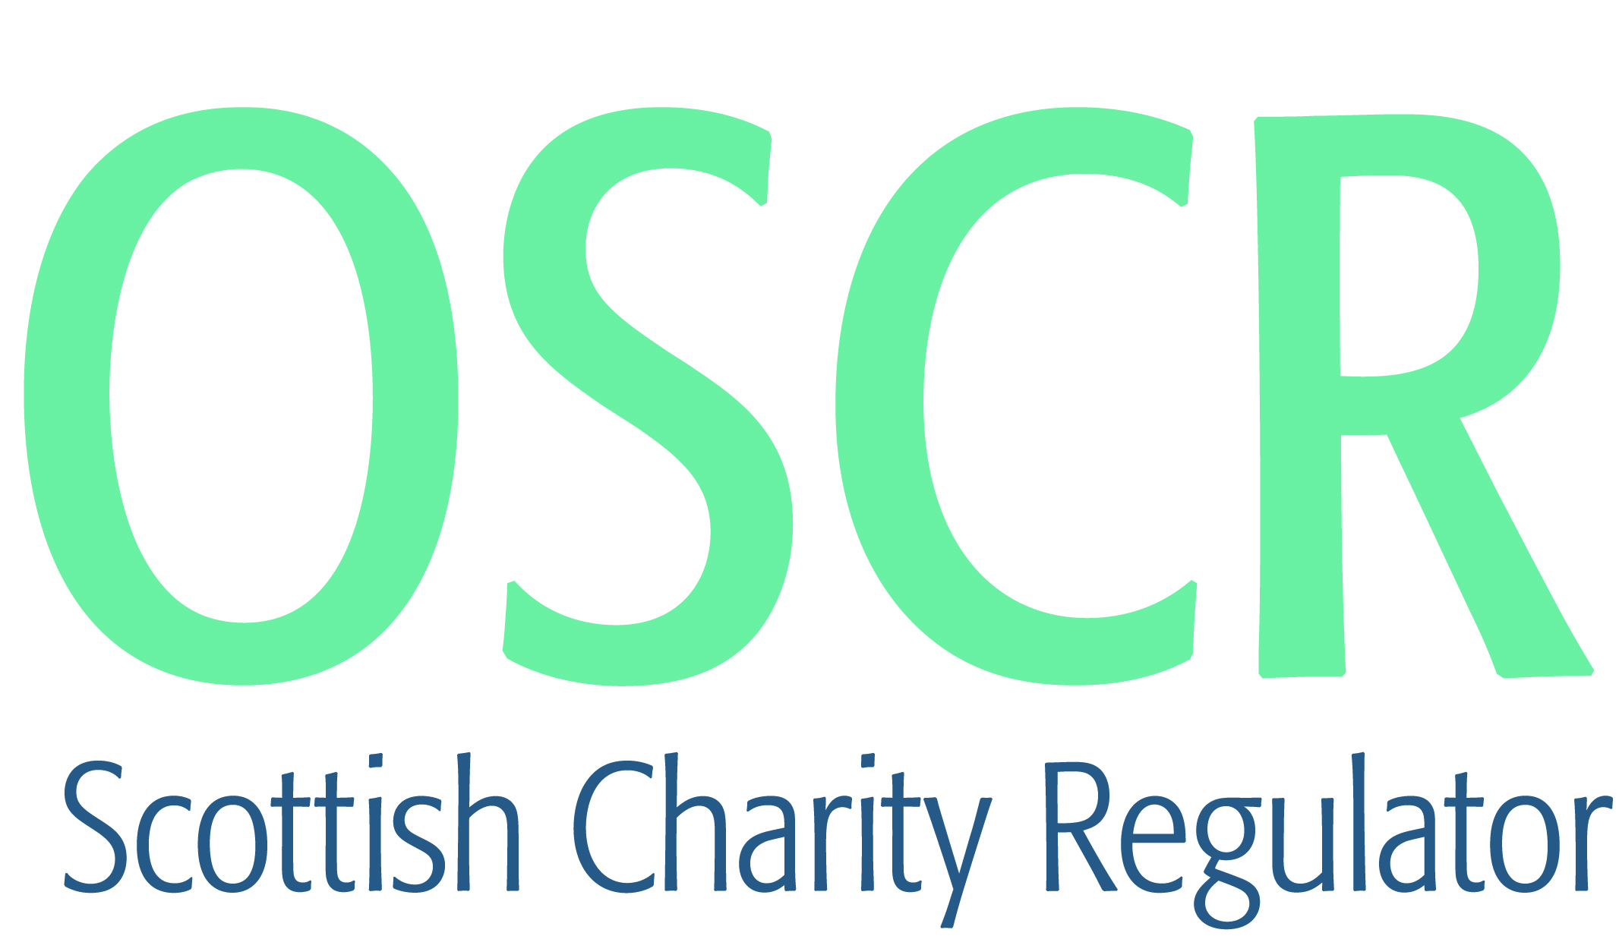

**Charities granted charitable status 1 to 31 August 2021**

|  |  |  |
| --- | --- | --- |
| **Charity Number** | **Charity Name** | **Constitutional Form** |
| [SC051167](https://www.oscr.org.uk/search-charity-register/charity-extract/?charitynumber=SC051167) | Baird TV Centenary | SCIO |
| [SC051168](https://www.oscr.org.uk/search-charity-register/charity-extract/?charitynumber=SC051168) | Scenic Sandbank | Company |
| [SC051169](https://www.oscr.org.uk/search-charity-register/charity-extract/?charitynumber=SC051169) | Darvel Hedgehog Highways Group | Unincorporated Association |
| [SC051170](https://www.oscr.org.uk/search-charity-register/charity-extract/?charitynumber=SC051170) | Arbroath RMVCC - Royal Marines Volunteer Cadet Corps (SCIO) | SCIO |
| [SC051171](https://www.oscr.org.uk/search-charity-register/charity-extract/?charitynumber=SC051171) | Charlie Charlie One | SCIO |
| [SC051172](https://www.oscr.org.uk/search-charity-register/charity-extract/?charitynumber=SC051172) | Future Youth (SCIO) | SCIO |
| [SC051173](https://www.oscr.org.uk/search-charity-register/charity-extract/?charitynumber=SC051173) | Hellenic Alliance of Scotland | Unincorporated Association |
| [SC051174](https://www.oscr.org.uk/search-charity-register/charity-extract/?charitynumber=SC051174) | Angulimala,The Buddhist Prison Chaplaincy | CIO |
| [SC051175](https://www.oscr.org.uk/search-charity-register/charity-extract/?charitynumber=SC051175) | TSC Support Scotland | SCIO |
| [SC051176](https://www.oscr.org.uk/search-charity-register/charity-extract/?charitynumber=SC051176) | Bahar | Unincorporated Association |
| [SC051177](https://www.oscr.org.uk/search-charity-register/charity-extract/?charitynumber=SC051177) | FlowFest | SCIO |
| [SC051178](https://www.oscr.org.uk/search-charity-register/charity-extract/?charitynumber=SC051178) | Thistle Youth Football Club | SCIO |
| [SC051179](https://www.oscr.org.uk/search-charity-register/charity-extract/?charitynumber=SC051179) | Little Lambs Baby and Toddler Group [SCIO] | SCIO |
| [SC051180](https://www.oscr.org.uk/search-charity-register/charity-extract/?charitynumber=SC051180) | Oban and Ganavan Heritage (SCIO) | SCIO |
| [SC051181](https://www.oscr.org.uk/search-charity-register/charity-extract/?charitynumber=SC051181) | 37th Argyll (Ardchattan) Scout Group | Unincorporated Association |
| [SC051182](https://www.oscr.org.uk/search-charity-register/charity-extract/?charitynumber=SC051182) | Banchory Community Football Club | SCIO |
| [SC051183](https://www.oscr.org.uk/search-charity-register/charity-extract/?charitynumber=SC051183) | AL FAJR FOUNDATION SCOTLAND UK (SCIO) | SCIO |
| [SC051184](https://www.oscr.org.uk/search-charity-register/charity-extract/?charitynumber=SC051184) | Dunnikier Park Community Golf | SCIO |
| [SC051185](https://www.oscr.org.uk/search-charity-register/charity-extract/?charitynumber=SC051185) | The Ohana Club | SCIO |
| [SC051186](https://www.oscr.org.uk/search-charity-register/charity-extract/?charitynumber=SC051186) | Irvine Tennis Club | SCIO |
| [SC051187](https://www.oscr.org.uk/search-charity-register/charity-extract/?charitynumber=SC051187) | Cancer Card | Company |
| [SC051188](https://www.oscr.org.uk/search-charity-register/charity-extract/?charitynumber=SC051188) | Erasmus Student Network UK SCIO | SCIO |
| [SC051189](https://www.oscr.org.uk/search-charity-register/charity-extract/?charitynumber=SC051189) | Fort, Seafield and Wallacetown Community Association SCIO | SCIO |
| [SC051190](https://www.oscr.org.uk/search-charity-register/charity-extract/?charitynumber=SC051190) | Air Training Corps (Central Scotland Wing) General Purpose Fund | Statutory Corporation |
| [SC051191](https://www.oscr.org.uk/search-charity-register/charity-extract/?charitynumber=SC051191) | Sight Relief (SCIO) | SCIO |
| [SC051192](https://www.oscr.org.uk/search-charity-register/charity-extract/?charitynumber=SC051192) | Cromdale Village Hall | Trust |
| [SC051193](https://www.oscr.org.uk/search-charity-register/charity-extract/?charitynumber=SC051193) | European GD Network Charitable Foundation | SCIO |
| [SC051194](https://www.oscr.org.uk/search-charity-register/charity-extract/?charitynumber=SC051194) | Project BrightStart UK | Company |
| [SC051195](https://www.oscr.org.uk/search-charity-register/charity-extract/?charitynumber=SC051195) | The Scottish College (Congregational and United Reformed) | SCIO |
| [SC051196](https://www.oscr.org.uk/search-charity-register/charity-extract/?charitynumber=SC051196) | Freuchie in Flower (SCIO) | SCIO |
| [SC051197](https://www.oscr.org.uk/search-charity-register/charity-extract/?charitynumber=SC051197) | Holocaust Memorial Day Trust | Company |
| [SC051198](https://www.oscr.org.uk/search-charity-register/charity-extract/?charitynumber=SC051198) | Scottish Samaritans Trust SCIO | SCIO |
| [SC051199](https://www.oscr.org.uk/search-charity-register/charity-extract/?charitynumber=SC051199) | Port Ellen Primary School parent Council | Unincorporated Association |
| [SC051200](https://www.oscr.org.uk/search-charity-register/charity-extract/?charitynumber=SC051200) | Paisley Art Institute (SCIO) | SCIO |
| [SC051201](https://www.oscr.org.uk/search-charity-register/charity-extract/?charitynumber=SC051201) | Easter Breich Wood Community Group (SCIO) | SCIO |
| [SC051202](https://www.oscr.org.uk/search-charity-register/charity-extract/?charitynumber=SC051202) | Lennox Evangelical Church | SCIO |
| [SC051203](https://www.oscr.org.uk/search-charity-register/charity-extract/?charitynumber=SC051203) | Clan Arthur Ancestral Lands Trust | SCIO |
| [SC051204](https://www.oscr.org.uk/search-charity-register/charity-extract/?charitynumber=SC051204) | Citizens Rights Project | Company |
| [SC051205](https://www.oscr.org.uk/search-charity-register/charity-extract/?charitynumber=SC051205) | The Scottish Jewish Heritage Centre | SCIO |
| [SC051206](https://www.oscr.org.uk/search-charity-register/charity-extract/?charitynumber=SC051206) | Power Press Athlete Fund | SCIO |
| [SC051207](https://www.oscr.org.uk/search-charity-register/charity-extract/?charitynumber=SC051207) | PMR-GCA Scotland | SCIO |
| [SC051208](https://www.oscr.org.uk/search-charity-register/charity-extract/?charitynumber=SC051208) | Highland Crisis Services (SCIO) | SCIO |
| [SC051209](https://www.oscr.org.uk/search-charity-register/charity-extract/?charitynumber=SC051209) | Greenview Church | SCIO |
| [SC051210](https://www.oscr.org.uk/search-charity-register/charity-extract/?charitynumber=SC051210) | The Dornoch Trust | SCIO |
| [SC051211](https://www.oscr.org.uk/search-charity-register/charity-extract/?charitynumber=SC051211) | The Moray Coast Methodist Church | Unincorporated Association |
| [SC051212](https://www.oscr.org.uk/search-charity-register/charity-extract/?charitynumber=SC051212) | Our Missing Peace SCIO | SCIO |
| [SC051213](https://www.oscr.org.uk/search-charity-register/charity-extract/?charitynumber=SC051213) | Harvest Ayr | SCIO |
| [SC051214](https://www.oscr.org.uk/search-charity-register/charity-extract/?charitynumber=SC051214) | Portree Youth Club SCIO | SCIO |
| [SC051215](https://www.oscr.org.uk/search-charity-register/charity-extract/?charitynumber=SC051215) | Bear Necessities in Airdrie | Unincorporated Association |
| [SC051216](https://www.oscr.org.uk/search-charity-register/charity-extract/?charitynumber=SC051216) | African Caribbean Society of Scotland | SCIO |
| [SC051217](https://www.oscr.org.uk/search-charity-register/charity-extract/?charitynumber=SC051217) | Cheviot Togs [SCIO] | SCIO |
| [SC051218](https://www.oscr.org.uk/search-charity-register/charity-extract/?charitynumber=SC051218) | Socialise SCIO | SCIO |
| [SC051219](https://www.oscr.org.uk/search-charity-register/charity-extract/?charitynumber=SC051219) | ACVC | SCIO |
| [SC051220](https://www.oscr.org.uk/search-charity-register/charity-extract/?charitynumber=SC051220) | Friends of Legion Park | SCIO |
| [SC051221](https://www.oscr.org.uk/search-charity-register/charity-extract/?charitynumber=SC051221) | Carse Active | SCIO |
| [SC051222](https://www.oscr.org.uk/search-charity-register/charity-extract/?charitynumber=SC051222) | Grow Together SCIO | SCIO |
| [SC051223](https://www.oscr.org.uk/search-charity-register/charity-extract/?charitynumber=SC051223) | Radio Lanarkshire | SCIO |
| [SC051224](https://www.oscr.org.uk/search-charity-register/charity-extract/?charitynumber=SC051224) | Scott Martin Trust | SCIO |
| [SC051225](https://www.oscr.org.uk/search-charity-register/charity-extract/?charitynumber=SC051225) | Aberdeen Independent Multiple Sclerosis SCIO | SCIO |
| [SC051226](https://www.oscr.org.uk/search-charity-register/charity-extract/?charitynumber=SC051226) | Lochend Football Academy | Unincorporated Association |
| [SC051227](https://www.oscr.org.uk/search-charity-register/charity-extract/?charitynumber=SC051227) | The Institution of Mechanical Engineers | Statutory Corporation |
| [SC051228](https://www.oscr.org.uk/search-charity-register/charity-extract/?charitynumber=SC051228) | Siyabonga [SCIO] | SCIO |
| [SC051229](https://www.oscr.org.uk/search-charity-register/charity-extract/?charitynumber=SC051229) | Roots & Resilience (SCIO) | SCIO |