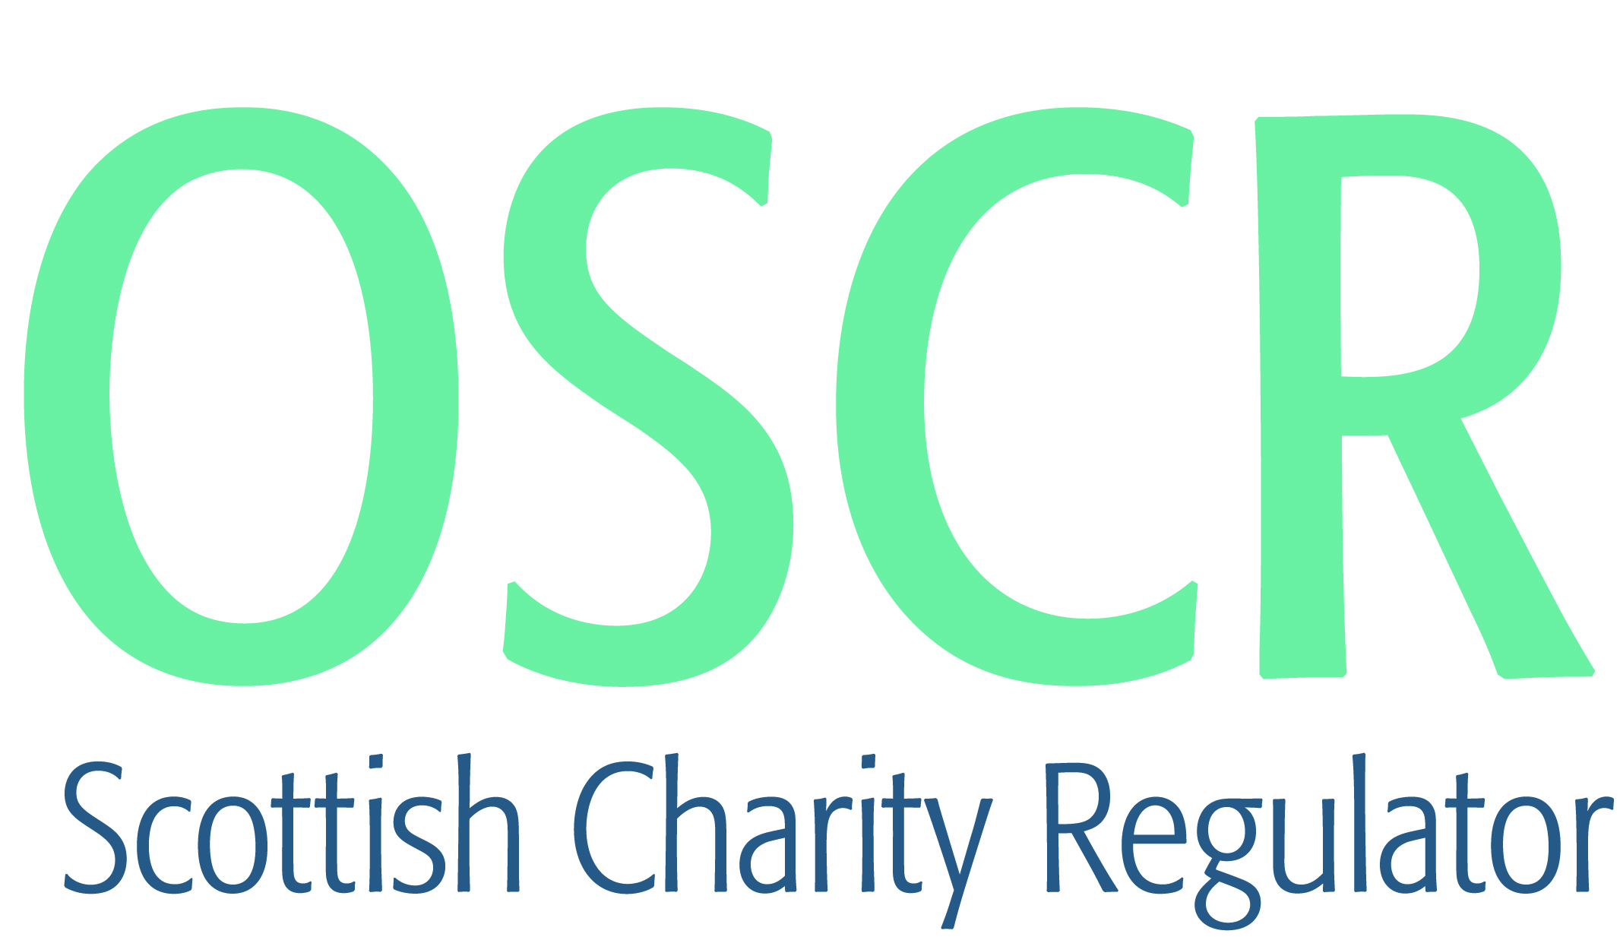

**Charities granted charitable status 1 to 31 May 2021**

|  |  |  |
| --- | --- | --- |
| **Charity Number** | **Charity Name** | **Constitutional Form** |
| [SC050949](https://www.oscr.org.uk/search-charity-register/charity-extract/?charitynumber=SC050949) | Tell it slant SCIO | SCIO |
| [SC050950](https://www.oscr.org.uk/search-charity-register/charity-extract/?charitynumber=SC050950) | LIVING HOPE (Skye and Lochalsh) | SCIO |
| [SC050951](https://www.oscr.org.uk/search-charity-register/charity-extract/?charitynumber=SC050951) | The Maria Manuela Sutherland Charitable Trust | Trust |
| [SC050952](https://www.oscr.org.uk/search-charity-register/charity-extract/?charitynumber=SC050952) | 2nd Brechin Rainbows | UnincorporatedAssociation |
| [SC050953](https://www.oscr.org.uk/search-charity-register/charity-extract/?charitynumber=SC050953) | 4th City of Edinburgh Guide Unit | UnincorporatedAssociation |
| [SC050954](https://www.oscr.org.uk/search-charity-register/charity-extract/?charitynumber=SC050954) | Fife Street Pastors | SCIO |
| [SC050955](https://www.oscr.org.uk/search-charity-register/charity-extract/?charitynumber=SC050955) | Grangemouth Golf Club (SCIO) | SCIO |
| [SC050956](https://www.oscr.org.uk/search-charity-register/charity-extract/?charitynumber=SC050956) | 1st Strichen Guide Unit | UnincorporatedAssociation |
| [SC050957](https://www.oscr.org.uk/search-charity-register/charity-extract/?charitynumber=SC050957) | 6th Fraserburgh Brownie Unit | UnincorporatedAssociation |
| [SC050958](https://www.oscr.org.uk/search-charity-register/charity-extract/?charitynumber=SC050958) | Glasgow Saints | SCIO |
| [SC050959](https://www.oscr.org.uk/search-charity-register/charity-extract/?charitynumber=SC050959) | Tots Aid | SCIO |
| [SC050960](https://www.oscr.org.uk/search-charity-register/charity-extract/?charitynumber=SC050960) | The Royal Tay Yacht Club Endowment Trust | Trust |
| [SC050961](https://www.oscr.org.uk/search-charity-register/charity-extract/?charitynumber=SC050961) | Help Us Educate | UnincorporatedAssociation |
| [SC050962](https://www.oscr.org.uk/search-charity-register/charity-extract/?charitynumber=SC050962) | Mearns 1st Rainbows Unit | UnincorporatedAssociation |
| [SC050963](https://www.oscr.org.uk/search-charity-register/charity-extract/?charitynumber=SC050963) | Medical & Emergency Response Team | SCIO |
| [SC050964](https://www.oscr.org.uk/search-charity-register/charity-extract/?charitynumber=SC050964) | Edinburgh Direct Aid International | SCIO |
| [SC050965](https://www.oscr.org.uk/search-charity-register/charity-extract/?charitynumber=SC050965) | Dunedin Fencing Club | SCIO |
| [SC050966](https://www.oscr.org.uk/search-charity-register/charity-extract/?charitynumber=SC050966) | Up & Down | SCIO |
| [SC050967](https://www.oscr.org.uk/search-charity-register/charity-extract/?charitynumber=SC050967) | Chapel of His Glory (CHG) Refugees' Empowerment and Evangelism Mission (CREEM) International (SCIO) | SCIO |
| [SC050968](https://www.oscr.org.uk/search-charity-register/charity-extract/?charitynumber=SC050968) | Adventure Oban Ltd | Company |
| [SC050969](https://www.oscr.org.uk/search-charity-register/charity-extract/?charitynumber=SC050969) | TELit SCIO | SCIO |
| [SC050970](https://www.oscr.org.uk/search-charity-register/charity-extract/?charitynumber=SC050970) | Migrant Voice | Company |
| [SC050971](https://www.oscr.org.uk/search-charity-register/charity-extract/?charitynumber=SC050971) | Christ Kingdom Victory Church of God International | SCIO |
| [SC050972](https://www.oscr.org.uk/search-charity-register/charity-extract/?charitynumber=SC050972) | Glasgow City Youth Network | SCIO |
| [SC050973](https://www.oscr.org.uk/search-charity-register/charity-extract/?charitynumber=SC050973) | Greyfriars Biophilic Community Garden | SCIO |
| [SC050974](https://www.oscr.org.uk/search-charity-register/charity-extract/?charitynumber=SC050974) | The Haven at Vanguard | SCIO |
| [SC050975](https://www.oscr.org.uk/search-charity-register/charity-extract/?charitynumber=SC050975) | Leanchoil Trust | Company |
| [SC050976](https://www.oscr.org.uk/search-charity-register/charity-extract/?charitynumber=SC050976) | Seaful | CIO |
| [SC050977](https://www.oscr.org.uk/search-charity-register/charity-extract/?charitynumber=SC050977) | Aberdeen Muslims SCIO | SCIO |
| [SC050978](https://www.oscr.org.uk/search-charity-register/charity-extract/?charitynumber=SC050978) | Mary's Well SCIO | SCIO |
| [SC050979](https://www.oscr.org.uk/search-charity-register/charity-extract/?charitynumber=SC050979) | IS Education Europe | SCIO |
| [SC050980](https://www.oscr.org.uk/search-charity-register/charity-extract/?charitynumber=SC050980) | KPT Development Trust | Company |
| [SC050981](https://www.oscr.org.uk/search-charity-register/charity-extract/?charitynumber=SC050981) | Luqma | SCIO |
| [SC050982](https://www.oscr.org.uk/search-charity-register/charity-extract/?charitynumber=SC050982) | Khaya Foundation | UnincorporatedAssociation |
| [SC050983](https://www.oscr.org.uk/search-charity-register/charity-extract/?charitynumber=SC050983) | One Scotland Initiative | SCIO |
| [SC050984](https://www.oscr.org.uk/search-charity-register/charity-extract/?charitynumber=SC050984) | National Basketball Youth Mentorship Programme | SCIO |
| [SC050985](https://www.oscr.org.uk/search-charity-register/charity-extract/?charitynumber=SC050985) | Dr Graham's Homes Kalimpong (UK) | Company |
| [SC050986](https://www.oscr.org.uk/search-charity-register/charity-extract/?charitynumber=SC050986) | Caledonian Transport Heritage Limited | Company |
| [SC050987](https://www.oscr.org.uk/search-charity-register/charity-extract/?charitynumber=SC050987) | The Society of Writers to Her Majesty's Signet | Other |
| [SC050988](https://www.oscr.org.uk/search-charity-register/charity-extract/?charitynumber=SC050988) | Board of Reformed Christian Education Scotland | Company |
| [SC050989](https://www.oscr.org.uk/search-charity-register/charity-extract/?charitynumber=SC050989) | Falkland Tennis Club SCIO | SCIO |
| [SC050990](https://www.oscr.org.uk/search-charity-register/charity-extract/?charitynumber=SC050990) | The Raymond & Moira Kelly Charitable Trust | Trust |
| [SC050991](https://www.oscr.org.uk/search-charity-register/charity-extract/?charitynumber=SC050991) | Feeling Strong SCIO | SCIO |
| [SC050992](https://www.oscr.org.uk/search-charity-register/charity-extract/?charitynumber=SC050992) | Action for Pulmonary Fibrosis | CIO |
| [SC050993](https://www.oscr.org.uk/search-charity-register/charity-extract/?charitynumber=SC050993) | BRIDGEND COMMUNITY TRUST | SCIO |
| [SC050994](https://www.oscr.org.uk/search-charity-register/charity-extract/?charitynumber=SC050994) | DARUL MUSTAFA | Company |
| [SC050995](https://www.oscr.org.uk/search-charity-register/charity-extract/?charitynumber=SC050995) | Prestwick Sailing Club | SCIO |
| [SC050996](https://www.oscr.org.uk/search-charity-register/charity-extract/?charitynumber=SC050996) | University of Aberdeen Development Trust SCIO | SCIO |
| [SC050997](https://www.oscr.org.uk/search-charity-register/charity-extract/?charitynumber=SC050997) | 3rd Strathaven Rainbows | UnincorporatedAssociation |
| [SC050998](https://www.oscr.org.uk/search-charity-register/charity-extract/?charitynumber=SC050998) | The Bridge of Allan and Dunblane Rotary Charity Trust | Trust |
| [SC050999](https://www.oscr.org.uk/search-charity-register/charity-extract/?charitynumber=SC050999) | 20th Dundee Scout Group | UnincorporatedAssociation |
| [SC051000](https://www.oscr.org.uk/search-charity-register/charity-extract/?charitynumber=SC051000) | Dumfries Partnership Action Group | SCIO |
| [SC051001](https://www.oscr.org.uk/search-charity-register/charity-extract/?charitynumber=SC051001) | Hub on the Hill | SCIO |
| [SC051002](https://www.oscr.org.uk/search-charity-register/charity-extract/?charitynumber=SC051002) | Calling for Help | Company |
| [SC051003](https://www.oscr.org.uk/search-charity-register/charity-extract/?charitynumber=SC051003) | 1st Westhill Ranger Unit | UnincorporatedAssociation |
| [SC051004](https://www.oscr.org.uk/search-charity-register/charity-extract/?charitynumber=SC051004) | Connecting Circles SCIO | SCIO |
| [SC051005](https://www.oscr.org.uk/search-charity-register/charity-extract/?charitynumber=SC051005) | Restored Hope Zambia UK | SCIO |
| [SC051006](https://www.oscr.org.uk/search-charity-register/charity-extract/?charitynumber=SC051006) | Mount Vernon Community Hall SCIO | SCIO |
| [SC051007](https://www.oscr.org.uk/search-charity-register/charity-extract/?charitynumber=SC051007) | The Robert, Margaret and Rhoda Fothergill Bequest | Trust |
| [SC051008](https://www.oscr.org.uk/search-charity-register/charity-extract/?charitynumber=SC051008) | Serve365 | Company |
| [SC051009](https://www.oscr.org.uk/search-charity-register/charity-extract/?charitynumber=SC051009) | Survivors Supporting Survivors | SCIO |
| [SC051010](https://www.oscr.org.uk/search-charity-register/charity-extract/?charitynumber=SC051010) | Remembering the Accused Witches of Scotland | SCIO |