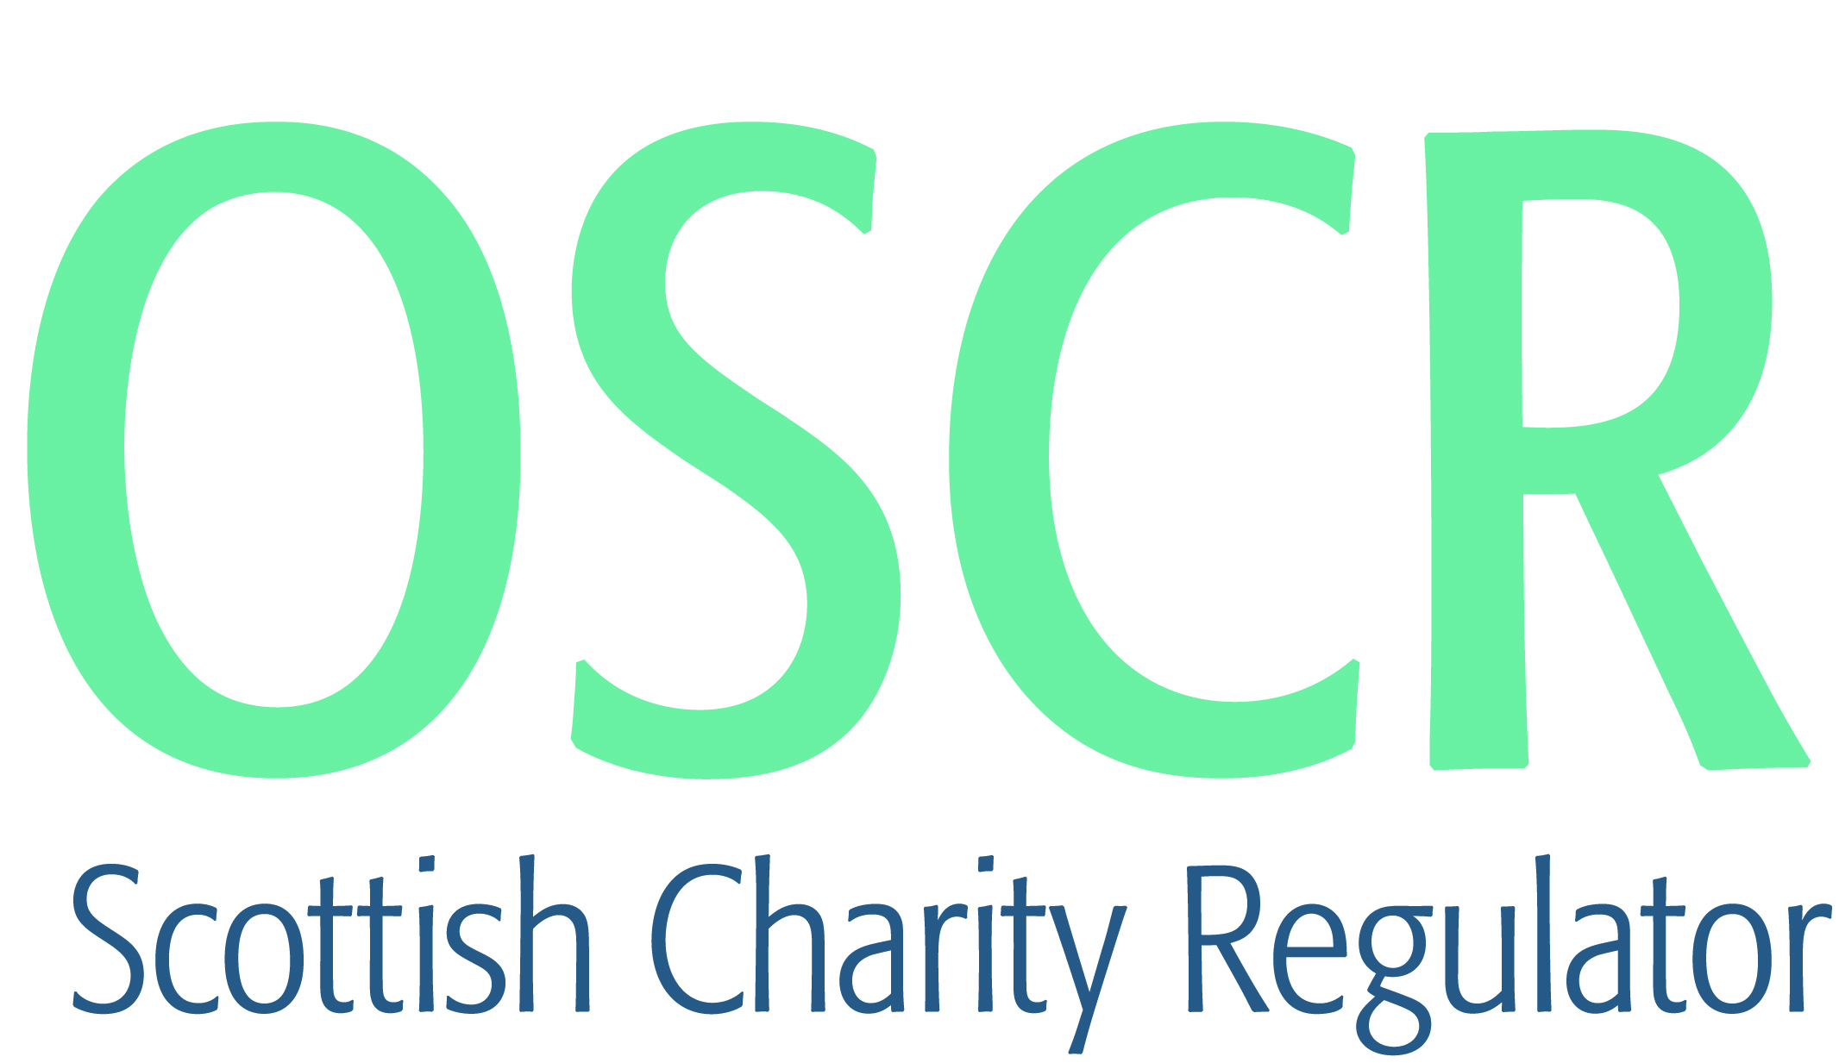

**Charities granted charitable status 1 to 30 November 2020**

|  |  |  |
| --- | --- | --- |
| **Charity Number** | **Charity Name** | **Constitutional Form** |
| [SC050553](https://www.oscr.org.uk/search-charity-register/charity-extract/?charitynumber=SC050553) | Scottish Orthopaedic Research Trust into Trauma | Company |
| [SC050554](https://www.oscr.org.uk/search-charity-register/charity-extract/?charitynumber=SC050554) | Wings of Grace International (Scotland) | UnincorporatedAssociation |
| [SC050555](https://www.oscr.org.uk/search-charity-register/charity-extract/?charitynumber=SC050555) | Tenants Information Service | Company |
| [SC050556](https://www.oscr.org.uk/search-charity-register/charity-extract/?charitynumber=SC050556) | British Society for Medical Mycology CIO | CIO |
| [SC050557](https://www.oscr.org.uk/search-charity-register/charity-extract/?charitynumber=SC050557) | Redstone Foundation | Company |
| [SC050558](https://www.oscr.org.uk/search-charity-register/charity-extract/?charitynumber=SC050558) | MySelf-Management, SCIO | SCIO |
| [SC050559](https://www.oscr.org.uk/search-charity-register/charity-extract/?charitynumber=SC050559) | Khumbu Sherpa Project | SCIO |
| [SC050560](https://www.oscr.org.uk/search-charity-register/charity-extract/?charitynumber=SC050560) | Fairfield Housing Association Limited | RegisteredSociety |
| [SC050561](https://www.oscr.org.uk/search-charity-register/charity-extract/?charitynumber=SC050561) | Family Groups Limited | Company |
| [SC050562](https://www.oscr.org.uk/search-charity-register/charity-extract/?charitynumber=SC050562) | Biggar Community Action Group | SCIO |
| [SC050563](https://www.oscr.org.uk/search-charity-register/charity-extract/?charitynumber=SC050563) | Presbytery of Fife Church of Scotland | UnincorporatedAssociation |
| [SC050564](https://www.oscr.org.uk/search-charity-register/charity-extract/?charitynumber=SC050564) | BOSNIAN GENOCIDE EDUCATIONAL TRUST | CIO |
| [SC050565](https://www.oscr.org.uk/search-charity-register/charity-extract/?charitynumber=SC050565) | The Aquila Foundation | Company |
| [SC050566](https://www.oscr.org.uk/search-charity-register/charity-extract/?charitynumber=SC050566) | Fort William Town Team SCIO | SCIO |
| [SC050567](https://www.oscr.org.uk/search-charity-register/charity-extract/?charitynumber=SC050567) | SPUC Pro-Life Scotland Ltd | Company |
| [SC050568](https://www.oscr.org.uk/search-charity-register/charity-extract/?charitynumber=SC050568) | Musselburgh Amateur Musical Association | SCIO |
| [SC050569](https://www.oscr.org.uk/search-charity-register/charity-extract/?charitynumber=SC050569) | West Lothian Battalion of the Boys' Brigade | UnincorporatedAssociation |
| [SC050570](https://www.oscr.org.uk/search-charity-register/charity-extract/?charitynumber=SC050570) | 2nd Kirkliston Guide Unit | UnincorporatedAssociation |
| [SC050571](https://www.oscr.org.uk/search-charity-register/charity-extract/?charitynumber=SC050571) | LAICH OF MORAY ACTIVE TRAVEL ROUTES SCIO | SCIO |
| [SC050572](https://www.oscr.org.uk/search-charity-register/charity-extract/?charitynumber=SC050572) | Douglas Community Development Company | SCIO |
| [SC050573](https://www.oscr.org.uk/search-charity-register/charity-extract/?charitynumber=SC050573) | FLACC (Ferry Learning & Community Centre) | SCIO |
| [SC050574](https://www.oscr.org.uk/search-charity-register/charity-extract/?charitynumber=SC050574) | Parker Linden Arts, Theatre Education & Development | SCIO |
| [SC050575](https://www.oscr.org.uk/search-charity-register/charity-extract/?charitynumber=SC050575) | Whiteadder Watersports Trust (SCIO) | SCIO |
| [SC050576](https://www.oscr.org.uk/search-charity-register/charity-extract/?charitynumber=SC050576) | The Ranch | SCIO |
| [SC050577](https://www.oscr.org.uk/search-charity-register/charity-extract/?charitynumber=SC050577) | Highland Educational and Cultural Trust | Trust |
| [SC050578](https://www.oscr.org.uk/search-charity-register/charity-extract/?charitynumber=SC050578) | International Spinal Research Trust | UnincorporatedAssociation |
| [SC050579](https://www.oscr.org.uk/search-charity-register/charity-extract/?charitynumber=SC050579) | Environmental Funders Network | CIO |
| [SC050580](https://www.oscr.org.uk/search-charity-register/charity-extract/?charitynumber=SC050580) | Acorns2Trees SCIO | SCIO |
| [SC050581](https://www.oscr.org.uk/search-charity-register/charity-extract/?charitynumber=SC050581) | 186th City of Edinburgh Rainbow Unit | UnincorporatedAssociation |
| [SC050582](https://www.oscr.org.uk/search-charity-register/charity-extract/?charitynumber=SC050582) | The Brooke Hospital for Animals | Company |
| [SC050583](https://www.oscr.org.uk/search-charity-register/charity-extract/?charitynumber=SC050583) | Finnart Football Academy SCIO | SCIO |
| [SC050584](https://www.oscr.org.uk/search-charity-register/charity-extract/?charitynumber=SC050584) | Remap 2010 | Company |
| [SC050585](https://www.oscr.org.uk/search-charity-register/charity-extract/?charitynumber=SC050585) | East Mains Baptist Church SCIO | SCIO |
| [SC050586](https://www.oscr.org.uk/search-charity-register/charity-extract/?charitynumber=SC050586) | The Institute of Materials, Minerals and Mining | UnincorporatedAssociation |
| [SC050587](https://www.oscr.org.uk/search-charity-register/charity-extract/?charitynumber=SC050587) | Kanzen Karate Limited | Company |
| [SC050588](https://www.oscr.org.uk/search-charity-register/charity-extract/?charitynumber=SC050588) | The Langholm Alliance | Company |
| [SC050589](https://www.oscr.org.uk/search-charity-register/charity-extract/?charitynumber=SC050589) | Friends of Healthy Valleys | SCIO |
| [SC050590](https://www.oscr.org.uk/search-charity-register/charity-extract/?charitynumber=SC050590) | Young Speakers Scotland (SCIO) | SCIO |
| [SC050591](https://www.oscr.org.uk/search-charity-register/charity-extract/?charitynumber=SC050591) | Bainsford War Memorial Association | SCIO |
| [SC050592](https://www.oscr.org.uk/search-charity-register/charity-extract/?charitynumber=SC050592) | SAFE | SCIO |
| [SC050593](https://www.oscr.org.uk/search-charity-register/charity-extract/?charitynumber=SC050593) | Rothes Way Association | SCIO |
| [SC050594](https://www.oscr.org.uk/search-charity-register/charity-extract/?charitynumber=SC050594) | The Joshi Project | UnincorporatedAssociation |
| [SC050595](https://www.oscr.org.uk/search-charity-register/charity-extract/?charitynumber=SC050595) | Bellshill Boys Club and Community Centre | SCIO |
| [SC050596](https://www.oscr.org.uk/search-charity-register/charity-extract/?charitynumber=SC050596) | St Andrews Film Festival | SCIO |
| [SC050597](https://www.oscr.org.uk/search-charity-register/charity-extract/?charitynumber=SC050597) | The Bill and Hilda Robertson Family Charitable Trust | Trust |
| [SC050598](https://www.oscr.org.uk/search-charity-register/charity-extract/?charitynumber=SC050598) | Disability Darts Scotland (SCIO) | SCIO |
| [SC050599](https://www.oscr.org.uk/search-charity-register/charity-extract/?charitynumber=SC050599) | ProjectChange | SCIO |
| [SC050600](https://www.oscr.org.uk/search-charity-register/charity-extract/?charitynumber=SC050600) | McKenzie Clinic [SCIO] | SCIO |
| [SC050601](https://www.oscr.org.uk/search-charity-register/charity-extract/?charitynumber=SC050601) | Aberchirder Village Hall (SCIO) | SCIO |
| [SC050602](https://www.oscr.org.uk/search-charity-register/charity-extract/?charitynumber=SC050602) | INSPIRED COMMUNITY ENTERPRISE TRUST LTD | Company |