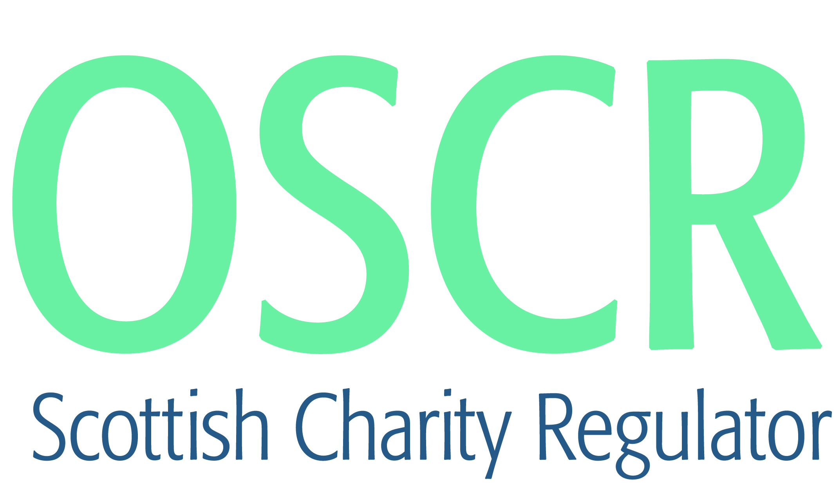

**Charities granted charitable status 1 to 31 October 2020**

|  |  |  |
| --- | --- | --- |
| **Charity Number** | **Charity Name** | **Constitutional Form** |
| [SC050506](https://www.oscr.org.uk/search-charity-register/charity-extract/?charitynumber=SC050506) | Egilsay Community Association SCIO | SCIO |
| [SC050507](https://www.oscr.org.uk/search-charity-register/charity-extract/?charitynumber=SC050507) | Children of Songea SCIO | SCIO |
| [SC050508](https://www.oscr.org.uk/search-charity-register/charity-extract/?charitynumber=SC050508) | Mrs Jeanette C Crighton's Charitable Trust | Trust |
| [SC050509](https://www.oscr.org.uk/search-charity-register/charity-extract/?charitynumber=SC050509) | Alpine Training Centre SCIO | SCIO |
| [SC050510](https://www.oscr.org.uk/search-charity-register/charity-extract/?charitynumber=SC050510) | 1st Auchinairn Rainbows | Unincorporated Association |
| [SC050511](https://www.oscr.org.uk/search-charity-register/charity-extract/?charitynumber=SC050511) | Tropika Life Support Scotland | SCIO |
| [SC050512](https://www.oscr.org.uk/search-charity-register/charity-extract/?charitynumber=SC050512) | The Warrior Academy for Rehabilitation | SCIO |
| [SC050513](https://www.oscr.org.uk/search-charity-register/charity-extract/?charitynumber=SC050513) | Sidekick | SCIO |
| [SC050514](https://www.oscr.org.uk/search-charity-register/charity-extract/?charitynumber=SC050514) | Margaret's Charitable Trust | Trust |
| [SC050515](https://www.oscr.org.uk/search-charity-register/charity-extract/?charitynumber=SC050515) | The Liminal Space | SCIO |
| [SC050516](https://www.oscr.org.uk/search-charity-register/charity-extract/?charitynumber=SC050516) | Canine Welfare & Training [SCIO] | SCIO |
| [SC050517](https://www.oscr.org.uk/search-charity-register/charity-extract/?charitynumber=SC050517) | Trauma Healing Together | SCIO |
| [SC050518](https://www.oscr.org.uk/search-charity-register/charity-extract/?charitynumber=SC050518) | Solway Sinfonia SCIO | SCIO |
| [SC050519](https://www.oscr.org.uk/search-charity-register/charity-extract/?charitynumber=SC050519) | James Support Group | SCIO |
| [SC050520](https://www.oscr.org.uk/search-charity-register/charity-extract/?charitynumber=SC050520) | Peebles Community Trust | Company |
| [SC050521](https://www.oscr.org.uk/search-charity-register/charity-extract/?charitynumber=SC050521) | Inspiring the Next... | SCIO |
| [SC050522](https://www.oscr.org.uk/search-charity-register/charity-extract/?charitynumber=SC050522) | Smith Memorial Hall - Darnick | SCIO |
| [SC050523](https://www.oscr.org.uk/search-charity-register/charity-extract/?charitynumber=SC050523) | The Douglas Park Project | SCIO |
| [SC050524](https://www.oscr.org.uk/search-charity-register/charity-extract/?charitynumber=SC050524) | Syeda Sirajunesa Trust | Trust |
| [SC050525](https://www.oscr.org.uk/search-charity-register/charity-extract/?charitynumber=SC050525) | Trojan Women | SCIO |
| [SC050526](https://www.oscr.org.uk/search-charity-register/charity-extract/?charitynumber=SC050526) | The Folan Trust | SCIO |
| [SC050527](https://www.oscr.org.uk/search-charity-register/charity-extract/?charitynumber=SC050527) | The ISSOS Foundation | SCIO |
| [SC050528](https://www.oscr.org.uk/search-charity-register/charity-extract/?charitynumber=SC050528) | Include Me (SCIO) | SCIO |
| [SC050529](https://www.oscr.org.uk/search-charity-register/charity-extract/?charitynumber=SC050529) | Mary Cameron Foundation | SCIO |
| [SC050530](https://www.oscr.org.uk/search-charity-register/charity-extract/?charitynumber=SC050530) | Home Education Scotland | Unincorporated Association |
| [SC050531](https://www.oscr.org.uk/search-charity-register/charity-extract/?charitynumber=SC050531) | Arbroath FC Community Trust | SCIO |
| [SC050532](https://www.oscr.org.uk/search-charity-register/charity-extract/?charitynumber=SC050532) | Moray Rape Crisis | SCIO |
| [SC050533](https://www.oscr.org.uk/search-charity-register/charity-extract/?charitynumber=SC050533) | Glasgow Dental Initiative | SCIO |
| [SC050534](https://www.oscr.org.uk/search-charity-register/charity-extract/?charitynumber=SC050534) | The Refuel Festival (Scotland) | SCIO |
| [SC050535](https://www.oscr.org.uk/search-charity-register/charity-extract/?charitynumber=SC050535) | Ettrickbridge and Dryden RDA Group | SCIO |
| [SC050536](https://www.oscr.org.uk/search-charity-register/charity-extract/?charitynumber=SC050536) | Kemnay Breakfast and After School Club SCIO | SCIO |
| [SC050537](https://www.oscr.org.uk/search-charity-register/charity-extract/?charitynumber=SC050537) | CRAG Community Arts SCIO | SCIO |
| [SC050538](https://www.oscr.org.uk/search-charity-register/charity-extract/?charitynumber=SC050538) | Morvern Community Woodlands | Company |
| [SC050539](https://www.oscr.org.uk/search-charity-register/charity-extract/?charitynumber=SC050539) | Docks and Piers Trust | SCIO |
| [SC050540](https://www.oscr.org.uk/search-charity-register/charity-extract/?charitynumber=SC050540) | Westhill Choi Kwang Do | SCIO |
| [SC050541](https://www.oscr.org.uk/search-charity-register/charity-extract/?charitynumber=SC050541) | 1st Aberdour Rainbow Unit | Unincorporated Association |
| [SC050542](https://www.oscr.org.uk/search-charity-register/charity-extract/?charitynumber=SC050542) | Uplifted | SCIO |
| [SC050543](https://www.oscr.org.uk/search-charity-register/charity-extract/?charitynumber=SC050543) | Lochlan's Legacy | SCIO |
| [SC050544](https://www.oscr.org.uk/search-charity-register/charity-extract/?charitynumber=SC050544) | Glen Urquhart Shinty Club SCIO | SCIO |
| [SC050545](https://www.oscr.org.uk/search-charity-register/charity-extract/?charitynumber=SC050545) | Garmouth and Kingston Community Association | SCIO |
| [SC050546](https://www.oscr.org.uk/search-charity-register/charity-extract/?charitynumber=SC050546) | Earlsferry Town Hall Limited | Company |
| [SC050547](https://www.oscr.org.uk/search-charity-register/charity-extract/?charitynumber=SC050547) | GamCare | Company |
| [SC050548](https://www.oscr.org.uk/search-charity-register/charity-extract/?charitynumber=SC050548) | Friends of Wood RecyclAbility SCIO | SCIO |
| [SC050549](https://www.oscr.org.uk/search-charity-register/charity-extract/?charitynumber=SC050549) | Cultarlann Inbhir Nis | Company |
| [SC050550](https://www.oscr.org.uk/search-charity-register/charity-extract/?charitynumber=SC050550) | Acacia Partnership Trust | Company |
| [SC050551](https://www.oscr.org.uk/search-charity-register/charity-extract/?charitynumber=SC050551) | Carse of Gowrie Group (SCIO) | SCIO |
| [SC050552](https://www.oscr.org.uk/search-charity-register/charity-extract/?charitynumber=SC050552) | Dundee West Community Trust | SCIO |