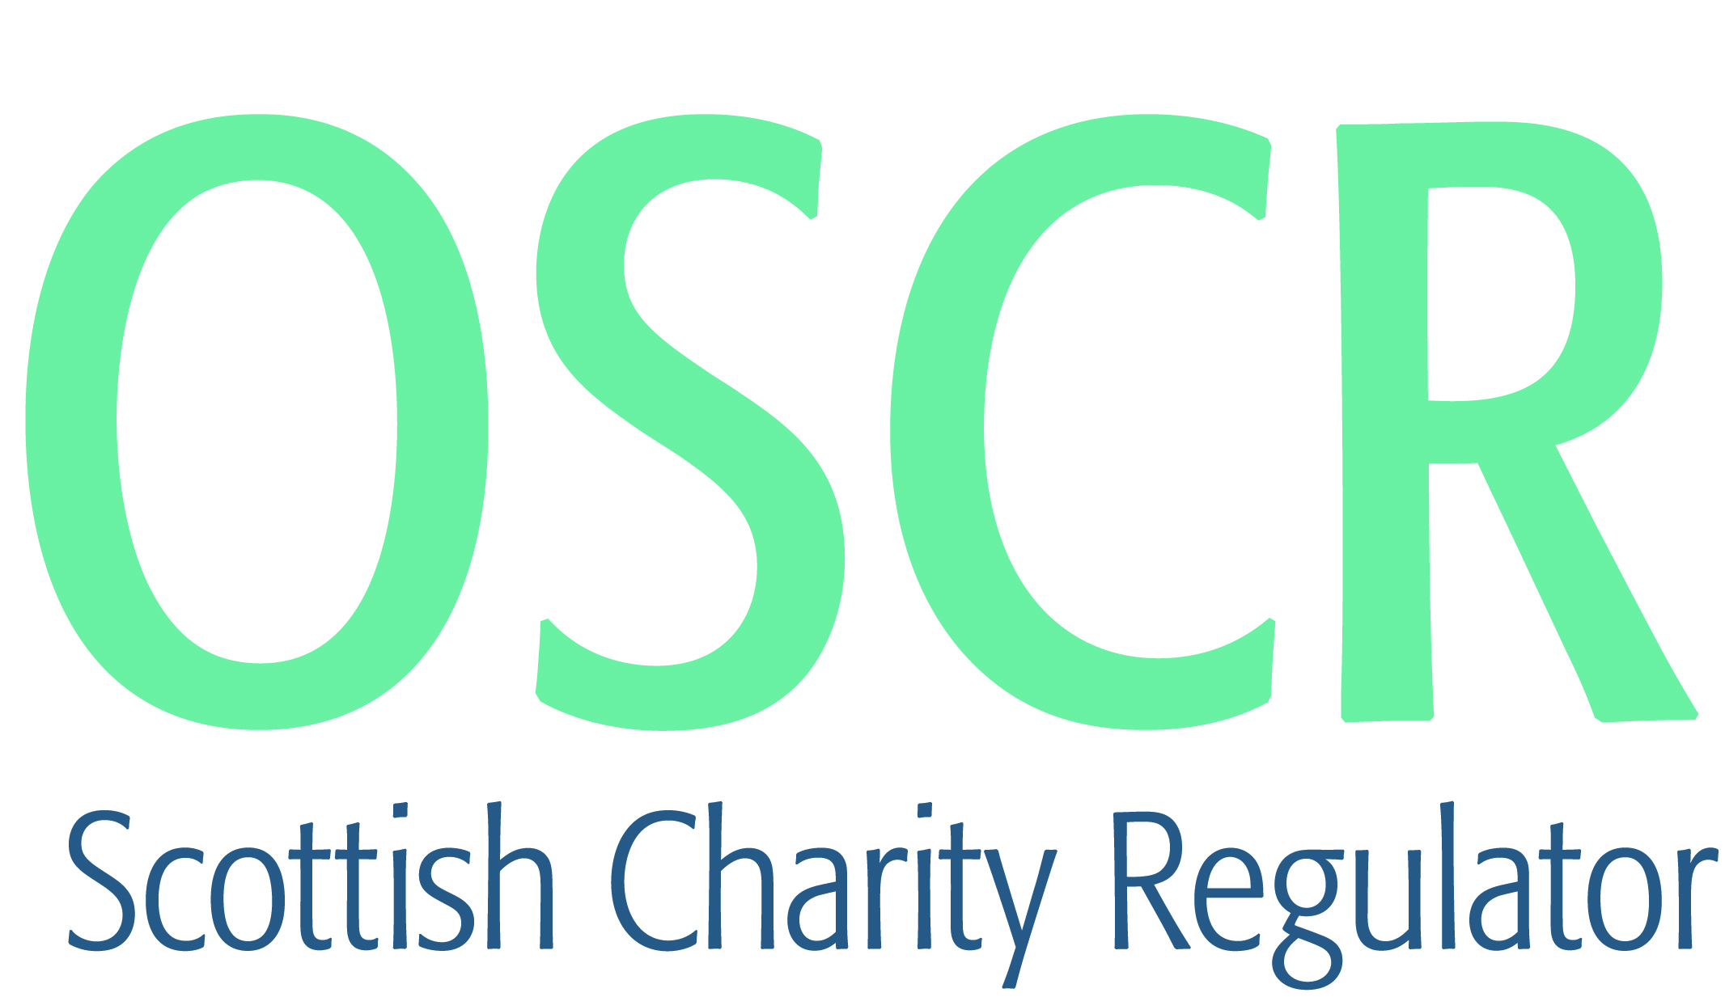

**Charities granted charitable status 1 to 30 April 2020**

|  |  |  |
| --- | --- | --- |
| **Charity Number** | **Charity Name** | **Constitutional Form** |
| [SC050069](https://www.oscr.org.uk/search-charity-register/charity-extract/?charitynumber=SC050069) | 28th Argyll Carradale Scout Group | Unincorporated Association |
| [SC050172](https://www.oscr.org.uk/search-charity-register/charity-extract/?charitynumber=SC050172) | Al Rahman Centre | SCIO |
| [SC050080](https://www.oscr.org.uk/search-charity-register/charity-extract/?charitynumber=SC050080) | Alford Cancer Massage | SCIO |
| [SC050076](https://www.oscr.org.uk/search-charity-register/charity-extract/?charitynumber=SC050076) | Breathe Easy Clackmannanshire Community Group | Unincorporated Association |
| [SC050067](https://www.oscr.org.uk/search-charity-register/charity-extract/?charitynumber=SC050067) | Catrine Games Hall (SCIO) | SCIO |
| [SC050060](https://www.oscr.org.uk/search-charity-register/charity-extract/?charitynumber=SC050060) | Chartered Institute of Fundraising | Statutory Corporation |
| [SC050079](https://www.oscr.org.uk/search-charity-register/charity-extract/?charitynumber=SC050079) | Confederation of Friends of Israel in Scotland | SCIO |
| [SC050087](https://www.oscr.org.uk/search-charity-register/charity-extract/?charitynumber=SC050087) | Dalmore Cemetery Lairholders Association SCIO | SCIO |
| [SC050102](https://www.oscr.org.uk/search-charity-register/charity-extract/?charitynumber=SC050102) | Divine Restoration Church | SCIO |
| [SC050093](https://www.oscr.org.uk/search-charity-register/charity-extract/?charitynumber=SC050093) | DORNOCH BEACH WHEELCHAIRS | SCIO |
| [SC050092](https://www.oscr.org.uk/search-charity-register/charity-extract/?charitynumber=SC050092) | Dumfries Get Together | SCIO |
| [SC050095](https://www.oscr.org.uk/search-charity-register/charity-extract/?charitynumber=SC050095) | Forth Valley Hearing Access Forum | SCIO |
| [SC050113](https://www.oscr.org.uk/search-charity-register/charity-extract/?charitynumber=SC050113) | Fountain Church | Unincorporated Association |
| [SC050091](https://www.oscr.org.uk/search-charity-register/charity-extract/?charitynumber=SC050091) | Fountain Trust | Unincorporated Association |
| [SC050097](https://www.oscr.org.uk/search-charity-register/charity-extract/?charitynumber=SC050097) | Good Foundation SCIO | SCIO |
| [SC050070](https://www.oscr.org.uk/search-charity-register/charity-extract/?charitynumber=SC050070) | Gorol Family Charity Trust | Company |
| [SC050088](https://www.oscr.org.uk/search-charity-register/charity-extract/?charitynumber=SC050088) | HAMILTON SPIRITUALIST CHURCH | Unincorporated Association |
| [SC050090](https://www.oscr.org.uk/search-charity-register/charity-extract/?charitynumber=SC050090) | Highland Gospel Male Voice Choir | Unincorporated Association |
| [SC050099](https://www.oscr.org.uk/search-charity-register/charity-extract/?charitynumber=SC050099) | Human Rights Consortium Scotland | SCIO |
| [SC050109](https://www.oscr.org.uk/search-charity-register/charity-extract/?charitynumber=SC050109) | Falmadair - North Lewis Maritime Trust (SCIO) | SCIO |
| [SC050063](https://www.oscr.org.uk/search-charity-register/charity-extract/?charitynumber=SC050063) | Nourish Support Centre | SCIO |
| [SC050080](https://www.oscr.org.uk/search-charity-register/charity-extract/?charitynumber=SC050080) | The Dino Club (SCIO) | SCIO |
| [SC050075](https://www.oscr.org.uk/search-charity-register/charity-extract/?charitynumber=SC050075) | Inveraray Bell Tower SCIO | SCIO |
| [SC050077](https://www.oscr.org.uk/search-charity-register/charity-extract/?charitynumber=SC050077) | Kettle Memorial Hall Committee (SCIO) | SCIO |
| [SC050094](https://www.oscr.org.uk/search-charity-register/charity-extract/?charitynumber=SC050094) | Kirkwood Community Aid | SCIO |
| [SC050085](https://www.oscr.org.uk/search-charity-register/charity-extract/?charitynumber=SC050085) | Leith Rugby Limited | Company |
| [SC050100](https://www.oscr.org.uk/search-charity-register/charity-extract/?charitynumber=SC050100) | Martyn's Monday Club (SCIO) | SCIO |
| [SC050082](https://www.oscr.org.uk/search-charity-register/charity-extract/?charitynumber=SC050082) | Mind Waves SCIO | SCIO |
| [SC050062](https://www.oscr.org.uk/search-charity-register/charity-extract/?charitynumber=SC050062) | National Emergencies Trust | CIO |
| [SC050068](https://www.oscr.org.uk/search-charity-register/charity-extract/?charitynumber=SC050068) | Pinc & Steel Cancer Rehabilitation Foundation UK & Ireland | SCIO |
| [SC050098](https://www.oscr.org.uk/search-charity-register/charity-extract/?charitynumber=SC050098) | Point Agricultural Society SCIO | SCIO |
| [SC050096](https://www.oscr.org.uk/search-charity-register/charity-extract/?charitynumber=SC050096) | Scotia Medical Group (SCIO) | SCIO |
| [SC050112](https://www.oscr.org.uk/search-charity-register/charity-extract/?charitynumber=SC050112) | Scottish Intensive Care Society SCIO | SCIO |
| [SC050084](https://www.oscr.org.uk/search-charity-register/charity-extract/?charitynumber=SC050084) | SISCO | SCIO |
| [SC050089](https://www.oscr.org.uk/search-charity-register/charity-extract/?charitynumber=SC050089) | Social Care Worker Support | SCIO |
| [SC050073](https://www.oscr.org.uk/search-charity-register/charity-extract/?charitynumber=SC050073) | Stornoway Angling Association SCIO | SCIO |
| [SC050083](https://www.oscr.org.uk/search-charity-register/charity-extract/?charitynumber=SC050083) | Strathspey Works - Grantown Remakery(SCIO) | SCIO |
| [SC050035](https://www.oscr.org.uk/search-charity-register/charity-extract/?charitynumber=SC050035) | The DRC Youth Project (SCIO) | SCIO |
| [SC050074](https://www.oscr.org.uk/search-charity-register/charity-extract/?charitynumber=SC050074) | The Economic Forum For Women Empowerment Scotland | SCIO |
| [SC050065](https://www.oscr.org.uk/search-charity-register/charity-extract/?charitynumber=SC050065) | The Fairthorn Foundation | Trust |
| [SC050104](https://www.oscr.org.uk/search-charity-register/charity-extract/?charitynumber=SC050104) | The Grantown Society (SCIO) | SCIO |
| [SC050106](https://www.oscr.org.uk/search-charity-register/charity-extract/?charitynumber=SC050106) | The Harvey Hext Trust- A Siblings Wish | CIO |
| [SC050110](https://www.oscr.org.uk/search-charity-register/charity-extract/?charitynumber=SC050110) | The James Young Outdoor Trust | SCIO |
| [SC050101](https://www.oscr.org.uk/search-charity-register/charity-extract/?charitynumber=SC050101) | The Johnston Smillie Charitable Trust | SCIO |
| [SC050105](https://www.oscr.org.uk/search-charity-register/charity-extract/?charitynumber=SC050105) | The Management Committee of the Boyack Scout & Guide Centre | SCIO |
| [SC050061](https://www.oscr.org.uk/search-charity-register/charity-extract/?charitynumber=SC050061) | The Moray Emergency Relief Fund | SCIO |
| [SC050071](https://www.oscr.org.uk/search-charity-register/charity-extract/?charitynumber=SC050071) | The Rainbow Boxes Foundation SCIO | SCIO |
| [SC050089](https://www.oscr.org.uk/search-charity-register/charity-extract/?charitynumber=SC050089) | The Upper Nithsdale Medical Fund | SCIO |
| [SC050064](https://www.oscr.org.uk/search-charity-register/charity-extract/?charitynumber=SC050064) | Tweed Reads [SCIO] | SCIO |
| [SC050078](https://www.oscr.org.uk/search-charity-register/charity-extract/?charitynumber=SC050078) | Westburn Development Trust SCIO | SCIO |
| [SC050066](https://www.oscr.org.uk/search-charity-register/charity-extract/?charitynumber=SC050066) | Wonderland Foundation | SCIO |
| [SC050111](https://www.oscr.org.uk/search-charity-register/charity-extract/?charitynumber=SC050111) | YMCA Scotland SCIO | SCIO |