Scottish Charity Regulator
OSCR

Guide for Charity Trustees
An Easy Read Guide to being a Charity Trustee

© European Easy-to-Read Logo: Inclusion Europe. More information at www.easy-to-read.eu

Guide for Charity Trustees

An Easy Read Guide to being a Charity Trustee

Contents

Page 2 Who this Guide is for Page 3 Where this Guide is from Page 3 What this Guide covers
Page 5 General charity trustee duties Page 16 Specific charity trustee duties Page 18 Paying charity trustees
Page 19 What happens when charity trustees break these rules
Page 20 What words mean
Page 22 Organisations and information resources

1

Who this Guide is for

This Guide is for anyone who is a trustee of a charity in Scotland.
Charity trustees are sometimes called Board Members, Directors or Committee Members. A charity trustee is anyone who controls and manages a charity.

We have tried to make this Guide easy to read.
We have printed hard words in blue and you can read what these words mean on page 20. You can phone us on 01382 220 446 if there is anything that you do not understand.

Where this Guide is from

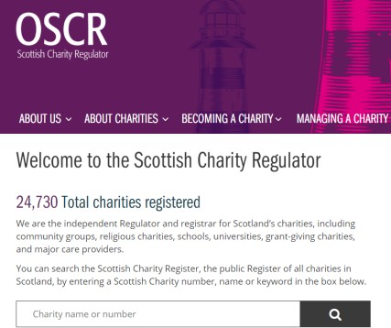
This Guide is written by the Scottish Charity Regulator also called OSCR. Every Scottish charity must register with OSCR. Anyone who wants to give money to a charity or volunteer with a charity can check OSCR’s Scottish Charity Register to make sure that the charity is real.

What this Guide covers

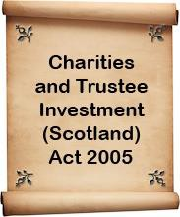
This Guide tells charity trustees what the law says they must do or must not do. The main law for charities is The Charities and Trustee Investment (Scotland) Act 2005.
OSCR is in charge of making sure that charity trustees do not break this law.

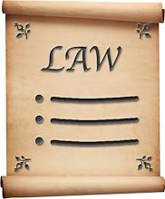
Some people are not allowed to be a charity trustee. If you are not sure if you can be a charity trustee, you can ask OSCR. Every charity trustee must make sure that he or she is not breaking the law by being a charity trustee.

Charity trustees have duties. A duty is something that you must do. There are 4 general duties and 5 specific duties. All of the charity’s trustees should work together to make sure that these duties are done.

This Guide tells you the main things you need to know about being a charity trustee. If you need any more information about anything
in this leaflet or about being a charity trustee, you can call us on 01382 220 446.

General duty 1

What the law says: You must act in the interests of the charity

What this means: Charity Trustees must do what is best for the charity.

- You must do what is best for the charity, not what is best for you or anyone in your family.

- You must put the needs of the charity before the needs of any other organisation or company that you are involved with.

Good practice – this means the best way to do things

You do not have to do all these things but they help make sure you do not break any rules.

- The charity should have a list of where charity trustees work and any other organisations they are involved with. This list is kept up to date.

- The charity has a ‘code of conduct’ that says what charity trustees should do if there is a conflict of interest. A conflict of interest is when a charity trustee might not be able to do what is best for the charity because he or she has a duty to another organisation or person.

- The charity has a policy that says what will happen if a charity trustee does something wrong.

- The charity has a rule that says it can stop someone from being a charity trustee if he or she breaks the law.

- There is a policy that makes it clear when it is okay for the charity to give money to charity trustees, their family or the organisation they work for.

General duty 2
What the law says: You must operate in a manner consistent with the charity’s purpose

What this means: You must make sure the charity does what it is meant to do.

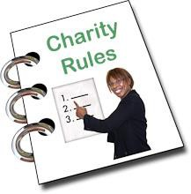
  - Every charity has a set of rules that sets up the charity and says what the charity does and how it is run. This might be called its ‘constitution’ ‘rules’ or ‘governing document’. They all mean the same thing.

  - You must make sure that the other charity trustees and the people working at the charity follow the rules in the governing document.

  - You must make sure that the charity's money is only used to do the things that are in the governing document.

Good practice – this means the best way to do things

You do not have to do all these things but they help make sure you do not break any rules.

  - Every charity trustee has a copy of the charity’s governing document.

  - Every charity trustee gets an information pack about the charity when they start.

  - When charity trustees plan what the charity will do, they make sure the plan fits in with the charity’s governing document.

General duty 3
What the law says: You must act with care and diligence

What this means: You must run the charity carefully.

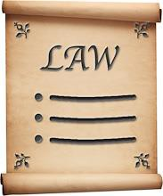
- You must run the charity properly and make decisions carefully.

- You must make sure that the charity does not break any laws, like health and safety or data protection.

- You must make sure that the charity has enough money to pay staff and other costs.

- Charity trustees must all work together for the good of the charity. You must make sure that no-one is breaking the law by being a charity trustee and that the charity trustees are all doing what is best for the charity.

- You must make sure that any staff and volunteers are treated properly and fairly.

- You must make sure that people who are not connected to the charity do not use the charity’s name and logo.

Good practice – this means the best way to do things

You do not have to do all these things but they help make sure you do not break any rules.

- Charity trustees look at the charity’s plans regularly to make sure that they are up to date and to discuss how the plan is being carried out.

- Charity trustees keep a record of the money the charity spends and the money that comes into the charity.

- Charity trustees decide how to support the charity’s staff and volunteers.

- Charity trustees know how to keep up-to-date with any changes to the law.

- Charity trustees decide what will happen if a charity trustee misses too many meetings.

- Once a year, charity trustees look at what the charity has done well and what it needs to be better at.

- The information pack for charity trustees has information about the charity’s sub-committees.

- The charity has a training plan for charity trustees.

- Charity trustees decide what will happen if they cannot agree with each other, or if they cannot agree with the charity’s staff.

- Every year, charity trustees look at the charity’s governing document to see if it needs to be changed.

- Charity trustees regularly look at how they do things to make sure that there is not a better way.

- Charity trustees can get legal or money advice from experts if they need to.

General duty 4
What the law says: You must comply with the 2005 Act.

What this means: You must make sure the charity does not break the law.

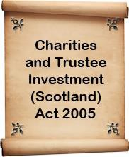
- You must make sure that the charity follows the rules in the Charities and Trustee Investment (Scotland) Act 2005 and any other laws.

Good practice – this means the best way to do things

You do not have to do all these things but they help make sure you do not break any rules.

- Charity trustees plan board meetings so they can meet at the right time to look at the charity's accounts and write the report for OSCR.

- Charity trustees follow the Fundraising Code of Practice.

- Charity trustees know how to get information about changes in the law.

- Charity trustees check that they have a good system to make sure they do all the things that the law says they must do.

Specific duties

These are things that charities must do. All the charity trustees must make sure that these things are done.

Specific duty 1
Charity details on the Scottish Charity Register

- Charity trustees must give OSCR the information it needs for the Scottish Charity Register. Like the name and address of the charity.

Specific duty 2 Reporting to OSCR

- Charity trustees must tell OSCR if any of the charity’s details change.

- Charity trustees must fill in a form about the charity each year. This form is called an online annual return.

- Charity trustees must send OSCR the charity’s accounts each year.

- Charity trustees usually need to ask OSCR before they change the charity’s governing document.

Specific duty 3
Financial records and reporting

- Charity trustees must make sure that the charity keeps a record of the money it gets in and the money it spends. This will help the charity trustees know how much money the charity has to cover costs.

- Each year the charity must prepare their accounts and get them audited or examined. This means that someone who knows a lot about money, like an accountant, makes sure that the accounts are okay. A copy of the accounts must be sent to OSCR.

- Charities must keep a copy of the accounts for 6 years.

Specific duty 4 Fundraising

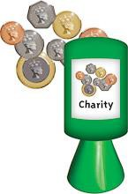
- Charity trustees must make sure that anyone who raises funds for the charity has an agreement that says how much they will get paid to do it.

- There are rules about charity fundraising and charity trustees must make sure that the charity follows these rules.

Specific duty 5
Providing information to the public

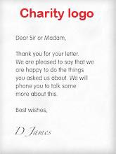
- Charity trustees must make sure that the charity’s details are on all the charity’s paperwork, like letters and
the charity’s website.

- Charities must give a copy of their governing document or latest accounts to anyone that asks for them.

Paying charity trustees

Charity trustees must always put the needs of the charity first. This means that charity trustees, people in their family or companies that they are involved with must not usually get paid any money by the charity.

There are times when it is okay for charity trustees to be paid by the charity. If you need information on this you can call OSCR on 01382 220446.

Charity trustees can get expenses, like train fares to get to a trustee meeting.

What happens when charity trustees break these rules

If a charity trustee does something wrong, OSCR will look at this and may have to do something about it. What it does will depend on what has happened.

There are lots of organisations that will support charity trustees who need help to carry out their duties or to understand what their duties are. You can get a list of these organisations on page 22 and 23.

What words mean

Charity – this first appears on page 2
A charity is an organisation on the Scottish Charity Register. Charities are set up to help other people or make things better for them.

Governing document – this first appears on page 7 A charity's governing document is the written
statement that sets up the charity, sets out its purpose, structure and describes how it will operate. Sometimes it is called a constitution, articles or rules.

Scottish Charity Regulator (OSCR) – this first appears on page 3
OSCR keeps a list of every charity in Scotland. If an organisation is not on the Scottish Charity Register, it is not a charity. OSCR makes sure that charity trustees do not break the law.

Charities and Trustee Investment (Scotland) Act 2005 – this first appears on page 3
This is the law that says what charity trustees must do or must not do.

Fundraising Code of Practice – this first appears on page 15
This is the rules that tell charities the best way to raise money and what the law says.

Scottish Charity Register – this first appears on page 3
This is a list of all the charities in Scotland. Anyone can look at this list on OSCR’s website and get details of a charity and how much money it gets each year.

Annual return – this first appears on page 16 This is a form that every charity fills each year and sends to OSCR with the charity’s accounts.

Charity’s accounts – this first appears on page 16 This is a set of figures that say how much money the charity got in the year and how much money it spent. Every charity must send a copy of its accounts to OSCR each year.

Sub-committees – this first appears on page 12
A sub-committee is a small group of people asked to look at a particular task or area, like finance or staff.

These organisations and resources can give you more information.

Charities and Trustee Investment (Scotland) Act 2005
www.opsi.gov.uk/legislation/scotland/acts2005/asp_20 050010_en_1

SCVO Governance - good practice for the voluntary sector www.scvo.org.uk/governance

Scottish Governance Code
www.governancecode.scot

Charity Commission for England and Wales www.gov.uk/government/organisations/charity- commission

The Law Society of Scotland
www.lawscot.org.uk

Third Sector Interface (TSI) www.gov.scot/publications/third-sector-interfaces- contact-details

Companies House www.gov.uk/government/organisations/companies- house

Information Commissioner's Office (data protection and access to information)
www.ico.org.uk

Directory of Social Change
www.dsc.org.uk

Scottish Fundraising Standards Panel
www.goodfundraising.scot

Institute of Fundraising
www.institute-of-fundraising.org.uk

Fundraising Regulator
www.fundraisingregulator.org.uk

Institute of Chartered Secretaries and Administrators
www.icsa.org.uk

Health and Safety Executive - information about health and safety at work
www.hse.gov.uk

Equality and Human Rights Commission
www.equalityhumanrights.com

Acas - employment issues
www.acas.org.uk

Volunteer Scotland
www.volunteerscotland.net

Association of Chief Officers of Scottish Voluntary Organisations
www.acosvo.org.uk

 Scottish Charity Regulator (OSCR) 2nd Floor
Quadrant House 9 Riverside Drive Dundee
DD1 4NY

 Telephone: 01382 220446

 Email: info@oscr.org.uk

 Website: www.oscr.org.uk

Twitter: @ScotCharityReg

Facebook: ScottishCharityRegulator

This guidance is also available in British Sign Language (BSL) on our website

Images © Copyright 2019 Photosymbols Ltd.

