Charity Investments: Guidance and Good Practice

1. Introduction
2. What is an investment?
3. Why have investments?
4. What can and should charity trustees do in relation to investments?
4.1 Investment powers
4.2 Charity trustee duties
4.3 Endowments
5. What else should you think about before investing?
5.1 How to align your investments to your charity’s purposes
5.2 Social and environmental returns (non- financial returns)
5.3 Environmental, social and governance (ESG) factors
5.4 Using your investments to influence change

6. Discussing your charity’s investment policy
7. Implementing your investment policy
7.1 Investment planning and review cycle
7.2 Case Studies
8. Providing information to the public
9. Glossary
10. Top 10 key points

1. Introduction

What this Guidance covers
This Guidance sets out some of the key points to consider if your charity has investments or is thinking about investing and how your duties as charity trustees apply. It is intended to help charity trustees feel confident and informed as they approach this aspect of their charity’s finances. It is not detailed guidance on all the requirements of the Charities and Trustee Investment (Scotland) Act 2005 (the 2005 Act), but should help you make decisions about your money today and in the future, keeping in mind the duties of charity trustees.

Legal requirements are something that the law says you must do and are highlighted by the ‘Legal Duty’ icon:
Good practice is not required by law but is something you could do to help make sure that your charity is doing its best to comply. What is good practice for your charity might depend on the size or type of charity you are. Examples of good practice are highlighted by the ‘Good Practice’ icon:
What this Guidance does not cover
This Guidance is not intended to provide detailed guidance on investments and finance. It does not constitute investment advice and does not cover the tax implications of investments. It is not intended as a detailed commentary on the law underpinning this area. Charity trustees should always take appropriate advice where necessary – see sources of help and advice.

Who is this Guidance for?
This Guidance is for:
- charity trustees of Scottish charities
- people working in Scottish charities
- professionals who advise Scottish charities or who manage investments on behalf of Scottish charities who may wish to use this Guidance as a tool to help their clients.

Myth busting
Charity law is not the same across the UK. It’s important to be aware that charity law in Scotland is different to the law which applies to charities in England and Wales. This means information you read from sources in England and Wales may not apply in Scotland.

How to use the Guidance
The guidance is split into sections to help you find the information most relevant to you and your charity.

Key terms are highlighted in bold purple type. Clicking on these terms will take you to either the charity law glossary on our website or to our specific investment terms glossary at section 9 of this guidance.

Sources of help and advice
OSCR publishes general guidance for charities, but can’t provide specific advice on the full range of things which affect your charity’s finances. You may need to consult an adviser for professional help and support, such as a lawyer, accountant, investment manager, financial planner or other consultant.

- Local Third Sector Interfaces offer a range of support to voluntary organisations.
- The Scottish Council for Voluntary Organisations (SCVO) has information on running a charity, including finance and business management.
- The Law Society of Scotland may be able to help you identify a professional firm with expertise in charity law.
- There are various accountancy bodies such as the Institute of Chartered Accountants in Scotland or the Association of Chartered Certified Accountants that may be able to help you to identify a professional firm with expertise in charity accounting or tax.
- For all tax matters see Her Majesty's Revenue and Customs (HMRC). The HMRC charity pages provide information and questions about tax issues relating to charities and charitable donations.

These organisations in England and Wales have reference material on some of the areas set out in this Guidance, including examples of investment policy statements. These don’t fully reflect the law and regulation in Scotland, however the materials may assist with charity trustee discussions:

- Charity Finance Group
- The Society of Trust and Estate Practitioners (STEP)
- Charity Commission for England and Wales: Charities and investment matters: a guide for trustees (CC14)

OSCR is grateful to the following people for their support and assistance in producing this guidance:

Co-author and project manager:
Julie Hutchison Aberdeen Standard Investments

Reference Group:
Louise Devine Archdiocese of Glasgow
Jane Ferguson Edinburgh and Lothians Health Foundation
Amanda Forsyth Murray Asset Management UK Ltd
Pauline Hinchion Scottish Community Re: Investment Trust
Lynne Lamont Brewin Dolphin
Alastair Wilson Brooks Macdonald

2. What is an investment?

An investment is intended to generate a return – to give something back to the person or organisation that owns it. In a charity context, investments are charity assets used to help the charity deliver its charitable purposes.

Usually investments are intended to provide a financial return in the form of money being earned for the charity to use (income) and/or by the value of the investments increasing over a period of time (capital growth).

However, investments can also involve other kinds of return in addition to a financial one, such as a social or environmental return, as covered in section 5.

A charity’s investments can involve a range of assets, for example:

- a building from which you receive rental income
- cash placed on deposit which generates interest
- a portfolio of stocks, shares and other assets
- or a right to income from some other asset, for example royalty income arising from owning the copyright to a book.

3. Why have investments?

If your charity is preparing to invest for the first time, it’s worth reflecting on why a charity might want to have investments. Generally, it means a charity has decided to generate income and/or capital growth to support the delivery of its charitable activities. It may be that investing offers a more sustainable way of financing the charity’s activities. However, charity trustees need to understand what they are doing with the charity’s money, weighing up the various risks involved. There are risks involved in both deciding to invest, or deciding not to invest. Financial markets can go up and down, and investment is never without risk, but doing nothing with the charity’s money can also be a risk since inflation causes cash to lose its real spending power over time. Investments might provide a longer term, valuable source of income if other funding streams are being reduced.

If your charity already has investments, it can be helpful for charity trustees to take a moment to reflect and ask some questions. This will make sure the charity trustees understand the charity’s current position, which may be the result of decisions made by previous charity trustees.

- What’s the background on why the charity is holding investments?
- When were these investments acquired?
- Were they gifted to the charity by a donor?
- Were they received as a result of some other windfall?
- What role do these assets play in supporting or delivering your charitable purposes?
- Were they given to the charity for specific purposes or projects?
- Are there any restrictions on what the charity trustees can do with the investments?

4. What can and should charity trustees do in relation to investments?

This section covers what charity trustees can do in relation to investments and what charity trustees should do when it comes to fulfilling charity trustee duties.

4.1 Investment powers

Charity trustees need to consider if they have the power to invest charity assets before undertaking this activity.
Charity trustee investment powers come from a combination of sources:
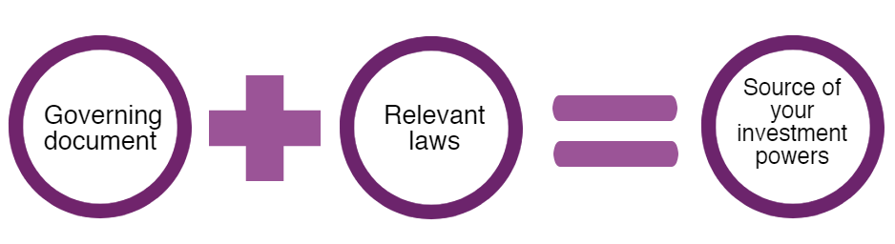

The name given to your governing document will depend on your charity’s legal form. The common legal forms for charities with investments are:

Legal form | Type of governing document
Company | Articles of association
Unincorporated association | Constitution
Trust | Trust deed
Scottish Charitable Incorporated Organisation (SCIO) | SCIO constitution
Royal Charter charity | Royal Charter, and any by-laws and rules

Investment powers may be listed in your governing document. If you’re not sure, seek advice.

If your governing document is silent on the matter of investment powers, there may be default investment powers available to the charity trustees, depending on the legal form of your charity. For example:

Legal form | Default investment powers
Trust | The Trusts (Scotland) Act 1921 gives trustees power to make ‘any kind of investment of the trust estate’. However, there are exceptions to this, if in doubt, you should seek advice
Company | Generally anything done by a company must be to advance its purposes and subject to any restriction in the governing document or in company law. If in doubt, you should seek advice.
SCIO | The 2005 Act gives a SCIO power to invest, subject to the requirement that anything done by a SCIO must be calculated to further its purposes or conducive or incidental to doing so.

4.2 Charity trustee duties
All charity trustees have legal duties and responsibilities under the 2005 Act. A duty is something that you must do and all the duties must be met. The general charity trustee duties in the 2005 Act set out a broad framework that all charity trustees must work within. As a charity trustee, you are trusted to look after the charity’s assets and you are responsible for making sure that the charity fulfils its charitable purpose(s).

General duties:

1. You must act in the interests of the charity

1.1 You must operate in a manner consistent with the charity’s purpose
1.2 You must act with care and diligence
1.3 You must manage any conflict of interest between the charity and
any person or organisation who appoints charity trustees

Charity trustee duties apply equally to all charity trustees and all activities carried out by charities. All of the charity’s trustees should work together to make sure that these duties are met.

As a charity trustee, you must make sure that any activities are in the interests of the charity. You need to weigh up the pros and cons before making any decision that could significantly impact the running of the charity. The risk associated with any investment needs to be properly understood. You may want to undertake training, attend information events, and take professional advice to help inform your decisions and help you understand more about investments, so that you can scrutinise and discuss this aspect of the charity’s finances.

As a charity trustee, you have a duty to act with the care and diligence that it is reasonable to expect of a person who is managing the affairs of another person.

This means that you must act with a higher level of care than you do with your own finances and affairs. When you are dealing with the charity’s affairs, you should do so as carefully as you would if you were looking after someone else’s affairs, for example a relative or a friend.
For example: You might decide to invest some of your own money on a high-risk investment with potentially large losses and/or returns. You would not be able to do that with the charity’s money.

You must make sure that you protect the charity’s resources and that you do not put the assets of the charity at undue risk. Charity trustees need to consider what’s appropriate for their charity, considering all relevant factors.

When charity trustees are making decisions about investments, they should make sure that:

- they have the power to make investments in terms of the governing document, or law governing the legal form of the charity.
- appropriate advice is taken, where necessary. You can use the charity’s money to get professional advice for the charity if needed.
- they identify potential risks to help with good decision making and decide how to manage risk where it exists.
- the investments are in the interests of charity, for example making sure the investments are not inconsistent with the charity’s purposes.
- they are acting in accordance with their charity trustee duties,
- investments are diverse where possible.
- any conflict of interest affecting a charity trustee is identified, declared by that trustee and managed appropriately by all charity trustees. This should be done in line with the charity’s conflict of interest policy.

Conflict of interest examples:
- The board of a charity might include a charity trustee whose sibling is the partner in a financial planning firm. If the charity is considering appointing a financial planner to assist the charity with its investments, that charity trustee should declare the family relationship and not take part in any process to select a financial planner, if their sibling is among those being considered.

- A conflict of interest can arise where charity trustees are considering investing in a company, and one or more of them are directly involved in that company. For example, a community trust may consider investing in a local hydro scheme. One of the trustees of the charity is also a director of the local hydro scheme. This conflict of interest should be declared by that trustee to the other trustees and managed by all charity trustees. The conflicted charity trustee should not be present or involved in any discussions about the investment in the hydro scheme, or the final decision.

Acting in this way will help charity trustees to meet their legal duties.

Charity trustees of certain legal forms of charity will also have duties under other legislation. For example, where the charity is a trust there are specific requirements in the Trusts and Succession (Scotland) Act 2024. Where the charity is a company there are requirements in the Companies Act 2006 that will apply to the charity trustees as company directors.
4.3 Endowments
It could be that some of your investments form part of an endowment fund. An endowment is a fund consisting of assets which are held for the benefit of the charity. The objective is to provide the charity with income to spend on its charitable purposes. There are two types of endowment funds - permanent and expendable.

- A permanent endowment fund is one that consists of assets that have been gifted to the charity with specific conditions attached and where the capital cannot be spent in any circumstances.
- In an expendable endowment, the capital may be spent in those circumstances specified in the terms of the endowment document.

A charity may have an endowment even though it no longer holds the paperwork that originally established it. It is important for charity trustees to know and understand any constraints that exist on how they may spend/use the charity’s assets. Other information may assist charity trustees in identifying whether they do hold an endowment, for example accounts for previous years and minutes of charity trustee meetings.

Despite a charity being given an endowment which is designed to provide income for future use, it may be possible (depending on the terms of the endowment) to change the assets within the fund. For example, some of the original investment portfolio could be sold and the proceeds reinvested in different investments. It may depend on the nature of the endowed asset as to whether it can be changed or not – for example, a building that was given to the charity for its own use is less likely to be capable of change.

Find out how to apply for consent to reorganise a restricted fund.

5. What else should you think about before investing?

Once you’re clear about the investment powers your charity has and understand your legal duties as a charity trustee, you can start looking at other factors which affect your investment decisions.

5.1 How to align your investments to your charity’s purposes

As set out in section 4.2, charity trustees have a duty to act with care and diligence so that the investments are in the interests of the charity. This could mean making sure investments are consistent with the charity’s aims. Charity trustees might also link the charity’s investments to its overall strategy, or protection of its reputation.

When it comes to screening to align with these aims, here are some examples of the methods that you could use:

Where charity trustees decide to apply some sort of screening on the basis of reputational concerns, they will need to be mindful of the extent to which (if at all) the scope for financial returns narrows as a consequence. Given the legal duties that charity trustees have, it is important that they consider these factors when making investment choices.

Myth busting
It’s not the case that charity trustees in Scotland have ‘a duty to maximise financial returns’. An investment doesn’t have to make money at any cost. It can provide both financial and non-financial returns but charity trustees have to consider all relevant factors and act in the interests of the charity at all times.

5.2 Social and environmental returns (non-financial returns)
A return from an investment used to mean a purely financial return. However, other investment options are available for charities, including investments that offer a social or environmental return as well as a financial one.

Social or environmental returns can allow a charity to make a link to the delivery of their charitable purposes.
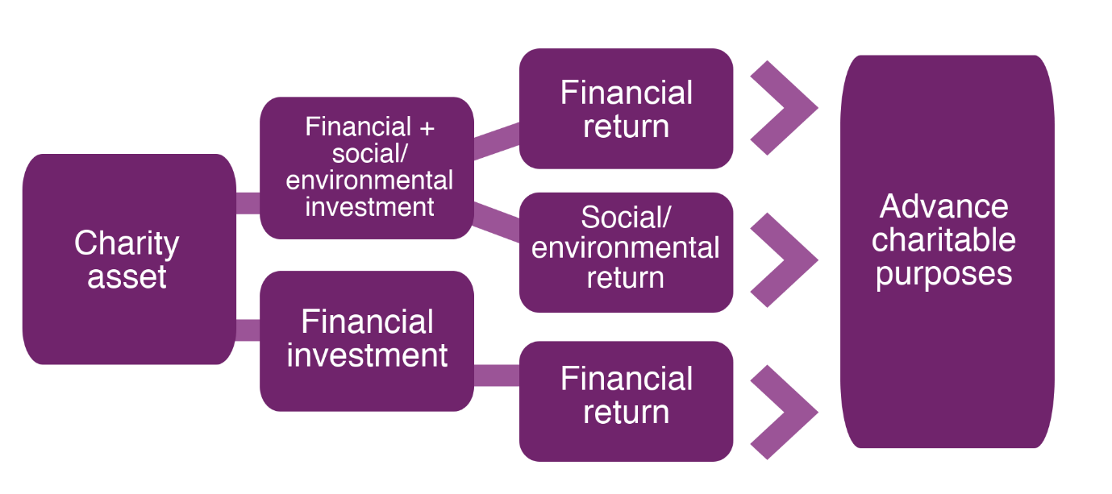

In England and Wales, there is a definition of ‘social investments’ in the Charities (Protection and Social Investment) Act 2016: ‘A social investment is made when a relevant act of a charity is carried out with a view to both directly furthering the charity’s purposes and achieving a financial return for the charity.’

There is no legal definition of social investments in Scotland. It is for a charity’s trustees to assess the suitability of any investment, keeping in mind:

- their investment powers, and
- the general duties to act in the interests of the charity, with care and diligence and in a manner consistent with the charity’s purposes.

5.3 Environmental, social and governance (ESG) factors

Regardless of whether charity trustees decide to apply any negative or positive screening of the kind set out in section 5.1, ESG factors are something to be aware of in the process of making decisions about the charity’s investments.

If a company you are investing in does not take a responsible approach to its impact on the environment, its employment practices or how its board operates, these factors could affect the financial performance of that company. This could affect the value of your investment and/or impact on the charity’s reputation.

Practice varies in the way investment managers approach these factors in selecting investments for your charity. An investment manager may do this as matter of course, or there may be additional options open to you. For more guidance on this, speak to your financial planner or investment manager.

The value your charity chooses to place on ESG factors can be reflected in your investment policy statement (see section 6) and in the kinds of questions you ask of an investment manager during the selection process (see section 7).

5.4 Using your investments to influence change

A further element to consider relates to how any investment manager you appoint uses your investments to influence change on your behalf. This is sometimes known as ‘active stewardship.’

Your investment manager can try to influence change by meeting the companies you are invested in, to influence the management of the company towards better policies or conduct on environmental, social or governance issues arising for that company. For example, this could involve your investment manager meeting the senior management of a company to find out what action is being taken in relation to media reports of poor employment practices. This activity is also called ‘engagement’.

A second element in active stewardship involves voting. Your investment manager is likely to arrange for votes to be cast on your behalf on various matters relating to the company you are invested in. The vote may be for, against, or a decision may be made to abstain.

Practice varies in the way investment managers approach engagement and voting, and the level of information available to you. For more guidance on this, speak to your financial planner or investment manager.

The value your charity chooses to place on active stewardship can be reflected in your investment policy statement (see section 6) and in the kinds of questions you ask of an investment manager during the selection process (see section 7).

6. Discussing your charity’s investment policy

Once you are clear about your charity’s investment powers, charity trustee duties and what you may or may not want to invest in, you can develop the charity’s investment policy in more detail.

There are some important process points around how charity trustees approach making investment decisions.
Some charities may find it helpful to set-up a Finance or Investment sub-committee, whose remit includes scrutiny and monitoring of the charity’s investments.

Sometimes, a charity co-opts external members onto its Finance or Investment Committee, to bring in expertise not available on the board of charity trustees. They will have additional meetings to spend extra time on detailed finance matters.

Bringing someone onto a sub-committee does not usually make them a charity trustee and it is important that any sub-committee has a core of charity trustees too. This provides the sub-committee with outside perspectives and experience, as well as a good understanding of the charity’s operations.

Ultimately, the decision-making about investments is the collective responsibility of all the charity trustees, beyond any smaller group on a Finance or Investment Committee. It is important that all trustees have a basic understanding of the finances of the charity and can quickly identify if there are any problems. Regular reporting from any sub-committee to the full board of charity trustees is essential for collective decision-making and proper oversight of the charity’s finances.

Investment Policy Statement
It is good practice for a Scottish charity which owns investments to have an up-to-date investment policy statement. If your charity is considering investing for the first time, it will be helpful for your charity to create an investment policy statement before taking the step to invest.

An investment policy statement provides a focal point for charity trustee discussions and a means of recording decisions. It also supports induction of new charity trustees, who can see what policy decisions have already been made. Larger charities (with an income of £500,000 or more) are also required to explain their investment policy within their Trustees’ Annual Report (see section 8).

There is no fixed format for an investment policy statement. Charity trustees will want to tailor this to reflect the needs of their charity.

The table below sets out questions to help prompt discussion among charity trustees about an investment policy. The answers to these questions will provide input and content for an investment policy statement.

Section in investment policy statement | Questions to prompt discussion | Content to cover in investment policy statement
1. Opening section | Taking stock of what the charity is here to do, what’s our strategy and what’s going on which might affect the charity and our beneficiaries? | Background on the charity, its purposes, current strategic objectives, external environment and context, and how the investments fit into these.
2. Contact information | Are the charity trustees going to sign a letter of authority/board minute naming key persons for liaison with external parties? | Charity name, key contact and registration information for the charity.
3. Value and other assets | How much are we investing? What other assets do we have and how do the investments fit into that bigger picture? | The value of the charity’s investments, or the amount to be invested. Also mention the other assets owned by the charity, to set the context for how the investments fit into these.
4. Goals and objectives | What financial return do we need from our investments, to support our charitable activities? | Specify any target for investment income and/or target for capital growth.
5. Time horizon | Looking ahead, what is the charity’s outlook, in terms of how long it anticipates money being invested? | Some charities may have a plan to spend their money in a set number of years. Others may anticipate having money invested in perpetuity.  There may be short, medium and long term elements here.
6. Risk appetite | What impact will inflation have on our assets and future spending power? Are we comfortable with the ups and downs of the stock market, if we already have a financial buffer in place? | Set out the charity’s capacity for loss and whether it can withstand the fluctuations of the stock market. Refer to the charity’s reserves policy and how this interacts with the charity’s risk appetite for its investments.
7. Ethical criteria and alignment | Are any sectors or organisations in conflict with our charity’s purposes or activities, which means we should exclude them? From a reputation perspective, what would our donors and beneficiaries expect (or not expect) of us? Is positive screening relevant for us? | List any sectors or organisations for exclusion, in view of a conflict with the charity’s purposes or operations, or due to significant concerns about reputational risk. Positive or negative screening criteria can be listed here.
8. ESG factors and active stewardship | What value and weight do we want our investment manager to place on ESG factors and their role in the investment process?  What value and weight do we place on active stewardship, for our investment manager? Is it important to us that our investment manager meets companies to influence for better outcomes? | State any position on ESG factors.  State any position on active stewardship, engagement and visibility on voting
9. Restrictions | Are any other restrictions relevant for our policy? For example, are certain asset classes to be excluded, or types of investment product excluded? | List any restrictions to be placed on the investment strategy.
10. Performance assessment | How are we going to judge whether or not our investments are performing well for us? Is there a benchmark that is relevant for us? | State how the charity will assess financial and non-financial returns, including any use of benchmarks or other measures.
11. Access | How quickly does the charity need to be able to access cash, if it is making a withdrawal? Would you face any difficulties if some of your investments were locked away for a longer period, or you had to pay a penalty for early access? | Set out your access requirements. This is sometimes called ‘liquidity’.  Many investments can’t be accessed on the same day, and it might take several days for them to be sold to make cash available.
12. Currency | Are all of our operations UK-based? Do we operate overseas? | Set out any foreign currency requirements. This is particularly relevant for charities with overseas operations.
13. Reporting requirements | What kind of channels of communication do we want with our investment manager/other adviser (if you have one)? How often do we want to meet them/receive reports? How will we have visibility over the value of our various assets and how this changes over time? | Set out how often you want to receive reports with valuations and commentary. Set out any online access requirements. State how frequently any key committee/board meetings take place where you expect your investment manager/other adviser to attend. If you have a building, state any policy relating to valuations or updates on the building’s condition. If you have cash, mention how often you receive statements and how these are accessed.
14. Review process | What is our process for updating and keeping the investment policy statement under review? | Set out how your investment policy statement will be kept under review, to ensure it continues to reflect the purposes, strategy and objectives of the charity, which may evolve over time. Mention if there a Finance or Investment Committee which more regularly considers the investment policy statement, and how often is it seen, discussed and approved by all charity trustees.
15. Sign-off |  | A note of the date when the investment policy statement was approved by the charity trustees plus dates of any reviews and amendments.

7. Implementing your investment policy

Once you have agreed your charity’s investment policy, you’re ready to start investing and this is where professional advice can be key.

Charity trustees need to understand what they are doing with the charity’s money, when it comes to investing. Some charity trustee boards may have the skills and knowledge to manage their own investments. Others will need some professional help and support at various stages of the process.

The type of support that charity trustees may need will depend on:

- the type of assets they are considering investing in,
- what their strategy is and
- the complexity of the arrangements that they will be entering into.

If charity trustees are considering seeking professional support, then there are some key points to consider:

- What stage are we at? You may need help thinking through what’s most important to your charity and what your overall strategy should be. Or you may need help developing a strategy or investment policy statement. Many professional advisers and consultants offer help in relation to strategy and policy.
- What kind of assets are we thinking about investing in? Stocks and shares may mean that you turn to an investment manager, financial planner or investment consultant. If your asset is a building, a surveyor or property consultant would be more suitable.
- What returns are we looking for on the investments? If you are seeking non-financial returns, then you might consider support from professionals with a special focus on social investments.
- What support might we need on an ongoing basis? Will you need support to understand how the investments are performing and whether any changes are needed?

Once you have decided what kind of support (if any) you need, the next step is to find the right help. There might be a range of professionals that can help, so you will need to choose the right provider for your charity’s needs.

You might want to invite professionals to give a presentation on the services they can provide or to interview them so you can choose the right service for your charity.
It is a good idea to make a list of your requirements and any questions you have. For example:

- What experience do you have of working with charities like us?
- Which individuals/team would look after our charity and where are they based? Will we be able to contact them if we have questions or concerns about our investments?
- What is your investment proposal for our charity?
- What investment performance could we expect?
- What information will we receive from you, in what format, and when?
- What is the total investment management cost? It is important to understand how much it will cost for the support you want and if the expertise provides value for money.
- What is your approach to ESG and active stewardship?

Once a professional adviser has been chosen by the charity trustees, the arrangement should be formalised so that each party is clear about what is expected and what is to be provided. For example, this could be done in a letter of engagement or investment management agreement.

7.1 Investment planning and review cycle
The decisions that charity trustees make about investing the charity’s money are important. These allow the charity to generate financial and non-financial returns for the future and support the charity’s purposes and strategy. However, these decisions are not just made once and then forgotten about – the charity’s approach to investing should be subject to regular review, taking into account changes of circumstances and the environment in which the charity operates.

The charity trustees will want to keep their contract with any professional firm under periodic review. As the charity’s strategy evolves over time, charity trustees need to ensure that its investment policy keeps pace, and that its investments are continuing to support the charity’s goals. Concerns over service or value for money may also prompt a review, for example.

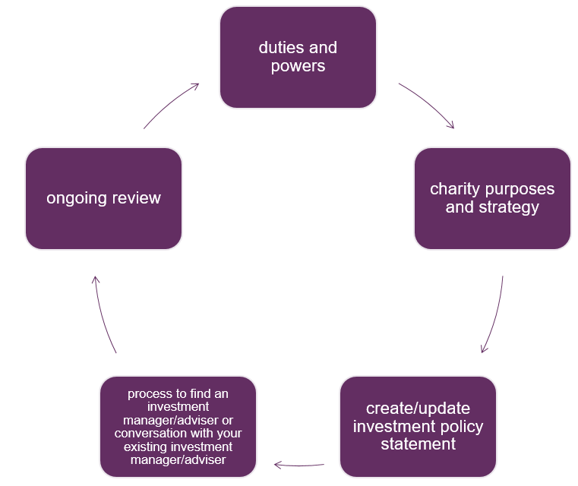

7.2 Case studies
The following case studies share examples of how different charities approached their investments.

Case study 1
This case study sets out how one charity approached a review of its investments. The charity’s assets included an investment portfolio worth under £1M.

The charity trustees carried out a skills audit to help flag any skills gaps on the board. This identified that there wasn’t a charity trustee with any investment experience currently on the board. A recruitment exercise was carried out and a new charity trustee with investment experience joined the board and also became a member of the Finance Committee.

Historically, the charity did not have an investment policy statement. The new charity trustee identified this gap and the Finance Committee was tasked with preparing a draft for consideration by the board. This was done, and the board reviewed and adjusted the investment policy statement, before approving it.

The investment policy statement contained ethical screening requirements, which were discussed by the Finance Committee and also the board of charity trustees. Tobacco, weapons manufacturing and pornography were excluded as sectors which caused harm to the beneficiary population of the charity or which caused significant reputational risks for the charity.

The Finance Committee developed a list of questions to ask investment managers, and a number of investment managers were invited to submit a tender. The investment policy statement was sent to investment managers along with the list of questions. A sub-group of the Finance Committee then attended presentations by the shortlisted investment managers. The Finance Committee made a recommendation to the board of charity trustees on which investment manager should be appointed. The board discussed and accepted this recommendation. The process to transfer the funds over to the new investment manager took several months.

On an ongoing basis, investment valuations are made available before Finance Committee meetings, and an online valuation service is also available. The investment policy statement is kept under review by the Finance Committee, and has since been further revised and approved again by the board of charity trustees.

Case study 2
This charity reviewed its investment portfolio following a specific process. Due to the background and sector in which the charity operates, the public procurement process was followed, in line with EU rules which lead to online notification of contracts for tendering.

The board of charity trustees sought advice from an investment consultant, to assist in identifying their requirements and to take advice on what investment approach would meet their goals. The investment portfolio was valued at seven figures.
From the many proposals submitted in response to the invitation to tender, a shortlisting exercise was completed. Investment managers were invited to meet a sub-group comprising some charity trustees, finance staff of the charity and the external investment consultant. In this way, an investment manager was identified and appointed.

Case study 3
A charity established with an initial endowment of £150,000 decided to invest into an ethical fund that is managed externally.

The charitable purpose is to assist Scottish communities, particularly rural communities, to find ways to work with the principles of sustainable development. One of the main activities is organising conferences that explore different aspects of rural development.

In 2014, the charity took a decision to invest £10,000 via the purchase of community shares in a Community Benefit Society (BenCom) involved in the field of community renewables. The investment was for a minimum period of three years and offers 3% - 4% return.

The charity trustees considered the community share investment to be more at risk than the funds placed with their ethical fund. Equally, they recognised that the financial return was also less certain.

However, the charity trustees agreed to invest in the community share offer because they believed that it fully aligned with their charitable purpose. It was also an opportunity for the charity to make a direct investment in a local project, the broad aims of which were also entirely consistent with the interests that the charity wishes to promote. Importantly, although not an overriding consideration, the investment was considered to offer a fair rate of return, although was likely to be significantly less than that generated from the ethical fund.

As this is a community share offer, the charity currently receives an annual dividend of approximately 3-4%. Under BenCom rules, after the three-year period, the capital value of the investment can be redeemed at the discretion of the BenCom and with the agreement of the investor. Due to the success of the community renewables venture, it is anticipated that the BenCom will be in a position to repay capital investments in the forthcoming years in order to reduce its debt repayments. In that case, the charity, which is interested in the long-term sustainability of the renewals BenCom, is likely to agree to the redemption offer, even though the level of financial return has proved to be satisfactory.

The community share investment offered the charity an opportunity to invest locally and to be more ‘productive’ with its money. As a result, the charity now considers itself more likely to invest ‘socially’ although also with an eye to securing a reasonable financial return.

Case study 4

An education charity holds an endowment. Its mission includes a commitment to make a positive impact for society and to make a significant sustainable and socially responsible contribution to the world. The charity is translating this commitment across its activities, including its endowment and treasury funds. It has a long-standing responsible investment policy, which includes the following four elements:

- The charity is committed to ESG integration, which means ESG factors are embedded in the research and investment process which underpins its investments. The charity is also a signatory to the UN Principles for Responsible Investment (as are its chosen investment managers).

- It applies negative screening and won’t invest in tobacco, controversial weapons or fossil fuels companies.

- The charity has undertaken positive investments in low carbon and renewables.

- It has committed to significant social investments, including an investment in a social fund which provides early stage finance to support local social enterprises.

8. Providing information to the public

Transparency and accountability in charity finances supports public confidence in charities.
Every charity in Scotland is legally required to prepare a trustees’ annual report and accounts and to submit these to OSCR. These are published on the Scottish Charity Register if the charity is a SCIO or its income is £25,000 or more. Where the charity has income of £250,000 or more or where it is a company of any size, it must prepare its accounts in line with the Charities Statement of Recommended Practice (SORP).

The SORP has specific requirements for the trustees’ annual report in relation to investments where the charity has income of £500,000 or more. These include:

- An explanation of the charity’s investment policy and objectives set where the charity holds material financial investments. This should include an explanation of the extent to which the policy takes into account social, environmental or ethical factors into consideration.

- A description of its social investment policies (where social investments form a material part of charitable and investment activities) and an explanation of how any programme-related investments contributed to the achievement of its aims and objectives.

There are also further requirements that need to be understood - more information is available in the SORP on how investments must be accounted for and what information must be included in the charity’s annual report and accounts about investments.

9. Glossary

Benchmarking: this refers to a way of measuring investment performance by comparing against a standard. Different standards are used depending on the type of investment.

Capital growth: this refers to an increase in the value of the investment. For example a property whose value goes up due to the property market going up or a portfolio of stocks and shares that have increased in value because the stock market is doing well. Capital growth can be temporary and will depend on the nature of the investment held.

Financial buffer: this refers to the amount of money that the charity has available to use if investments do not perform as expected – like a financial ‘safety net’ for the charity.

Financial planner: this term describes a professional adviser who provides regulated financial advice. A financial planner can help a charity select investments or an investment manager, and can help a charity by managing an investment manager interview process.

Investment consultant: this term describes a professional adviser who tends to work with charities whose investments run into many millions of pounds, such that the charity is a ‘professional investor’. An investment consultant usually gives advice on the appropriate mix of investments for a charity and helps a charity select an investment manager, by managing the investment manager interview process.

Investment manager: this term describes a firm that manages portfolios of stocks, shares and other assets on behalf of charities, among other clients. Some charities use a financial planner or investment consultant for help in selecting an investment manager. Some charities liaise directly with investment managers to manage the investment manager interview process themselves.

Liquidity: a term used to refer to how easy it is to access cash or convert an investment into cash – that is, how quickly can an investment be sold if cash is needed by the charity?

Material (or materiality): When we talk about a charity having material investments this means that the value of these investments is so significant that the overall picture of the charity’s finances or activities would be distorted if they were not taken into account. It is the responsibility of the person preparing the charity’s accounts to decide whether an item is material or not.

Portfolio of stocks, shares and other assets: a term commonly used to refer to a diversified collection of different types of investments that are grouped together and belong to an investor. What is contained within a portfolio can vary. For example, a portfolio might include a mixture of stocks and shares held in different companies, assets that generate a fixed income from governments or companies, cash and other types of investment.

10. Top 10 key points

Key points to help you make decisions about your charity’s investments:

- Understand your charity’s finances, including investments
All the charity trustees are collectively responsible for the charity’s investments and should have access to investment valuations and reports (not just the Treasurer or Finance/Investment Committee).

- Check your investment powers
Understand what, if anything, your governing document says about investments and any legislation relevant to your charity’s legal form.

- Know your charity trustee duties
You must make sure that any investment activities are in the best interests of the charity, weighing up the pros and cons before making a decision that could significantly impact the running of the charity.

- Consider your charity’s reputation
Your reputation is an asset to be protected. Charity trustees have a duty to act with care and diligence to protect a charity’s assets and reputation.
- Get help and advice if you need it
Consider what help or advice you need to support your charity in making decisions about its investments.

- Create an investment policy statement
It’s good practice for charity trustees to record policy decisions, keep them under review and include the information in your annual report and accounts.
- Think about your charity’s purposes
Consider how you connect your investments with your charity’s purposes and delivery of your strategy.

- Think about the range of investments
Understand there are different kinds of returns, measured in different ways: financial, social, environmental or otherwise – think about what is right for your charity.
- Understand your responsibilities
You may have power to delegate investment decisions to an investment manager, but you retain overall responsibility.
- Keep up to speed
Stay up to date with investment developments through events, seminars and other training.

