Fundraising Guidance for Charity Trustees

1. Introduction
What this guidance covers
What this guidance doesn’t cover
Who this guidance is for?
How to use the guidance
Sources of help and advice

2. Self-regulation and OSCR’s role
Self-regulation – legal responsibilities and best practice
OSCR’s role – statutory regulation
Other laws
Sources of help and advice

3. Charity Trustee duties and fundraising
Acting in the interests of the charity
Acting with care and diligence
Complying with the 2005 Act
Breach of charity trustee duties and misconduct
Sources of help and advice

4. Fundraising with third party organisations
Fundraising agreements
Information given to donors
Sources of help and advice

5. Public collections and exempt promoters
Public charitable collections
The Exempt Promoter Scheme
Sources of help and advice

1. Introduction

Fundraising is a key contact between charities and the public. Get it right, and your charity secures funding and public goodwill. Get it wrong, and you risk undermining the public’s confidence in your charity and the wider sector.

Many charities rely on money from the public to continue and it’s up to you, as charity trustees, to make sure that your charity – and anyone fundraising for your charity – observe the legal requirements and, importantly, the kind of fundraising practices that will encourage the public’s continued support.

Fundraising is also an important way to raise awareness and promote your charity and its aims.

Whoever does the fundraising in your charity, you as charity trustees are ultimately responsible for any activities carried out in your charity’s name.

Fundraising varies hugely in scale and covers a wide range of activities, including:

- Applying for grants
- Working with businesses
- Bucket collections
- Organising an event
- Helping volunteers to raise money
- How to run a raffle
- Fundraising by post and direct marketing
- Working with a consultant or freelancer.

What this guidance covers

There are many aspects of fundraising which OSCR does not regulate and that we cannot provide guidance on.

This guidance covers the areas that we do regulate. The two pieces of legislation OSCR oversees that set out some of the rules for fundraising in Scotland are:

- The Charities and Trustee Investment (Scotland) Act 2005 (the 2005 Act)
This guidance highlights the duties of all charity trustees under the 2005 Act and how these duties can apply to fundraising. It sets out the rules that charity trustees must follow when their charity carries out fundraising activities, whether small, occasional fundraising or as its main source of income.

- The Charities and Benevolent Fundraising (Scotland) Regulations 2009 (the 2009 Regulations)

This guidance outlines some of the main requirements of the 2009 Regulations. The full detail of the regulations can be found in our Technical Guide to the 2009 Regulations.

Fundraising regulation is a mix of statutory and non-statutory rules and involves different regulators depending on the rules involved and who is carrying out the fundraising in question.

OSCR is responsible for making sure that charities follow the rules under the 2005 Act and this guidance focuses on how those rules apply in a fundraising context.

Cross-border charities
Scottish charities also registered in another country or subject to other regulators may have to comply with additional fundraising requirements in that other country. The two other UK Charity regulators are:

- The Charity Commission for England and Wales
- The Charity Commission for Northern Ireland.

For cross-border charities the Fundraising Regulator is the non-statutory regulator which deals with any complaints about their fundraising practices.

What this guidance doesn’t cover

This guidance does not tell you about:

- The full range of laws that can apply to different types of fundraising
- All the requirements set out in the Code of Fundraising Practice and the Rulebooks for face to face fundraising which outline the fundraising standards expected across the UK
- How to fundraise
- Rules about the collection of goods
- Local authority requirements for public collections.

But, we do link to other sources of help and advice which cover some of these things.

SOURCES OF HELP AND ADVICE
OSCR publishes general guidance for charities, but we can’t provide specific advice about fundraising practices. These organisations can also help with some or all of the areas of fundraising:

- Technical Guide to the 2009 Regulations
OSCR’s revised draft guidance to the 2009 Regulations.

- Institute of Fundraising Scotland
The Institute of Fundraising is the professional body for UK fundraising whose aim is to promote the highest standard of fundraising practice.
- Scottish Fundraising Adjudication Panel
The Panel is the fundraising self-regulatory body for Scotland. They deal with complaints about charity fundraising and promote standards for charity fundraising in Scotland.
- Fundraising Regulator
The Fundraising Regulator holds the Code of Fundraising Practice for the UK and deals with complaints about fundraising by charities registered England and Wales and Northern Ireland.
- Charity Commission for England and Wales
The Charity Commission regulate charities registered in England and Wales.
- Charity Commission for Northern Ireland
The Charity Commission regulate charities registered in Northern Ireland.

- HMRC – Gift Aid
HM Revenue and Customs advises on Gift Aid, the Gift Aid Small Donations Scheme and other tax matters. You can also download Gift Aid declaration forms and guidance.
- Scottish Council for Voluntary Organisations
SCVO is a membership organisation offering a range of support for charities, community groups, social enterprises and voluntary organisations of all shapes and sizes across Scotland.
- Information Commissioner’s Office
The ICO oversees the UK privacy and data protection laws.
- Third Sector Interfaces
TSIs offer a range of support and advice to voluntary organisations in all the local authority areas in Scotland.

- Gambling Commission
The Commission license and regulate the people and businesses that provide gambling in Great Britain including Small society lotteries which raise money for charitable causes.

- Advertising Standards Authority
The ASA is the UK’s independent advertising regulator. The ASA makes sure ads across UK media stick to the advertising rules (the Advertising Codes).

- Ofcom
Ofcom is the communications regulator for the TV, radio and video-on-demand sectors, fixed-line telecoms, mobiles and postal services, plus the airwaves over which wireless devices operate.

- Direct Marketing Association
The DMA runs a number of preference services that allow consumers and businesses to opt-out of unsolicited marketing communications via telephone, mail or fax.

2. Self-regulation and OSCR’s role

SUMMARY

The fundraising landscape in the UK can be complex. Fundraising regulation is a mix of statutory and non-statutory rules and involves different regulators depending on the rules involved.

Charity trustees of Scottish charities have legal duties and responsibilities under the 2005 Act. We explain how these relate to fundraising in the next section.

The Code of Fundraising Practice sets out the standards expected of all fundraising across the UK.

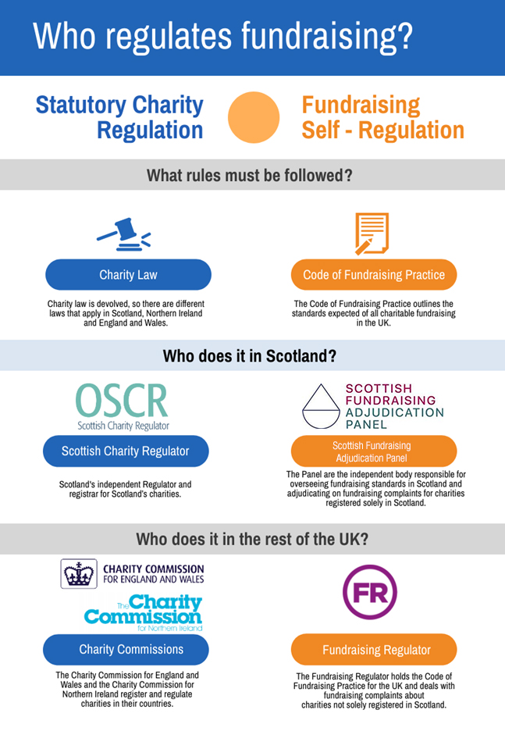
MORE DETAIL
UK fundraising regulation is split between:

- non-statutory regulation: standards set which cover the legal requirements and best practice

- statutory regulation: requirements set out in law.

These two types of regulation fall under different organisations:

 | Non-statutory regulation: The Code of Fundraising Practice and Rulebooks | Statutory regulation: Charity law
Scotland | Scottish Fundraising Adjudication Panel | Scottish Charity Regulator (OSCR)
England and Wales | Fundraising Regulator (including cross-border charities) | Charity Commission for England and Wales
Northern Ireland |  | Charity Commission for Northern Ireland

Self-regulation – legal responsibilities and best practice
In Scotland the system of non-statutory regulation is referred to as self-regulation, in the rest of the UK non-statutory regulation is referred to as independent regulation. This means that charities are the first point of call for any concerns about their fundraising and that charities play a role in setting the fundraising standards for the sector.

The Code of Fundraising Practice and its associated Rulebooks for face to face fundraising outline the standards and legal responsibilities expected of all charitable fundraising across the UK. The standards were developed by the fundraising community through the work of the Institute of Fundraising (IoF) and Public Fundraising Association (PFRA).

The Fundraising Regulator now has responsibility for the Code and the rulebooks.

Fundraising complaints
Under self-regulation, individual charities are the first point of call for any complaints about fundraising practices. Making sure charities can have robust procedures in place for dealing with complaints is a key part of self-regulation. If your charity doesn’t have a complaints procedure that covers fundraising you might want to adopt the Scottish Fundraising Adjudication Panel's model complaints handling procedure.

Where a charity is unable to resolve the complaint, the complainant can escalate it to one of the following:

- Scottish Fundraising Adjudication Panel: for charities only registered in Scotland
- Fundraising Regulator: for charities registered in the rest of the UK (England and Wales and Northern Ireland), including cross-border charities.

The Institute of Fundraising is the professional membership body for UK fundraising and has a range of guidance and advice on many fundraising matters.

OSCR’s role – statutory regulation
OSCR is responsible for making sure that charities follow the rules under the 2005 Act. OSCR will only usually become involved in a fundraising complaint where there is a risk to public trust and confidence in the charity or the wider sector. Specific concerns we look at are:

- a breach of charity trustee duties, or misconduct which includes mismanagement, by the charity’s trustees
- a risk to charitable assets.

Other laws
As well as the rules under the 2005 Act and the 2009 Regulations there are a range of rules that you should be aware of that apply to different types of fundraising activities, which are not covered in this guidance. If you need to you should get advice to make sure that your charity and those who fundraise for you know what rules to follow.

The Code of Fundraising Practice outlines these other laws and the types of activities they apply to, such as:

SOURCES OF HELP, ADVICE AND BEST PRACTICE
- Scottish Fundraising Adjudication Panel
The Panel is the fundraising self-regulatory body for Scotland. They deal with complaints about charity fundraising and promote standards for charity fundraising in Scotland.
- Institute of Fundraising Scotland
The Institute of Fundraising is the professional body for UK fundraising whose aim is to promote the highest standard of fundraising practice.

- The Scottish Fundraising Working Group report
This report explains how the self-regulation system in Scotland was developed.
- Fundraising Regulator
The Fundraising Regulator holds the Code of Fundraising Practice for the UK.

- Scottish Council for Voluntary Organisations
SCVO is a membership organisation offering a range of support for charities, community groups, social enterprises and voluntary organisations of all shapes and sizes across Scotland.
- Information Commissioner’s Office
The ICO oversees the UK privacy and data protection laws.
- Third Sector Interfaces
TSIs offer a range of support and advice to voluntary organisations in all the local authority areas in Scotland.

- Charity Commission for England and Wales
The Charity Commission regulate charities registered in England and Wales.
- Charity Commission for Northern Ireland
The Charity Commission regulate charities registered in Northern Ireland.

3. Charity Trustee duties and fundraising

SUMMARY
In this section we explain how the charity trustee duties under the 2005 Act relate to your charity’s fundraising activity and what that might mean in practice.

The duties in the 2005 Act and how they relate to fundraising have not changed.

The charity trustee duties set out a broad framework that all charity trustees must work within. There is more detailed guidance called Guidance and good practice for Charity Trustees on our website.

Charity trustees are required by law to act in the interests of the charity. This means as charity trustees you must make sure any fundraising carried out by, or on behalf of, your charity complies with all relevant laws and does not put the charity or its reputation at unnecessary risk. As charity trustees you must:

- comply with all relevant legal requirements
- make sure that all funds which are raised are properly accounted for
- only spend donations on the purposes for which they were raised.

The 2005 Act provides charities with control over those who fundraise for them. It requires that charities have a written agreement in place before any fundraising is carried out for them by a professional fundraiser or a commercial organisation.
In this guidance we refer to the written agreement as a ‘fundraising agreement’.

The 2009 Regulations set out what must be contained in a fundraising agreement. These requirements are explained in more detail in the next section.

MORE DETAIL
These duties separate out into general duties that set out a broad framework that all charity trustees must work within, and specific duties detailed in the 2005 Act. The duties are set out in the diagram below.

The general and specific duties apply equally to all charity trustees and to all charities registered in Scotland. All of the charity’s trustees should work together to make sure that these duties are met.

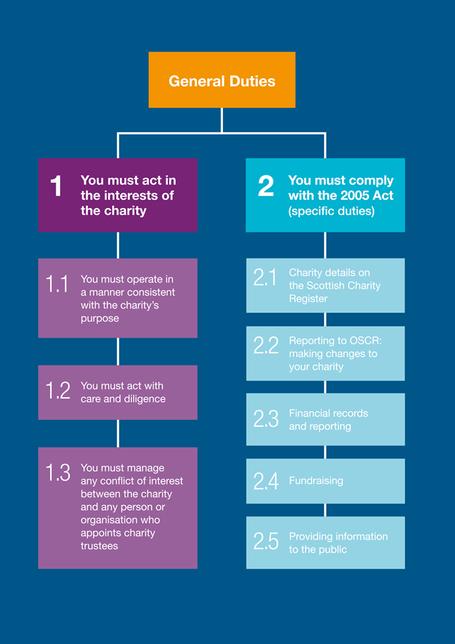

Your fundraising may be carried out by:

- Volunteers
- Charity staff
- Third party professional fundraisers
- Commercial organisations
- Trading subsidiaries of the charity.

The role of a charity trustee will vary from charity to charity. Some charities have staff who are responsible for daily operations, with the charity trustees providing strategic oversight and governance. Other charities are run solely by charity trustees.

Whoever does your fundraising you, as charity trustees need to make sure there are systems in place to allow them to understand what they can and can’t do. As charity trustees you need to oversee the fundraising activities to make sure that they are in the best interests of your charity.

The main charity trustee duties to bear in mind for your charity’s fundraising are:

- Acting in the interests of the charity
- Acting with care and diligence
- Complying with the 2005 Act.

A. Acting in the interests of the charity
This means you must do what is best for your charity and its beneficiaries and put the needs of your charity before the needs of any other organisation or individual. Doing what is best for your charity means protecting the long-term interests of the charity, its assets and reputation.

You should be able to show how the money you spend on fundraising is in the best interests of your charity:

- Show how you balance the financial or reputational risks and rewards to the charity
- Make sure that any third party fundraising agreements are favourable to your charity – carry out proper checks on any third party fundraisers you intend to use
- Show transparency in your fundraising relationships
- Be able to explain your fundraising work to the public, supporters and donors
- Make sure fundraising is regularly on the agenda at charity trustee meetings
- Take appropriate advice if you need it.

B. Acting with care and diligence

Whatever your charity trustee role involves – hands on or strategic oversight – the decisions you make about the charity should show that you are acting with care and diligence that it is reasonable to expect of a person who is managing the affairs of another person.

How to plan for and have oversight of your charity’s fundraising activities:

- Assess the risks of any fundraising activity. You should be able to justify the amount spent on fundraising compared with the amounts received
- Make sure you have the systems in place so that any money raised is properly accounted for, recorded and used only for the reasons for which it was collected
- Any funds raised for a particular project or appeal is a restricted fund and can only be spent on the stated activities
- Exercise reasonable commercial sense and develop a sound business case for any large scale fundraising activity
- Look for a range of funding sources – don’t put all your eggs in one basket
- Monitor and review fundraising performance regularly, including any third party fundraisers you use
- Embed the charity’s values into your fundraising plans and demonstrate your commitment to good practice: sign up to the fundraising guarantee from the Scottish Fundraising Adjudication Panel
- Be open and accountable – have procedures for dealing with complaints: adopt the Scottish Fundraising Adjudication Panel's model complaints handling procedure.
C. Complying with the 2005 Act

Fundraising
The 2005 Act sets out certain requirements for benevolent fundraising. The next section on the 2009 Regulations outlines these requirements and the Technical Factsheet on the 2009 Regulations sets them out in detail.

Publicising that you are a charity
All charities registered in Scotland must publicise the fact that they are a charity. Charity trustees must make sure that certain charity details, including the charity name and number are on all of the charity’s external documents including any fundraising material, like labels on collection buckets.

These rules also apply to any third parties who produce documents on behalf of your charity, including fundraisers. You need display your charity’s details, this means:

- your charity's name, as entered in the Scottish Charity Register
- any other name your charity is known as (the ‘known as’ name)
- your Scottish Charity Number (SC0[zero]xxxxx)
- the fact that you are a charity, if this is not already clear from your name.
For example: ‘Monkstown After School Club (known as Monkey Club) is a Scottish Charitable Incorporated Organisation (SCIO), Scottish Charity number: SC098765’.

You could add the OSCR Registration logo to your documents. More information can be found at: Publicising that you are a charity.

Breach of charity trustee duties and misconduct
If you fail to comply with these duties then this is misconduct and we do have powers to take action against charity trustees, where appropriate. Our response will be proportionate depending on the situation.

Where a charity trustee has acted reasonably and honestly, it is unlikely to be treated as misconduct. Find out more about what we can and cannot do and what to expect if we have a concern about your charity.

SOURCES OF HELP, ADVICE AND BEST PRACTICE
- OSCR’s Guidance and good practice for Charity Trustees and Being a Charity in Scotland.

- Institute of Fundraising Scotland
The IoF’s Scottish trustees and fundraising - a practical guide may be useful for many Scottish charities, as will their Treating Donors Fairly 2016 guidance.
- Charity Commission for England and Wales
The Commissions guidance Charity fundraising: a guide to trustee duties and checklist for charity trustees may be useful for larger Scottish charities and those that operate in England and Wales too.

- Fundraising Regulator
The Fundraising Regulator holds the Code of Fundraising Practice for the UK.

- NPC’s briefing paper on how trustees can support their charity’s fundraising.

4. Fundraising with third party organisations

SUMMARY

There are specific rules you need to follow when your fundraising involves third party organisations. The rules set out in the 2009 Regulations state:

- the information that must be supplied when asking for money on behalf of a charity and
- the information that must be contained in the fundraising agreements between charities and those who fundraise for them.

The 2009 Regulations cover benevolent fundraising, which means more than just charity fundraising. It means fundraising for any charitable, benevolent or philanthropic purposes.

Our technical guide explains the details and covers all benevolent fundraising – in this guidance we focus on the 2009 Regulations and how they relate to charities.

MORE DETAIL

In this section we outline the rules for ‘benevolent fundraising’ set out in the 2009 Regulations and how they apply to charity trustee duties. Benevolent fundraising includes raising money for a specific charity or for general charitable, benevolent or philanthropic purposes.

Benevolent fundraising and benevolent fundraisers are the terms used in the 2009 Regulations. In this section of the guidance, we refer to fundraising and fundraisers to cover all types of benevolent fundraising.

The Technical Guide to the 2009 Regulations explains all the details of the regulations.

The 2009 Regulations deal with three types of fundraisers:

Benevolent fundraiser (internal to the charity)
This is any benevolent body and companies connected with it. A benevolent fundraiser can also be an individual who is associated with the body or connected companies in the following ways:

- as a person in management or control
- as an employee or agent
- as a volunteer.
For example: a benevolent fundraiser may be a salaried charity fundraiser, the chief officer of a charity or a charity’s trading subsidiary.

Professional fundraiser (external to the charity)
This is a person who runs a fundraising business or who gets paid to raise money for a benevolent organisation or for general charitable, benevolent or philanthropic purposes.

A professional fundraiser is not an employee or trustee of a charity, a trading subsidiary, or a commercial participator.

For example: a professional fundraiser may be a company that is paid to conduct face to face or telephone fundraising on behalf of a charity.

Commercial participator (external to the charity)
This is a business that takes part in a promotional venture that sees some or all of the proceeds given to one or more benevolent organisations or will be applied for charitable, benevolent or philanthropic purposes.

A commercial participator is not the same as a professional fundraiser.
For example: a high street shop selling Charity Christmas cards and donating a certain proportion of the profits to the charity is a commercial participator.

The 2009 Regulations focus on:

- The fundraising agreements that organisations must have with any professional fundraiser or commercial participator that fundraises for them
- What those fundraising agreements must say and
- What information different fundraisers need to provide in different situations.

Many charities decide to work with professional fundraisers or commercial participators to help them raise funds and this is perfectly legitimate. You, as charity trustees, need to make sure that your charity is working with these third parties in a way which is both legal and fits with the ethics of your charity.

The charity trustee duties require that you assess and understand the risks and benefits of working with third parties and make decisions in the best interests of the charity.

Fundraising agreements
If you’re working with a professional fundraiser or a commercial participator your charity must have a fundraising agreement in place. The agreement must be in writing (electronic is fine) and it must contain certain elements, including:

- The name and address of the parties involved
- The dates the agreement covers and was signed
- What the aim of the agreement is and the fundraising methods involved
- How much the professional fundraiser or commercial participator is paid and when they are paid.

If the agreement is with a commercial participator, it also needs to include:

- the proportion of money from sales which will be given to the charity, and/or
- the amount of donations the commercial participator will make to the charity from the sales.

You can find details of all the requirements for fundraising agreements in our Technical Guide: Charities and Benevolent Fundraising (Scotland) Regulations 2009.

Information given to donors
The 2009 Regulations require different information to be given to potential donors depending on who is carrying out the fundraising and how they are doing it, for example face to face or in writing. It is important that those fundraising for your charity know what information they need to give potential donors and when.

You can find details of all the information to be given to donors in our Technical Guide: Charities and Benevolent Fundraising (Scotland) Regulations 2009. The Code of Fundraising Practice also details these requirements.

Any money raised for your charity by a professional fundraiser or commercial participator must be transferred as soon as possible and at the latest within 28 days of receipt.

SOURCES OF HELP, ADVICE AND BEST PRACTICE

- Technical Guide: Charities and Benevolent Fundraising (Scotland) Regulations 2009
This factsheet details all the requirements of the 2009 Regulations.

- Institute of Fundraising Scotland
The Institute of Fundraising’s Scottish charity law in relation to charitable collections guidance provides key information on these requirements.
- The Code of Fundraising Practice.

LEGAL NOTE
- Charities and Benevolent Fundraising (Scotland) Regulations 2009

5. Public collections and exempt promoters

SUMMARY
In this section we explain two aspects of fundraising in public:

- Public charitable collections
A public charitable collection is a collection of money from the public for charitable purposes in public or house-to-house.

- Exempt promoters
Anyone organising collections over the whole or a substantial part of Scotland may apply to OSCR to be an exempt promoter.

MORE DETAIL
Both the public charitable collections and exempt promoter’s rules come under different laws than the rest of the points in this guidance. OSCR does not oversee these laws.

5.1 Public charitable collections
Public charitable collections are a fundraising method that is the subject of specific regulations administered by local authorities.

What is a public charitable collection?
A public charitable collection is a collection of money from the public for charitable purposes taken either in a public place, like a street collection, or by house-to-house collections.

In this case ‘charitable purposes’ are not just those set out under the 2005 Act which OSCR regulates, they have a wider meaning and include any charitable, benevolent or philanthropic purposes.

The Fundraising Regulator holds the Rulebooks for face to face fundraising.
The need for permission
Anyone who wants to hold a public charitable collection must have permission from the local authority in which they plan to hold it. If you don’t have the right permissions, you could face a fine.

Contact the local authority for information about how to apply, most have forms for public charitable collections on their website, or search on GOV.UK licence finder for contact details.

Detailed requirements
Public charitable collections come under the Civic Government (Scotland) Act 1982. All organisers of public charitable collections should familiarise themselves with the Public Charitable Collections (Scotland) Regulations 1984, which provides the rules for the duties of organisers, collectors, the opening of collecting boxes and envelopes and accounting requirements in respect of public charitable collections. Organisers and collectors who breach the regulations can be fined if convicted.

The Institute of Fundraising’s Scottish charity law in relation to charitable collections guidance provides key information on the public charitable collections rules.

5.2 The Exempt Promoter Scheme
The Exempt Promoter scheme comes under the Public Charitable Collections (Scotland) Regulations 1984 and 1988.

Some larger charities that organise regional or national collections in Scotland can apply to OSCR to register as ‘exempt promoters’. The benefit of being an exempt promoter is that it reduces the administrative burden on the organiser (‘promoter’) of having to co-ordinate with many local authorities throughout Scotland when organising a public charitable collection.

An exempt promoter does not have to have permission from the local authority to hold a collection, but they must give the local authority at least three months’ notice of their intention to hold a collection and must follow the other requirements in the regulations.

An exempt promoter is an individual not an organisation. Usually exempt promoters are employees of specific charities using their exemption for collections organised by that charity. The list of Exempt Promoters is available on OSCR’s website.

Applying to be an Exempt Promoter
If you wish to apply to be an exempt promoter, or to have an exempt promoter in your organisation, please contact us at info@oscr.org.uk.

If you want to be an exempt promoter, you must provide OSCR with evidence that you have:
- Collected over a wide area of Scotland (at least 15 local authority areas) over each of the three financial years preceding the date of application
- Collected a reasonable sum in each area in each year
- Incurred expenses in organising the public collections of not more than 30% of the total collected.
In addition, you must submit the three most recent annual reports and accounts of the organisation and copies of any agreements relating to public charitable collections in Scotland that the organisation has with a third party professional fundraiser.
If approved we will issue a formal Direction which brings the exemption into force.
Reporting requirements
To retain the status, exempt promoters must submit the following information every year to OSCR:
- An audited account of the public charitable collections carried out
- A breakdown by local authority area of the amounts collected and expenses incurred
- A signed Organiser’s Statement
- A signed Auditor’s Statement
- A copy of a notice summarising the audited collection account published in a newspaper with national Scottish circulation. The notice must be published within one month of submission to OSCR of the audited collection accounts and local authority breakdown.

OSCR will check all the information and let the exempt promoter know if the exemption is continued.

SOURCES OF HELP, ADVICE AND BEST PRACTICE
- Institute of Fundraising Scotland
The Institute of Fundraising’s Scottish charity law in relation to charitable collections guidance provides key information on the requirements of public charitable collections and exempt promoter’s rules.

- GOV.UK licence finder for local authority contact details.

LEGAL NOTE
The current legislation for public charitable collections and exempt promoters as contained in the Civic Government (Scotland) Act 1982 and the Public Charitable Collections (Scotland) Regulations 1984 and 1988 remains in force:

- Section 119 Civic Government (Scotland) Act 1982
- Public Charitable Collections (Scotland) Regulations 1984
- Regulations 10(2)(c) and 11(5)(b) regarding the opening of collecting boxes have been amended by the Public Charitable Collections (Scotland) Amendment Regulations 1988

The wording to be used is set out in the Schedule to the 1984 Regulations
The wording to be used is set out in the Schedule to the 1984 Regulations

