A Guide to Incorporation

- Introduction
- What incorporation means
- Before you start
- The 6 step OSCR process
- Incorporation FAQs
- Factsheets and checklists

Introduction

Summary
Charities can take a number of legal forms. The legal form is the structure of a charity. Some legal forms are unincorporated, some are incorporated. When a charity wants to move from an unincorporated legal form to an incorporated legal form there are certain things the charity has to do, or should be aware of, for that move to happen properly.
What this guide covers
This guide is for charities considering changing from one structure to another structure which is incorporated. This is usually a Scottish Charitable Incorporated Organisation (SCIO), although it could also be a company. This guide does not cover charitable companies who want to convert to a SCIO. This is a separate process and you will find more details in SCIOs: A Guide.
In this guide we will refer to incorporation to a SCIO, and highlight where there are any differences for incorporation to a company.
This guide sets out the process charities should follow to meet the requirements of the Charities and Trustee Investment (Scotland) Act 2005 (the 2005 Act) when they are incorporating. The guide also sets out other things charities need to know and consider about incorporation.
Who is the guide for?
This guide is for:
- Anyone who is a charity trustee of an unincorporated charity registered in Scotland.
- Anyone who runs an unincorporated organisation (not a charity) that wants to become an incorporated charity. See FAQs for more information.
- People working with or advising charities and other third sector organisations.
How to use the guide
This guide sets out the charity law process for incorporating a charity and some of the other things you will need to consider which don’t relate to charity law but can affect the process.
The glossary provides you with further information, definitions and descriptions of some key terms. We’ve highlighted these key terms in bold purple type. Clicking on these terms will take you straight to the glossary.
This guide is split into sections that explain the different steps of the process and is supported by factsheets produced by the stakeholders below who worked with OSCR to shape and inform the guide.
OSCR is grateful to the following people for their support and assistance in producing this guide and the factsheets:
Steff Bell: Edinburgh Voluntary Organisations’ Council (EVOC)
Alan Eccles: Charity Law sub-committee of the Law Society of Scotland
Sandy Mathers: Aberdeen Council of Voluntary Organisations (ACVO)
Rhonda McLean: Scottish Council for Voluntary Organisations (SCVO)
Tom Mitchell: Institute of Chartered Accountants of Scotland (ICAS)
Eliza Scoffield: Early Years Scotland
Thirza Wilson and Philip Yeaman: Care Inspectorate

Sources of help and advice
OSCR publishes general guidance for charities, but we can’t provide specific advice on the full range of things which can happen in or affect your charity.
These organisations can help with some or all of the areas set out in the guide and more:
- Local Third Sector Interfaces (TSIs) offer a range of support to voluntary organisations.
- The Scottish Council for Voluntary Organisations (SCVO).
- You may need to consult a professional advisor. The Law Society of Scotland and the Institute of Chartered Accountants of Scotland may be able to help you to identify a professional firm with expertise in charity law or accounting.
- If your charity is part of an umbrella organisation, such as Early Years Scotland or the Development Trusts Association Scotland, the umbrella organisation or parent charity may be able to give you support.
- Companies House if incorporating to a company.
- HMRC for tax matters.
2. What Incorporation means
Essentially incorporation means you open a new, incorporated charity, and close the old one. You undertake two separate processes:

- Apply to OSCR to create a new charity, and
- Apply to OSCR for consent to wind up the old charity.

Once charitable status and consent are granted, the ‘old charity’ can then transfer the assets and liabilities to the ‘new charity’.
In this guide we use the terms old and new charity as follows:
Old charity means the unincorporated charity that will wind up or dissolve.
New charity means the incorporated charity that will continue the work of the old charity.

The new charity might have the same staff, charity trustees, members, offices, etc but it will be a separate, different legal entity.

This means that the new charity will have a new Scottish charity number and a new name (see FAQs for more information). Any existing contracts, leases, funding arrangements or other agreements need to be moved to the new charity.

What is the difference between legal forms?
Charities can take a number of legal forms. The legal form is the structure, which becomes a charity. Some of these structures are ‘unincorporated’ and some are ‘incorporated’.
Think about whether you want to become a SCIO or a company. Our legal forms factsheet sets out the key characteristics of these types of charity legal form and some of the pro’s and con’s of each.

Put simply unincorporated charities, unlike companies and SCIO’s, do not have a legal personality. This means unincorporated charities cannot enter into contracts in their own name, the charity trustees have to do so on the charity’s behalf and may be personally liable if something goes wrong.

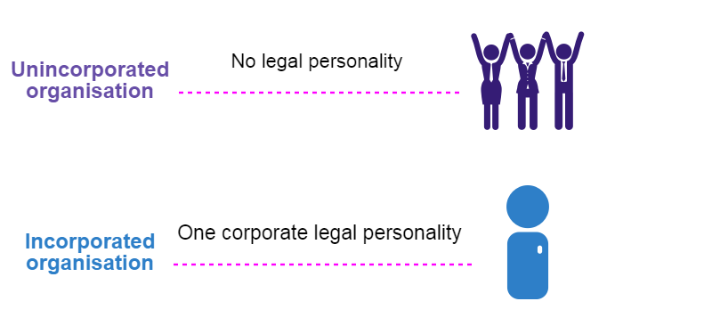

In Scotland the four most common types of charity legal form are:
- Unincorporated | - Incorporated
- Unincorporated association | - Scottish Charitable Incorporated Organisation (SCIO)
- Trust | - Company limited by guarantee

3. Before you start
Incorporation is a significant decision for any charity; there are important actions the charity will need to take. You are creating a new legal entity and will need to transfer all assets and liabilities of the old charity to the new charity.

It is important that charity trustees and members understand the full implications of the decision, plan ahead and acknowledge that it will take time for the process to be completed.
Charity trustees have a legal duty to comply with the requirements of charity law, the requirements of their own governing document and to act with care and diligence when making decisions.

If setting up a company you also need to comply with company law.

Here are the key questions that all charities looking to incorporate should ask:

- Why do you want to become an incorporated charity?
Many unincorporated charities may decide to change to a SCIO or company to secure funding streams or because they employ staff or own property. Incorporation means that the charity as a legal entity can enter into contracts in its own right and the charity trustees do not have the same liability if something goes wrong.
It also means that you’re setting up a new organisation that will need to have a different name, charity number, and governing document and must comply with other legal requirements associated with being a SCIO or a company.
- Do you want to be a company or a SCIO?
Our legal forms factsheet sets out the key characteristics and differences between companies and SCIOs. Members of a SCIO (unlike members of an unincorporated association) are subject to some of the general duties of charity trustees; specifically, they must:
- act in the interests of the SCIO, and
- seek, in good faith, to ensure the SCIO acts in a manner which is consistent with its charitable purposes.
See our SCIOs Guide for more information.
Charitable companies in Scotland are regulated by OSCR and by Companies House and must comply with company and charity law.
- Does your existing governing document contain the power to wind up the old charity and transfer the assets to the new charity?
If you don’t currently have the power to wind up the old charity or transfer the assets you may need to change your governing document before you can start the process. See FAQs for more information.
- What does your existing governing document say about making this kind of change?
- Do you need to consult with and get agreement from the members?
- Are there timescales and procedures for consulting with members?
- What are the voting requirements?
- Which other regulatory organisations do you need to contact?
You might need to contact one or more of these organisations:

- Funding organisations
- Local authority
- HMRC
- Disclosure Scotland
- Information Commissioner’s Office (ICO) - UK
- Other Regulators like the Care Inspectorate (see FAQs for more information).
As you are creating a new legal entity you may need to re-register with them and there may be costs involved. This is a specific issue for bodies registered with the Care Inspectorate. An application to cancel the Care Inspectorate registration for the old charity must be made and in some cases this can be refused – so contact the Care Inspectorate as soon as possible. See the Care Inspectorate Factsheet for more information.

- Will you need a new bank account?

Speak to your bank. You will need to set up a new bank account once the new charity is created so it is ready to receive the cash balances from the old charity. You should do this once the new charity is registered.

It may be that you need to run both bank accounts for a short time until the assets are all transferred across. Many banks have accounts suited to specific legal forms; make sure you have the correct one set up.
- Will you need to set up new agreements with your funders?

Speak to your funders and find out what they require. You may need their consent if you are transferring grants (or assets bought using grant funding) to a new charity and they may require you to sign/update a new funding agreement.

- Will you need a new insurance policy?

If you have insurance you should contact your insurers and find out what they require. Remember you are establishing a new charity; it may be that new insurance certificates are required.

- Do you employ staff?

If yes then you should consider your legal responsibilities under The Transfer of Undertakings (Protection of Employment) Regulations 2006 (TUPE regulations), plus any change to PAYE and national insurance.
- Do you operate a pension scheme?

There will be issues here you must consider. Dissolution of the old charity may mean that a large cessation debt (as the old charity will be ceasing membership of the pension scheme) becomes immediately payable which could be a major financial problem – this is often called the crystallisation of the pension fund. Where a body is a member of a multi employer scheme there may also be significant implications. Professional advice will be needed. See the Pension fund considerations Factsheet for more information.

- Are you registered for VAT or Gift Aid?

Seek professional advice on tax matters. You may need to obtain a new VAT registration for new charity. You should do this once the new charity is registered.

Your VAT advisers should also be asked if there are other VAT implications from the transferring operations to the new charity. If you operate gift aid you will need to register the new charity for gift aid and cancel your previous registration – HMRC will be able to assist with this. See FAQs for more information.

- Does your charity get legacy donations, for example being left money in Wills?
If so, see FAQs for more information.
- Do you have any of the following?

- Leases?
- Contractual agreements – do claw back provisions apply?
- Property?
- Other people holding property on the charity’s behalf?
- Pensions?
- Intellectual property – software licences, websites, trademarks?
- Endowments?
- Liabilities?
- Investments?
- Claims pending – insurance claims or claims against contractors?

You will need professional advice on how to transfer these to the new charity. Leases of equipment may not be transferable and there may be penalties for early termination.
Make a list of all the organisations you need to contact and all the things you need to transfer over to the new charity.

4. The 6 step OSCR process
Once the pre-application considerations are complete and the decision to incorporate has been taken, you are ready to start the OSCR process.
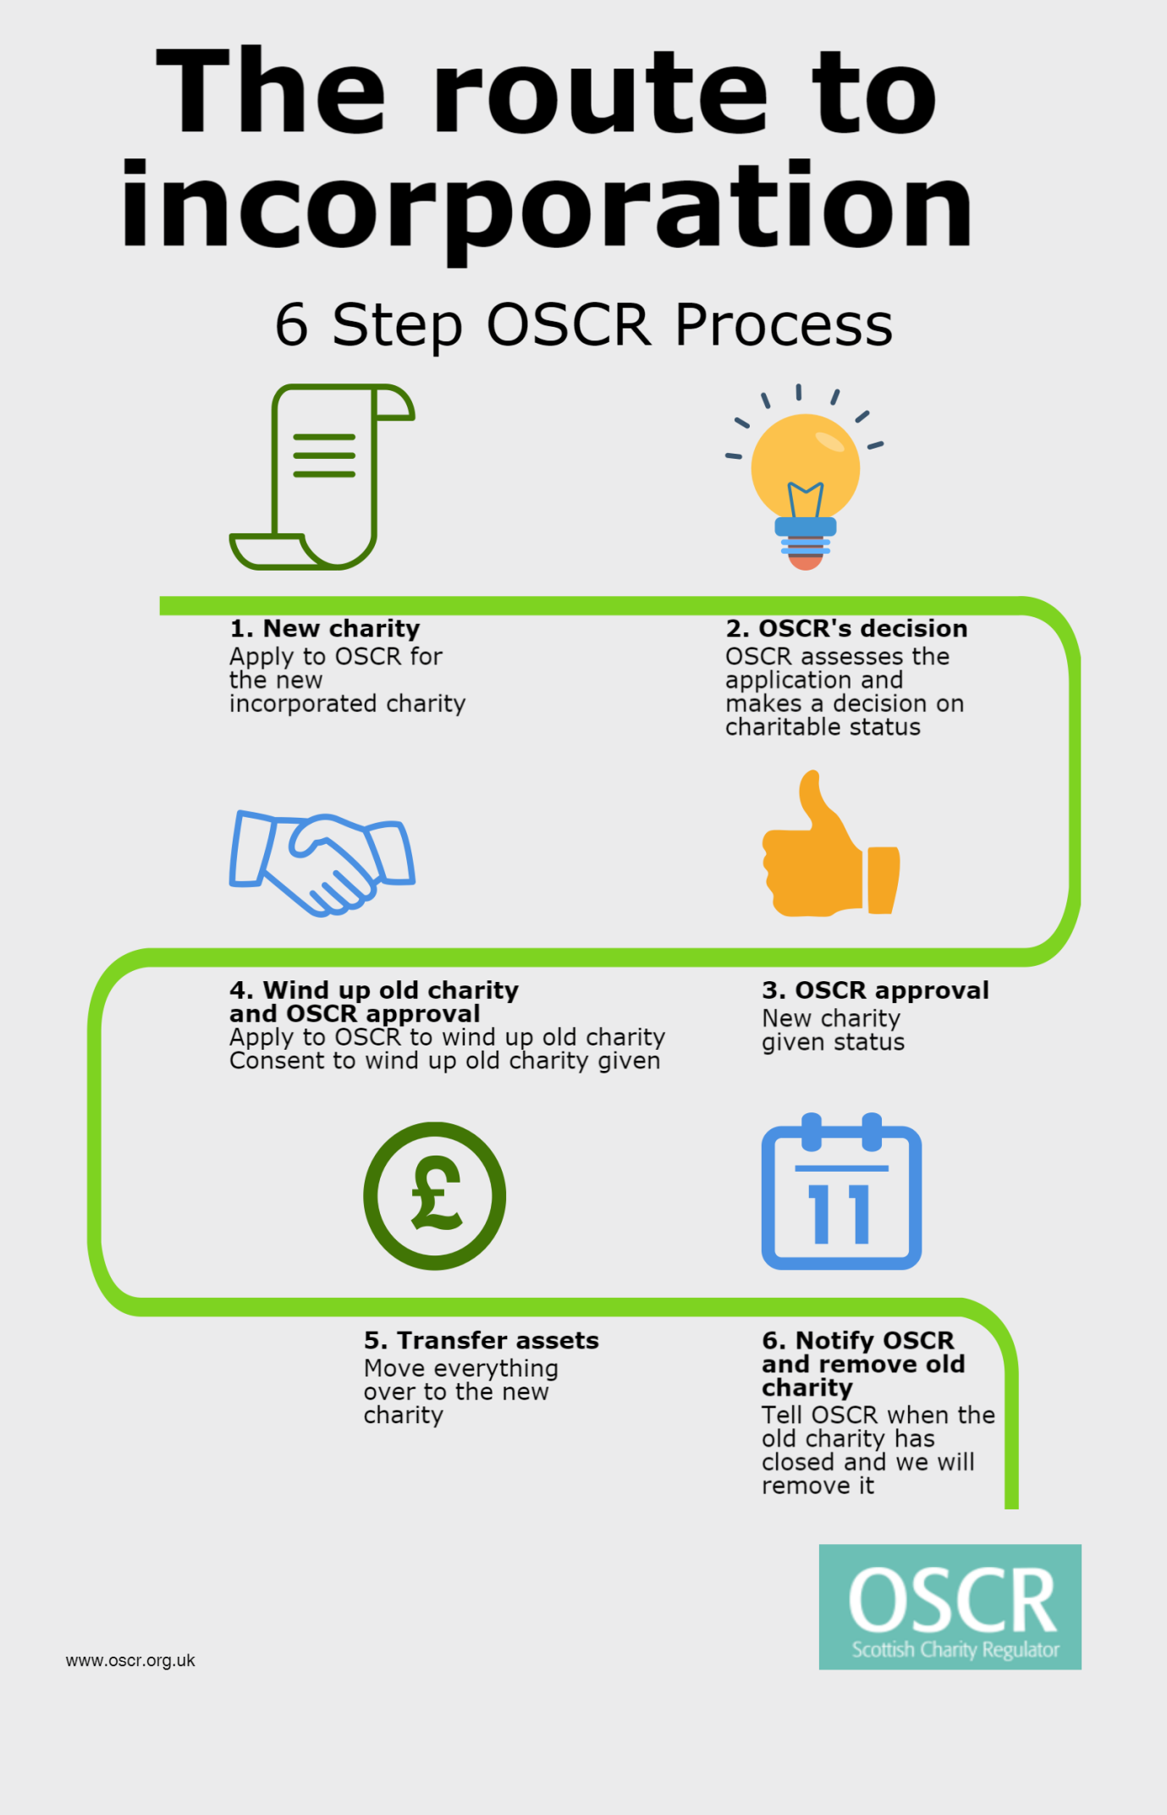

Step 1  Application for charitable status for the new charity | Complete the correct application form and read the guidance carefully. These forms ask if you are replacing an existing charity. You must answer all the questions in this section.  - SCIO: Application for Charitable Status  - Company: Application for Charitable Status  The new charity will need a new name, as charity law does not allow two charities with the same name on the Register. Charity trustees should consider this and it may be you simply add ‘SCIO’, the ‘year’ or ‘Limited’ (if a company) to the old charity name.  You also need to send us:  - A new draft governing document – SCVO have model governing documents which you could use. For SCIO’s it is a SCIO constitution. For companies it is Articles of Association.  - Make sure you explain the activities and public benefit – it’s a new entity, you need to assume we know nothing!  - Make sure you complete the application form as fully as possible to enable us to assess whether the charity test is met.  See the Checklist: Incorporation documents for OSCR.  If there is insufficient evidence for us to make a decision we will let you know.  It can take up to three months (or longer for more complex applications) for charitable status to be granted.
Step 2  OSCR’s decision on status | We will assess the application against the Charity Test in the same way we do for all applications for charitable status.  If charitable status is granted we will:  - Write to the new charity confirming status and providing the new charity number.  - The new charity will be entered on the Scottish Charity Register - there will be a cross-reference identifying the relationship between the old and new charity.  As both charities are on the Register, this gives the old charity time to deliver its activities as normal, and make sure the full transfer takes place effectively.  Until the old charity is removed from the Register, both charities will have to fulfil the annual reporting requirements and other regulatory requirements.
Step 3  The new charity | If the new charity is issuing external documents, these must state the details of the new charity (for example the new name and charity number).  If the new charity is a SCIO, it must state it is a SCIO on its external documents.  We will exercise some discretion in this area as charities use up old batches of stationery.  Read our guidance that outlines the specific requirements you must meet.
Step 4  Applying to wind up the old charity and OSCR’s consent | Complete the Application form for Consent to Wind-up.  See the Checklist: Incorporation documents for OSCR.  You must ask for our consent at least 42 days before you propose to wind up the old charity.  If we grant consent to wind up the old charity:  - We will tell you in writing and set out the requirement to notify us once the wind up is complete.  - You can start the transfer of assets once the new charity is on the register and the old charity has consent to wind up.  - You must follow the rules set out in the old charity’s governing document for how to wind up. For example you may need to pass a special resolution at a general meeting.  - You also need to follow any rules set out by other Regulators you fall under.
Step 5  Transfer | Transferring the various assets and liabilities from the old charity to the new charity can take time, depending on the type of things being transferred.  See the Factsheets and FAQs for more information.
Step 6  Notifying OSCR and removal of the old charity | When the transfers are complete you must notify us that the old charity has wound up. You must tell us within three months of the wind up being completed.  You will have to send us:  - the completed declaration sent out when we gave our consent and,  - any evidence we requested, such as evidence of transfer – date of completion, closing of the old bank account.  See the Checklist: Incorporation documents for OSCR.  Once we receive the information we will remove the old charity from the Register and the OSCR process is complete.  You may still need to complete other activities and processes not related to OSCR. For example HMRC, Care Inspectorate.  At this point you may also want to change the name of the new charity to that of the old one – see FAQs.

5. Incorporation FAQs
- Can we keep our name and charity number?

No. Incorporation means your charity becomes a new legal entity. Scottish charity law prevents us from entering two charities on the Scottish Charity Register with the same name. This means you have to have a new charity number and a new name.

If you don’t want to change the name significantly you could add the ‘year’, ‘SCIO’ or ‘Limited’ (if you’re changing to a company) to the end of the old charity name.
For example: ‘Save the Porpoise’ becomes ‘Save the Porpoise SCIO’.

Once the old charity has been removed from the Scottish Charity Register you could apply to OSCR to change the name of the new charity back to that of the old charity.

- Do we have to change all the details on our paperwork?

Yes. Our guidance on Publicising that you are a charity sets out the details that you must provide and where you must provide them. This is a legal requirement for all charities.

If the new charity is a SCIO, you must have the details on your external documents as soon as possible after the new charity is registered. However, OSCR will be proportionate with charities using up old stationery.
If you are a company you will need display your company details too.

- How long will it take to complete the process?

How long it takes will depend on a number of factors, including:

- How much preparation you have done.
- What other organisations you have relationships with or are regulated by.
- The types of assets you need to transfer.
- The complexity of your application for the new charity and your application to wind up the old charity.
- Membership requirements and agreements set out in your governing document.
- Staff and pensions.

The experience of many charities is that the application and wind up process takes between 9 and 12 months, with additional time for other organisations that may be involved.

- We are an unincorporated organisation (not a charity) and want to apply to become a SCIO, what do we need to know?

If you are an unincorporated organisation (not a charity) applying to become a SCIO, many of the issues highlighted in this guide, such as transferring assets, staff considerations and funding will apply to you. You need to understand that there may be a lot of work you need to do before you’re ready to apply to OSCR to become a charity. Contact one of the organisations listed in Sources of help and advice.

- Who else might we need to tell about the charity incorporating?

You might need to contact one or more of these organisations:

- Funding organisations
- Local authority
- HMRC
- Disclosure Scotland
- Information Commissioner’s Office - UK
- Other Regulators like the Care Inspectorate
- Bank
- Insurance company
- Pension’s provider.

There may also be other organisations you need to contact about incorporating. See the factsheets which accompany this guide.

- What do we do with our accounts?

See the Incorporation to SCIO: Accounts Factsheet for information on what type of accounts to prepare. If changing to a company you need to follow the accounting requirements for company law.

- Where can we get advice and guidance?

You may decide to seek professional advice to inform your decision on incorporation or more generally to support the charity during the process. Contact one of the organisations listed in Sources of help and advice.

You may also need professional advice about the transfer of property or leases. We strongly suggest you get professional advice if you operate a pension scheme and/or have:

- Property – land and buildings
- investments
- leases
- contractual agreements.

- We have no powers in the existing governing document to wind up

Before you apply to wind up the old charity, you need to check what the governing document says about how you need to go about it. You will usually find this in the ‘dissolution clause’.

If the governing document does not say anything about winding up you may still be able to do this, or you may need to change your governing document or re-organise the old charity to allow it to be wound up. If the governing document does not say anything about winding up you will need advice. Contact one of the organisations listed in Sources of help and advice.
- We want to become a company

If your charity wants to incorporate to become a company, you will need to provide us with draft articles of association when applying for charitable status for the new charity. We can only issue an ‘in principle’ decision on the application at first. The next step is to incorporate the company at Companies House. After the new company has been registered at Companies House, you will need to tell us and send copies of the Certificate of Incorporation and the final articles of association. Then we can confirm charitable status and issue a new charity number.

- We are a Village Hall

Village Halls looking to incorporate should take professional advice first. We have found that the governing documents of these charities can present certain difficulties.

Many of the village halls on the Register are trusts, and we are aware that a lot are considering incorporation. For some of these, their trust deeds won’t give charity trustees the power to wind up and transfer the assets. For others where there is the power we have found that it does not permit the transfer of the hall to another charity. See our technical guidance on Village Halls for charity advisers for more information.

- What if we change our mind?

There may be a range of reasons why a charity may change its mind and decide to withdraw from the incorporation process. If this happens, you should inform us immediately and we can either cancel any application for charitable status or advise you how to wind up the new charity.

If you are having major problems with the incorporation process that threaten to have a significant impact on the charity or its assets, you may want to consider raising this with us as a Notifiable event.

- We are regulated by the Care Inspectorate what do we need to do?

Charities who are registered with the Care Inspectorate (CI) who wish to become SCIOs will have to apply for a new (CI) registration. See the Care Inspectorate Factsheet for more details.

Full application details can be found on the Care Inspectorate website. In the case of SCIO’s, the Care Inspectorate registration can only be completed once the new charity has been registered by OSCR.
- We want to leave the existing charity on the Register – (legacy charities)

You may decide not to wind up or dissolve the old charity but instead keep it in existence as a ‘legacy’ charity. The purpose of these charities is usually to receive legacies, for example money left in a Will and pass them to the new charity.

If so, you should make OSCR aware of your intention in the status application form for the new charity. If you leave the old charity as a legacy charity it will still need to meet all the requirements of being a charity. In particular the old charity will:

- Still need to meet the charity test.
- Still need to have charity trustees who comply with all the charity trustee duties.
- Still have to comply with annual monitoring: preparing and submitting accounts, trustees’ annual report and the Online annual return.
The legacy charity should consider if its governing document needs to be changed. The purposes and powers of the old charity will reflect what it was originally set up to achieve – for instance they may not cover transferring legacy funds to the new charity, and may need to be changed. Other aspects of the governing document may also need to be amended if they no longer fit the new role of the legacy charity, for example the provisions about membership and the holding of meetings.

To make changes to the charity’s purposes you will need our prior consent. Other changes should be made in line with the requirements of your charity’s current governing document and then notified to OSCR. See our guidance on changing charitable purposes for more information.

- What do we need to do about tax?
You may need to obtain a new VAT registration for your SCIO, and you may wish to seek professional advice particularly if any interests in property are to be transferred to it.
If you operate gift aid you will need to register the new charity for gift aid and cancel your previous registration – HMRC will be able to assist with this.
You will need to apply to HMRC for any tax exemptions you currently receive. Tax relief is not an automatic part of being a charity and HMRC will need to assess a new application for tax relief from the new charity. See the Tax matters Factsheet for more information.

- Do we need to re-register for the Water Charges and Sewerage Exemption scheme?
Yes, you’re creating a new charity so you will need to re-register. See our FAQs for more information on the scheme. Full information is available on the Scottish Government website.

6. Factsheets and checklists
Before making the decision to incorporate charity trustees must consider the full implications for the charity. These factsheets and checklists highlight some of the issues you may need to consider before a decision to incorporate is reached.

Not all of these things will be applicable to all charities and there may be other factors that affect your individual charity. For this reason we recommend you get advice on your specific circumstances before taking any decisions on incorporation.

Factsheets and checklists | What it says
Legal Forms Factsheet | This factsheet tells you the four main legal forms for charities in Scotland and sets out some of the key points to consider when deciding what legal form is best for your organisation.
Incorporation to SCIO: Accounts factsheet | This factsheet tells you what types of accounts you can prepare for the old and new charity.
Care Inspectorate Factsheet | This factsheet is relevant to charities also regulated by the Care Inspectorate. It outlines the rules for de-registering the old charity service and registering the new charity service with the Care Inspectorate.
Pension fund considerations Factsheet | This factsheet is relevant to charities with paid employees. It outlines the two main types of pension schemes, lists things you will need to consider when transferring pension schemes and recommends always taking advice on pensions.
Early Years Scotland Factsheet | This factsheet is for Early Years charities and is designed to help those charities decide whether incorporation is the right move. It outlines the different things you will need to consider and where to go for help and support.
Advice and support on your move to incorporation Factsheet | This factsheet tells you which organisations can offer advice and support for different elements of the incorporation process.
Transferring assets and liabilities Factsheet | This factsheet explains what assets and liabilities are and what you need to think about for transferring them.
Charity Incorporation – Banks, Investments, Insurance and Licences Factsheet | This factsheet tells you about what you should be aware of in terms of your banking, insurance and any licences you may hold.
Tax matters Factsheet | This factsheet highlights the different tax issues that you may need to think about before and during the incorporation process.
Assets Register Factsheet | This factsheet highlights how to record things in an asset register.
Checklist: Incorporation documents for OSCR | This checklist sets out the documents and information OSCR needs from you during the incorporation process.
5 Tips for Incorporation | 5 things every charity should know before they start to incorporate.

