Being a charity in Scotland

Being a charity in Scotland

Scotland has around 24,000 charities of different sizes and wide-ranging purposes, including community groups, religious charities, schools, universities and care providers. Many people give their money and time generously to help charities, which play a valuable role in enhancing life in our communities and beyond.

What this Guide covers

This Guide covers the two main areas of the Charities and Trustee Investment (Scotland) Act 2005 (the 2005 Act):

The charity test
To be a charity in Scotland you must meet the charity test. This applies equally to existing charities and organisations that want to be charities.

Charity trustee duties
Charity trustees are the people who have general control and management of a charity. Charity trustee duties are at the centre of running a charity. The duties are set out in law and charity trustees must follow them. If the duties are not followed OSCR may take action.

This Guide sets out the key points charities need to know about the 2005 Act. It is not a detailed guide to all the requirements of charity law. Throughout the Guide there are links to specific guidance on our website and details of other organisations that can give help and advice to charities.

Who is this Guide for?

This Guide is for:

- charity trustees of existing charities or people working in charities, especially smaller ones.
- people who want to set up a charity.
- professionals who advise charities and organisations that want to become charities.

Sources of help and advice

OSCR publishes general guidance for charities, but we can’t provide specific advice on the full range of things which can happen in or affect your charity.

These organisations can help with some or all of the areas set out in the Guide and more:

- Local Third Sector Interfaces offer a range of support to voluntary organisations.
- The Scottish Council for Voluntary Organisations (SCVO).
- You may need to consult a professional advisor. The Law Society of Scotland and the Institute of Chartered Accountants in Scotland may be able to help you to identify a professional firm with expertise in charity law or accounting.
- If your charity is part of an umbrella organisation, such as Early Years Scotland or the Development Trusts Association Scotland, the umbrella organisation or parent charity may be able to give you support.

The charity test

To be a charity in Scotland you must meet the charity test. If you don’t meet the charity test you cannot have charitable status or call yourself a Scottish Charity.

What does it mean to have charitable status?
Having charitable status in Scotland tells the public, your supporters, funding organisations and people who benefit from your charity, that:

- your charity meets the charity test
- it is regulated by the Scottish Charity Regulator (OSCR)
- its charity trustees (the people who control and manage it) must meet certain duties and provide certain information to OSCR and to the public.

What is the charity test?

A charity must:

- have only charitable purposes, and
- provide public benefit in Scotland or elsewhere.

You cannot meet the charity test if:

- Your governing document allows the charity’s assets to be used for a non-charitable purpose. This applies during the lifetime of the charity and when it is being wound up (closed down).
- Your governing document expressly permits government Ministers to control the charity’s activities. This applies to both Scottish and UK Ministers.
- You are set up to be a political party or advance a political party. This doesn’t stop a charity campaigning or lobbying to advance its charitable purposes.

What is a governing document?

A charity's governing document is the written statement that sets out its purpose, structure and describes how it will operate.

The charity trustees must make sure that the charity follows its governing document, which usually contains key information about:

- what the charity exists to do (its charitable purposes)
- what powers it has to achieve its charitable purposes
- who the charity trustees are, how many charity trustees there should be and how they are appointed and removed
- whether the charity has any members and if so who can be a member
- rules about charity trustees' and members' (if any) meetings, how they are arranged and conducted and how decisions are made and recorded
- how to change the governing document
- how to close the charity down.

The name given to the governing document will depend on your charity's legal form. The most common legal forms for charities are:

Legal form | Type of governing document
Company | Memorandum and articles of association
Unincorporated association | Constitution
Trust | Trust deed
Scottish Charitable Incorporated Organisation (SCIO) | SCIO Constitution
Community Benefit Society | Rules

Charitable purposes

Charitable purposes are the first requirement of the charity test. Your charity’s purposes will be set out in your governing document. They say what the aims of your charity are and what it has been set up to achieve. They might be called objects, aims or purposes.

Your charity’s purposes don’t need to be exactly the same as the charitable purposes in the 2005 Act, but it should be easy to see how they relate to them. Detailed guidance about each purpose can be found in our Meeting the Charity Test: Guidance.

If you want to change your charitable purposes you need to ask OSCR for permission first. Detailed guidance on this can be found on our Making changes webpage.

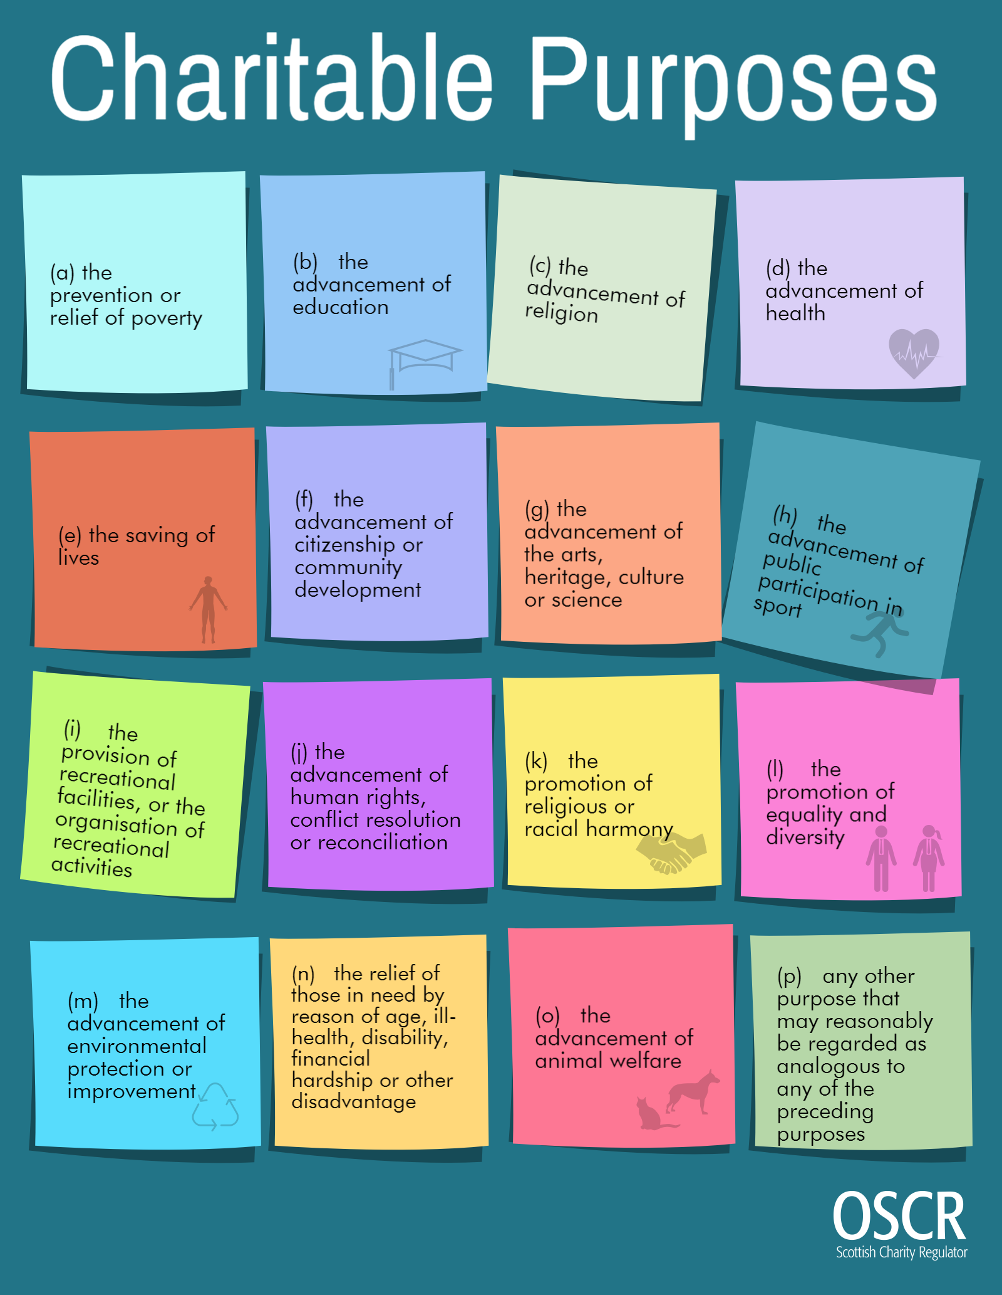

Public benefit

Public benefit is the second requirement of the charity test and key to being a charity. Charities can provide public benefit in many different ways.

Put simply, public benefit is the way your charity makes a positive difference through the activities it does to advance its charitable purposes.

Our Guidance on the individual charitable purposes has more information on what activities may provide public benefit when advancing each charitable purpose.

All charities must describe the work that they do, and their achievements, in a Trustees Annual Report. This is one part of the annual report and accounts that every charity must prepare and file with OSCR. This information allows the public to see how your charity makes a positive difference and how you provide public benefit.

It is important to explain how you provide public benefit and to review your charity’s purposes, activities and achievements annually.

Other factors that can affect whether you provide public benefit

- Private benefit
This is when someone benefits from your charity’s activities as a private individual, rather than as a member of the public. If this happens we need to decide how this private benefit compares to any public benefit your charity provides.

Too much private benefit can mean your charity fails the charity test. We need to look at the amount of the private benefit and decide if it is incidental to how your charity provides public benefit:

- incidental means that the private benefit is a necessary result or by-product of your charity’s activities.

For example:
Your charity has paid staff, because without them your charity could not function. This is private benefit to the individuals being paid salaries, but it is necessary for your charity to be able to advance its charitable purposes and provide public benefit.

- Disbenefit
Disbenefit is the opposite of benefit and we take it to mean the same as detriment or harm to the public. If there is disbenefit that outweighs any public benefit, your charity may fail the charity test.

- Undue restriction
Many charities have to limit the number of people who can benefit from their activities. Restricting public benefit is fine as long as you can show that the restrictions are reasonable, lawful and justified. In other words, they are not undue restrictions.
For example:
Your charity might need to charge for some or all of its activities. You should be able to show that the charges are reasonable for the activity and, where possible, help is given to those who can’t afford the charges.

Charity trustee duties

This part of the Guide tells charity trustees what the law says they must do or must not do. The charity trustee duties under the 2005 Act set out a broad framework that all charity trustees must work within. There is more detailed guidance called Guidance and good practice for Charity Trustees available on our website.

A duty is something that you must do. All of the charity’s trustees must work together to make sure that these duties are met.

What are a charity trustee’s duties?
As a charity trustee, you are trusted to look after the charity’s assets and you are responsible for making sure that the charity fulfils its charitable purpose(s).

There are general duties that help charities to be run properly and specific duties that are legal requirements all charities must meet.

There are also some broad principles that you should always take into account when running a charity:

Collective responsibility
All the charity trustees are collectively responsible for the charity. No one individual charity trustee should have more power or control over the charity than the others. Charity trustees are not only responsible for their own actions; they are also responsible for the joint actions and decisions taken by the charity trustees.

Decision making
Making good decisions is an important part of running any charity. To make good decisions you should:

- have the right information to make decisions
- make decisions in line with rules set out in your governing document
- record the decisions and
- be able to justify your decisions if necessary.

Don’t be afraid to think again about a decision if it doesn’t work out the way the charity trustees planned or if circumstances change. You should get professional advice if you need to.

Finance and assets
Make sure you have the right skills, policies and procedures to look after the charity’s finances and assets. This includes anything the charity owns like property, investments, money in the bank. It also includes any money the charity may owe to anyone else (liabilities).

Having the right skills includes making sure that all the charity trustees have access to and an understanding of the charity’s finances.

Reputation
A charity’s reputation is one of its assets and where that reputation is in question this can have a negative impact on how the public supports the charity and whether funding organisations will give the charity money. It can also impact on how the charity sector is viewed in general.

Charity trustees have individual and collective responsibility for the charity’s reputation. It is important that you maintain the respect of your beneficiaries, the public and others, by behaving with honesty and integrity when acting as a charity trustee. If you don’t do this you risk bringing your charity and its work into disrepute.

What the law says:

1. You must act in the interests of the charity

What this means:
- You must do what is best for your charity and beneficiaries, not what is best for you, your friends, family or business interests.
- You must put the needs of your charity before the needs of any other organisation or company that you are involved with.

How you can achieve this:
- Your charity has a list of where charity trustees work and any other organisations they are involved with. This list is kept up to date and will help to identify any potential conflicts of interest.

- Your charity has a “code of conduct” that says what charity trustees should do if there is a conflict of interest. A conflict of interest is when a charity trustee might not be able to do what is best for the charity because he or she has a duty to another organisation or person.

- Your charity has a policy that says what will happen if a charity trustee does not act in the interests of the charity.

- Your charity has a policy that makes it clear when it is ok to pay charity trustees, their family or the organisation they work for. You should read our full guidance first if you intend to do this and check if your governing document allows it. There are specific rules about paying charity trustees and people connected to them. Charity trustees can get expenses, like train fares to get to a charity trustee meeting; this isn’t considered a ‘payment’.

More information:
- Charity Trustee Duties: http://www.oscr.org.uk/charities/guidance/guidance-and-good-practice-for-charity-trustees/charity-trustee-duties

- Managing your charity: http://www.oscr.org.uk/charities/managing-your-charity/trustee-duties
- Remuneration (Paying charity trustees and connected persons): http://www.oscr.org.uk/charities/guidance/guidance-and-good-practice-for-charity-trustees/remuneration-paying-charity-trustees-and-connected-persons

What the law says:

1.1 You must operate in a manner consistent with the charity’s purpose

What this means:

- Every charity has a “governing document”. This contains the rules that say what the charity does and how it is run.

- You must make sure that the other charity trustees and the people working for the charity follow the rules in the governing document.

- You must make sure that the charity's money and property are only used to do the things that are allowed by the governing document.

- You must make sure that the charity’s activities advance its charitable purposes.

How you can achieve this:

- Charity trustees get an information pack about the charity when they start, including a copy of the charity’s governing document.

- Charity trustees plan what the charity will do and make sure the plan fits in with the charity’s governing document.

- Charity trustees regularly review the governing document to make sure it is still up to date and relevant.

More information:
- Governing Documents and Meetings: http://www.oscr.org.uk/charities/guidance/guidance-and-good-practice-for-charity-trustees/governing-documents-and-meetings

- Meeting the Charity Test: http://www.oscr.org.uk/charities/guidance/meeting-the-charity-test-guidance

What the law says:

1.2 You must act with care and diligence

What this means:

- You must run the charity carefully and must all work together for the good of the charity.

- You must make sure that the charity complies with any relevant laws, for example health and safety or data protection.

- You must make sure that the charity has enough money to pay staff and other costs.

- You must make sure that any staff the charity has are treated properly and fairly.

- You must make sure that the charity’s name, number and logo are not used without permission.

How you can achieve this:

- Charity trustees review the charity’s plans regularly to make sure that they are up to date.
- Charity trustees work together to protect the charity including its beneficiaries, assets and reputation. This means assessing potential risks to help good decision making.
- Charity trustees must keep accounting records that include the money the charity spends and the money that comes into the charity.

- Charity trustees should report any notifiable events to OSCR.
- Charity trustees agree what will happen if a charity trustee misses too many meetings.

- Every year, charity trustees review:
  - what the charity has done well
  - what it could do better
  - the charity’s governing document to see if it needs to be changed.
- Charity trustees have access to training if they need it.

- Charity trustees are clear how to make a decision when they don’t all agree with each other.

- Charity trustees make sure there are rules in place to deal with any grievances raised by the charity’s staff and/or volunteers. For example, an internal complaints procedure.

- Charity trustees make sure that volunteers are treated properly and fairly.

- Charity trustees get legal or financial (money) advice from experts if they need to.

- Charity trustees must comply with all relevant laws and have a good system to make sure they keep up-to-date with any changes to the law. There are lots of organisations that can help you do this. See Sources of help and advice for details.

More detailed information:
Charity Trustee Duties:
http://www.oscr.org.uk/charities/guidance/guidance-and-good-practice-for-charity-trustees/charity-trustee-duties

Managing your charity: http://www.oscr.org.uk/charities/managing-your-charity/trustee-duties

Reporting Notifiable Events: http://www.oscr.org.uk/charities/managing-your-charity/notifiable-events

What the law says:

1.3 You must manage any conflict of interest between the charity and any person or organisation who appoints charity trustees

What this means:

A conflict of interest exists when your duty to act in the interests of the charity conflicts with:

- The interest of the person or organisation that appointed you as a charity trustee (an “appointment conflict”).
Although not mentioned in the law there is another type of conflict of interest that you should be aware of:

- Conflicts with your own personal or business interest (a “personal conflict”).
How you can achieve this:

Conflicts of interest can and do come up: it is how you manage them that is important.

- Identify:
  - Have conflict of interest as a regular agenda item at the beginning of charity trustee meetings.
  - Declare any potential conflicts of interest as soon as you become aware of them.

- Manage:
  - Have a conflict of interest policy.
  - Have clear procedures in place that state what should happen if there is a conflict of interest and how the charity trustees will deal with it. For example, the conflicted charity trustee might withdraw from the meeting or part of the meeting.

- Record:
  - Keep a written record of the situation and what the charity did about it.
- Learn:
  - Learn from the experience, make improvements to the charity’s policy and procedures and where necessary seek professional advice.

More information:

Conflict of interest: http://www.oscr.org.uk/charities/guidance/guidance-and-good-practice-for-charity-trustees/conflict-of-interest

2. You must comply with the 2005 Act (specific duties)

These are things that charities must do. The charity trustees must make sure that these things are done. You can find more detail about the specific duties on our website.

Specific duty 2.1: Charity details on the Scottish Charity Register
You must give OSCR the information it needs for the Scottish Charity Register and make sure the information is up to date.

Specific duty 2.2: Making changes to your charity and telling OSCR
- Charity trustees must tell OSCR if any of the charity’s details on the Scottish Charity Register change.

- Charity trustees need to ask OSCR for permission before making certain changes, such as:

  - changing the charity’s name
  - changing the charity’s purposes
  - winding up the charity.

Specific duty 2.3: Financial records and reporting
- Charity trustees must make sure that the charity keeps accounting records. These should include a record of the money it receives and the money it spends as well as anything the charity owns like property, investments, money in the bank (assets) and any money the charity may owe to anyone else (liabilities).

- Every year you must send us your:
  - Annual accounts
  - Trustees’ Annual Report
  - External scrutiny report, and
  - Online annual return.

- You must keep a copy of the accounting records for 6 years.

Specific duty 2.4: Fundraising
- You must make sure that anyone who raises funds for your charity is allowed to do so.
- There is specific information that your charity must provide to a donor before they agree to donate. This is explained in our guidance on Charities and Benevolent Fundraising.
- There are specific regulations that say what must be contained in a fundraising agreement between your charity and professional fundraisers.

- You must make sure that any fundraising you carry out directly or that someone else carries out on the charity’s behalf complies with the Code of Fundraising Practice.

Specific duty 2.5: Providing information to the public
- Charity trustees must make sure that the charity’s details, including the Scottish Charity Number (SC0[zero]xxxxx), are on all the charity’s formal communications, like letters, emails, invoices and websites.

- Charities must give a copy of their governing document or latest accounts to anyone that asks for them.

Breach of charity trustee duty: What happens when charity trustees break these rules

- If a charity trustee breaks these rules, OSCR may take action in line with our Inquiry Policy.

- There are lots of organisations that will support charity trustees who need help to carry out their duties or to understand what their duties are. See Sources of help and advice for details.

- There are lots of organisations that will support charity trustees who need help to carry out their duties or to understand what their duties are.

Top 10 key points to running a charity properly

- Always do what is best for your charity: as a charity trustee you have a legal responsibility to put the interests of your charity above your own interests. All the charity trustees are collectively responsible for making sure that the charity is run properly and lawfully.

- Act with care and diligence: you have to protect your charity including its beneficiaries, assets and reputation.
- Understand your charity’s legal responsibilities: make sure your charity is meeting its legal duties under charity law and other relevant laws.
- Declare and manage conflicts of interest: all charity trustees have a collective responsibility to manage conflicts of interest and to act in the charity’s interests.
- Know and understand your charitable purpose(s): everything you do should be directed at achieving only the purposes set out in your governing document.

- Have a copy of your governing document: know what it says, understand what it means, and what you have to do.
- Understand your charity’s finances: all the charity trustees are responsible for the charity’s finances and must have access to the financial records.
- Send OSCR the correct information, on time: you must send us your accounts, Trustees’ Annual Report, External Scrutiny report, and online annual return every year.

- Make sure your charity’s details on the Scottish Charity Register are correct and any changes are made properly: you can update some details using OSCR online. It’s a legal requirement for you to make sure Principal Contact details are up to date. If you want to make certain changes to your charity you must ask OSCR for permission first.
- Give people the correct information: make sure your charity publicises that it is a charity. Display your charity number.

- Phone 01382 220446
- Mail info@oscr.org.uk
- Twitter @ScotCharityReg
- Facebook ScottishCharityRegulator

OSCR, 2nd Floor,
Quadrant House,
9 Riverside Drive,
Dundee DD1 4NY

