Michelle Sansom
Accounting Standards board
5th Floor, Aldwych House
71-91 Aldwych
London
WC2B 4HN

Our ref: PD/STK/07-051

28 April 2011

Dear Michelle

Consultation – The Future of Financial Reporting

1. The Office of the Scottish Charity Regulator
The Office of the Scottish Charity Regulator (OSCR) is established under the Charities and Trustee Investment (Scotland) Act 2005 (the ‘2005 Act’) as a Non-Ministerial Department forming part of the Scottish Administration. OSCR is the registrar and regulator of charities in Scotland. OSCR’s responsibilities are the operation of an effective regulatory framework including the granting of charitable status, maintenance of a public register of charities, the investigation of apparent misconduct and facilitation and monitoring of compliance with the 2005 Act. In a charity accounting context, OSCR is part of the joint SORP-making body alongside the Charity Commission for England & Wales.

2. Our response to this consultation

There are a number of critical points that we wish to make in response to this consultation, focused mainly on the proposals in relation to public benefit entities. The attached paper contains the points that we wish to put forward.
We are not responding to every question contained within the consultation document, but instead have limited our comments to those areas that are particularly relevant for us as the regulator of charities in Scotland. In addition, we will, along with the Charity Commission for England & Wales be submitting a consultation response as the joint Charities SORP-making body.
We would welcome the opportunity to discuss further the points made in our response should this be considered helpful by the ASB.

Yours sincerely,

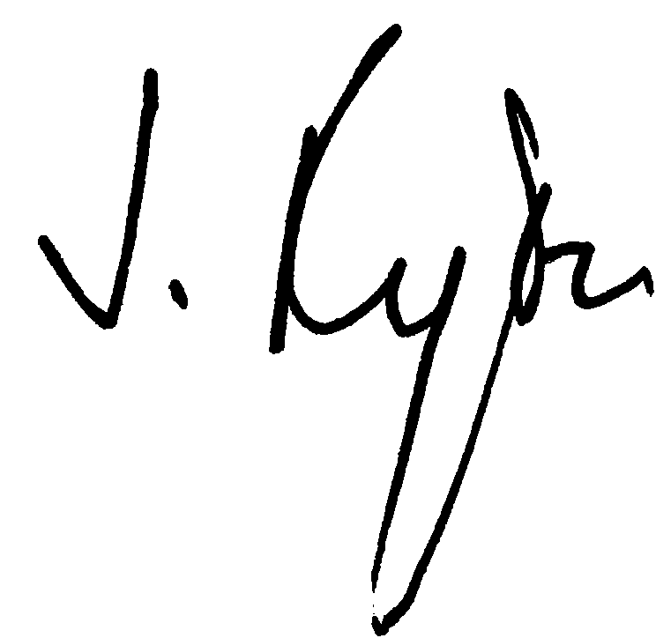
Jane Ryder
Chief Executive

