

Baby Bank Scotland SCIO
(SC047393)

Annual Report of Trustees
2025/2026

Registered Address:
5 Bairds Crescent
Allanshaw Industrial Estate
Hamlilton
ML3 9FD

Phone: 01698 457 756
Email: info@babybankscotland.org

Charity Trustees
- Jillian Thompson (Chair)
- Agnes Kerr (Treasurer)
- Sheenagh Williamson
- Neil Ross
- Emma Kennedy (Secretary)

Overview
As we look back on the past year, our overwhelming feeling is one of gratitude. We would like to say a heartfelt thank you to everyone who has supported Baby Bank Scotland through donations, volunteering, fundraising, and advocacy. Your generosity allows us to provide essential items to families experiencing poverty and financial hardship, ensuring that babies and children have access to the things they need to thrive.
The reality is that poverty continues to affect many families across Scotland, and we know that financial hardship can happen to anyone. Thanks to the ongoing support of our community, we have been able to respond quickly and compassionately to families facing difficult circumstances, providing practical support with dignity and respect.
This year has been one of growth and change for Baby Bank Scotland. As demand for our services has continued, we reached an exciting milestone with the appointment of our first member of staff. This marks an important step in our journey and reflects how far the organisation has come since it was founded.
While we celebrate this achievement, our volunteers remain the heart of Baby Bank Scotland. Their commitment, kindness, and hard work make everything we do possible. From sorting donations and preparing referral packs to supporting events and raising awareness, our volunteers continue to go above and beyond for the families we support. We simply could not do this work without them.
Alongside delivering our services, we have spent time strengthening the organisation behind the scenes. We have reviewed and developed our policies, procedures, and governance arrangements to ensure we are well placed to continue growing and meeting the needs of families safely, effectively, and sustainably.
To end the year, we have begun the process to recruit new Trustees to our Board. As the charity develops, it is important that we have the right skills, experience, and leadership in place to support our future ambitions. We are looking forward to strengthening our Board and are grateful to all our Trustees for their commitment and guidance.
Although it has been a busy year, it has also been an incredibly positive one. We are proud of what we have achieved together and of the difference our supporters, volunteers, staff, trustees, and partners continue to make every day.
Thank you for being part of our journey. Together, we are helping to provide dignified solutions to poverty and ensuring that families across Scotland receive the support they need when they need it most.

Objectives and activities
Baby Bank Scotland supports families living in poverty or experiencing financial difficulty. We provide baby and child essentials that families would otherwise struggle to afford, offering dignified and practical support.
Poverty remains a reality for many in Scotland. The challenges families face can arise from a range of circumstances that can quickly put immense pressure on household budgets. These can include single parenthood, inadequate support networks, reliance on benefits, mental health difficulties, in-work poverty, and the need to escape domestic abuse.
We believe that every child deserves the essentials they need to thrive, regardless of their family's circumstances.
Our support includes clothing, bedding, cots, prams, car seats, baby equipment, nappies, wipes, and baby care products. We also provide toiletries for the entire family, helping to maintain health, wellbeing, and dignity through access to everyday essentials such as soap, shampoo, deodorant, toothpaste, toothbrushes, and period products.
The majority of the items we distribute are generously donated by local individuals, community groups, and businesses. By redistributing high-quality pre-loved items, we not only support families in need but also promote sustainability and reduce waste within our communities.
From our Hamilton base, a dedicated team of volunteers carefully sorts, stores, prepares, and packages donations with care and respect. Every referral is treated as more than a collection of items; it is an opportunity to provide reassurance, compassion, and practical support during a difficult time.
Families can access our service through referrals from health professionals, social workers, schools, charities, and other third-sector organisations when a need is identified.
At Baby Bank Scotland, dignity, confidentiality, and respect are at the heart of everything we do. We operate with absolute discretion, safeguarding the privacy of every family we support in full compliance with GDPR requirements. Only essential information is retained for service management and reporting purposes.
By responding quickly to families facing hardship, we help alleviate immediate pressures, restore dignity, and ensure that babies and children have access to the essentials they need during life's most challenging moments.

Structure, governance and management

Staffing and volunteers
The recruitment of the first paid member of staff has been a significant milestone this year. In September 2025 we successfully appointed our first manager on a two-year fixed term contract.
We have a core group of regular volunteers, who this year gave 4113 hours of their time to ensure the day-to-day operations of the baby bank.
We continue to receive regular support from our corporate volunteers, who with thanks to their employers are released to support our activities.

Governance
Our governing document is in the form of a constitution. As a charity, we comply and adhere to our policies and principals as defined by our constitution. A copy of our governing document is available upon request.

Trustee recruitment and appointments
In our last annual report, we committed to grow and strengthen our board to ensure continued effective governance of our organisation. This year Emma Kennedy has been appointed to the role of board secretary and in January 2026 we began recruitment for new trustees. After a successful recruitment process two new trustees will join the board in the coming months.

Achievements and Performance
This year we supported 2119 babies and children, and 15 adults, providing families with essential items.
Through our Christmas appeal we gave gifts to 1186 children.
This year we distributed:
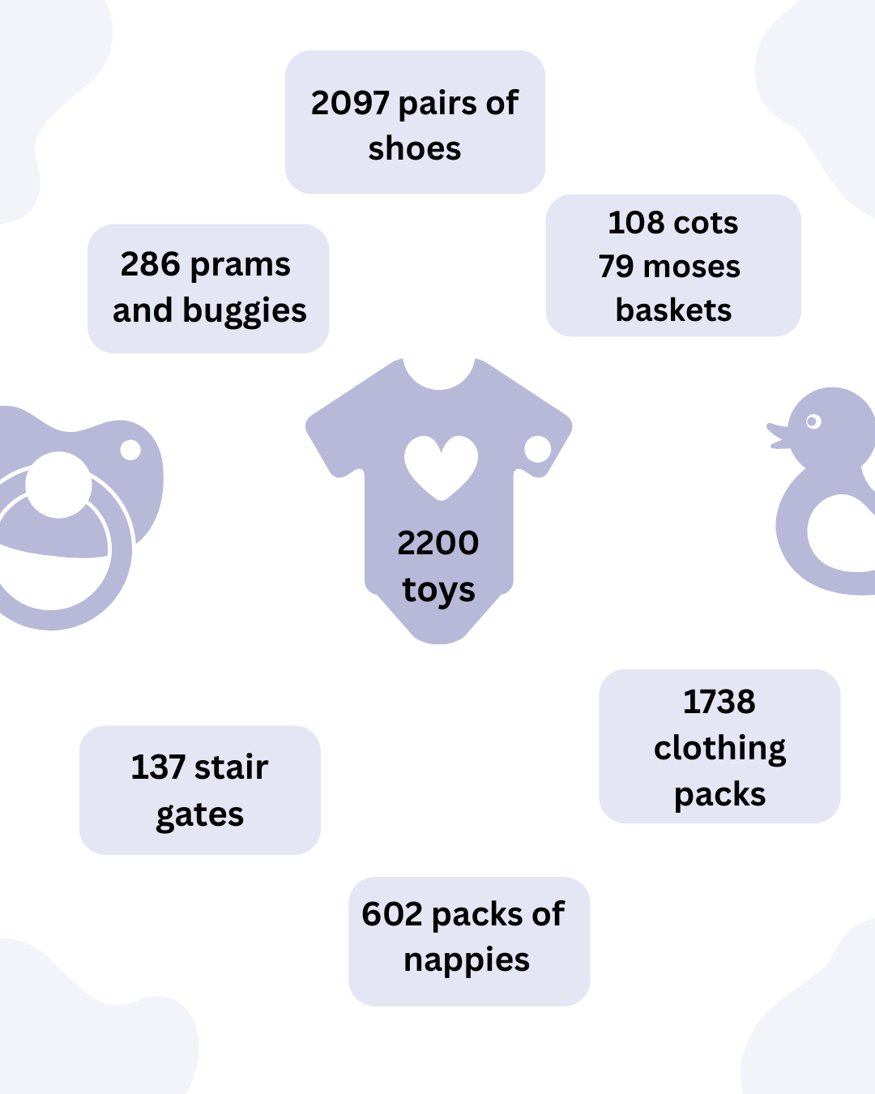

Financial Review
The following provide the breakdown of the main sources of income and expenditure in financial year 2025-2026.
Baby Bank Scotland (LBB) SCIO SC047393
Receipts and Payments Account for the Year End 1st March 2026
Receipts | 2026 | 2025
Donations | £9,526.03 | £14,602.40
Fundraising | £16,240.15 | £15,021.30
Grants | £9,835.00 | £27,573.20
Cash for Clothes | £2,130.46 | £1,920.84
100 Club | £8,248.10 | £9,163.82
Total income | £45,979.74 | £68,281.56
Payments
Wages | £9,591.00 | £0.00
Rent | £15,000.00 | £15,000.00
Insurance | £43.90 | £985.03
Internet | £744.01 | £0.00
Utilities | £5,035.36 | £4,221.65
Travel | £130.02 | £265.00
Other | £20,330.35 | £11,747.69
Total expenses | £50,874.64 | £32,219.37
Net surplus / deficit | -£4,894.90 | £36,062.19

Baby Bank Scotland (LBB) SCIO SC047393
Statement of Balances as at 1st March 2026
Balance Sheet | March 2026 | March 2025
Account 1 | £52,366.67 | £65,509.67
Account 2 | £27,464.81 | £19,216.71
Total assets | £79,831.48 | £84,726.38
Funds
Opening funds | £84,726.38 | £48,644.19
Deficit / Surplus for the year | -£4,894.90 | £36,062.19
Closing funds | £79,831.48 | £84,706.38

All funds remaining are unrestricted. The members of the board are required to act in accordance with the charity’s constitution.
Signed: 
Agnes Kerr (Treasurer)

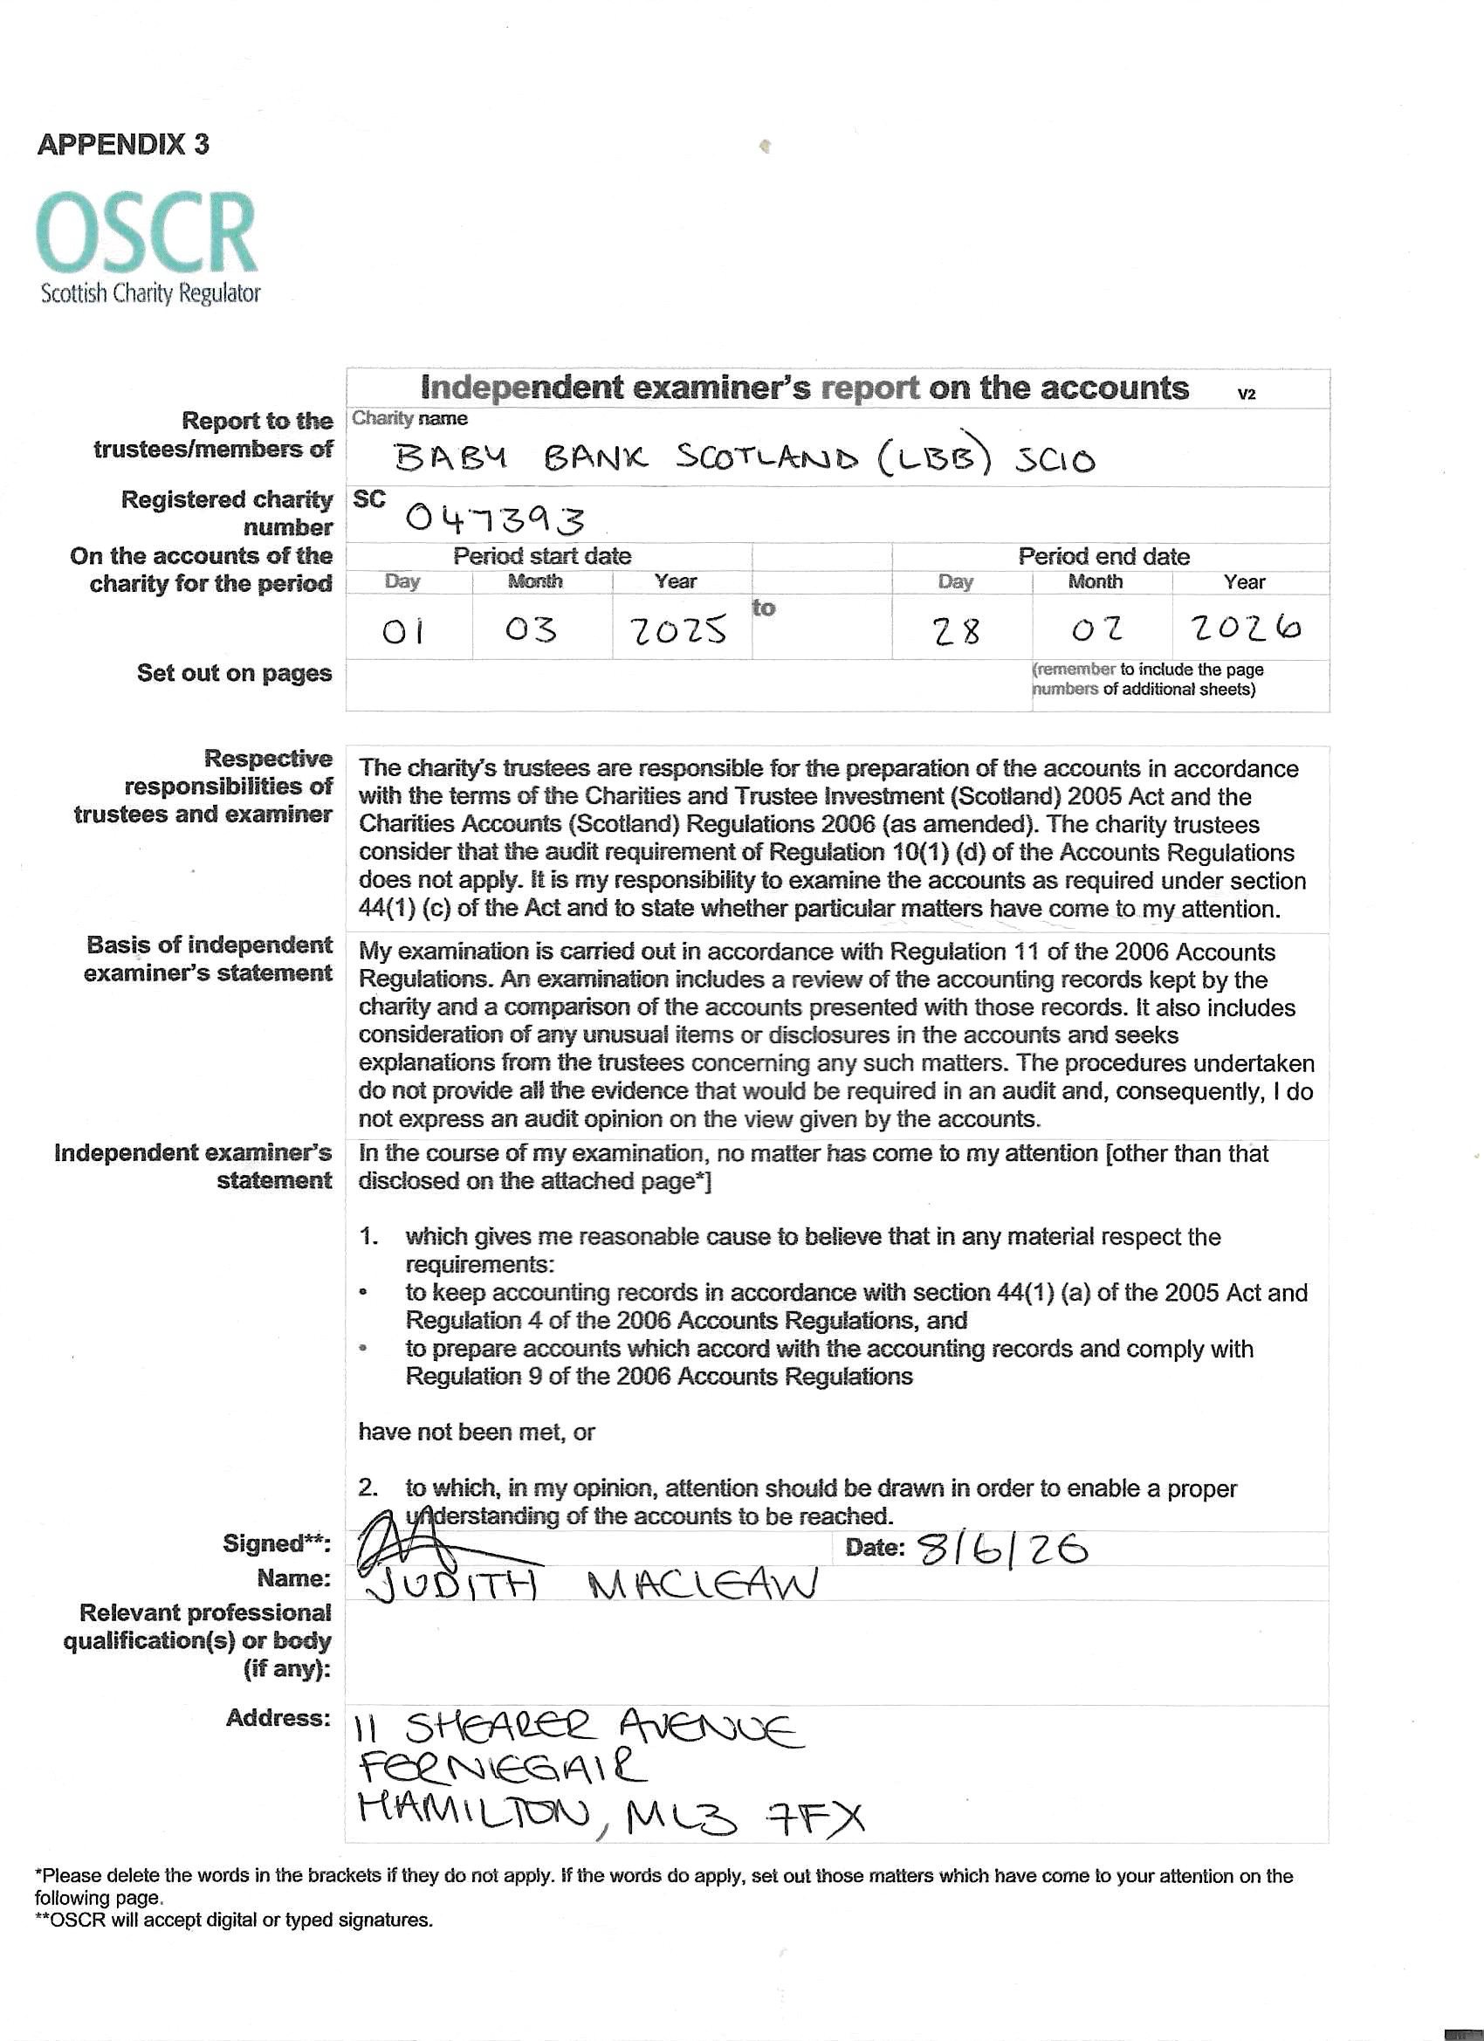


Statement of the charity’s policy on reserves
Our Financial reserves policy states that 12 month’s general running costs be held in reserve along with an additional amount of £3,000 to cover unforeseen emergency expenditure in relation to running costs. Based upon current levels of expenditure, 12 months running costs would total £42,000 and the emergency fund of £3,000 would mean that £45,000 would be held in reserve.

This amount allows a level of comfort in sustaining the charity should the level of donations or fundraising activities dwindle. The £3,000 emergency fund also provides a fair level of comfort to support unforeseen running costs.

The manager position was recruited on a two-year fixed term contract reflecting the available unrestricted funds for the duration of the post. The future of this position, post year two will be dependent on successful income in the next business year. Generating income to ensure the ongoing sustainability of this post will be the responsibility of the postholder.

It is also agreed that surplus funds beyond the amount to be held in reserve could be used for the benefit of the organisation. It was agreed that surplus funds could be used as follows –

- to maintain stock levels of certain items required but not often donated

- to pay volunteer expenses

- to purchase sundry items in relation to cleaning and running costs

- to cover costs relating to office stationery.

This policy will be reviewed and updated on an annual basis.

Future Plans
In the coming year we look forward to working with our manager to support the continued development of our services. We will continue to build relationships with our partners and stakeholders to ensure we are reaching the families who require our support.
We will continue to assess the impact of the changes to our referral system and seek alternative routes to distributing to families. This includes our partnership with Craigneuk Family Centre, supporting this drop-in facility as a route to distribute any excess stock. We will also test out a monthly ‘care and share’ model where families can drop-in to our premises, without a referral, to access support. This model provides open access but requires follow-up via referral for core items, we hope that offering a variety of ways to access our services will ensure we reach families in need.
In this year we will work with our manager to seek new sources of funding, with a focus on maintaining the manager position.


Declaration
Signed on behalf the charity trustees:
Print Name: Jillian Thompson
Designation: Chair
Date: 20th July 2026

